OXON 20 2019 Important Information.

We hope you enjoy this year’s 40/20 at – Longburrow Hall in Stokenchurch.
Parking is available from 06:15, approx 750yds from the Walk HQ, please allow sufficient time to arrive and register AT THE HALL BEFORE proceeding (allow 10 mins) to the start AT STOKENCHURCH GREEN (see map and directions below): 20 mile walkers and runners 09:00. Please note the CP opening times, entrants arriving early will not be allowed in. If you expect to complete either course at over 6mph please inform the Help desk at registration.
Car Parking.
As spaces are limited please car share if possible. We have the use of two car parks, both off the M40/A40 from junction 5 into Stokenchurch, please park as directed by the marshals. For directions use HP14 3SX on your SatNav or GR SU756964 on your OS map.
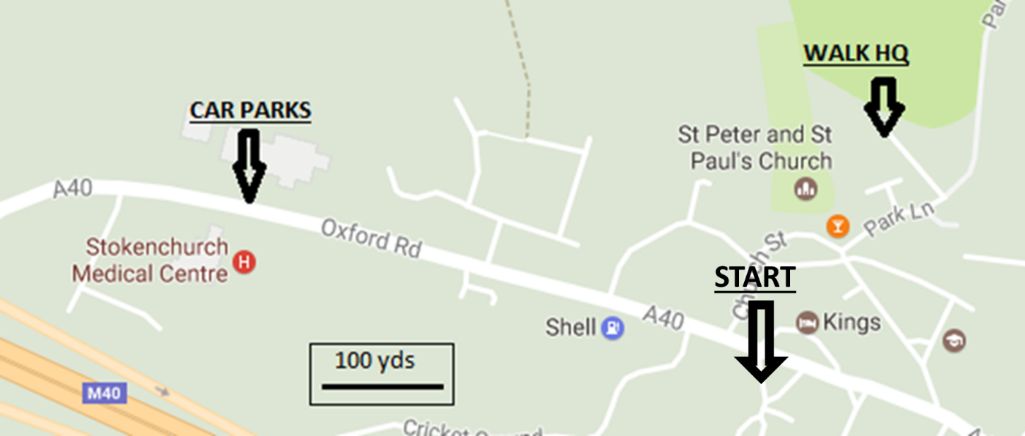MAP
Registration.
YOU MUST REGISTER AT THE HALL BEFORE STARTING . Ensure we have the correct course and details recorded. There will be mass starts for the 20 (runners and walkers) and any last minute information or changes to the route will be notified at the briefing a few minutes before the start.
For the event.
Please ensure that you have printed out, and brought with you, a copy of the route description as there will not be any available on the day. Also you must have the required maps, a mug, suitable clothing, a basic first aid kit, if possible a charged and switched on mobile phone and sufficient food and drink to allow you to get between the checkpoints.
Emergency Phone on the event : 07935 160854

OXON 20-2019 Route Description

Place names: Italics = name or path number can be seen from route
CAPITALS = name appears on O.S. Landranger 165/175 (1:50,000)
Abbreviations: ahd=ahead: B=bear: bld=building: BW=bridleway: CB=compass bearing (magnetic): cont=continue: CW=Chiltern Way: encl=enclosed: F=fork: fld=field: fllw(ing)=follow(ing): FP=footpath: FPS=FP sign: GT=gate: GR=O.S. grid ref: immed=immediately: junc=junction: K/G=kissing gate: L=left: LHS/RHS=L/R hand side: m=mile: opp=opposite: OW=Oxfordshire Way: R=right: RD=road: RW=Ridgeway: SP=Signpost(ed): ST=stile: TK=track: thru=through: T=turn: wd=wood: WM=waymark(ed) (often white arrows): X=cross/across: yds=yards
All GRs are SU xxxxxx unless stated

Directions to Start : Leave hall through car park and turn R back into Stokenchurch. At the Royal Oak, turn 2nd L passing the Old Croft House. At the end of the line of houses, TR on Kings Row. Pass thru the Kings Hotel Car Park and cross the A40 AT THE PEDESTRIAN CROSSING, obeying the marshals. Assemble around the bus shelter to the R of the crossing.
Start Stokenchurch Green. GR 760 963.
1. X grassy area heading west, heading for gap in houses (quiet please!). TL on lane to swing round LHS of cricket pitch. Ahd to join path which rises to cross M40. Soon join TK thru houses, ahd to T junc and TL. After 70yds TR at hidden FPS onto Mill Lane. Ahd onto FP to X RD and cont on Mill Lane thru industrial estate. X small RD and ahd on TK for 200 yds. At end of TK, through grey GT to R of Wormsley Estate sign. Ahd on faint TK (CB 260 deg), keep R of nearest power pole, down thru fld, X ST and TL. GR 747 962
2. Follow WM thru wd, eventually descend to cross RD with No public access signs to R and L. Over ST and climb through fld. X ST into wd, climb to meet TK near top and BL. Swing R to descend to path junc, where TL on path L19. Ahd 1000yds downhill on wide path to meet lane. GR 744 950
3. TR on lane and pass to L of thatched house, ahd on lane for 450yds, ignoring turnings to R. At sharp RH bend, BL on TK, later becoming path. After 500 yds BR on encl FP, ignoring climbing path to L, to stay within valley. 150 yds after dead tree on R, which is opp a first grey gate, reach double grey GTs on L and WM on post. TR immed after this thru gap in hedge to R and K/G next to another grey GT, onto CW. X fld, thru K/G, lane, K/G, another fld and K/G to emerge on a lane. TR for 40yds, then BL onto CW, joining SH4. Ahd 200yds to path junc, where ahd (leaving CW), passing immed to LHS of an urn sculpture GR 736 935
4. Cont on SH4 thru wd for 1700yds, climbing steadily. On reaching top, after passing thru some holly bushes, TL on path SH5. Follow thru trees and along RH side of several fences to reach RD after 700yds. X and take FP opp thru K/G. Ahd X flds thru GT to descend to K/G into wd (PS2). Ahd on encl FP to reach T-junc at Priors Grove Cottage. GR 718 929
5. TL on metalled lane, 200 yds to entrance to Queen and College Wds. Ahd (ignoring OW) on rutted TK for 550 yds to reach TK junc with GTs to R and L. TL and go round LHS of wooden GT. Descend on wide TK thru wd to bottom of valley. T sharp L here onto BW at blue WM, leading up valley, 750 yds to reach fingerpost and painted WMs on tree. TR on W5a, leaving OW. Climb thru wd for 350 yds then along RHS of flds and thru a series of K/Gs to emerge on TK next to long brick bld. GR 727 929
6. Pass to L of bld then ahd thru gap in hedges. BL to go through grey GT with white WM. 30yds later, ignoring two WMs pointing L, BR on unmarked path (do not proceed to RD). After 50yds emerge on driveway and cont ahd to L of walls of houses, eventually joining TK at Brackendale House. Ahd on TK, ignoring CW turnings, becoming RD to eventually reach checkpoint on R
CP1 Northend Village Hall GR 734 925, Opens 10.10 Closes 13.00, 7.1 miles
7. Head NNE over common, joining RD on RHS of common. Pass duck pond and TR at T junc (SP: Turville). Ahd on RD for 600yds. On entering wd, BL immed onto unmarked FP between 2 tree stumps. Follow FP downhill, parallelling LHS of RD. Do not descend steps at FP junc after 900yds but BL off RD again following blue WM. X lane then BR twice after 50yds and 100yds on blue BW WMs, keeping to valley bottom. Ahd over lane for 1000yds (X another lane) to RD, where TL. Cont on RD into centre of TURVILLE, passing to L of church GR 768 911
8. TL on CW opposite phone box and between houses. After 100yds thru ?broken GT then immed TR thru K/G, staying on CW. X fld, thru K/G then thru wd for 400 yds, emerging unexpectedly onto lane (danger : listen for traffic!). X lane, thru GT, and after 80yds, BR downhill (CW) into FINGEST village. TL on RD then TL at Chequers Inn GR 777 912
9. Ahd up RD with church to L. Pass phone box and TR at Sundawn onto encl FP. At end of fence, cont ahd on encl FP, ignoring ST to L. Thru 2 K/Gs then BL on TK, keeping under electric wires for 300yds to reach Nissen Huts, where BR on lower FP. Keep under electric wires, BL on TK, past animal pens thru gate to RH corner of next fld, where X ST. Ahd below lower set of electric wires.
CARE NEEDED : 180yds after the ST mentioned above, at GR 787 917, swing R with the electric wires/posts and hedge, but after 20 yds, T sharp L onto FP heading on CB:45 towards a bowl shaped depression. Do not go thru K/G to RD.
X fld on faint FP, X ST and shortly ST into wd. Climb path and thru K/G and ST to pass thru encl FP, eventually emerging next to cattle grid, where TL on RD to X main RD with care at Cadmore End. Ahd on lane opp (water available) GR 790 925
10. Ahd over M40 bridge At X TKs at farm entrance, TR into Cadmore End Common at notice board. Follow widest TK for 650yds , ignoring tracks to L then R that lead to houses, going twice under electric wires, to join lane at bend in front of Watercroft Cottage. TL following signs to Watercroft Farm, In 100 yds, just after FP sign, TL thru K/G. Ahd LHS of fld, thru GT into wd, over 2 K/Gs, then descend thru holly, X TK and ahd down thru fld. Into wd to reach valley bottom, where TR on wide TK (S52). BR off main TK after 250 yds at picnic tables/parking area GR 792 935
11. Go round LHS of barrier, X TK and ahd on FP for 700yds to reach 4 way junct. 15 yds before this junct (don’t X ST), TL and climb up LHS of fld. BR at crest of hill to X fld and ahd at marker post over Xing path. Cont to enter wd and ascend on WMs, eventually S53, for 700 yds. BR to pass behind green garage to A40 GR 791 951
12. X busy A40 with GREAT CARE. TR on opposite pavement, ahd to A40 London sign, where BL on Old Dashwood Hill. Ahd 250 yds on pavement into STUDLEY GREEN village. Just after The Chilterns, TL on BW and follow this downhill through wds to reach board for Bottom Wood Nature Reserve. GR 797 953
13. TL along fence on RA31 and follow this wide path for 800yds, ignoring permissive path, to reach another Nature Reserve board. Ignore crossing ‘Circular Path’ after this but 40 yds later, take WM to R for RA32 (faint WM). Uphill on sunken FP, thru GT then ahd on LHS of fld thru GT to join TK, where BR. Ahd to go thru wooden GT then between wooden blds. As gravel TK swings R, ahd following WM over X TK, thru GT and X fld and K/G to RD. GR 794 962
14. TL, ignore first FP sign, pass junc with Radnage Common Road, then 150yds after this, take BW thru GT on R. X valley for 900yds to reach lane, where TL. After 60yds, TR onto BW, climb by side of fence and uphill for 500yds to reach Chinnor Road on top of ridge. X RD, TL and follow RD for 500yds. Pass church to reach
CP2 Bledlow Ridge Village Hall. GR 797 978 Opens 11.45 Closes 18.30 16.4 miles
Note there are numerous intersections with the 40 route after this. Follow the route description NOT those ahead of you.
15. Leave Village Hall and TR on RHS of RD. After 330 yds TR after Honeysuckle onto CW. At end of TK, BL on encl FP for 650yds, ignoring path to R. On reaching TK just after wooden fence, TL (40s go ahd) to reach main RD after 150yds. TR on grass verge for 40yds, then X with care to go thru K/G just after Yewsden House. GR 790 985
16. Ahd LHS of fld to enter Nature Reserve at K/G. In 5 yds, BR downhill to reach wooden post after 50m, where TL to pass ‘Welcome to Yoesden’ board. Descend on path (not on OS maps) for 550yds to reach GT and TR leaving nature reserve and join CW (that we follow to finish). Thru GT, ignore TK to L, follow thru several flds and GTs then graveyard to reach entrance to St Mary’s Church. GR 785 979
17. Down to T-junct, X RD (1/2R), thru gate and fld on CW. Thru gate and BL to join TK leading to RD, TL down RD (40s go R) to bend and TR on Horseshoe Road (CW) After 150yds, BR over ST (CW). Ascend round back of Elbow Knap, over ST to BR uphill on RHS of fld, eventually joining lane. After lane swings to R, TL on FP (CW) through 2 GTs. Descend along fence then thru GT, TL and down thru gap in trees. TL along top end of fld to WM, TR and descend on chalk path to reach lane at farm. TL for 20yds, then TR thru gap in hedge, X fld and 2 ST to reach TK, where TR for 100yds to reach signpost GR 775 971
18. TL on CW rising to hedge. X TK then ahd on CW on LHS of 2 flds for 600yds. In middle of second fld, BL onto TK at WM and TR. Follow TK for 300yds, BL before grey GT over fld. Cont through bushes, K/G then fld for 400yds, to emerge at lane. TL on lane for 100yds then TR to Longburrow Hall and register at the FINISH.
Well Done! 20.1 miles 2567ft ascent

