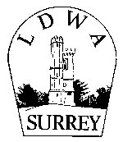

LDWA Surrey Group

Expenses Claim Form

Expenses should be claimed within 30 days of the event.
You can complete this form on-screen by clicking and typing in the boxes. Alternatively you can print it off, fill in the boxes manually and then scan it back in.
Please email the completed form to our Treasurer at surrey.treasurer@ldwa.org.uk
Please include scanned images of receipts, where available.
Expenses will be paid directly into your bank account wherever possible so please ensure your bank details are correct, including the full name.

Your details
Name
Address |  |  | Post Code

Event (if applicable) :

I would like to claim the following expenses incurred on the above event:-
 | Brief details | Amount claimed
Travel*
Supplies
Printing/
postage
Other
* you may claim up to 45p/mile for car travel |  | Total:

Your bank details
Full name of bank account
Sort Code |  |  |  | Account number

Date:
Date

