Introduction
The tally template has been created to reduce the workload of LDWA 100 organisers, but it can also be adapted by LDWA local group challenge walk organisers. The design allows you to populate 550 tallies from a single master sheet. The template was first used for the 2016 Dorset 100 and this guide offers a simple how to guide and advice on printing the tallies.
All the information on the tally below can be updated through the master sheet apart from the logo/badge and the barcode.
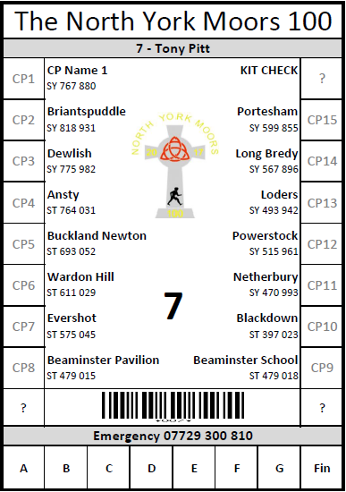
Figure 1: The tally

Timeline
Creating the outline template can be created early in the planning cycle but the final print wasn’t completed for the Dorset 100 until after entries had closed and the final qualifying event had taken place, which was the weekend before the marshals’. It goes without saying that the information on the tally should be accurate and match the route description.

Creating your template
- Open the tally template
- Save a local copy to your PC or Laptop
- Select the Master sheet at the bottom of the page

- By changing the text in the green areas, this will update the sample tally on the right which in turn updates the other tabs/tallies.
  - Update check points, emergency phone No. and clippers in column B
  - Update entrants in column F and G. This can be added by running a report in SiEntries and exporting names to excel, and copy and paste the entrants into the corresponding cells in Column F and G
  - The white areas can be unlocked by going to Review Tab > Unprotect sheet

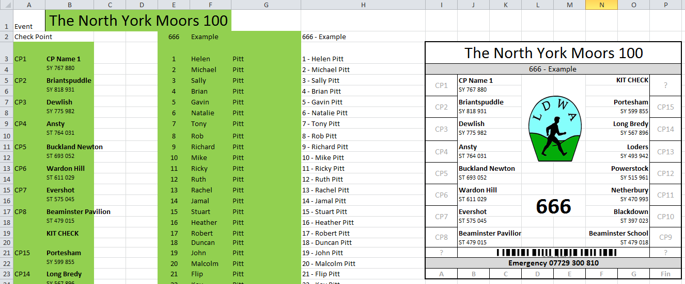

Inserting the event logo on to the tallies
- Go to sheet 1-4
- Delete the logos on tally 1 to 4
- Copy and paste your logo onto the tally 1
- Resize your logo to fit
- Carry out a print preview ( the logo will need resizing and checking again)
- Once you are happy copy & paste the logo onto tally 2 to 4 and position each correctly
- Check Print Preview again
- Once you are happy hold down shift and click on the 4 logos on the sheet so all four are selected
- Right click and copy
- Go to sheet 5-8 delete logos and paste
- Whilst all four logos are selected position correctly on tally (you should be able to do all four at the same time)
- Repeat though all tabs (don’t forget to save occasionally)

Proofing and Printing
Save tallies to PDF
- Select sheets to printed
To select all apart from the Master sheet select sheet 1-4 hold down shift and click on the right (end) navigation button and select the last sheet, this will select all the sheets.

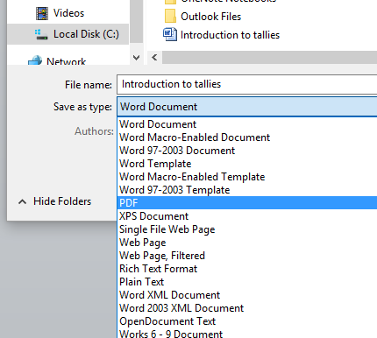

- Save the file as PDF
File> Save As> In the Save type select PDF and Save
- Proof and double check tallies

Printing Advice
For self-printing use waterproof paper on Laser printer
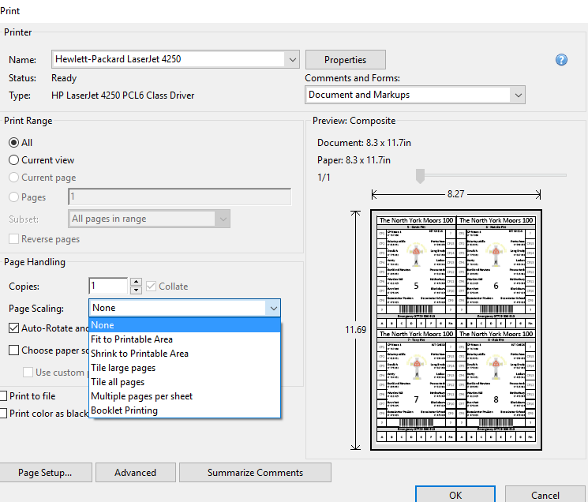
Paper order 2 boxes of 100 sheets of A4, I use Zecom paper ordered from: https://www.weatherwriter.co.uk/Item/zecom-waterproof-paper
Test print one page. I found that choosing None for Scaling produced the best results pushing the margins nearer to the edge of the page, but this may be dependent on the printer
Print no more than 10 pages at a time, immediately separate the printed sheets and lay on a flat surface. The sheets are hot when printed the paper remembers any curl as it cools.

