20th FOUNDERS CHALLENGE – 27 mile route

Saturday, October 8th 2016

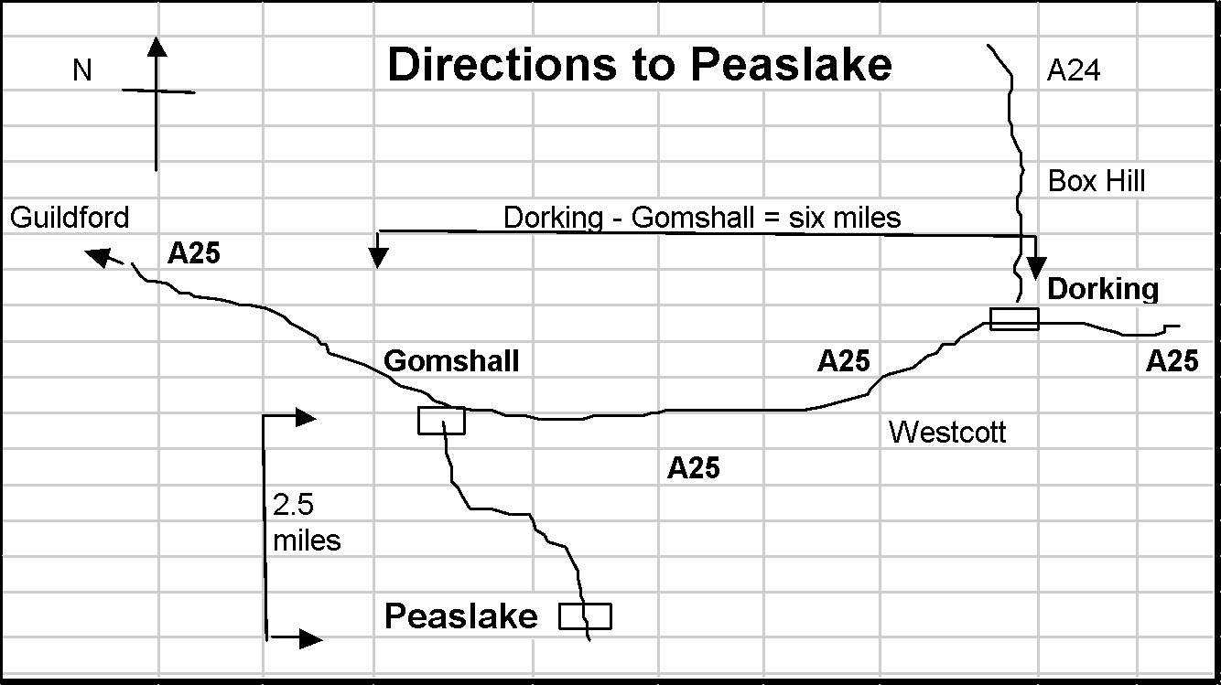

PLEASE NOTE:
- Most of the route is on rough or uneven terrain.
- Some of the paths are becoming badly eroded in places, with loose rocks & exposed tree roots.
- There may be slippery stiles and descents, especially in wet weather.
- Watch out for cyclists.
- There are some road crossings & short sections on narrow roads & on roads with no pavement where Highway Code advice should be followed (maintain single file and keep right except at right-hand bends).

PLEASE TAKE CARE AT ALL TIMES - YOU UNDERTAKE THIS WALK AT YOUR OWN RISK

For those of you who have entered the Founders Challenge in previous years this year’s 27m route is the same as the 2015 route up to checkpoint 1 (although the description has changed, we hope for the better!) but has some changes between checkpoints 1 and 2.

Please Note also that those on the longer route are expected to climb steeply & directly up St Martha’s Hill as this is a Challenge Event! The route using the Downs Link path across the shoulder of St Martha’s Hill is on the 16 mile route, a lesser challenge.

HQ Mobiles [coverage uncertain!]:
Adam Dawson 07767321960
Gordon Parker 07891196930
Emergency Telephone: 01306 730851 (messages – Hurtwood Inn)
Abbreviations: B = bear; BW = bridleway; cont. = continue; F = fork; FB = foot bridge; FG = field gate; FP = footpath; GW = Greensand Way; KG = kissing gate; km = kilometres; L = left; m = metres; NDW = North Downs Way; NT = National Trust; R = right; RD = road; ST = stile; T = turn; TK = track; X-RD = cross roads
Maps: OS LR 187 (3ml on LR 186) or Exp 145 & 146.
All Compass bearings are from Magnetic North.

1. GR 086447 PEASLAKE MEMORIAL HALL Post Code: GU5 9RR

1.1 From the Hall exit to your L and go up paved BW opposite, passing church on your R. At the end of this path BL round wooden barrier to pass graveyard on your R.

1.2 Ascend gently on broad sandy TK for 600m then, at large triangular clearing with cairn FL. Continue ahead and in 1km GW joins from the L. You will follow the GW for the next 4km, reassured by numerous GW posts. Continue past house on R. At end of garden fork R uphill (GW). Join track from R, pass a metal seat at a viewpoint. At junction, BL (wooden rails on your L) on FP, round edge of hill. At next GW waymark post BL on wide track to seat and PITCH HILL MEMORIAL TOPOSCOPE (commemorating LDWA’s founders). Retrace steps for 20m and TL to trig point.

1.3 Follow TK ahead (320°), for 400m, down to car park and TL. Cross RD ( take care) and cont. on GW, on drive for 20m, thru fence next to MILL COTTAGE, ahead uphill on eroded FP and BL off main track to pass windmill on your L. ahead (240°) for 80m then BR (250°) and after crossing two BWs, descend on FP, ahd for further 20m to cross RD (Winterfold Heath Road sign visible opposite take care). FL through car park pass Hurtwood Control notice board, and ahead uphill on path (GW). At top, pass viewpoint and artistic red & black bench on L. Enjoy the views/glimpses of the Weald below on your left, but don’t be tempted to wander down there.

GR 073423 REYNARDS HILL 2.5 miles

1.4 After 160m (GW post) go ahead. Soon fork R, then L at GW post. On approaching road (wooden barrier) BL (at GW post) parallel with road, to later join road, with deep hollow on L. Do not cross road. Pass deep gulley (Jelly’s Hollow) to GW sign and follow uphill 210 degrees. Then after 50m BR 220° to GW post. Cross tarmac drive, then after 80m turn R. After 400m reach car park (great view on L). TR through low wood posts and car park (leaving GW). Cross road, and in 35m turn L on track that runs parallel with road. Track soon bends right, heading north. In 520m cross road (take care) at Keepers Cottage signs.

1.5 Continue ahead on broad track. At end of paddock BR with wire fence on R.
At cross track (metal FG ahead) TL. In 400m TR around large tree (faded FP signs) on narrow path which heads in a northerly direction. Follow main path for 800m ignoring tracks to R & L to vehicle track with electric cables overhead. TL and in 550m cross road.

1.6 In 20m TR on sandy track. Continue on this track for 1.3km ignoring tracks/paths to R & L. Track narrows to become rocky gully. Descend to reach BW (power lines overhead & wooden fence on L). Turn L for 45m to reach tarmac lane opposite cottage. Turn R (wooden fence on L). At end of tarmac continue ahd. After 150m continue on a bearing of 320° passing small round posts with blue tops. After 800m pass seat on L then bear slightly R through woods and after 200m keep ahead, X two TKs and after 50m reach corner of Blackheath Village cricket ground. Then TR. At RD TR into car park (GR 036 463).

1.7 On the north side of the car park take the BW on the L, between 2 low wooden posts, heading north. FL to join RD from L and in 50m FL into BW. After 20m ahd across BW. Cross next RD (unpaved), ahd to take Downs Link BW north. Cross the A248 to pass Lockner Farm.

1.8 After Longfrey Farm pass Downs Link on R (ROUTES SPLIT) and in 10m TL at permissive FP sign. TR on FP for 250m. BR in front of gate to rejoin BW. At fingerpost TR (St Martha’s) to ascend steeply. At churchyard wall BR to join broad sandy track (the NDW) and keep low wooden fence on R. Keep ahd (do not FL on NDW) to pass pillbox on L (ROUTES RE-JOIN), ahd 250m then BL into car park and checkpoint.

CHECKPOINT 1 GUILDFORD LANE CAR PARK (10.30 am - 1.00 pm)
GR 033485 9 miles

2.0 From car park TL on lane. Where lane TR, FL, pass to L of gate & imm TR on NDW. Cont to climb steadily parallel to RD, descend steps to X RD (take care – blind bend to L), cont up on opp side on NDW. Thru barrier, up 10m then BR on NDW. BL at fork then BR past waymark sign as path opens out then ahd to contour across field (90°, don’t follow NDW at L field boundary) & then up towards A25 (public toilets; kiosk at Newlands Corner on L before RD).

2.1 At stony track 25m before RD (A25) TR down hill. Cont. down for 800m bearing R then L, pass TK joining from R. Just before narrow waymarked TK going up on R TL to pass cottages on R.

GR 046484 WATER LANE COTTAGES 11 miles
2.2 Keep L at garages, ahd past metal gate on TK and in 500m, at cottage on R, BR on FP (110°) and keep ahead through open metal FG (or over stile next to it). Cont. ahead (110°) on TK then soon BR (130°) on FP where it leaves TK.

2.3 In 250m cross concrete access RD to quarry and cont. for 400m on FP, crossing 2 stiles and through KG to RD. Cross A248 (take care, fast traffic) and ascend with church on your R. Cont. ahead thru KG and then ahead across field thru KG and into Silver Wood. Keep ahead through wood, thru KG and then same line of travel across field/drive/field (125°) then thru KG to descend through trees to TL on lane.(ROUTES SPLIT HERE)

2.4 When lane joins RD (Upper St) cross over (take care), TL and cont. for 30m. TR on broad track immediately after house. In 130m track bears right to run parallel with A25. When main track BR, cont. ahead on narrow FP, through trees, to reach sunken cross track. Do not cross the A25 here.

2.5 TR and descend for 60m then TL on TK to head north and go under A25 (GR 072482). Cont. uphill for 900m (soon becoming 60°) and at top TR on waymarked cross tracks on to NDW. Follow NDW for 1.5km, then FR at NDW finger post (take care, easily missed). TR thru gap then after 80m, in front of FG/KG, BL with fence on R and follow NDW for a further 650m to KG (take care: trip hazard) & NT BLATCHFORD DOWN signpost. Cont ahd on NDW for 300m to reach 2nd NT BLATCHFORD DOWN sign at X-TK & KG.

GR 103488 BLATCHFORD DOWN 14.5 miles

2.6 Through KG, cross TK and through 2nd KG. Continue on NDW for 1km. Go thru KG at NT White Down Lease sign. Cont. on NDW & in 200m (where it TR to descend to road) reach NDW signpost. Leave NDW and continue ahead on narrow winding path, which curves L around edge of ancient pit. Ignore path on R over bank. Keep ahead on narrow path through plantation, soon with sharp drop on your R. Continue ahead, and in 110m turn R at T-junction. In 100m pass beside railings of reservoir on your L. At end of railings turn R on track. In 50m turn L on track. Ahead at BW signpost, heading North. Continue across TK (SHEEPWALK LANE) and ahead on FP to RD by house. Cross RD (take care) and proceed up drive for 80m (dogs on lead through farm & fields please).

GR 111502 DUNLEY HILL FARM 17 miles

2.7 TR at FP sign before gate to buildings (Ranmore Wines). Follow TK as it bends L, then go ahead on narrow path between fence and buildings. Over stile and turn half R (60°) to cross stile beside FG in far corner. Continue across field on same bearing to a KG in the middle of the fence ahead. Through KG, TL immediately on FP winding through wood with many fallen trees/branches. FR near RD (CRITTEN LANE) and cross RD (take care) to go through KG. Go slightly L up bank, & follow FP eastwards crossing 3 stiles (you may meet some friendly llamas) and continue on drive. Cross RD (take care) at Friars Elm signs. Ahead on drive opposite (Haneys) and when drive bends R continue ahead uphill on FP. Cross next RD (take care) at Gatehouse Cottage and descend path past Hogden Cottage’s garages.

GR 125505 HOGDEN LANE 18 miles

2.8 Cross TK (Hogden Lane) at bottom, and continue ahead uphill over roots. Cross TK at top and descend to next bottom where T half L (to 2nd ride on L) and go through barrier (45°). Keep ahead on grassy glade, bearing L where another glade joins from the R. Go through old barrier, turn L, initially on surfaced drive, and pass Lonesome Cottage on your L. Bear R on grassy TK. Pass through barriers each side of a crossing TK, and continue. In 70m BL through gate and continue on a wide track between beech trees descending to a cottage (GR 134515). Immediately after cottage, before gates, TR on TK (this track is very slippery when wet, take care) descending more steeply before rising to give view of Polesden Lacey on your L. Cont. ahead to the ALAN BLATCHFORD MEMORIAL SEAT outside Tanners Hatch YH.

CHECKPOINT 2 TANNERS HATCH YH (12.30 pm - 4.00 pm)
GR 140515 19 miles

3.0 From Memorial Seat retrace steps for 5m. FL on TK and in 20m FL again. Follow this wide track going S for 1,100m to emerge beside Fox Cottages. TL on roadside grass and in 200m TR to cross RD (take care) to car park.

At eastern end of car park TR at NT Notice Board, through gate, to enter STEER’’S FIELD.

GR 142503 STEER’S FIELD 20 miles

3.1 TR (260°) onto broad level TK. Ahd 250m thru KG. Ahd past Ranmore Common sign (NDW), ahd 750m on NDW. Pass barrier and KG (on L), ahd 35m to TK by sign, FL on stony, downhill Byway (leaving NDW). At bottom of hill BR to join TK, downhill 30m to junc with sign. BR signed Bridleway (250°) on slightly rising TK with field and railway down to L.

3.2 Cont ahd on level TK thru gate. Ahd 400m to sign where TK bends R, TL thru gate (BW) (initially 190°) and follow RHS of field to go under railway bridge.

GR 127492

3.3 TK swings R then L, then R again. Ignore FP on L to join concrete area by farm buildings and The Empty Box Co, then TL on broad TK, ahd 590m to T-junc.

3.4 X tarmac lane and BL on FP with fence then gate on R. Ahd 350m (on encl FP) becoming very narrow) to RD [Coast Hill Lane]. BL 20m to main RD [A25 Coast Hill], TL on LHS pavement. Ahd 40m, grass bank on L, TR to X busy RD at best visibility point (take extreme care) heading for gap in low bank opp. On far side TL on narrow footway, ahd 150m to junc, Rookery Drive (take care: RD with no pavement).

GR 134483
3.5 BR and after 15m TR signed BW btw stone pillars. Ahd 320m on tarmac, BR to X bridge over mill stream with waterfall on L. Ahd 50m then, BL on BW which becomes stony. Ahd 450m to reach metal gate on L and isolated ST on R. Pass R of ST , then ahd (GW)(180°), uphill.

3.6 Emerge from gully onto level ground. Over stile TR onto broad sandy TK, BL after 15m, ahd 200m. Just before RD, TL (GW). At sign Pheasant Wood BL (GW). Ahd 140m then TR at sign FP, X ST.

3.7 Ahd (230°) for 50m BL (160°), down steep bank to tarmac drive. ½ L across drive to sign (FP), BR down bank to RD [Sheephouse Lane], (!!! FP emerges directly onto RD with no pavement)

GR 130474
3.8 TL, ahd 80m to reach Damphurst Cottage on R. Ahd on RD for a further 45m to KG on R. Through KG (sign Wotton Estate on R), follow barbed wire fence on R for 20m then BL (190°) ahd 430m, initially parallel to sunken RD on L then bearing R, to junc at brow of hill, with TK from L.

3.9 Ahd 90m to sign by double gates, BL (180°. wire fence on R) 430m to T-junc. TR onto wide, initially grass TK (260°), after 300m TK starts to descend, ahd steeply downhill. Thru KG, then TL before bridge. Follow TK, BR at cottage and cont. ahead to X-RD. TR and follow path on L, beside road, up steps and through wood (fence on your R) to car park and CP3.

CHECKPOINT 3 FRIDAY STREET (1.30 pm - 6.00 pm)
GR 126457 24 miles

4.0 From CP3 take vehicle track to L of “disease control area”, (215°), winding through woods in SW’ly direction. Descend to X-TKs then ascend (240°) on track. Continue ahead (260°) on FP (may be overgrown) for 320m to RD. Cross RD (Hollow Lane) (take care) to FP on R side of green and cross another RD [Abinger Lane]. X RD with care, ahd 210m on encl FP. At end of ranch style fence on R, BR (240°) for 20m. Cont ahd (230°) over X-path on TK in gully uphill which becomes wide and rutted forestry TK.

4.1 Cont. ahd 900m. Then FL on narrow path down steep descent (care) & thru KG cont. ahead to RD (Horsham Road, Holmbury St Mary). TL on pavement for 120m. At sunken white house on L with fancy double wrought iron gates (Pond House) cross RD (take care) to FP - on opposite side of the road (easily missed!). The FP bears L climbing gently. In 100m just before it reaches the corner of back garden TR on a bearing of 310° to go steeply up an indistinct and narrow FP through trees. As the path flattens out BL to go thru barrier to meet a wider path on which TR.

4.2 Ahd 350m ignoring paths to L & R to descend to wide X-TK. Ahd (320°) for 100m uphill to path junc. Cont ahd for 280m (290°), ignoring paths to L & R, to reach car park on R.

4.3 From far end of car park, ahd 90m (270°) ignoring paths to L and R. Ahd at fork (R fork) for 40m (270°) to reach a clearing. Cont ahd then FR down sandy TK (310°), TK bends L then R to pass btw ponds, ahd uphill (290°). From top of slope keep ahd on main TK for 460m (ignore X-ing path).

4.4 Pass 1st X-TK with 1st sign on your L, ahd 50m to 2nd X-TK and 2nd sign (FP & BW). Ahd slightly L 10m btw trees to 3rd sign (FP), BR (300°), ahd 50m on faint FP thru trees to pass 4th sign (FP). Ahd 400m on clear FP (280°) later keeping to partly sunken TK/gully swinging to 260°. At wide X-TK with sign on R, cont ahd uphill (280°), over 3 X-ing TKs, thru gap in wooden barrier and along encl FP.

4.5 Thru 2nd barrier, ahd on drive. Cross lane [Plaws Hill] ahd thru wooden barrier. Down steep earth FP, thru wooden barrier to RD [Radnor Rd] (!!! path emerges blind onto road. The final 110m are on RDs with no pavement: take extra care). TR, ahd to RD junc and X Ewhurst Road (take care) to pass war memorial on your R. Ahd to pass Hurtwood Inn on R. Ahd on RD (Walking Bottom) past Pedal & Spoke cycle shop (old Peaslake Post Office, the birthplace of the LDWA) to the
FINISH AT

GR 086447 PEASLAKE MEMORIAL HALL (2.00 pm - 6.30 pm)

CONGRATULATIONS!
YOU HAVE COMPLETED THE 20th FOUNDERS CHALLENGE
27 MILE ROUTE
2016

