21st FOUNDERS CHALLENGE – 27 mile route

Saturday, October 14th 2017

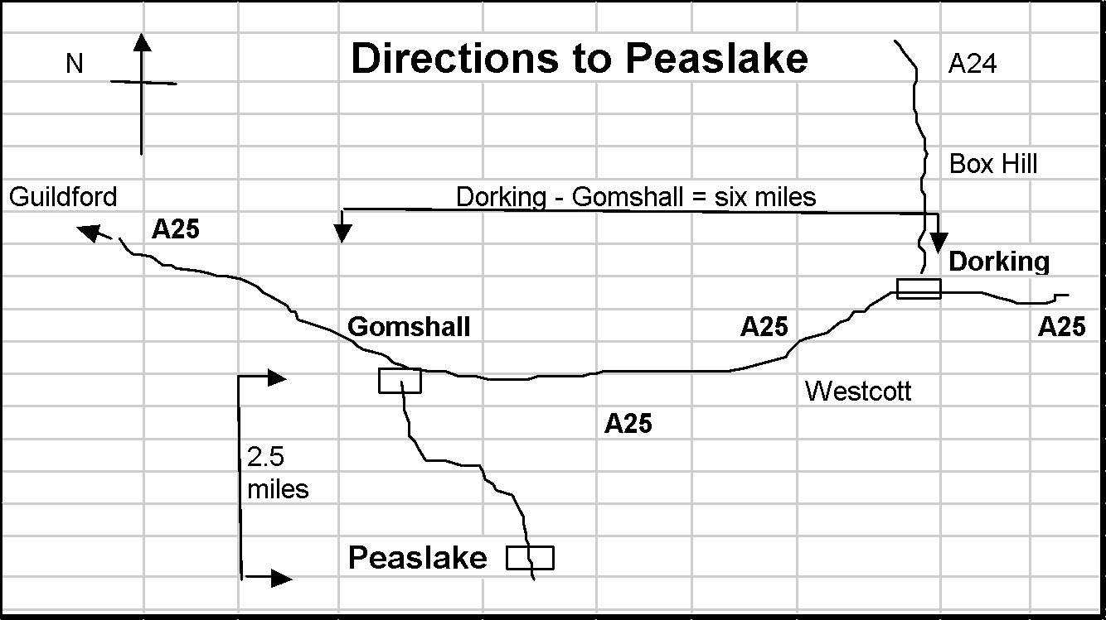

PLEASE NOTE:
- Most of the route is on rough or uneven terrain.
- Some of the paths are becoming badly eroded in places, with loose rocks & exposed tree roots.
- There may be slippery stiles and descents, especially in wet weather.
- Watch out for cyclists.
- There are some road crossings & short sections on narrow roads & on roads with no pavement where Highway Code advice should be followed (maintain single file and keep right except at right-hand bends).

PLEASE TAKE CARE AT ALL TIMES - YOU UNDERTAKE THIS WALK AT YOUR OWN RISK

For those of you who have entered the Founders Challenge in previous years this year’s 27m route is the same as the 2016 route. Please follow Rights of Way especially between CP1 and Newlands Corner.

Please Note also that those on the longer route are expected to climb steeply & directly up St Martha’s Hill as this is a Challenge Event! The route using the Downs Link path across the shoulder of St Martha’s Hill is on the 16 mile route, a lesser challenge.

HQ Mobiles [coverage uncertain!]:
Gordon Parker 07891196930
Lonica Vanclay 07835102864
Emergency Telephone: 01306 730851 (messages – Hurtwood Inn)
Abbreviations: B = bear; BW = bridleway; cont. = continue; F = fork; FB = foot bridge; FG = field gate; FP = footpath; GW = Greensand Way; KG = kissing gate; km = kilometres; L = left; m = metres; NDW = North Downs Way; NT = National Trust; R = right; RD = road; ST = stile; T = turn; TK = track; X-RD = cross roads
Maps: OS LR 187 (3ml on LR 186) or Exp 145 & 146.
All Compass bearings are from Magnetic North.

1. GR 086447 PEASLAKE MEMORIAL HALL Post Code: GU5 9RR

1.1 From the Hall exit to your L and go up paved BW opposite, passing church on your R. At the end of this path BL round wooden barrier to pass graveyard on your R.

1.2 Ascend gently on broad sandy TK for 600yds then, at large triangular clearing with cairn FL. Ahead and in 1100yds GW joins from the L. You will follow the GW for the next 2½ miles, reassured by numerous GW posts. Pass house on R. At end of garden fork R uphill (GW). Join track from R, pass a metal seat at a viewpoint. At junction, BL (wooden rails on your L) on FP, round edge of hill. At next GW waymark post BL on wide track to seat and PITCH HILL MEMORIAL TOPOSCOPE (commemorating LDWA’s founders). Retrace steps for 20yds and TL to trig point.

1.3 Follow TK ahead (320°), for ¼ mile, down to car park and TL. Cross RD ( take care) and cont. on GW, on drive for 20yds, thru fence next to MILL COTTAGE, ahead uphill on eroded FP and BL off main track to pass windmill on your L. Ahead (240°) for 100yds then BR (250°) and after crossing two BWs, descend on FP, ahd for further 20yds to cross RD (Winterfold Heath Road sign visible opposite take care). FL through car park pass Hurtwood Control notice board, and ahead uphill on path (GW). At top, pass viewpoint and artistic red & black bench on L. Enjoy the views/glimpses of the Weald below on your left, but don’t be tempted to wander down there.

GR 073423 REYNARDS HILL 2.5 miles

1.4 After 200yds (GW post) go ahead. Soon fork R, then L at GW post. On approaching road (wooden barrier) BL (at GW post) parallel with road, to later join road, with deep hollow on L. Do not cross road. Pass deep gulley (Jelly’s Hollow) to GW sign and follow uphill 210 degrees. Then after 50yds BR 220° to GW post. Cross tarmac drive, then after 100yds turn R. After ¼ mile reach car park (great view on L). TR through low wood posts and car park (leaving GW). Cross road, and in 40yds turn L on track that runs parallel with road. Track soon bends right, heading north. In 500yds at Keepers Cottage signs cross road (take care).

1.5 Ahead on broad track. At end of paddock BR with wire fence on R.
At cross track (metal FG ahead) TL. In 270yds TR around large ash tree (faded FP signs) on narrow path which heads in a northerly direction. Follow main path for ½ mile passing tracks to R & L. At vehicle track with electric cables overhead TL and in 500yds cross road.

1.6 In 20yds TR on sandy track. Ahead for 1400yds passing tracks/paths to R & L. Track narrows to become rocky gully. Descend to reach BW (power lines overhead & wooden fence on L). Turn L for 50yds to reach tarmac lane opposite cottage. Turn R (wooden fence on L). At end of tarmac continue ahd. After 200yds continue on a bearing of 320° passing small round posts with blue tops. After ½ mile pass seat on L then bear slightly R through woods and after 200yds keep ahead, X two TKs and after 50yds reach corner of Blackheath Village cricket ground. Then TR. At RD TR into car park (GR 036 463).

1.7 On the north side of the car park take the BW on the L, between 2 low wooden posts, heading north. FL to join RD from L and in 50yds FL into BW. After 20yds ahd across BW. Cross next RD (unpaved), ahd to take Downs Link BW north. Cross the A248 to pass Lockner Farm.

1.8 After Longfrey Farm pass Downs Link on R (ROUTES SPLIT) and in 10yds at permissive FP sign TL. TR on FP for 275yds. BR in front of gate to rejoin BW. At fingerpost TR (St Martha’s) to ascend steeply. At churchyard wall BR to join broad sandy track (the NDW) and keep low wooden fence on R. Keep ahd (do not FL on NDW) to pass pillbox on L (ROUTES RE-JOIN), ahd 275yds then BL into car park and checkpoint.

CHECKPOINT 1 GUILDFORD LANE CAR PARK (10.30 am - 1.00 pm)
GR 035485 9 miles

2.0 From car park TL on lane. Where lane TR, FL, Pass to L of gate & imm TR on NDW. Climb steadily parallel to RD, descend steps to X RD (take care – blind bend to L), cont up on opp side on NDW. Thru barrier, up 10m then BR on NDW. At fork BL then at NDW waymark sign as path opens out BL to follow NDW along L field boundary, then up towards A25 (public toilets; kiosk at Newlands Corner on L before RD).

2.1 At stony track 25yds before RD (A25) TR down hill. Descend for ½ mile bearing R then L, pass TK joining from R. Just before narrow waymarked TK going up on R TL to pass cottages on R.

GR 046484 WATER LANE COTTAGES 11 miles
2.2 Keep L at garages, ahd past metal gate on TK and in 1/3 mile, at cottage on R, BR on FP (110°) and keep ahead through open metal FG (or over stile next to it). Ahead (110°) on TK then soon BR (130°) on FP where it leaves TK.

2.3 In 250yds cross concrete access RD to quarry. Ahd ¼ mile on FP, crossing 2 stiles and through KG to RD. Cross A248 (take care, fast traffic) and ascend with church on your R. Ahead thru KG and then ahead across field thru KG and into Silver Wood. Keep ahead through wood, thru KG and then same line of travel across field/drive/field (125°) then thru KG to descend through trees to TL on lane.(ROUTES SPLIT HERE)

2.4 When lane joins RD (Upper St) cross over (take care), TL. After 30yds. immediately after house TR on broad track. In 150yds track bears right to run parallel with A25. When main track BR, ahead on narrow FP, through trees, to reach sunken cross track. Do not cross the A25 here.

2.5 TR and descend for 60yds then TL on TK to head north and go under A25 (GR 072482). Uphill for 1000yds (soon becoming 60°) and at top TR on waymarked cross tracks on to NDW. Follow NDW for 1 mile then FR at NDW finger post (take care, easily missed). TR thru gap then after 80yds, in front of FG/KG, BL with fence on R and follow NDW for a further 700yds to KG (take care: trip hazard) & NT BLATCHFORD DOWN signpost. Cont ahd on NDW for 300yds to reach 2nd NT BLATCHFORD DOWN sign at X-TK & KG.

GR 103488 BLATCHFORD DOWN 14.5 miles

2.6 Through KG, cross TK and through 2nd KG. Continue on NDW for 1100yds. Go thru KG at NT White Down Lease sign. Cont. on NDW & in 200yds (where it TR to descend to road). Leave NDW and continue ahead on narrow winding path, which curves L around edge of ancient pit. Pass path on R over bank. Keep ahead on narrow path through plantation, soon with sharp drop on your R. In 120yds turn R at T-junction. In 100yds pass beside railings of reservoir on your L. At end of railings turn R on track. In 50yds turn L on track. Ahead at BW signpost, heading North. Cross TK (SHEEPWALK LANE) and ahead on FP to RD by house. Cross RD (take care) and proceed up drive for 80yds (dogs on lead through farm & fields please).

GR 111502 DUNLEY HILL FARM 17 miles

2.7 TR at FP sign before gate to buildings (Ranmore Wines). Follow TK as it bends L, then go ahead on narrow path between fence and buildings. Over stile and turn half R (60°) to cross stile beside FG in far corner. Continue across field on same bearing to a KG in the middle of the fence ahead. Thru KG, TL immediately on FP winding through wood with many fallen trees/branches. FR near RD (CRITTEN LANE) and cross RD (take care) to go through KG. Go slightly L up bank, & follow FP eastwards crossing 3 stiles (you may meet some friendly llamas) and continue on drive. Cross RD (take care) at Friars Elm signs. Ahead on drive opposite (Haneys) and when drive bends R continue ahead uphill on FP. Cross next RD (take care) at Gatehouse Cottage and descend path past Hogden Cottage’s garages.

GR 125505 HOGDEN LANE 18 miles

2.8 Cross TK (Hogden Lane) at bottom, and continue ahead uphill over roots. Cross TK at top and descend to next bottom where T half L (to 2nd ride on L) and go through barrier (45°). Keep ahead on grassy glade, bearing L where another glade joins from the R. Go thru old barrier, turn L, initially on surfaced drive, and pass Lonesome Cottage on your L. Bear R on grassy TK. Pass thru barriers on far side of a crossing TK, and continue. In 70yds BL through gate. Ahd on a wide track between beech trees descending to a cottage (GR 134515). Immediately after cottage, before gates, TR on TK (this track is very slippery when wet, take care) descending more steeply before rising to give view of Polesden Lacey on your L. Ahd to the ALAN BLATCHFORD MEMORIAL SEAT outside Tanners Hatch YH.

CHECKPOINT 2 TANNERS HATCH YH (12.30 pm - 4.00 pm)
GR 140515 19 miles

3.0 From Memorial Seat retrace steps for 5yds. FL on TK and in 20yds FL again. Follow this wide track going S for 1200yds to emerge beside Fox Cottages. TL on roadside grass and in 200yds TR to cross RD (take care) to car park.

At eastern end of car park TR at NT Notice Board, through gate, to enter STEER’’S FIELD.

GR 142503 STEER’S FIELD 20 miles

3.1 TR (260°) onto broad level TK. Ahd 250yds thru KG. Ahd past Ranmore Common sign (NDW), ahd ½ mile on NDW. Pass barrier and KG (on L), ahd 40yds to TK by sign, FL on stony, downhill Byway (leaving NDW). At bottom of hill BR to join TK, downhill 30yds to junc with sign. BR signed Bridleway (250°) on slightly rising TK with field and railway down to L.

3.2 Ahd on level TK thru gate. Ahd ¼ mile to sign where TK bends R, TL thru gate (BW) (initially 190°) and follow RHS of field to go under railway bridge.

GR 127492

3.3 TK swings R then L, then R again. Ignore FP on L to join concrete area by farm buildings and The Empty Box Co, then TL on broad TK, ahd 650yds to T-junc.

3.4 X tarmac lane and BL on FP with fence then gate on R. Ahd 400yds (on encl FP) becoming very narrow) to RD [Coast Hill Lane]. BL 20yds to main RD [A25 Coast Hill], TL on LHS pavement. Ahd 40yds, grass bank on L, TR to X busy RD at best visibility point (take extreme care) heading for gap in low bank opp. On far side TL on narrow footway, ahd 150yds to junc, Rookery Drive (take care: RD with no pavement).

GR 134483
3.5 BR and after 15yds TR signed BW btw stone pillars. Ahd 350yds on tarmac, BR to X bridge over mill stream with waterfall on L. Ahd 50yds then, BL on BW which becomes stony. Ahd 450yds to reach metal gate on L and isolated ST on R. Pass R of ST , then ahd (GW)(180°), uphill.

3.6 Emerge from gully onto level ground. Over stile TR onto broad sandy TK, BL after 15yds, ahd 200yds. Just before RD, TL (GW). At sign Pheasant Wood BL (GW). Ahd 150yds then TR at sign FP, X ST.

3.7 Ahd (230°) for 50yds BL (160°), down steep bank to tarmac drive. ½ L across drive to sign (FP), BR down bank to RD [Sheephouse Lane], (!!! FP emerges directly onto RD with no pavement)

GR 130474
3.8 TL, ahd 80yds to reach Damphurst Cottage on R. Ahd on RD for a further 50yds to KG on R. Through KG (sign Wotton Estate on R), follow barbed wire fence on R for 20yds then BL (190°) ahd ¼ mile, initially parallel to sunken RD on L then bearing R, to junc at brow of hill, with TK from L.

3.9 Ahd 100yds to sign by double gates, BL (180°. wire fence on R) ¼ mile to T-junc. TR onto wide, initially grass TK (260°), after 300yds TK starts to descend, ahd steeply downhill. Thru KG, then before bridge TL. Follow TK, at cottage BR and ahd to X-RD. TR and follow path on L, beside road, up steps and through wood (fence on your R) to car park and CP3.

CHECKPOINT 3 FRIDAY STREET (1.30 pm - 6.00 pm)
GR 126457 24 miles

4.0 From CP3 take vehicle track to L of “disease control area”, (215°), winding through woods in SW’ly direction. Descend to X-TKs then ascend (240°) on track. Ahd (260°) on FP (may be overgrown) for 350yds to RD. Cross RD (Hollow Lane) (take care) to FP on R side of green and cross another RD [Abinger Lane]. X RD with care, ahd 220yds on encl FP. At end of ranch style fence on R, BR (240°) for 20yds. Ahd (230°) over X-path on TK in gully uphill which becomes wide and rutted forestry TK.

4.1 Cont. ahd ½ mile. Then FL on narrow path down steep descent (care) & thru KG cont. ahead to RD (Horsham Road, Holmbury St Mary). TL on pavement for 120yds. At sunken white house on L with fancy double wrought iron gates (Pond House) cross RD (take care) to FP - on opposite side of the road (easily missed!). The FP bears L climbing gently. In 100yds just before it reaches the corner of back garden TR on a bearing of 310° to go steeply up an indistinct and narrow FP through trees. As the path flattens out BL to go thru barrier to meet a wider path on which TR.

4.2 Ahd 350yds ignoring paths to L & R to descend to wide X-TK. Ahd (320°) for 100yds uphill to path junc. Cont ahd for 300yds (290°), passing paths to L & R, to reach car park on R.

4.3 From far end of car park, ahd 100yds (270°) passing paths to L and R. At fork (R fork) ahd for 40yds (270°) to reach a clearing. Ahd then FR down sandy TK (310°), TK bends L then R to pass btw ponds, ahd uphill (290°). From top of slope keep ahd on main TK for 500yds (ignore X-ing path).

4.4 Pass 1st X-TK with 1st sign on your L, ahd 50yds to 2nd X-TK and 2nd sign (FP & BW). Ahd slightly L 10yds btw trees to 3rd sign (FP), BR (300°), ahd 50yds on faint FP thru trees to pass 4th sign (FP). Ahd ¼ mile on clear FP (280°) later keeping to partly sunken TK/gully swinging to 260°. At wide X-TK with sign on R, ahd uphill (280°), over 3 X-ing TKs, thru gap in wooden barrier and along encl FP.

4.5 Thru 2nd barrier, ahd on drive. Cross lane [Plaws Hill] ahd thru wooden barrier. Down steep earth FP, thru wooden barrier to RD [Radnor Rd] (!!! path emerges blind onto road. The final 120yds are on RDs with no pavement: take extra care). TR, ahd to RD junc and X Ewhurst Road (take care) to pass war memorial on your R. Ahd to pass Hurtwood Inn on R. Ahd on RD (Walking Bottom) past Pedal & Spoke cycle shop (old Peaslake Post Office, the birthplace of the LDWA) to the
FINISH AT

GR 086447 PEASLAKE MEMORIAL HALL (2.00 pm - 6.30 pm)

CONGRATULATIONS!
YOU HAVE COMPLETED THE 20th FOUNDERS CHALLENGE
27 MILE ROUTE
2016

