20th FOUNDERS CHALLENGE – 16 mile route

Saturday October 8th 2016

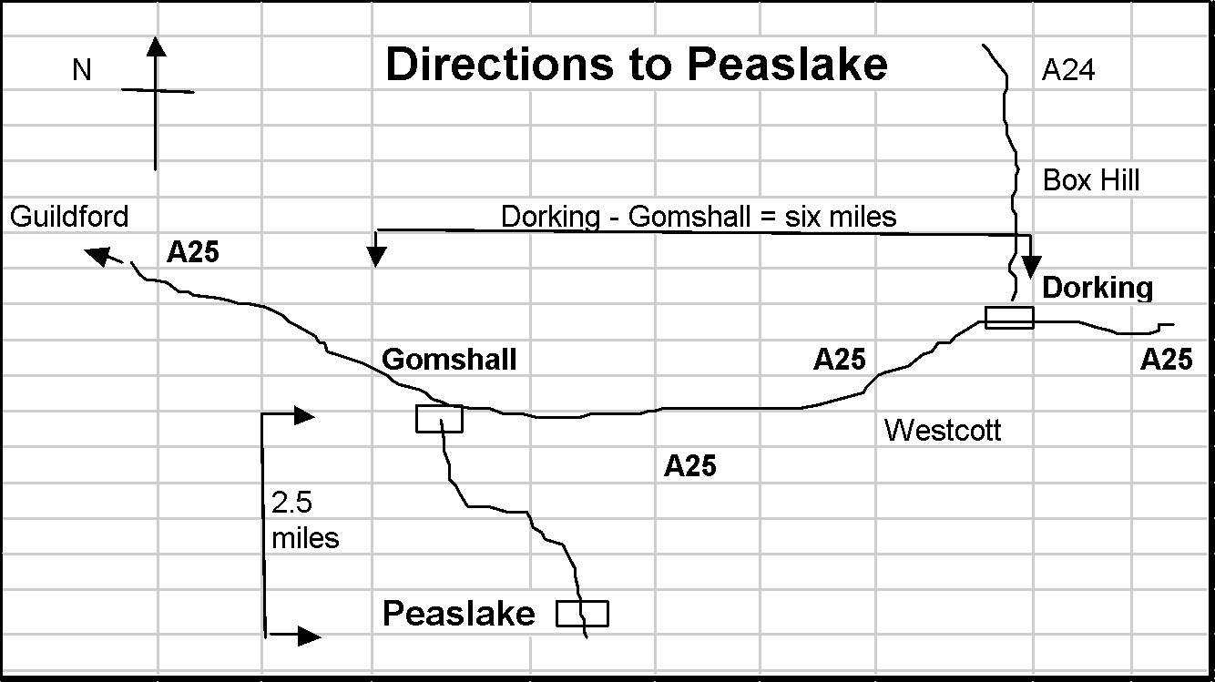

PLEASE NOTE:
- Most of the route is on rough or uneven terrain.
- Some of the paths are becoming badly eroded in places, with loose rocks & exposed tree roots.
- There may be slippery stiles and descents, especially in wet weather.
- Watch out for cyclists.
- There are some road crossings & short sections on narrow roads & on roads with no pavement where Highway Code advice should be followed (maintain single file and keep right except at right-hand bends).

PLEASE TAKE CARE AT ALL TIMES - YOU UNDERTAKE THIS WALK AT YOUR OWN RISK

For those of you who have entered the Founders Challenge in previous years this year’s 16 mile route is the same as in 2015. Up to St Martha’s some of the description has been re-written. The route diverges from the 27 mile route before St Martha’s Hill and again just before Shere.

HQ Mobiles [coverage uncertain!]:
Adam Dawson 07767321960
Gordon Parker 07891196930
Emergency Telephone: 01306 730851 (messages – Hurtwood Inn)

Abbreviations: B = bear; BW = bridleway; cont. = continue; F = fork; FB = foot bridge; FG = field gate; FP = footpath; GW = Greensand Way; KG = kissing gate; km = kilometers; L = left; m = meters; NDW = North Downs Way; NT = National Trust; R = right; RD = road; ST = stile; T = turn; TK = track; X-RD = cross roads
Maps: OS LR 187 (3ml on LR 186) or Exp 145 & 146.
All Compass bearings are from Magnetic North.

1. GR 086447 PEASLAKE MEMORIAL HALL Post Code: GU5 9RR

1.1 From the Hall exit to your L and go up paved BW opposite, passing church on your R. At the end of this path BL round wooden barrier to pass graveyard on your R.

1.2 Ascend gently on broad sandy TK for 600m then, at large triangular clearing with cairn FL. Continue ahead and in 1km GW joins from the L. You will follow the GW for the next 4km, reassured by numerous GW posts. Continue past house on R. At end of garden fork R uphill (GW). Join track from R, pass a metal seat at a viewpoint. At junction, BL (wooden rails on your L) on FP, round edge of hill. At next GW waymark post BL on wide track to seat and PITCH HILL MEMORIAL TOPOSCOPE (commemorating LDWA’s founders). Retrace steps for 20m and TL to trig point.

1.3 Follow TK ahead (320°), for 400m, down to car park and TL. Cross RD ( take care) and cont. on GW, on drive for 20m, thru fence next to MILL COTTAGE, ahead uphill on eroded FP and BL off main track to pass windmill on your L. ahead (240°) for 80m then BR (250°) and after crossing two BWs, descend on FP, ahd for further 20m to cross RD (Winterfold Heath Road sign visible opposite take care). FL through car park pass Hurtwood Control notice board, and ahead uphill on path (GW). At top, pass viewpoint and artistic red & black bench on L. Enjoy the views/glimpses of the Weald below on your left, but don’t be tempted to wander down there.

GR 073423 REYNARDS HILL 2.5 miles

1.4 After 160m (GW post) go ahead. Soon fork R, then L at GW post. On approaching road (wooden barrier) BL (at GW post) parallel with road, to later join road, with deep hollow on L. Do not cross road. Pass deep gulley (Jelly’s Hollow) to GW sign and follow uphill 210 degrees. Then after 50m BR 220° to GW post. Cross tarmac drive, then after 80m turn R. After 400m reach car park (great view on L). TR through low wood posts and car park (leaving GW). Cross road, and in 35m turn L on track that runs parallel with road. Track soon bends right, heading north. In 520m cross road (take care) at Keepers Cottage signs.

1.5 Continue ahead on broad track. At end of paddock BR with wire fence on R.
At cross track (metal FG ahead) TL. In 400m TR around large tree (faded FP signs) on narrow path which heads in a northerly direction. Follow main path for 800m ignoring tracks to R & L to vehicle track with electric cables overhead. TL and in 550m cross road.

1.6 In 20m TR on sandy track. Continue on this track for 1.3km ignoring tracks/paths to R & L. Track narrows to become rocky gully. Descend to reach BW (power lines overhead & wooden fence on L). Turn L for 45m to reach tarmac lane opposite cottage. Turn R (wooden fence on L). At end of tarmac continue ahd. After 150m continue on a bearing of 320° passing small round posts with blue tops. After 800m pass seat on L then bear slightly R through woods and after 200m keep ahead, X two TKs and after 50m reach corner of Blackheath Village cricket ground. Then TR. At RD TR into car park (GR 036 463).

1.7 On the north side of the car park take the BW on the L, between 2 low wooden posts, heading north. FL to join RD from L and in 50m FL into BW. After 20m ahd across BW. Cross next RD (unpaved), ahd to take Downs Link BW north. Cross the A248 to pass Lockner Farm.

1.8 At BW junction (after Longfrey Farm) TR (ROUTES SPLIT) and follow Downs Link for 800m uphill. TR on sandy BW to pass pillbox on your L. (ROUTES RE-JOIN), ahd 250m then BL into car park and checkpoint.

CHECKPOINT 1 GUILDFORD LANE CAR PARK 10.30 am – 1.00 pm)
GR 033485 9 miles

2.1 From car park TL on lane. Where lane TR, FL, pass to L of gate & imm TR on NDW. Cont to climb steadily parallel to RD, descend steps to X RD (take care – blind bend to L), cont up on opp side on NDW. Thru barrier, up 10m then BR on NDW. BL at fork then BR past waymark sign as path opens out. Then ahd on contour across field then up towards A25 (public toilets; kiosk at Newlands Corner on L before RD).

2.2 At wide stony path 25m before RD (A25) TR down hill. Ahd on TK for 800m which bears R then L, passing TK joining from R. Just before narrow TK going up on R at waymarked post, TL on broad TK with cottages on R.

GR 046484 WATER LANE COTTAGES 11 miles
2.3 Keep L at garages, ahd past metal gate on TK and in 500m, at cottage on R, BR on FP (110°) and keep ahead through open metal FG (or over stile next to it). Cont. ahead (110°) on TK then soon BR (130°) on FP where it leaves TK.

2.4 In 250m cross concrete access RD to quarry and cont. for 400m on FP, crossing 2 stiles and through KG to RD. Cross A248 (take care, fast traffic) and ascend with church on your R. Cont. ahead thru KG and then ahead across field thru KG and into Silver Wood. Keep ahead through wood, thru KG and then same line of travel across field/drive/field (125°) then thru KG to descend through trees to TR on lane.(ROUTES SPLIT HERE)

2.5 Cross Tillingbourne river TL. Continue AHD with the Tillingbourne on your L to the cross roads which is the centre of Shere Village. (See notes on last page)
TR and pass the White Horse and William Bray pubs. Cross road and just past wooden shop TR into Pilgrims Way.
TL at end go up narrow path to RD. Cross RD and R up path to a wider residential road. Ahd along path into woods. Join path from right and in 10m FR, in 10m FL and continue to road. Cross road and continue down over Xtk then TL
to cross railway line. (TAKE CARE AND OBEY RAILTRACK’S SAFETY INSTRUCTIONS)

2.6 TR and pass houses on L. Continue in a southerly direction for 2km to Lockhurst Hatch Farm. Cross farm road and continue ahead on narrower track which bears round to the left and then joins a track from the right. Continue ahead for 150m then FL.to a bearing of 160° in 520m TL thru barriers onto a path that then TR and goes uphill to join a residential road. FR on road and continue until you come to Shere Road.

2.7 Cross road and take track which goes NE for 120m then E for 600m to Peaslake
House. FR on drive and then TL on RD for 60m then TR into Walking Bottom and continue past car park on R to Peaslake Memorial Hall.

FINISH

GR 086447 PEASLAKE MEMORIAL HALL (2.00 pm - 6.30 pm)

CONGRATULATIONS!
YOU HAVE COMPLETED THE 20th FOUNDERS CHALLENGE
16 MILE ROUTE
2016

Notes on Shere Village

As you come into Shere on the left are some allotments with interesting
flowers and vegetables, all guarded by a variety of scare crows.
In the short front garden of a house on the right you will see the 2 flower pot men. A further 40 yards up on the right is the old Village Prison House.
At the cross roads to the left are public toilets with a tea/coffee/ ice cream
shop opposite.

Straight across from the crossroads is the village church. Many of you will know that this church has featured in films such as Four Weddings and a Funeral, The Holiday and a number of BBC Period Dramas.

What very few people know was that in 1329 the young Christine Carpenter
volunteered to become an Anchoress and she was bricked into the North wall of the church. On the outside wall there is a plaque which denotes that this was the site of Christine’s cell. Inside the church you can see where she was given food and drink. The almost full story of Christine, which was originally written in Latin is in the church but now has the English translation beside it for those of you who would like to read it.

After exploring Shere you have only 4 miles to go to reach Peaslake.

