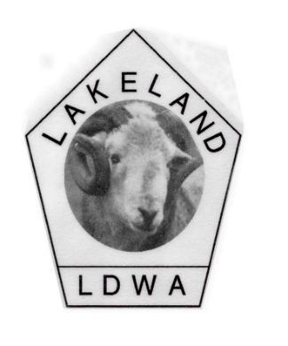

LDWA Lakeland Local Group
6th Annual General Meeting
Saturday 23 November 2019
3.00pm at the Whoop Hall Hotel, A65 Kirkby Lonsdale
Preceded by a 9.00 am walk from the Devil’s Bridge and a lunch at 2.00pm

Followed by a talk about the Appalachian Trail by Jim Bispham, one of less than 200 people to complete of the Triple Crown of America Hikes

A G E N D A
1 Apologies for absence
2 Minutes of the 2018 AGM to be agreed
3 Matters arising
4 Chairman’s Report
(a general update on the year)
5 Secretary’s Report
(update on future challenge walks and general group plans)
6 Social Walks Co-Ordinator/Webmaster’s Report
(update on social walks, website and facebook)
7 Finance Officer’s Report
(update on the accounts and feedback from the local group reps’ meeting held recently)
8 Nominations and election of 2019/20 committee members
9 Motions requiring a vote:
10 Topics for Discussion:
11 Any Other Business and closure of the AGM.

