MALVERN MIDSUMMER MARATHON ENTRY FORM 2016
BLOCK CAPITALS Please! (Only one entry per sheet. Please photocopy if necessary).
SURNAME …………………………………………………………… FORENAME …………………………………………………
(For use on certificate).
ADDRESS …………………………………………………………………………………………………….……………………………….…
…………………………………………………………………………………………………….……………………………………
………………………………………………………………………………………Post Code ……………………………...
Home phone ………………………………………………………............... Mobile..................................................................
E-mail address-print carefully for route description and confirmation of entry
………………………………………………………………………………………………………………………………………………………………………………
Car Registration (If parked at event HQ). ……………………………………………………………….………………………………
DISTANCE 14 miles - 26 miles -
START TIMES 26ml Walker – 8.00 14ml Walker – 8.30
26ml Runner – 9.00 14ml Runner – 9.30
Group / Club ………………………………………………………………………………….. LDWA No ……………………………

___________________________________________________________________________________________________________________________________________
I agree to abide by the rules of the event and to observe the Country Code at all times. I have sufficient knowledge, experience, equipment and navigational skills to take part in a long distance walk in all conditions. I confirm that I am in good health and have no medical condition that may cause undue concern or inconvenience to others. I confirm that I participate at my own risk and that no liability is accepted by the organisers for injury, damage or loss sustained by me before, during or after the event. I have read the statement regarding data protection – see NOTES. I will observe the requirements of the Country Code.
I enclose a cheque/PO (payable to 'HEART OF ENGLAND LDWA') for £7 for LDWA members or £11 if a non member. (See Rule 3)
Confirmation of entry will be sent by e-mail if supplied, otherwise if postal confirmation is required please supply a stamped, addressed envelope.
Final Details & Route Description will be sent by e-mail. Otherwise a stamped, addressed envelope (9" X 4" minimum size) must be supplied for this purpose.

Signed ……………………………………………………………… Date …………………………….
IF UNDER 18: Age ………………………………
(See rule 1)
Name of Parent/Guardian/Adult ……………………………………………………..……………………..………………
(Block Capitals)
Signature of Parent/Guardian ………………………………………………………..…………………………………………
This parent or Guardian must accompany the entrant if the entrant is not an LDWA member.

RETURN COMPLETED ENTRY FORM, TOGETHER WITH CHEQUE TO:

MMM, 30 Baveney Road, St Johns, Worcester, WR2 6DS
Make cheque payable to 'HEART OF ENGLAND LDWA’
Include an SAE for final details and Route description if you have not given us an e-mail address.
RULES:
- The Malvern Midsummer Marathon is open to all persons aged 18 or over on the day of the Event.
Entrants under 18 are allowed but must be either:
        - A member of the LDWA (those under 16 must be accompanied at all times by a responsible adult), or
        - If a non-member, must be accompanied at all times by a responsible adult.
In either case the relevant adult/parent/guardian must sign the Entry Form.
- Entries must be made on the official entry form, a photocopy, or SEF with only one entry per form. The closing date for entry is 15th June or when the entry limit is reached.
- The entry fee is £7 for LDWA members or £11 for non-members online £1 extra.
- The organisers reserve the right to refuse any entry and return the full fee. Any entrant cancelling their entry prior to 1st June will have their entry fee refunded less £2 (to cover costs).
- Walkers must register at the start between 6.45am & 7.45am and runners before 8.45am to receive their tally and details of any route changes. The route description will show checkpoint opening and closing times. Entrants must leave each checkpoint before the closing time. Anyone arriving after the closing time must retire.
- Start times for walkers 26ml at 8.00am and 14ml at 8.30am from the Wyche Primary School (GR SO773441). Runners starts 26ml at 9.00am 14ml at 9.30am. The walk must be completed by 8:00pm and participants must pass through each checkpoint in the correct order. They must ensure that they are recorded and have their tally punched at each checkpoint. Anyone missing two checkpoints will be deemed to have retired and MUST IMMEDIATELY CONTACT THE ORGANISERS or navigate straight to the nearest open check point or to the finish.
- Retiring entrants should hand in their tally at a checkpoint and transportation to the finish will be arranged as soon as possible. In an emergency - if retiring entrants cannot reach a checkpoint - they should pass their tally to another entrant to hand in at the next checkpoint. Under no circumstances retire without telling the organisers!
- The checkpoint marshal may retire anyone showing signs of undue stress or who has broken the rules.
- NO DOGS ALLOWED ON THIS EVENT.
- In all matters the decision of the organisers is final.
PLEASE DETACH THIS HALF & KEEP FOR YOUR FUTURE REFERENCE.

NOTES
- It is a requirement that all participants carry OS maps LR 149 & 150 or Exp 190 or GPS maps, compass, spare food/drink/waterproof clothing, basic first aid, and a mug.
- There will be several checkpoints on the route, all will supply cold drinks and simple food, some will also supply hot drinks. All entrants should carry food/drink in case of emergency.
- There will be hot drinks and a simple meal at the finish.
- All successful finishers will be given a certificate. Results will be posted on our website.
- Observe marshals’ instructions when parking on residential streets around the school. Late arrivers will park further away from school, allow plenty of time in order to park, register and prepare yourself.
- Baggage may be left at the School, at the owners risk.
- Accommodation overnight is the responsibility of the entrant. Malvern Tourist Information 01684 892289.
- Final details & route description will be sent out by 15th June. If you do not receive yours by 16th June contact the Entries Secretary.
- Any urgent information will be displayed under Events on the LDWA website.

www.ldwa.org.uk/heartofengland
Or contact the Entries Secretary at:

MMM, 30 Baveney Road, St Johns, Worcester, WR2 6DS
email: heartofengland@ldwa.org.uk
telephone: 01905 426682 8pm -10pm
The Country Code: Enjoy the countryside and respect its life and work; Guard against all risk of fire; Fasten all gates; Keep your dogs under close control; Keep to public paths across farmland; Use gates and stiles to cross fences, hedges and walls; Leave livestock, crops and machinery alone; Take your litter home; Help to keep all water clean; Protect wildlife, plants and trees; Take special care on country roads; Make no unnecessary noise.

MALVERN MIDSUMMER
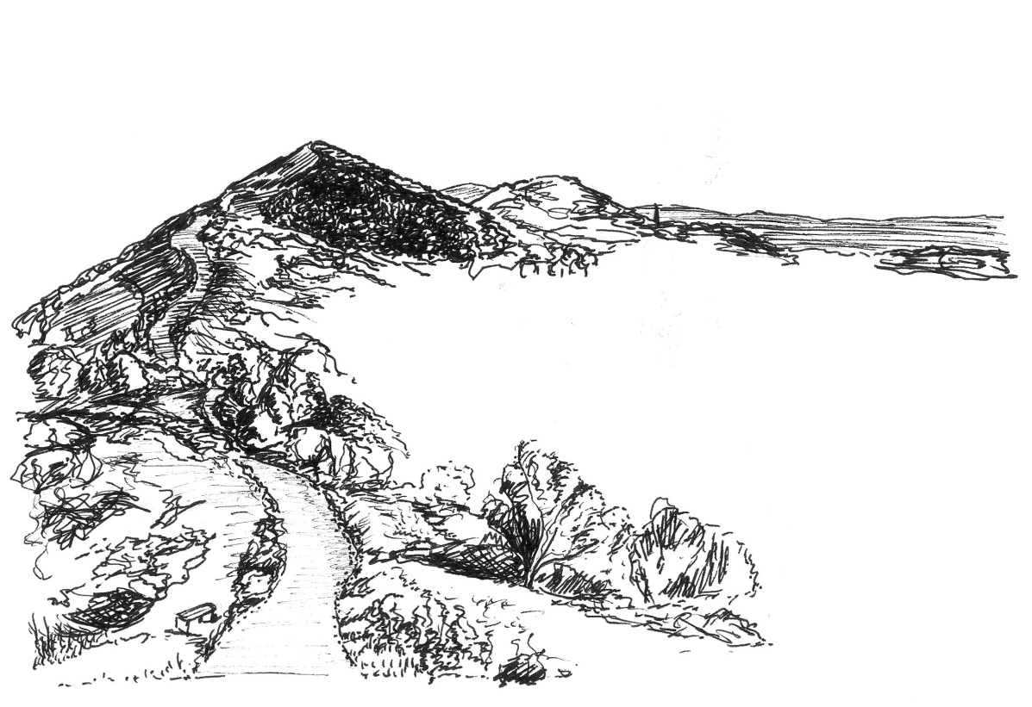
MARATHON

Saturday
18th June 2016

14 or 26 MILES
on and around the beautiful
Malvern Hills
from

The Wyche Primary School, Malvern
Grid Reference SO773441, Post Code WR14 4ET

LONG DISTANCE WALKERS ASSOCIATION

HEART OF ENGLAND

