NOTES

- Birmingham has more miles of canals than Venice. This low cost transport network, the equivalent of today's motorways, fuelled the industrial revolution. Most are now quiet back waters, linear arms of the country that penetrate deep into the city. Never dull, the backdrop varies from rural to industrial heritage and then to state of the art development. We invite you on these walks/runs with a difference exploring Britain’s second city from a new perspective. All routes are circular starting and finishing at Ackers Trust Residential Centre. Taking in the Cole Valley Way, Stratford on Avon Canal, Birmingham and Worcester Canal, Birmingham Wolverhampton Main Line Canal and Soho Loop (26 miles only) Fazeley Canal and returning via the Grand Union Canal. They pass Sarehole Mill (inspiration to Tolkien’s Middle Earth), Gas Street Basin, home of the International Convention Centre, the award winning Brindley Place development, and under the dark bowels of Spaghetti Junction. They are 97% off road with very few crossings, no stiles and probably the least ascent and descent you will do this year!!

- The walk is organised by Heart of England LDWA. Start point – The Ackers Adventure Centre Golden Hillock Road Sparkbrook Birmingham B11 2PY

- It is recommended that all participants carry a map (OS Explorer map 220 or Landranger 139 or probably best Birmingham A-Z), food /drink, simple first aid and money. Entrants are also advised to wear sensible footwear and carry waterproof clothing.

- There will be five checkpoints (26.2 mile) en route. All will supply cold drinks and simple food, checkpoint 1 will supply hot drinks but entrants should carry their own supplies to supplement these. Please note: IT IS ESSENTIAL TO BRING A MUG as cups will not be provided. There will be hot drinks and a meal at the finish including a vegetarian option. Showers and changing rooms are also available on completion. All finishers will receive a certificate.

- Baggage may be left at the start at the owners risk. Please label your baggage with your name and address and contact number.

- The nearest train station is Small Heath. Trains leave New Street every 30 mins on a Saturday - allow a 10 minute walk. The Ackers is also served by several buses from the city centre - ring Traveline 0871 2002233 - press 1 then 6 to get through to the West Midlands Call centre. Extensive free parking is available on site at owner’s risk.

- Accommodation is available on site, in bunk-bedded rooms sleeping 2 or 4 people. Priority for the double rooms will be given to couples. Please bring towel and sleeping bag. His and hers showers are available. Food on the Friday evening and Breakfast will be included, cost £15.00 pppn taken on a first come first served basis (20 places max available so book early). For alternative accommodation please ring the Birmingham Tourist information office 0121 780 5005 or online at www.bookdirectrooms.com/birmingham.

CHECKLIST
___ Form completed clearly and signed; detach keeping rules and notes for reference
___ Cheque made payable to Heart of England LDWA
___ S.A.E essential to receive number and route description if email not supplied

When completed please return to
Entry Secretary: Alan Athey, 23 Yeomans Close, Astwood Bank, Redditch B96 6ET
For queries or more information please email alan.athey@googlemail.com or tel 0758 403 6547, write to the above address, or see our website www.ldwa.org.uk/heartofengland
RULES

- Entrants as young as 12 may participate. All those younger than 18 must have the signed permission of a parent or guardian. Additionally those under the age of 16 must be accompanied by a named responsible adult at all times and check in together with that adult at every checkpoint.

- Entries must be made on the official entry form or photocopy with only one entry per form. If an email address is not supplied a stamped addressed envelope must be enclosed to allow route description to be forwarded. Postal entries close on the 7th September 2014 or when the combined entry limit of 350 has been reached. Please contact the entry secretary for entry on the day.

- The entry fee is £8 for either event and £12 for non-members of the LDWA (cheques made payable to LDWA Heart of England). Any on the day entries will be charged at £15.

- The organisers reserve the right to refuse any entry and return the full amount. If the event has to be cancelled the full entry fee will be returned. If entrants cancel prior to 06/09/14 the charge will be returned less a £2 administration fee. If cancelled after 06/09/14 no refund will be given.

- The route will start from The Ackers Adventure Centre, Golden Hillock Road, Sparkbrook Birmingham B11 2PY, Grid ref SP096 847. Walkers 26.2 mile route start will be 0800; Registration opens at 0700. Runners for all courses and walkers for the 18 mile course will start at 0930; Registration opens at 0845. The event must be completed by 18:00 for (10 hour time limit for 27 mile route) and entrants must pass through each check point in the correct order.

- The route description will show checkpoint opening and closing times. Opening times are geared to 5mph (8km) pace from the main start at 08:00 and 8 mph from the runners start at 09:30. IF IT IS LIKELY THAT YOU WILL EXCEED 5 mph PLEASE START AT 09:30 HRS. Closing times are geared to approx 2.5 mph from 08:00. Participants must leave each checkpoint before the closing time and anyone arriving after the closing time will be retired or diverted onto the shorter course.

- Retiring entrants must hand in their tally at a checkpoint and transport to the finish will be arranged as soon as possible. In an emergency, if the retiring entrant cannot reach the next checkpoint, they should pass their tally on to another entrant to be handed in to a marshal at the next checkpoint. A mobile number will be given on the route description for emergency use only. Under no circumstances retire without telling the organisers.

- Unfortunately dogs are not allowed.

- The checkpoint marshal may retire anyone showing undue signs of stress or who has broken the rules. In all matters the organiser’s decision is final.

Follow the Waterways Code

IMPORTANT: Protect the waterways environment; don't damage vegetation or the banks. Take home any litter. Be safe and aware of dangers, particularly on narrow stretches of the tow path or where cyclists may approach at speed on blind corners. Watch for concealed mooring pins, ropes or other hazards on the tow path. Follow warning signs. The risks are small but advise your doctor if you become ill within 2 weeks of swallowing canal water. Do not dive in the water even to rescue someone. Be considerate to other canal users particularly fishermen and cyclists. Please read the Health and Safety assessment included with the route description.


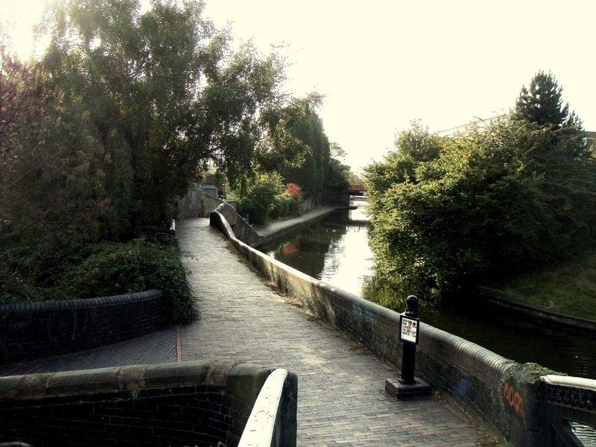
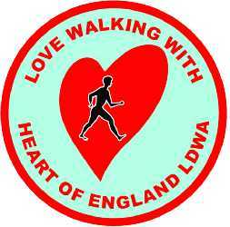
BIRMINGHAM CANAL CANTER / MINI CANTER

Saturday 13th September 2014
26.2 miles or Mini Canter 18 miles

Explore the big Heart of England
with the Heart of England LDWA
BIRMINGHAM CANAL CANTER / MINI CANTER
SATURDAY 13th SEPTEMBER 2014
THE ACKERS ADVENTURE CENTRE, GOLDEN HILLOCK ROAD, B’HAM B11 2PY

Details may be held on computer for the sole purpose of administering the event- the LDWA is registered under the Data Protection Act.

PLEASE COMPLETE IN BLOCK CAPITALS (use a separate sheet per entrant)

Forename ..................................................... Surname................................................................

Address ............................................................................................................................................

…………..….................................................................................... Postcode ..............................

Emergency telephone number (inc. Std code) …..............................................................................

Mobile number contactable on the day ............................................................................................

Car registration on day (if left during walk) ….................................................................................

Email address ...................................................................................................................................
(To ensure receipt of route description please write email address carefully, particularly underscores hyphens and full stops)

Vegetarian meal option required □ LDWA Membership No….................Group ......................

Walker □ Runner □ Full Route (26.2 miles) □  Mini Canter (18 miles) □

Accommodation @ £15.00 including food in the evening and breakfast (bring towel & sleeping bag). Please specify room reservation is for: MALE □ FEMALE □ 
Note: we will privilege couples for double rooms (2off available only) and single sex rooms available of four per room (4off) - for exclusive room please specify by mail to entry secretary who you wish to share with and book early. There are only 20 places available.

Please enter me for the above event
  - I confirm that I consider myself fit and healthy enough to take part in the walk.
  - I agree to abide by the rules of the event.
  - I understand that no liability is accepted by the organisers for any injury damage
or loss caused to me as a result of participating in the event.
  - I agree to follow the Waterways Code and to show consideration for others.
  - I enclose cheque or postal order payable to LDWA Heart of England for £12.00 / £8.00

Signed............................................ If under 18 signature of parent/guardian......................................

Name of parent or guardian................................ Specified responsible adult.....................................
Entrants as young as 12 may participate, those younger than 18 on the day of the event must have the signature of a parent or guardian. Additionally, those younger than 16 must be accompanied by a specified responsible adult at all times.
Please detach this form and send with SAE (if email address not supplied) & cheque payable to H of E LDWA to: Alan Athey, 23 Yeomans Close, Redditch B96 6ET. OR,enter online at www.sportident.co.uk
note there is an additional charge of £1.00 applies to online entry.

