LDWA – BBN – Northampton Round – 2011 - 2015

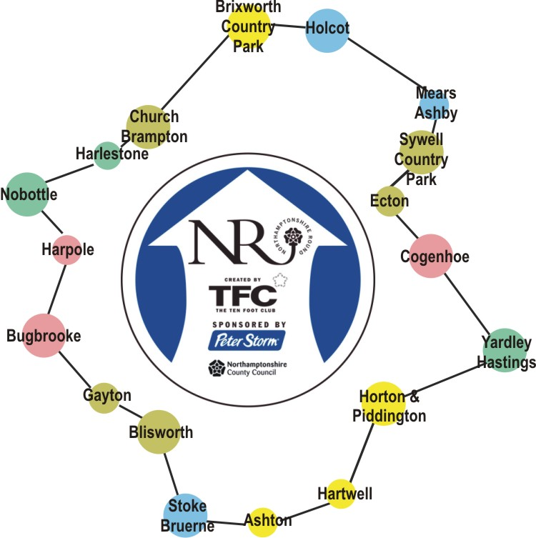

27th January 2011 – Piddington to Stoke Bruerne
1st December 2011 – Piddington to Cogenhoe
6th December 2012 – Church Brampton to Holcot
29th August 2013 – Cogenhoe to Holcot
11th September 2014 – Church Brampton to M1 near Bugbrooke Mill
4th December 2014 – Blisworth to M1 near Bugbrooke Mill
5th February 2015 – Blisworth to Stoke Bruerne

