CP3 - Candra, St. Breward, BODMIN PL30 4NP SX 1191 7797

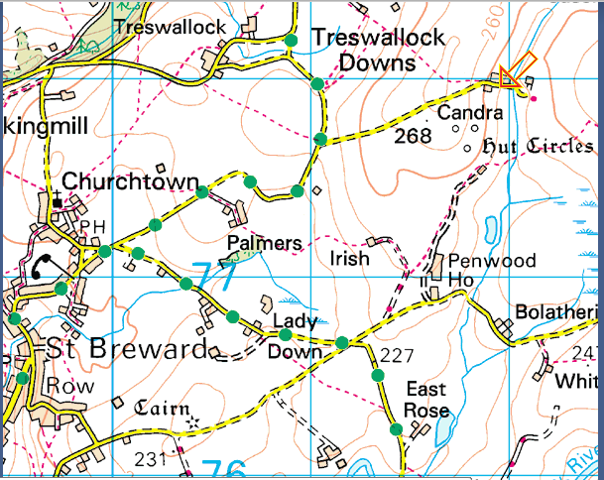

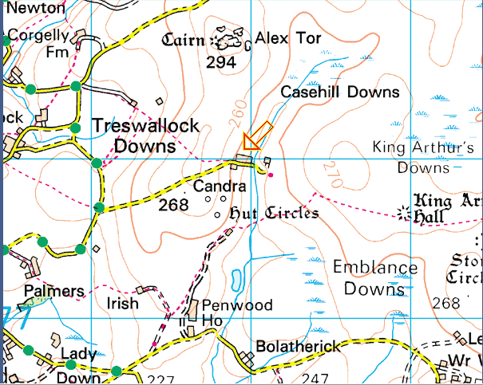

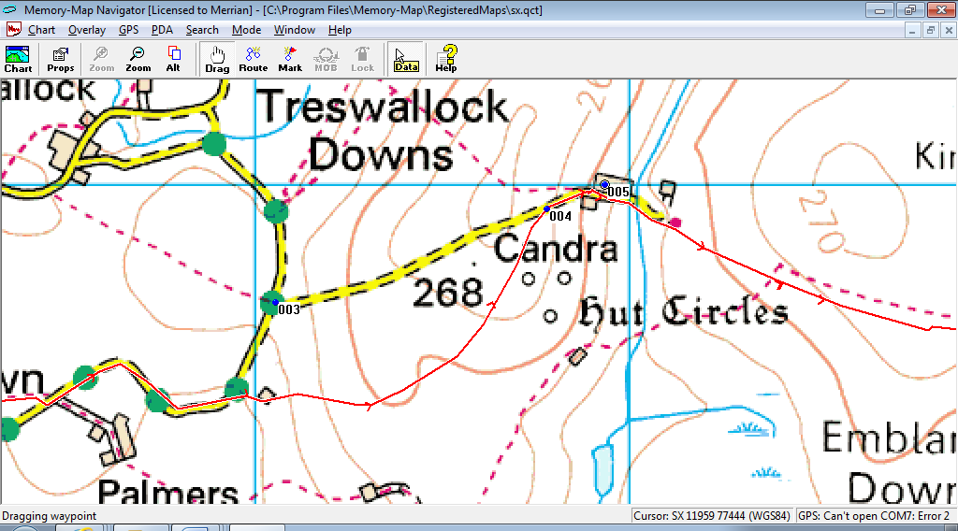
The red line is the route the walkers take, west to east. Candra is signed from road at point “003”, walkers join tarmac track at “004”, checkpoint is barn at “005”. Park on moorland on side of road, probably near “004”.

