Shillington Shuffle – Sunday 19th November 2017
Route: Following success on Steppingley Step last year, we went from 4 to 3 checkpoints, Pirton, Lilley and Meppershall. To avoid walking along a stretch of the B655 the medium/long routes where changed to go via Clouds Hill Farm and Wellbury House. The change in Meppershall to go to the checkpoint meant that, for the long route, the loop off Warden Hill via Butterfield Green was removed so the distance remained at 26 miles. This allowed the medium route to be same as the long route going to Lilley rather than the same as the short route, thereby making the distances between checkpoints more even.

Entries: We used SiEntries and set the entry limit to 300 and reached this on 19th October. Any subsequent entries went onto a waiting list. On 20th October Mike emailed everyone to ask them to let him know if they couldn’t make it on the day. It isn’t possible for entrants to cancel their own entry. Mike emailed everyone again on 7th November. After some late cancellations, and after Merrian said that she would print the paper work on Saturday, we were able to offer places to everyone on the waiting list, the last ones being offered on Friday 17th November. One person had four days to enter but either didn't see the email or was away. The last four had only a day or two to enter but didn't join us. One person would have entered but had problems paying, so we agreed to let him pay on the day but his wife found a list of jobs for him to do instead (Shopping!! carrying her bags around). Hopefully the reason some people had problems paying has now been fixed. 335 people entered, including one who entered twice, 36 cancelled their entries before the day, everyone on the waiting list was offered a place and all but 5 took up the offer. We had no postal entries.

The Marshal’s Walk took place on Sunday 29th October. 10 people did the marshals’ walk on the day, or thereabouts. It didn’t rain on the marshals’ walk, but was a bit nippy! No-one provided support this year.

Menu: CP1 – hot and cold drinks, crisps and cheddars, biscuits, jaffa cakes, assorted cakes, chocolate raisins, sweets
CP2 – sweet and savoury sandwiches and brioches (Nutella, Bovril, tuna mayo, jam), biscuits
CP3 – Ritz, cheese cubes, cakes, swiss roll, chocolate, plus left-overs from CP1
HQ – hot and cold drinks, tinned soup (tomato, vegetable), french bread, assorted sweet pies, custard
Some left-overs were donated to a couple of “hungry students”, other bits taken by marshals.
Tracking: One person on 18 mile route felt unwell (nothing serious) after a mile and returned to HQ. One person on the 26 mile route went wrong before CP1 and returned to HQ. One person on 18 mile route retired at CP2 and had own transport. One person on 26 mile route retired at CP2 and was transported back to HQ.
Two people were given the same number, which caused some queries. 10 people changed from 26 to 18, 1 from 26 to 12, 4 from 18 to 12 and 1 from 18 to 26. The last two finished 50 minutes before 1830, so we were cleared up well before the hall was due to close at 1900.
Mainly because of Mike’s efforts managing the cancellations and waiting list, we only had 11% non-starters, which is below the figure most events are getting these days. There was pretty even split between walkers and runners who didn’t turn up. Other analyses are included in a separate document.
We only had one item of lost property, a compass. We only had two event certificates left behind. We handed out 190 new Shuffle badges and 4 old Shuffle badges.

Entries | Expected | Non-starters | Starters | Retired | Finished
12 mile | 52 | 1 | 51 | 0 | 51
18 mile | 45 | 3 | 42 | 2 | 40
26 mile | 196 | 29 | 167 | 2 | 165
overall | 293 | 33 | 260 | 4 | 256

S-S-S triples | Marshals | Main
1sttriple | 1 | 20
2ndtriple | 1 | 9

Finances | Income |  | Expenditure
Entries | £2303.70 | Food | £408.73
Tea donations | £60.00 | Hall hire | £442.00
Total | £2,363.70 | Other (van hire, printing) | £572.93
Total Income | £2,363.70 | Expenditure on walk | £1,423.66
Total Expenditure | £1,723.66 | Donation to Air Ambulance | £300.00
Surplus | £640.04

Marshals: Alan Leadbetter, Karen Earwicker, Sandra Hyland, Mike Hyland, Lynn Yorston, Dave Yorston, Ian Sage, Pat Sage, Graham Missing, Dave Findel-Hawkins, Jim Morrison, Merrian Lancaster, Gordon Shaughnessy, Norman Corrin, Margaret Skerman, Roger Skerman, Gill Bunker, Mike Bowley, Beryl Bowley, Mary Knight, Derek Jacob, John Davies, Martin Lawson, Terry Brown, Jackie Burnett, Dee Brockway, Phil Friede.
Thank you to all the marshals who helped to make it a jolly good event. 27 people helped at various times and we’ve had many comments about how friendly and helpful everyone was.
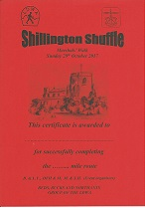
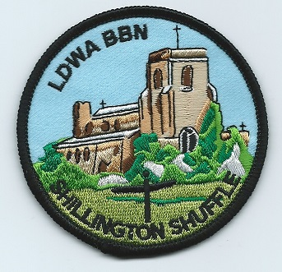
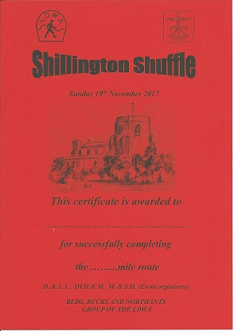

The next SS event is Sundon Saunter on Sunday 18th November 2018, the marshals’ walk is on Sunday 28th October 2018. If you’re willing to marshal on the event, please contact Dave Yorston.
Merrian Lancaster, Dave Findel-Hawkins, Lynn Yorston, Dave Yorston, Mike Hyland, Sandra Hyland
November 2017

