“Normal people do this in two days …….. ”

The Greensand Ridge Walk in a Day: 10th July 2016

Back by popular demand – an opportunity to walk the 40 mile Greensand Ridge in a day – as a BBN social walk.

The day will have the same format as last time - we will leave Baker Street car park, Leighton Buzzard at 6am by coach which will drop us in Gamlingay for a 7am start on our 40 miles. The walk will be led by Gill Bunker (Gamlingay to Northill), Dee Brockway (Northill to Woburn) and Dave Findel-Hawkins (Woburn to Leighton Buzzard). All three leaders are walking the entire route and we hope to be walking into Leighton Buzzard between 10 pm and 11 pm.

The cost of the day is £22 – this includes coach travel, breakfast (Northill), lunch (Ampthill) and tea (Woburn). There will be hot and cold drinks at all stops, and also frequent water points on the way – so we only need to carry our usual “emergency stuff” and a mug.

We all enjoyed the fantastic day out Nigel organised last time, helped by lovely and much-missed Kathy. But planning such a day is a lot of work - and this year a small team of us are organising the event – Mary, Gill and Norman.

The coach is booked, the halls are booked – we just need you to register for the walk. You’ll find the registration form on the BBN website Form.

Nigel is taking the entries so get your registration form off to him, but if you have any questions about the day please have a chat with one of the team. We will try and help - we want you to come along and have a great day.

Planning is still at a very early stage, but please address any queries about the route, distances, timings etc to Gill (gillbunker@googlemail.com) and any questions about food, catering etc to Mary (maryjknight@hotmail.co.uk). If you have any special dietary requirements please let Mary know – we will do our best to help. Norman will be Chief Marshal on the dayt

Further information about the walk will appear on the BBN website (Under “Group Activities”) and via email nearer the day.

Anyone not walking - but would like to be part of the day ??
We have people in place to organise the three meal stops – Northill, Ampthill and Woburn - but as ever a few more pairs of hands would be welcome.
Let us know if you can spare a few hours to help on the day.

Everybody who walked last time agreed it was a great day out – so here’s looking to this year’s event! For most of us it is a challenge to walk 40 miles, but we will be well supported and looked after all day and we will be walking through some lovely countryside.

Mary, Gill and Norman

Eager to start: Gamlingay 2014

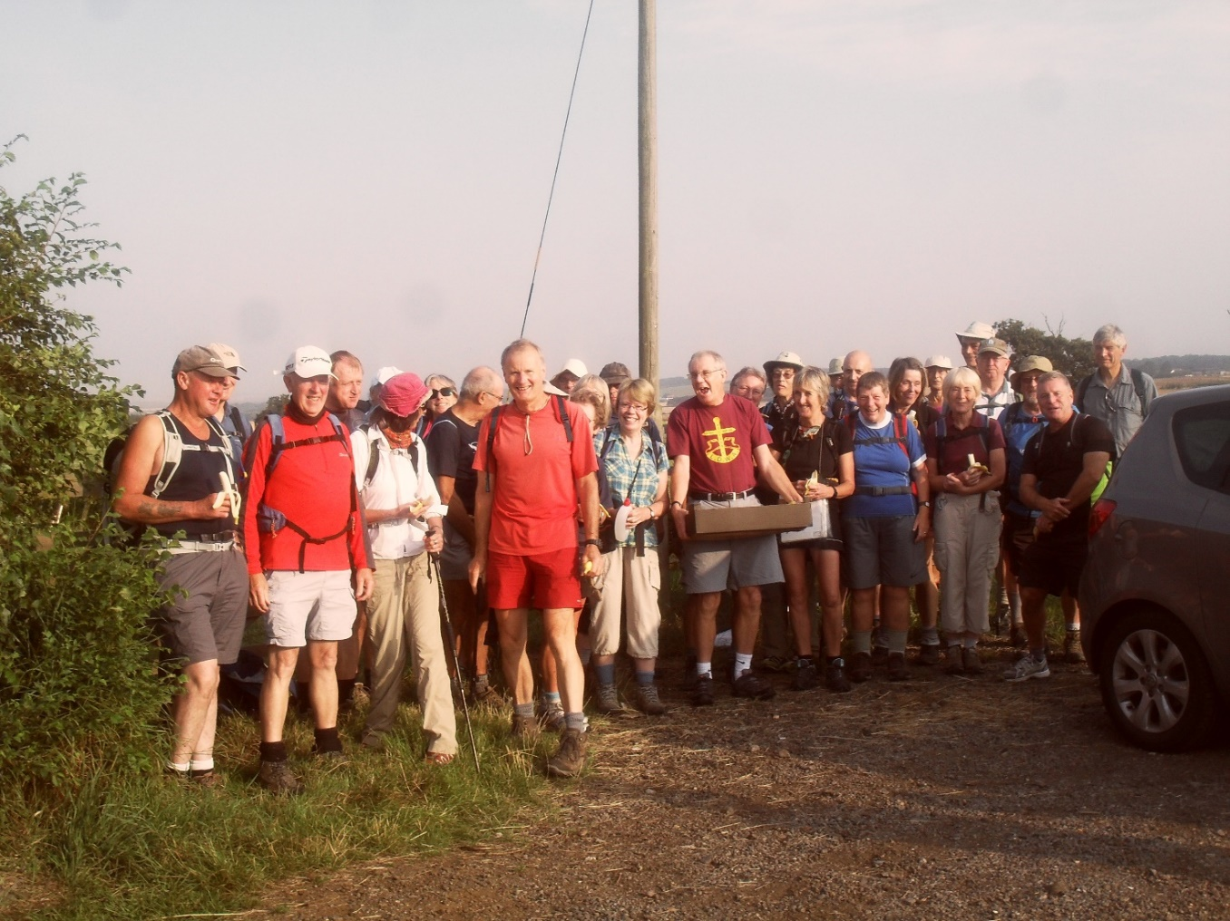
Look at the BBN website for more photos and comments on a great day.
Greensand Ridge in a Day 2014 Photos

