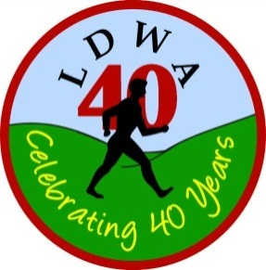 | LONG DISTANCE WALKERS ASSOCIATION  AIM: TO FURTHER THE INTERESTS OF THOSE  WHO ENJOY LONG DISTANCE WALKING

BEDS BUCKS &
NORTHANTS GROUP

NEWSLETTER
OCTOBER 2012

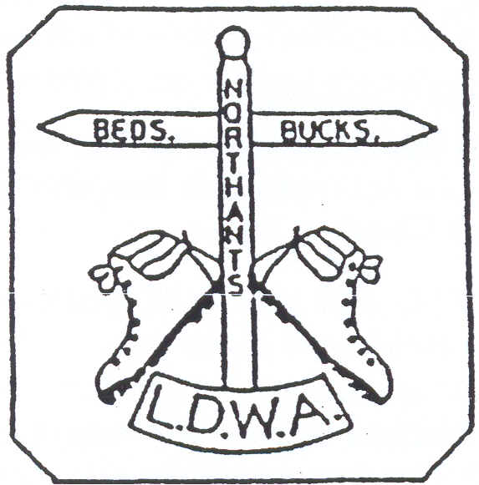

HAVE A GREAT DAY OUT, WALK WITH BBN
www.ldwa.org.uk/bedsbucksandnorthants

New Members
A very warm welcome to the following who have joined BBN since the last Newsletter:
Yvette Etchell, Dave Jones, Alan Leadbetter,
Peter Sinfield and family, David Tassell

Congratulations to Gill Howe and Andrew Gilbertson who were married on the 24th August at Northampton Registry Office, honeymooning at All Stretton Bunkhouse with a 46 mile walk on the Sunday in the wake of the Wenlock Olympian Walk route. Our very best wishes to them both for a very happy married life together.

BEDS BUCKS & NORTHANTS GROUP: COMMITTEE 2012

Chairman: | Nigel Schofield T: 01462 442338 E: nicelegs.schofield@btinternet.com  Nigel.Schofield@north-herts.gov.uk
Secretary: | Norman Corrin 68 Montgomery Crescent, Bolbeck Park, Milton Keynes  MK15 8PS T: 01908 608667 E: norman.corrin@btinternet.com /  bbn@ldwa.org.uk
Treasurer: | Ian Sage T: 01582 661256 E: iansage@waitrose.com
Social Walks: | Dee Brockway T: 01582 881809 E: dmrbrockway@ntlworld.com
Membership: | David Findel-Hawkins T: 01908 216476 E: davefh@gmail.com
Website: | Merrian Lancaster T: 01908 642803 M: 07933 735338  E: merrian22@gmail.com
Merchandise/  Equipment: | Lynn Yorston T: 01494 868371 E: lynn.yorston@dsl.pipex.com
Newsletter: | Gill Bunker 1 Abbey Way, Bradville, Milton Keynes, MK13w 7AN  T: 01908 321308 E: gillbunker@googlemail.com
Thursday Walks: | Gordon Shaughnessy T: 01582 518791 M: 07990 971323  E: gordon_shaughnessy@hotmail.com
Member: | Martin Lawson T: 01933 678594 E: jimranit@btinternet.com

A big thank you to everyone who has contributed to this Newsletter.
Please let me have items for the next Newsletter by the end of January.
E: gillbunker@googlemail.com
1 Abbey Way, Bradville, Milton Keynes, MK13 7AN

Hearts of Oak – BBN’s walk to celebrate the LDWA’s 40th Anniversary - 23 September

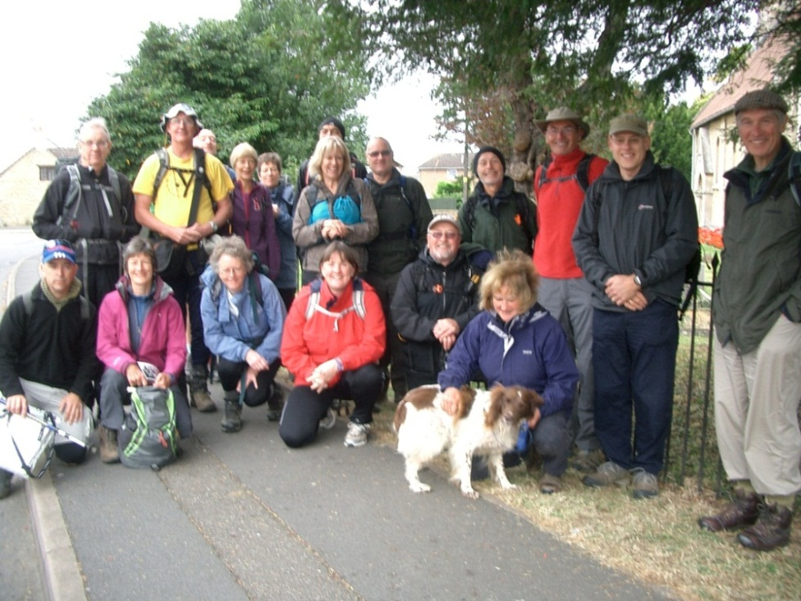

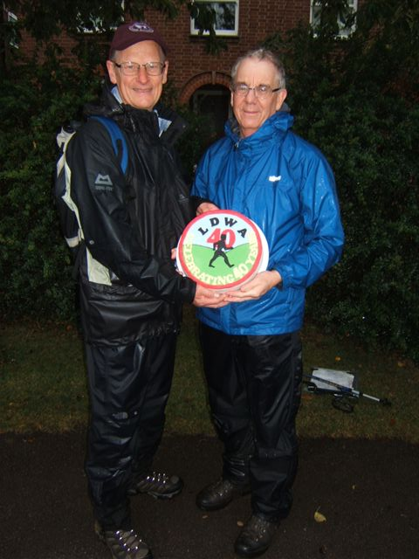 | The choice of 23rd September 2012 to celebrate 40 years of the LDWA was we in BBN hope a good day for the other celebration walks. But in the woosie south the rain spread from the south coast during the morning and drenched 21 stalwart BBN members and one dog walking the 20 mile Hartwell Hearts of Oak. Devised and led by Martin Lawson (BBN Committee Member) he of Holy Hobble fame and for those who survived to complete in the even wetter afternoon distant memories of both Holy Hobbles came flooding back (geddit?). The Chairman commissioned a celebration cake which was enjoyed by three. Despite the weather the walk was completed and a good day was enjoyed by all.... If you believe that .......

NOTICE OF ANNUAL GENERAL MEETING

Our AGM will be held on Sunday 25th November at 2.00pm at the Navigation Inn, Cosgrove (MK19 7BE). An 8 mile walk starting at 9.00 from The Navigation will be followed by lunch and then the AGM.
The menu is included on pages 6 and 7 (hope this is legible). It will also be sent out by email and will be at the Sundon Saunter. Please book your meal via Gill Bunker (contact info p.2) by 20th November.
A copy of the provisional Agenda is shown on the opposite page. If anyone has any additional items that they wish to raise please could they contact me either by email at Norman.Corrin@btinternet.com or on my home phone which is 01908 608667

Norman Corrin

A Remembrance Day Marathon - An invitation to join Norman Smith on a unique walk:

This is an annual walking event which I put together several years ago, having been prompted by seeing Portland stone military gravestones in local churchyards whilst flying gliders from Bicester Airfield. I’ve walked the route six times on Remembrance Sunday and it has featured in my local paper on two occasions.

The 23 mile route is from/to Bicester Airfield. Over 100 RAF World War II graves are passed by in five churchyards. The 11.00 wreath laying ceremony at Upper Heyford is attended. On arrival back at Bicester a final tea break is taken, prior to the marathon distance being completed with a three mile circuit of the airfield boundary.

We set off from Bicester Airfield on 11th November at 7.20 to walk the nine miles to Upper Heyford for the wreath laying ceremony. After this, the afternoon section can be walked at a convenient pace. Food for three stops should be carried. On completion the Windrusher Bar at the Airfield will be available, and a supper can be delivered from town. Bicester Airfield Gate is located at OS GR SP 592242; (access by gate code which I will supply).

I’ve found the day’s events to be very moving indeed.
Norman W Smith Tel: 07835 101560

Sundon Saunter – Marshals’ Walk
The marshals’ walk will be on Sunday 4th November, starting at 8am from the playing field near the Barton Hall as usual. Please contact Dave Yorston (contact info as for Lynn p.2) if you need any other information. Also, please let him know if you are intending to walk.

LDWA : BEDS BUCKS NORTHANTS GROUP : ANNUAL GENERAL MEETING
SUNDAY 25TH NOVEMBER 2012 AT 2 PM : THE NAVIGATION INN, COSGROVE
PROVISIONAL AGENDA
1. Apologies
2. Minutes of the 2011 Annual General Meeting and Matters Arising
3. Officers’ Reports
(a) Chairman  (b) Secretary  (c) Treasurer  (d) Membership  (e) Social Walks Secretary  (including Thursday Walks) | (f) Merchandising  (g) Equipment  (h) Webmaster  (i) Newsletter  (j) Local Groups Representative

4. Election of Officers Existing Post Holder
(a) Chairman Nigel Schofield
(b) Secretary Norman Corrin
(c) Treasurer Ian Sage
(d) Social Walks Secretary Dee Brockway
(e) Election of Committee Members Lynn Yorston, Gordon Shaughnessy,
Merrian Lancaster, Dave Findel-Hawkins,
Gill Bunker, Martin Lawson
(f) Appointment of Committee Members to specific roles:
(i) Membership Secretary  (ii) Merchandising Secretary  (iii) Webmaster | (iv) Newsletter  (v) Local Groups Representative  (vi) Minute Secretary
(g) Cheque Signatories Ian Sage, Nigel Schofield, Norman Corrin

5. Subscriptions for 2013 – Proposal to pay for more than 1 year
6. Group Finances/Donations/Projects
7. BBN Challenge Events
(a) Steppingley Step 2011 & “SS” Events, (b) Pick & Mix 2012,
(c) Chiltern Kanter 2013

8. LDWA Hundreds
(a) Games 100 2012, (b) Cornwall & Devon 2013 (c) South Wales 2014
9. LDWA 40th Anniversary 2012
10. BBN 30th Anniversary Celebrations 2013
11. Group Activities — Weekends — Social Events
12. A.O.B.

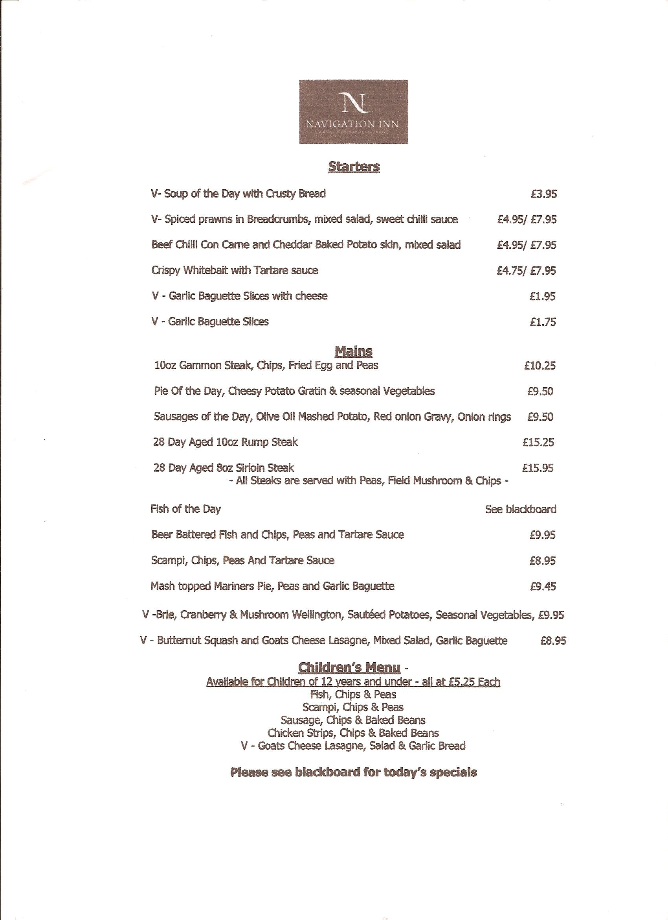

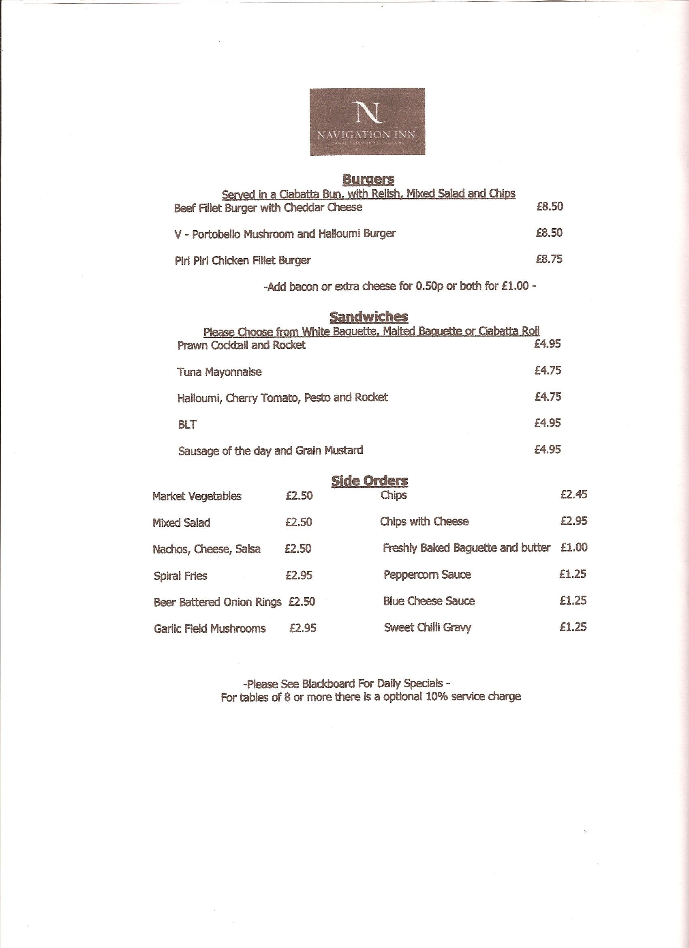

Chiltern Kanter 2013

The date for the Chiltern Kanter in 2013 is Sunday 3rd March 2013, the marshals’ walk being the previous Sunday 24th February. The event has reverted back to the normal date of the first weekend in March.

The event starts from a new venue this year - the Pitstone Memorial Hall and parking at the hall will be for event marshals only. Parking for entrants is 7 minutes’ walk away at Goodrich Engineering who have very kindly allowed us to use their premises. With 200-300 spaces that should be sufficient!

There will be a choice of 3 distances 26, 18 or 13½ miles starting at 8 a.m. and all to finish by 6 p.m. The routes by various combinations will encompass the Tree Cathedral at Dunstable, Bridgewater Monument and Ivinghoe Beacon. But not all routes will go to all of these points. This will give many of our members who’ve not been out that way since the Kanter in 2009 the opportunity to visit the BBN memorial bench in honour of our two founder members Chris Meredith OBE and Chris Goodman. The bench is located outside the Ivinghoe Village Centre.

As with all events many hands make light work. If you’ve not marshalled on an event before then why not try it - it is great fun being the other side of the desk. But don’t expect to lose any weight! If anyone is interested in marshalling on the day then please contact me.
Norman Corrin

100 Camel Teign Ivor's Dream 100 ( http://www.ldwa.org.uk/2013Hundred)

BBN will be looking after checkpoint 3 on the main event, Saturday 25th May 2013.
This will be in a barn at Candra, so slightly restricted on what can be offered. It will be cold bite size pieces of food e.g. sausage rolls, pork pie portions, cheese biscuits, cherry tomatoes, crisps, assorted cakes, bananas. If a gas urn can be organised then hot drinks will be offered. Cold drinks available too. More food will be added to give a bigger variety on the savoury side but that's as far as the organisers have got at the moment.
I don't know what distance that is, or checkpoint opening and closing times. If you can help us at the checkpoint, please let me know. The marshals' walk is on 4th-6th May and entries for that have already opened.
Pictures of the checkpoint are here:
http://www.ldwa.org.uk/BedsBucksAndNorthants/W/2133/2013-100-cp3-candra.html

Merrian Lancaster

CHATTING WITH THE COMMITTEE – Gordon Shaughnessy
What first started you walking?
Family holidays to the Lake District in the 1990’s. Seeing so many people heading into the hills I decided that was for me. I started regular walking in late 1999.
How did you come to join the LDWA?
When I started walking I already knew Roger and Margaret Skerman. They were members of the LDWA and told me about Strider magazine. I wasn’t thinking of challenge walks at the time but thought it worth joining for the magazine alone. It was the year of the Foot & Mouth outbreak so we confined our walking to places like Grafham Water and Marston Vale.
Favourite Event?
Steppingley Step. It was my first event and I completed all 10.
Favourite Walk?
Herriot Way. A nice circular walk in North Yorkshire. I have walked this route twice, each time over 4 days.
Best mile (anywhere in the world)?
The short climb from Ghorapani to Poon Hill in the Himalaya. We set off before sunrise to arrive in time to see the sun light up the Annapurna range of mountains. A very early start but well worth it for the view.
What's your favourite lunchtime snack when walking? You’ve become very interested in cooking in the last few years and your lunchtime snacks look delicious Do you have a favourite recipe?
On social walks I usually take Cous Cous with cooked vegetables for lunch, but tend to eat bread or pasta on events.
What luxury item do you carry with you that you don’t need to?
I only take essentials but have been known to carry Jelly Babies sometimes.
Other passions? I know you enjoy playing the ukulele. What first got you interested?
I began playing guitar when I was 12 (my uncle was a professional musician and gave me my first guitar and lesson), but I had to stop a couple of years ago because of arthritis in my thumb joints. I have since taken up the Ukulele as this is less painful although the level of playing is still restricted.
What’s your favourite tune?
My favourite guitar instrumental is an old blues number called “The Stumble”, originally written by Freddie King. The particular version I like is by Peter Green (the man who formed the original Fleetwood Mac).
Also model aircraft?
In recent years I have taken a renewed interest in building and flying model aircraft. I have joined a club and am surprised at how many of my generation had also taken it up again, after an absence of 40 years or more.
If you could live anywhere in the world where would you choose and why?
I have only travelled out of Europe on one occasion (to Nepal in 2009), but if I were to choose anywhere in the world based on what I’ve read and heard from friends, it would probably be New Zealand. Apart from anything else, I am told it is a great country for walking and trekking.

CHATTING WITH THE COMMITTEE – Lynn Yorston

How did you come to join the LDWA?
By supporting Dave on the long events.

Favourite Event? (Walking or catering!!)
I just enjoy checkpointing in general. A chance to chat to all those diverse people.

Favourite Walk?
My 2 long distance paths – Hadrian’s Wall and Coast Isle of Wight.

Best mile (anywhere in the world)?
Got to be Great Glen in Scotland.

You are well known for your knowledge of food and your culinary skills – how did you first get interested in food preparation?
I actually failed my cookery ‘O’ level !! I just enjoy basic foods and needed to know how to prepare and serve safely as I cook with my Brownies. Some of these girls have allergies which are a big problem but the more knowledge, the safer we can be.

What food you would you most like to find waiting for you when walking into a checkpoint?
Cheese and/or jam sandwiches

A great deal of your time is taken up by your commitment to the Brownies – how many years have you been involved? Favourite place for a pack holiday?
I’ve been working with Brownies for about 20 years – 5 years as 2nd in command and 15 as Brown Owl. I hold a Pack Holiday licence which allows me to take the girls away. I have been a District Commissioner and Pack Holiday advisor too. I now mentor new Guiders for leadership qualifications and for their pack holiday licences.
We are off today for our weekend away. We are going to a purpose built house near Rickmansworth. This will be the sixth year running we have been here. Next year, though, we are going to a house near Whipsnade Zoo.

If you could live anywhere in the world where would you chose and why?
Just where I am now – we are very happy here.

ooooooooOOOOOOOOoooooooo
Ian White writes from Weston on the Green
…. Just to let you know I am still walking but not LDWA distances. Mostly 5 or 6 miles in the local area.  However in April I finished the Roman Road which starts nearby at Chesterton and ends at Cirencester – Akeman Street. From there the Ermine Street took us to Silchester (near Reading) – we then headed north on nameless Roman Roads to Dorchester, finishing in Alcester (near Bicester) 170 odd miles.  Julia and I spent a day in Zermatt, Switzerland in October. Took a cable car up to 1,000 ft and saw the Matterhorn in clouds. Took a photo on the way up to the viewing point – hence the sketch.  Regards to all at BBN.  Ian White | 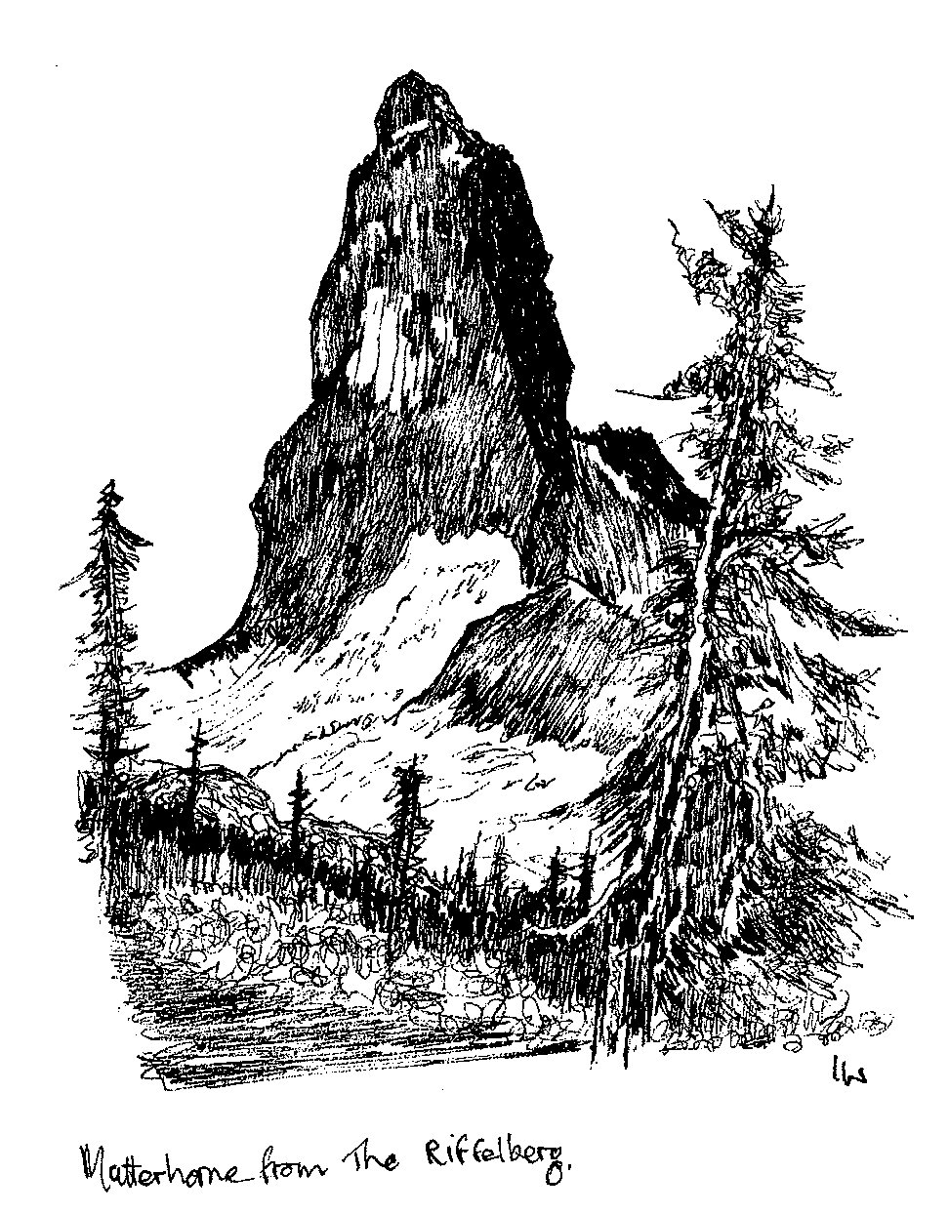

Marshal for Hire

I was on a BBN social walk sometime back in April this year following Steve Smith through a wood (I know my place!) and mentioned about the events that I was due to marshal on instead of walking and it totalled up to 5 events in 6 weeks! So the idea (with a bit of prodding from Gill) came about to keep a record of what happened.

The first event was:

Milton Keynes Marathon Sunday 29th April 2012
Wet Wet Wet was a band back in the 80s (hand up who remembers them?) but it equally described the weather of the inaugural Milton Keynes Marathon. Gill and I had volunteered to marshal one of the stages of the route which was being sponsored by the charity Cancer Research and organised by a BBN member Kevin Lamming.

Our marshalling point was by the roundabout at Kingston near Tesco’s and we were at opposite ends of the underpasses. They did provide some shelter but of course when the runners turned up we had to be out in the open to show them the way. After approx 60 mins the first runner turned up and from then on it was a continual stream of runners streaming through, some in fancy dress all which showed various stages of dishevelment. We gave them lots of encouragement recognising faces such as Bobby Sauerzkapf from Norfolk & Suffolk group plus Andrew Gilbertson from BBN. His beard had been shaved off by then which probably explained why he was moving so quickly!

After a while the runners had been through and it was the joggers and walkers followed by the very slow walkers who came through. One of the last walkers to come through was wearing tracksuit bottoms with a cardigan (not waterproof!) carrying a water bottle in her hand and on her own. Gill and I both thought “Where’s the fun in that?” Once we were finished on the way to dropping Gill back home we passed some runners outside of Conniburrow who were clearly in distress before the climb up Downs Barn Hill. There but for the grace of God…….

Games 100 Marshals’ Walk Saturday May 5th to Monday May 7th 2012
My second stint of marshalling was a week later. I’d been coerced, sorry asked, by Lynn (along with hubby Dave organising the Marshals’ 100) to be the CP closing marshal for all of the checkpoints from Mottingham CP to the Breakfast point at Belmont School.

I didn’t have to be at Mottingham till about 3 p.m. and by the time I’d arrived there most of the walkers had been through. There were a few stragglers but the main person we were waiting for was Chris Dawes who had been spotted going in the wrong direction! Eventually he turned up and the checkpoint was closed.

You might not have been aware but there was a football match taking place that Saturday afternoon between a team from darn sarf and a team from oop north (ok the FA Cup Final Liverpool V Chelsea for those who don’t know!). Paul Lawrence, the Games 100 Organising Committee Chairman, very kindly lent me the key to his house so I could watch the match in comfort. We were losing 1-0 when I phoned Ian Sage at the next checkpoint to see how many walkers were left to come through. “There’s only 1 to come Norm”. Panic!!!!! So I got over to Farnborough St Giles as quickly as I could and unfortunately missed Andy Carroll’s equaliser and his disallowed goal (that would have taken his tally for the season to ….7!). So it was probably a good thing I only had to suffer by listening to the radio.

Ian and Pat’s checkpoint was closed without any problem as was the next one at Biggin Hill Spitfire Centre. The next checkpoint after that was in Martin Burnell's van at a roadside checkpoint just outside Woldingham along with Neil Higham. We sat by the light of the silvery moon waiting for the 40 plus walkers to appear at very spaced out intervals where they were fed and watered from the back of Martin’s van. The last walker was Chris Dawes and whilst we were waiting for him to appear it got very cold with all 3 of us on the front seat of the van. That prompted Neil’s now infamous reply to Lynn when she phoned to ask how we were doing “Lynn there are 3 stiffies in this van”……Cue fits of hysterical laughter from Lynn and Sandra Hyland in the background!

Once Woldingham was closed I followed Neil to Merstham Village Hall where Betty Sherry, Adrian Hudson and Luis Broz where sat waiting patiently for Chris Dawes. During her stint on this checkpoint Betty felt she’d aged by a year. She had, due to it being her birthday! She was offering the walkers who arrived a slice of the Marshals 100 cake she’d had commissioned from Costco.

From Woldingham it was onto Box Hill to close John and Judy Nickerson's checkpoint and then to the finish at Belmont School to be greeted by Dave Yorston and Coral plus the ladies from the Surrey Group. Once fed and watered it was back to the finish just outside Windsor to be greeted by Lynn, Sandra and Les Maple. I was due to go out and take over from Mike Hyland at Staple Hill but felt so tired I would not have felt safe driving. Sorry Mike! From what I was told the next morning it became very cold overnight but each of the stiffies was at least in their own car!

The Moon Walk Saturday 12th May to Sunday 13th May 2012
One week later I was down in London for arguably the most difficult and demanding of all my marshalling trips. The Moon Walk is a 26 mile walk through the streets of the London starting at midnight. It is predominantly for women to raise money for breast cancer and the ladies (and occasional men) are all encouraged to decorate their bras. Did I say this marshalling was easy??

I got down to Hyde Park at about 9pm to collect my marshalling gear and we were

bussed out to our section between Albert Bridge and Battersea Bridge (at about 13miles). For the next 6 hours I chaperoned all the women with “Good morning ladies,
you’re looking wonderful. Please take care at the lights”. I get all the good chat up lines!

It really was a very enjoyable experience even when I attracted one individual who was telling me about how he and his girlfriend had split up whilst I’m trying to make sure that the ladies filtered through on the correct part of the route. Gill wrote an excellent article about the event in the June newsletter, so read that for greater detail.

At 6ish our stretch was closed and we were bussed back to Hyde Park and thanked for our efforts. I wandered back to the station via the 7/7 bombings Hyde Park memorial and then returned home to Milton Keynes and some much needed sleep By the way, there is also a 13 mile route on the Moon Walk which is called the Half Moon. So I could never figure out if the women have to wear half a bra on that one. Guess I’ll just have to marshal again next year to find out.

Cancer Research Race for Life Milton Keynes Saturday 19th May 2012
I had marshalled on this event for the last two years and had offered my services once again. The format had changed this year with the 10 km route starting in the afternoon. I walked into MK Bowl, heard the sound of a cycle bell and “Hello Piglet” and turned round to see it was Merrian Lancaster. She was returning from having a pint somewhere to start her second stint that day.

By the time I’d arrive unfortunately they’d run out of T-shirts so I went over to the Marshals Briefing to be allocated my duties, one of which was to be part of a line of marshals holding back the runners before they set off. Once they’d left I wandered around the site looking at the various stalls (free ice cream being one of them) and then was to go to the finish line and hand out the goody bags and water bottles to the finishers. I know some of the entrants didn’t come through the finish line but still asked for their prizes. Not good.

Having helped to tidy a bit of the site up I met with Dave FH & Merrian (to be joined later by Jim Morrison) in Wetherspoons to chew the cud. I was also trying to convince them of my psychic powers by re-assuring them that they were about to win the Champions League for the first time in their history that evening. Neither of them believed me but the rest as they say is history. You now only have 4 to go before you catch us up though!

Games 100 Saturday 2nd June to Monday 4th June 2012
The final chapter in this saga of marshalling was the Games 100 starting from just outside the Olympic Stadium in Hackney, passing through LDWA Founders sites of interest in Surrey and ending up in Windsor.

I learnt how advantageous a sat nav is when on the Friday afternoon delivering spare route descriptions to a London Group member I got very lost and disorientated as the street I was looking for was right on the hinge of my London A-Z! Eventually I delivered the route descriptions and set off to Trevelyan School in Windsor via the M25. Big mistake as I ran into the mother of all traffic jams on the motorway. I finally arrived at the school 2 hours later than I should have done.

From there it was back to Betty’s at Bushey and then on to the start to see everyone off. The start did become somewhat chaotic with the runners overtaking the marshals who were trying to prevent them from running through residential streets. I then went to the BBN Checkpoint 3 at Mottingham to in Merrian’s words “spend some time with the family” A lovely phrase M. I spent some 4 hours there seeing various BBN members come through and watched BBN Angel Lucy perfect the art of making wraps!

At 6 pm I left the warmth of the BBN checkpoint to return to the finish at Trevelyan School where I spent the next 36 hours doing various tasks such as Event Control, Welcome Desk and trying to sleep! Finally at about 1 pm with the school being closed and all of the entrants on their way it was back to Milton Keynes to normality and get final proof from the Diamond Jubilee concert that Paul McCartney should now retire.

Norman Corrin

ooooooooOOOOOOOOoooooooo

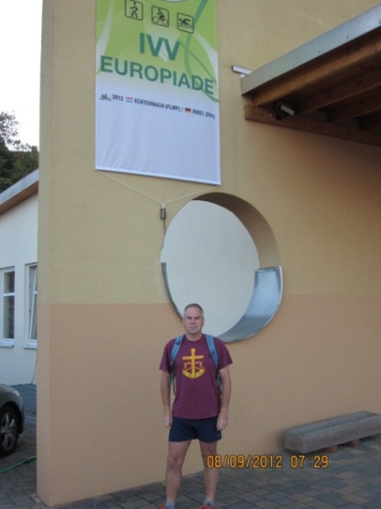 | This is my entry in the occasional series  "Where’s your BBN t-shirt been seen ?".  Adrian Moody at the IVV Eurpoiade in  Luxembourg on 8th September.

WALKS PROGRAMME DECEMBER 2012 – APRIL 2013

Sun Dec 2 A Walk to Bozeat
17ml. 09.00 from Market Square, Olney. Map: Exp 207 Start GR SP889514.
C: Roy Carter T: 01234 301182 (evenings) M: 07784 208997 (on day).

Thu Dec 6 More Northampton Round
15ml. 09.30 from Pitsford Water Causeway c.p. Maps: LR 141,152 Start GR SP782701. C: David Findel-Hawkins T: 01908 216476 M: 07724 025807 (on day only).

Sun Dec 9 Santa from Sandy
12ml. 09.00 from c.p. by Ghandi Restaurant, High St, Sandy (if barrier down, park in local streets). Map: Exp 208 Start GR TL174492. Pls bring wrapped gift value £1. Santa will lead us, with carol singing at churches, mulled wine + mince pies en route.
C: Santa’s Secretary Norman Corrin T: 01908 608667 M: 07980 378656 (on day).

Sun Dec 16 Ashridge and the Golden Valley
19ml. 09.00 from New Road, just N of Berkhamsted. Please park facing uphill (N) on E side of the castle. Maps: LR 165 Exp 181 Start GR SP996082. C: John Davies T: 01442 874875 M: 07949 796470 (on day).

Wed Dec 26 The Rudolph Ramble
10ml. 10.00 from free c.p. in Woburn (opp church). Map: Exp 192 Start GR SP950332. C: Roy Carter T: 01234 301182 (evenings) M: 07784 208997 (on day).
Sun Jan 6 In the Dog House Again! Walk & Meal
9ml. Start 09.00 from The Doghouse p.h. Broughton Crossing. Park in pub c.p. Map: LR 165 Start GR SP840147. Morning walk followed by meal in pub. Please book meal with Norman by 3rd Jan. C: Norman Corrin T: 01908 608667 M: 07980 378656 (on day).
Thu Jan 10 Rushmere Revisited
15ml. Start 09.30 from old A5 road SE of Little Brickhill. Park 1km SE from church on old road parallel to A5 – just beyond lodge at FP into Duncombe Wood. Map: LR 152 Start GR SP917316. C: David Sedgley T: 01525 714961 M: 07583 091770 (on day only).
Thu Jan 24 Four Counties Walk
15ml. Start 09.30 from Burghley House visitors' c.p. (Pilsgate Lodges entrance) off B1443. Map: Exp 234 Start GR TF043069. C: Anne Addison T: 01780 740414.
Sun Jan 27 Lakemill Wonder
16ml. Start 09.00 from Harrold Country Park c.p. Map: Exp 208 Start GR SP956566.
C: Christine Bramley T: 01234 822557.

Sun Feb 3 Ever Done Everdon?
17ml. Start 09.00 from Norton Church (near Daventry). Map: Exp 222 Start GR SP602638. C: Andrew & Gill Gilbertson T: 01327 871451 M: 07922 068591.
Sun Feb 10 Stomping to Fenny
15ml. Start 09.00 from Stoke Hammond. Park in Bragenham Lane (opp Dolphin p.h.) nr sports field. Map: Exp 192 Start GR SP886294. C: Sylvie Eames T: 07788 287701.

Thu Feb 14 A Walk from Little Paxton
15ml. Start 09.30 from Little Paxton Nature Reserve c.p. Map: LR 153 Start GR TL195629. C: Peter Bearne T: 01780 444362 M: 07761 036108 (on day only).

Sun Feb 17 Greenfield Gallivant
20ml. Start 09.00 from village hall, Church End, Eversholt – 200m NW of church. Pls park quietly in overspill c.p. Maps: Exp 192,193 Start GR SP982326. C: David Sedgley T: 01525 714961 M: 07583 091770 (on day only).

Sun Feb 24 Chiltern Kanter Marshals' Walk
For CK marshals only. C: Norman Corrin T: 01908 608667 M: 07980 378656.

Thu Feb 28 Around Olney
15ml. Start 09.30 from Olney Rugby Club, East Street. Olney. Map: Exp 207 Start GR SP890516. C: Jenny Greatbatch & Ian Turnbull T: 01908 607215 M: 07891 683422 (on day only).

Sun Mar 3 Chiltern Kanter – New Venue
26, 18 or 13½ ml. from Pitstone Memorial Hall, LU7 9EY Start GR SP937155. Please note this is a map reading event. Circular routes round Dunstable Downs, the Chilterns & Vale of Aylesbury through farmland and National Trust land. A written description will be issued for part of the 26 & 18 mile routes. Maps: LR 165 or Exp 181. Start: 08.00 - 08:30 for 26 &18m; 8.30-9:00 for 13½m; runners 09:00-09:15 (all to finish by 18.00). Entry: in advance up to 23 Feb £5 (non-LDWA £6); U16s £3; OTD £7 incl refreshments at Cps; hot meal & cert at finish. Postage for results included. Postal entries close 23 Feb. Parking in Goodrich Engineering, Pitstone Business Park, Westfield Road, LU7 9GT (GR SP933154). SEF accepted with SAE. Organised by & chqs payable to LDWA BBN. Entry forms can be downloaded from the BBN website. C: Mike Hyland, 55 Broadlands Avenue, Chesham HP5 1AL T: 01494 774154 E: mike.myland@btinternet.com

Sun Mar 10 Ouseing with Rails and Mills
20ml. Start 09.00 from Harrold Country Park c.p. (voluntary fee £1). Map: Exp 208 Start GR SP956566. Via Podington, Souldrop, Sharnbrook & Radwell. Pls bring packed lunch. C: John Ledger T: 01933 387645.

Thu Mar 14 The Whaddon Chase
15ml. Start 09.30 from the Westcroft Centre (Morrison’s) c.p., west Milton Keynes, by junction of V2 (Tattenhoe Street) & H7 (Chaffron Way). Park at S end opp Howe Park Wood. Map: LR 152 Start GR SP830346. C: Brian Graves T: 01908 631013 M: 07563 728633.

Sun Mar 17 Walk from Shefford
19ml. Start 09.00 from Old Station Way free c.p. Shefford. Map: Exp 193 Start GR TL143391. C: Terry Brown T: 01462 631057 M: 07932 627476.

BBN Weekend : Walking in Norfolk in the Spring
22nd – 24th March : 2 nights at the Deepdale Granary hostel
See p.24

Thu Mar 28 Down, Flat Out, Then Up
15ml. Start 09.30 from free c.p. at Ivinghoe Hills on minor road from B489 towards Ringshall. Map: LR 165 Start GR SP962160. C: Gordon Shaughnessy T: 01582 518791 M: 07518 364036.

Sun Apr 7 From the Source of the River Lea
18ml. Start 09.00 from c.p. Bramingham p.h. near Sainsbury’s (corner of Quantock Rise & Whitehorse Vale), Luton. Map: Exp 193 Start GR TL076254. C: Therese Jamin T: 07779 227675.

Thu Apr 11 Greyhound and Badgers
15ml. Start 09.30 from Ashridge c.p. on the L of road to the Monument. Map: LR 165 Start GR SP975128. Figure of 8 walk. C: Roger & Margaret Skerman T: 01525 405540.

Sun Apr 14 A Lover’s Knot
20ml. Start 09.00 from Gaddesden Row (road) in parking area alongside Gaddesden Row Primary School. Maps: LR 166 Exp 182 Start GR TL050130. Picnic lunch near p.h. Joint walk with Essex/Herts. C: Gabriel Newfield T: 01727 832696 M: 07868 507565 (on day only).

Thu Apr 25 A Totter from Totternhoe
15ml. Start 09.30 from c.p. in Tottenhoe. From main road take lane signed Totternhoe Knolls, NE, to reach c.p. Maps: LR 165 Exp 192 Start GR SP998218. C: Ruth Bowles T: 07901 565863.

Sun Apr 28 Stewkley and Cross Paths
15ml. Start 09.00 from St Michaels & All Angels Church, High St, Stewkley. Pls park considerately on nearby rds. Map: Exp 192 Start GR SP852261. C: Sylvie Eames T: 07788 287701.
Comedy Corner

I changed my iPod's name to Titanic. It's syncing now.
When chemists die, they barium.
Jokes about German sausage are the wurst.
I know a guy who's addicted to brake fluid. He says he can stop any time.
How does Moses make his tea? Hebrews it.
I stayed up all night to see where the sun went. Then it dawned on me.
This girl said she recognized me from the vegetarian club, but I'd never met herbivore.
I'm reading a book about anti-gravity. I just can't put it down.
I did a theatrical performance about puns. It was a play on words.
PMS jokes aren't funny; period.
Why were the Indians here first? They had reservations.
I didn't like my beard at first. Then it grew on me.
Did you hear about the cross-eyed teacher who lost her job because she couldn't control her pupils?
When you get a bladder infection urine trouble.
Broken pencils are pointless.
I tried to catch some fog, but I mist.
What do you call a dinosaur with an extensive vocabulary? A thesaurus.
England has no kidney bank, but it does have a Liverpool.
I used to be a banker, but then I lost interest.
I dropped out of communism class because of lousy Marx.
All the toilets in New York’s police stations have been stolen. The police have nothing to
go on.
I got a job at a bakery because I kneaded dough.
Haunted French pancakes give me the crêpes.
Velcro — what a rip off!
A cartoonist was found dead in his home. Details are sketchy.
Venison for dinner again? Oh deer! Norman Corrin

My Marathon Cycle Ride – Lands End to John O’Groats
June 2012
Dear Friends

As you will probably have deduced by now, I have either finished my marathon cycle ride.... or fallen off the top of Britain. I am delighted to say that the former is the case.
Spurred on by Little Ted (who could be surprisingly vociferous from his back pannier or front handlebar position - weather dependent) and, particularly, by your incredibly generous sponsorship, I arrived at John O'Groats in brilliant sunshine after battling 65 miles of headwinds and 30 miles of very large hills. I proved that I am just as daft as you all feared, in that one day I elected without coercion to extend the ride to 75 miles as opposed to 58 in order to cycle up a 2 mile hill to the highest village in Scotland. I think this proves once and for all that I am completely barking.
The journey was surprisingly pleasant and swift - if 16 days and 1030 miles can be described as such. The route was all off main roads and was very attractive (if 'hilly' - slight understatement this!). My co-sufferers were all incredibly nice and we were all very much the same standard - or at least they pretended to be. My legs and bottom didn't complain once and I honestly don't really feel as if I did it (now!). The same cannot have been said at some points on the trip when yet another huge hill loomed up at 70 miles, or on the trek over Dartmoor in lowering drizzle, or on the 25% hill which just appeared round a corner in Derbyshire on a rather wet day when we had already had 2 hours of rather unpleasant inclines.
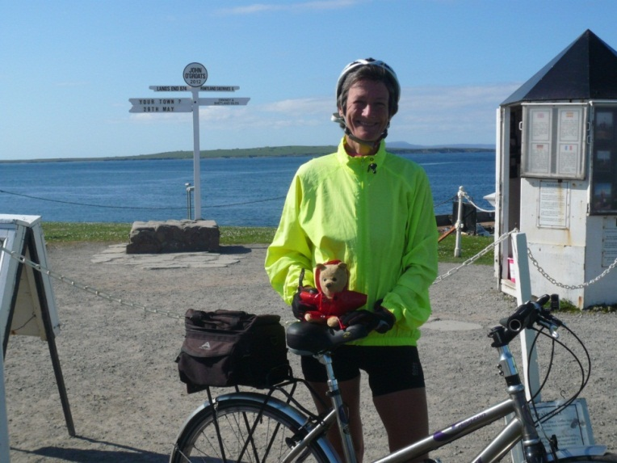 | The hotels and b&bs made up for all this and there was the occasional personal highlight - like climbing Fleet Moss in Yorkshire, all 1900 feet at the end of a very long day which started with a 1000 foot climb, a 1000 foot descent and then another 1000 foot climb, all within the space of 5 miles!  I did learn that in order to be considered a truly serious cyclist you have to be able to consume your body weight in cake at least twice a day
- in between a full cooked breakfast and porridge, a curry for lunch and a 3 course evening meal including lasagne, bread and crumble. I tried my hardest, but I think it safe to say that I will only ever reach 'aspiring amateur' status (or was that 'perspiring

amateur'?), although I do remember a particularly good slice of tea cake in Braco one morning when I had lost all feeling in both hands and stopped for a coffee just so I could hold something hot. The lady in the tea shop jumped a mile on coming into contact with my hands when I paid at the till and emerged from the kitchen 30 seconds later with mounds of hot towels which she insisted on binding round my hands! Fortunately this was not witnessed by any of my co-conspiritors as they had already overshot the tea room and were well on the way to the next 2 course lunch stop!!)
I'll stop wittering now, but I do want to say a huge thank you to all of you who were so generous in your sponsorship that you made it absolutely impossible for me to drop off the back of the tour. Your generosity has raised an incredible £3000 including gift aid and I know that the SD Brain Tumour Trust will put this money to very good use. Thank you all from the bottom of my heart (no posterior jokes in future please!).
Clare Francis
ooooooooOOOOOOOoooooooo

N.U.M.P.T.I.E.S !!!

It just had to be done. Being of the rare breed, an LDWA member never to have completed a national trail, and having previously ‘challenge walked’ the ‘far’ SW half of The Ridgeway, the other 44 miles from Streatley to Ivinghoe Beaconed, I mean beckoned.

Of course Betty was up to joining me in anything that involved a modicum of strategic advance thinking. With a spare weekend, 2 cars and 44 linear miles to cover, what could be more simple? It only took 2 planning meetings.
(At this point please pay extra attention. D = Dee, B = Betty)

The Plan
Day 1 - Saturday 23 miles Chinnor to Ivinghoe. 2 cars, B&D meet at Ivinghoe. B,D and 1 car drive to Chinnor.* B&D walk along the trail back to Ivinghoe to use the car, cunningly left that morning, to drive back to D’s house for the customary meal and suitable refreshments.
Day 2 - Sunday 21 miles Streatley to Chinnor. B,D and 1 car drive to Streatley. B&D walk the 21 miles back to Chinnor, pick up car left 24 hours earlier, to drive back to Streatley.
Mission accomplished, easy or what….. or not, as the case may be.

The Event
Up to the point afore marked *, the plan was achieved with relative success. D’s ability to read a street map of Chinnor had resulted in only a 100-yard walk before B spotted
the first Ridgeway sign. A magnificent route, lovely weather and easy to follow signs made for an enjoyable walk. D did remark that the busy road they passed under at 5 miles must have been built after she purchased her, now obviously out of date, OS map. B rightly suggested it was not necessary to have one’s nose stuck in a map when the scenery was beautiful and the way well marked. 8 blissful miles gone and it was time to stop to eat on a bench conveniently situated next to a Ridgeway information board. “Look how far we have gone already…” a gleeful B enthused, “not that many miles left to Streatley!” The penny dropped for both girls at the exact same moment…..they were supposed to be heading towards Ivinghoe. Initial reaction, hysterical laughter.” I bet it is a lot nicer views walking in this direction, at the end we will only be 21 miles from our nearest car and taxi cabs are very reasonable these days”. (NUMPTIES!).

Later, sitting in Streatley enjoying a coffee by the banks of The River Thames: 3 phone calls had established that the only 2 possible sources of rescue were not in fact available, (D’s son was at a Radio Head gig in Manchester and Steve Clark was selfishly working, driving his lorry up in Northumberland somewhere) and a private hire car would cost £55! A beer was now needed, over which a pleasant couple at a neighbouring table listened to the girls’ tale of woe, whilst politely suppressing their giggles. (NUMPTIES!). The lovely lady and gentleman, who had just returned from a rugby match involving their son in Chinnor, offered to return, for mere petrol reimbursement, to reunite B&D with their car. They couldn’t possibly accept, OK perhaps they could. So, by 9.30pm B,D and both cars (work that out yourselves) were safely back at D’s house. Too late to eat out, but a frozen quiche and a bottle of wine in the fridge were all that was really needed, with no change of clothes required for a visit to the pub. (NUMPTIES!).

Due to having already walked the planned section and now having both cars at home slight alterations were necessary for the day 2 plan. (In hindsight it would have been risky to leave a car overnight at Chinnor and we now luckily have the nearer section left to complete). (NUMPTIES!). Having had ample practice the previous day, leaving one car at The Beacon car park and the other in Chinnor proved really quite easy AND there could be no question of the direction to initially take. 11 miles later, coffee and cakes in Wendover, all was well. An hour and a half later a teeny-weeny mistake (bet the last sign post had been broken) saw the walkers just slightly off course. Naturally, within 10 minutes, it was a simple task for Dee to map read the pair back to the trail where Betty was quick to see a partially hidden trail sign to reinstate them on the route. 4 happy miles later, shock! Horror! Why did that big house so closely resemble the one passed just outside Wendover? They had completed a 3 hour out and back trail with the little ‘wrong’ loop at one end. (It just goes to prove leading a walking the opposite way is as
good and interesting as a new route). (NUMPTIES!). With no chance of now reaching the

Beacon before dark, this offered a great opportunity to fine-tune their ability to ‘think on one’s feet’.

Tring, where it was assumed there would be numerous taxi ranks, was just 6½ miles from the end and only one mile from the trail itself. It was just slightly bad luck that the town had only one rank at the station and whoever heard of a town with its station 2 miles outside its centre. Having a natural good faith in human nature, B&D just knew the 2 young men now approaching them in the High Street, smartly adorned with several tattoos and body piercing, spiky hair and remarkable large ‘washer things’ in both ear lobes would be happy to help them. (NUMPTIES!). They actually exceeded expectations, calling 3 cab firms (by chance included in their mobile phone contact list of friends) and negotiating the best price to Ivinghoe, which arrived just 5 minutes later. Having been thoroughly entertained, hearing the exciting adventure of his two passengers, the friendly cab driver drove to the Beacon car park, nearly 2 miles outside the actual village, at no extra charge.

(NUMPTIES!). (NUMPTIES!). (NUMPTIES!). What a wonderful, rewarding weekend. B&Ds' achievements included completing a further 38 miles of the Ridgeway Trail, making good friends with a like-minded couple whose son played rugby for Chinnor (and were now aware that the LDWA could help them realise their walking aspirations), they now knew that the more metal through the body the nicer the person, they had restored their faith in taxi cab drivers and, most importantly of all, had been thoroughly rejuvenated with a jolly good laugh during 2 great days of wonderful walking….AND …..they could still look forward to an enjoyable day, perhaps with the help of friends, completing the final 6 miles of a national trail, with time to stop at a nice little bistro en route!

The motto of this true story, always believe in NUMPTIES! Never Underestimate Mega Positive Thinking In Extenuating Situations.

PS For those slightly concerned (Nigel), membership of BBN was at no time revealed to others inadvertently involved in the above events!
Dee Brockway
oooooooOOOOOOOooooooo

An Ireland Story – Castle Bar 4 Day Walking Festival – June 2012

This was my first visit to the Castlebar walking festival and after having such a wonderful time, I am sure it will not be my last.

I was lucky enough to go with two experienced BBN pals Norman and Gordon (the old codgers), who knew the ropes and had everything organised in advance. We flew to Knock and rented a University apartment in Castlebar. The flats were very nice,
although we had to complain that Norman’s mattress was excessively squeaky. The lovely ladies in charge did not bat an eye lid and duly replaced it with a quiet one and they were really helpful and friendly and keen to provide everything we needed.
Of course the boys had to start our little holiday with some pints of Guinness, even though it was only 5pm in the afternoon! Blame can be put down to the fact that Jonny Mac’s Bar is just opposite the hotel which is the HQ of the walking festival. Needless to say that our first evening went swimmingly!

Since we were in the West of Ireland the weather forecast was for sun and showers and so there was no getting away from getting a bit damp. However, there were lots of enthusiastic leaders and lots of cheery fellow walkers from all over Europe who were all determined to have a good time whatever the weather. If fact all the 4 days were a bit damp but when the clouds did part, the most spectacular scenery came into view and it never seemed to dampen anyone’s spirits. We opted for the cross country rambles each day but there were a number of other distance road options. All the walks were really well organised and they even arranged to put portaloos as various points on each walk for our comfort.

Best of all was the amazing warm welcome from everyone from those on the walks and all the locals we met. It is a walking holiday for everyone and anyone especially if you want a laugh. so why not think of joining us next year.

Lucy Tink
Walking in Norfolk in the Spring – BBN Weekend Away
22nd – 24th March 2013
2 nights at the Deepdale Granary Hostel
www.deepdalefarm.co.uk/grouphostel/index.asp
For £25 per head come and enjoy a weekend of walking the coastal path and the lovely
countryside of Norfolk. Walk leader Frances Craven. We will self-cater or pop to the local pub. With 19 beds available, please book early with a £10 deposit.
Please contact Chris Bent to reserve your bed.
Chris.Bent@btopenworld.com
Tel: 07837 367575

Words of Wisdom from our members
Luis Broz at the end of the Birmingham Canal Canter: “Every time I see Martyn Greaves he looks like a hospital case whereas you Norm look like a stocky athlete”

LONG DISTANCE WALKERS ASSOCIATION - BEDS BUCKS & NORTHANTS GROUP
MINUTES OF COMMITTEE MEETING HELD ON THURSDAY 11TH OCTOBER 2012
AT 3 LODGE LANE, PRESTWOOD (TO BE APPROVED)

The meeting commenced at 7.45 pm.

Present: Gill Bunker (Newsletter), Norman Corrin (Secretary), Dave Findel-Hawkins (Membership), Martin Lawson, Merrian Lancaster (Website), Ian Sage (Treasurer), Nigel Schofield (Chairman), Gordon Shaughnessy (Thursday Walks), Lynn Yorston (Equipment and Merchandising)

Nigel thanked Lynn for hosting the meeting and thanked everyone for attending.

1. Apologies: Dee Brockway (Walks Programme)

2. Minutes of Previous Meeting (18th May 2012) and Matters Arising
(i) Mike Hyland has completed the engraving of the new BBN cutlery.
(ii) Norman said that the 2013 AGM would be in Worcestershire.
The Minutes were approved as a true record. Prop: M Lancaster; Sec: L Yorston

3. Officers’ Reports

(a) Chairman – Nigel Schofield
Nigel circulated his report:
A riddle for you: At the start there were 20 and a dog, 90 minutes later there were 21 and a dog, 240 minutes later there were 3 and no dog, 30 minutes later there were 4 and finally at 165 minutes later there were still 4, and five minutes after that there were 3 who enjoyed a slice of cake. Answers on a postcard please. (see below for a clue).

I hope that you have had a good summer of walking on holidays, with BBN, other local groups and the many challenge walks on offer. Congratulations to those who completed the Herts Stroller and White Cliffs Challenge, fantastic weather on both, and commiserations to those who did not.

The social walks programme for December 2012 to April 2013 has just been released by Dee Brockway. Twenty two walks (Thursday and Sunday), so thanks to all walk leaders and the Chiltern Kanter on 3 March 2013. If you can help out on the main event then the Marshals’ walk is on Sunday 24 February – please contact Norman Corrin.

I had a mega August, Herts Stroller, Founders Marshals’ and St Peters Way in a Day, good preparation for a week in the Bernese Oberland, based in Wengen. Highlight was
a 5272 feet of ascent to the top of the Shilthorn – 9744 feet, (no snow, so no James Bond) and 7136 feet of descent to Murren and Lauterbrunnen. I can thoroughly recommend this area for some good mountain walking, good food and fresh mountain air.

Martin Lawson is making progress on the location and routes for the 3 x 30 km walks for our 30th Anniversary next year, one in each BBN County. Martin ably and nobly led (after three hours of dry at the start) a very wet bunch of walkers on the Hartwell Hearts of Oak as the BBN Celebratory Walk for the 40th Year of LDWA. At the end came a slippery walk on the tree canopy walk in Salcey Forest for non-existent views. Lucky were the groups who did not choose 23 September for a celebration walk. Chris Bent will be leading a 30 mile ‘social’ for our 30th Anniversary on Saturday 22 June 2013. Do come if you can.

Please do your utmost to attend the BBN AGM and walk on 25 November starting from Cosgrove with a meal and then the AGM. It is your walking club and you need to be there to have a say in what goes on. If the Committee do not receive comments or feedback it is difficult to know if what we do is alright with you. Are we doing OK?

Don’t forget ‘Santa from Sandy’ on 9 December where the rotund ho ho gentleman will be leading the walk. Will it be mince pies at the end or a poppadum?

As always your Committee and others work tirelessly on your behalf to organise events and arrange a very full social walks programme and Thursday programme. Dee will always love to hear from you to propose a walk.

I hope that you all have a good walking autumn and stay healthy.

Please think what you could do for BBN and not necessarily what the BBN can do for you and don’t forget ‘to have a great day out on a walk with BBN’.

There were no questions following Nigel’s report.

(b) Secretary – Norman Corrin
Norman circulated his report:
I’ve received the following:
The Voluntary & Community Action South Beds newsletters for June, August & October 2012.
Newsletters or email updates for the following groups:
Essex Herts: June 2012; Kent: August 2012; London: Summer 2012
Thames Valley: Various items on their website forum
If any committee members or group members wish to read them please contact me.

New Members/Enquiries from Public
I've received notification from the national membership secretary of 18 new LDWA members who live within our group’s area and have emailed them all information packs. I’ve also emailed the information onto Dave for when/if they join BBN. In addition there have been 3 transfers from other groups to BBN. 1 each from Kent, London & Wessex. There has been 1 transfer out from BBN to Surrey, Peter Lockyer. There has been 1 transfer out from BBN to Nidderdale, Christine Pendlebury. 7 members of the public have enquired about the LDWA. I’ve emailed them with information about the association and BBN.

Event Entry Forms/ Walk Related Information
I’ve emailed the following event entry forms or walk related information to the group:
Daily Telegraph 50 Great Coastal Walks 19th & 20th May 2012
18th Alwinton Round 9th June 2012
100 km walk for blind veterans 9th and 10th June 2012
10th Hills and Dales Walks 8th September 2012
Birmingham Canal Canter 15th September 2012
The Centurions Annual 100 miles walk on 22nd/23rd September 2012

Miscellaneous
Striders for August 2012 for local libraries have been sent to Nigel Schofield, Gill Bunker (for Bedford Library), Ian Sage, Steve Clark, Merrian (OU) and Gordon for Luton Library.

2 batches of 40th Anniversary badges have been received and handed out.

Greensand Ridge committee meeting minutes June 2012 have been received.

I emailed Douglas Robinson from London Group information about installing kissing gates as they have surplus funds which they wish to use.

I received a letter from the Air Ambulance for Berks/Oxon/Bucks thanking us for our donation and asking if we would appreciate a talk from one of their representatives.

I am not crying wolf as I did in 2010 but next year will be my last as Secretary. But to be quite honest if any other committee member or group member wishes to take the job on I will be more than happy to step down this year.

Regarding the proposed talk by the Air Ambulance, it was agreed that a walk that included a visit to their offices (thought to be near High Wycombe) would be the best way to take this forward.

Nigel thanked Norman for his report
(c) Treasurer – Ian Sage
Ian said there had been little activity since the last meeting.
The balance of group funds as at 30th September:

Current Account £2,439.48
Business Reserve £4,000.07
Total £6,439.55

Cheques issued but not presented £20.00 (2x£10 Housman 100 cheques to
marshals)
Cheques to be issued £0.00

Corrected balance at 30.09.12 £6,419.55

At the meeting Ian wrote cheques for Norman (postage) and Gill (Newsletter postage), Nigel (LGRs’ meeting), and received membership monies (£21) and Sundon Saunter entries (£400).

Ian had done some research on interest bearing accounts but, in view of the current low interest rates and the fact that some of these funds may be put towards BBN’s 30th anniversary events next year, it was agreed to leave the money in the existing reserve account at least for the next 12 months.

Ian said he would now be sending the accounts to Phil Friede to check ready for presentation to the AGM.

Nigel thanked Ian for his report and his hard work.

(d) Membership – Dave Findel-Hawkins
Since the last meeting we have the following new members:
Yvette Etchell, Dave Jones, Alan Leadbetter, Peter Sinfield and family, and David Tassell. Norman Smith has rejoined.

The following have not renewed and therefore have been removed from the list:
Graham Crowe, Ron Mills, Eugene Stratton.
The three other members who had not paid by the last meeting have now paid. One of those who had been removed before the last meeting has now paid and has therefore been reinserted. Christine Pendlebury has changed groups to Nidderdale but as she has paid to the end of the year I have left her on the current list.

Total membership is therefore up three to 159.

Dave confirmed that he would email the membership list to anyone who wanted a copy.

(e) Social Walks – Dee Brockway
THURSDAY NIGHT? OH NO! I thought it was Friday night.....sorry, sorry, sorry. I am not coming back until Friday morning. Still, I don't think I am very important. The Jan to April walk programme is all sorted.
If there is discussion about the post for next year, if no-one else is forthcoming, I am happy to continue for another year if no-one else has a burning desire to do it.

(f) Thursday Walks – Gordon Shaughnessy
Gordon said the Thursday walks continue to average 15-20 walkers. There have been two a month with plenty of leaders.
Gordon said that one of the September walks he led had been part of the Beds Walking Festival and 4 or 5 new people had come. At the end of the walk he had been offered a tip by one of the walkers which he had found embarrassing, but it transpired that the walks festival leaflet had indicated a tip could be offered if the walk had been enjoyed.

There appears to be a growing problem of walkers going off in front of the leader on group walks.

It was agreed to put a Thursday walk on the Beds Festival programme next year.
Gordon said that Yvette Burnell of Thames Valley contacts him when arranging their midweek programme to avoid any clash.

(g) Merchandising/Equipment – Lynn Yorston
Merchandise: There have been no sales since the last meeting.
Equipment: I have circulated an equipment list and have had good feedback from everyone. We seem to have lost some tea towels and maybe 1 water carrier. If anyone else has any input, please let me know.
Lynn is trying to trace 7 fold up chairs. Norman to contact Sylvie Eames to see if she still has them.
It was agreed not to purchase any more tea towels as most people take their own when checkpointing.
It was agreed that Lynn would look into the purchase of BBN aprons/tabards.

(h) Website – Merrian Lancaster
Merrian had little to report but it was noted that the website pictures were being looked at and the routes of walks done were popular – people could see where they had been.
It was noted that Rachel Martin had offered to set up BBN on Facebook, but those present were not sure how this would work and the benefits for the group. It was confirmed that the LDWA is on Facebook. Gill to check with Rachel and Nigel will ask for the benefits of Local Groups being on Facebook to be discussed at the next LGRs’ meeting.
Nigel thanked Merrian for her work on the website.

(i) Newsletter – Gill Bunker
Gill said the Newsletter was almost ready and would be sent out when the minutes of this meeting were done. She has sufficient contributions.

(j) Local Group Representative – Nigel Schofield
Nigel confirmed he would be attending the next LGRs meeting in Coalport on 16th/17th/18th November (same weekend at Sundon Saunter) and would report back at the AGM.
Lynn asked Nigel to raise the fact that certain LDWA walks were only accepting online entries – this appears to exclude walkers who do not have access to a computer or who do not wish to make online payments. It was agreed that this is a valid issue and Nigel will ask for this to be discussed.

(k) Other Committee Members
Martin had nothing to report.
Nigel commented that there is often a lot of talk about the Hundred – he feels that the Hundred should not dominate the LDWA.

4. Auditor
This had already been discussed under the Treasurer’s Report.

5. Insurance Issues – Incident Reports
There were no matters to report.
Merrian said that she and Dave walked a lot with other groups and BBN still appear to be the only group collecting names of non-members at the start of a walk. Nigel said he would ask for this to be added to the agenda for the LGRs meeting. Gordon said it was not onerous collecting this information. He did it on all the walks he went on and posted the form to the leader of any walks he was unable to attend.

6. Group Activities
(a) 2013 100 – Merrian confirmed that we will be at CP3 - a “barn” at Candra – serving cold bite size food and possibly hot drinks. Water containers are needed. Confusingly, as entrants must carry a mug, cups for hot and cold drinks are being supplied.
(b) 2014 100 – Merrian confirmed this will be a tent outside the Bryn Ffynnon Hotel.

7. AGM 25th November 2012 – Navigation Inn, Cosgrove
Norman said this was all in hand – he has walked out the morning walks. Gill has the menus for the Newsletter. The menus will also be at the Sundon Saunter and emailed to everyone. Meal choices need to be with the landlord by 22nd November.

Norman had produced a draft Agenda and this was discussed and amendments agreed. This can to be put on the website/newsletter with the wording: “This is the provisional agenda for the AGM - should any member have any item they wish to put forward for discussion - please contact Norman.”

8. BBN Events

(a) Sundon Saunter 18th November 2012 – Lynn Yorston
Plans are in progress for this year’s SS event. The routes are done apart from the last minute revisions.
The halls are all sorted and the menus are done. Merrian is sorting the CP staff.
I will wait to see the entry numbers before compiling a shopping list. We seem to be up to about 100 entries and I have some cheques (£400) to pass to Ian.
The Marshals’ walk will be on Sunday 4th November. We will start at 08.00 from the playing field near the Barton Hall, as usual. Please contact Dave Yorston if you need any other information. Also, please let him know if you are joining us on this walk.
The badge and certificate were handed round and admired.
It was noted that the marshals’ walk is the same day as a BBN social walk. Lynn said that the marshals’ walk is now on a Sunday as both Mike and Sandra work on Saturdays. If any marshal is unable to walk on the marshals’ walk they can do the walk at any time.
Nigel thanked everyone involved with the event for their efforts.

(b) BBN 30th Anniversary Events:
- Canal Boat Trip – Norman said he has been in contact with Grebe Canal Cruises. Their calendar for next year is not available yet – various options were available and it was agreed to have a walk in June in the Chilterns followed by a 3 hour evening cruise with meal from Pitstone to Marsworth and back. The cost is £20 per person but it was agreed there may be scope for the trip to be subsidised from group funds;
- Brewery Trip – John Davies has been looking into a walk including/finishing with a tour of the Chiltern Brewery, Terrick, nr Wendover. This will be on a Saturday as the Brewery does not do tours on a Sunday;
- Lynn also mentioned a new brewery opening in Prestwood – the Malt Brewery– and it was agreed a visit could be included on walk later in the year;
- Quiz – October 2013 Norman said this would be in October, when there was not so much on. He will book Paradise Hall at Newton Longville;
- Doghouse – 6th January 2013. A New Year walk and lunch;
- 3 x 30km group walks - Martin said he had no dates yet but the walks would be in three different months next summer, June, July and September. Martin will lead in Northants, Sue Leonard in Beds and Dave Y/Mike Hyland in Bucks;
- 30 mile walk led by Chris Bent from Whittlebury 22nd June (Revised date);
- Commemorative Mug – after some discussion it was agreed we will look into giving a BBN commemorative mug to all BBN members rather than just to completers of the 3x30km group walks. Lynn will check suppliers/prices, etc;
- Walking MK Boundary Walk – October 2013. Sylvie Eames is co-ordinating walking the Boundary Walk over 3 days in October – the walks to be led by Sylvie, Steve Clark and Gill B.

(c) Chiltern Kanter 3rd March 2013 – Norman Corrin
Norman confirmed the event will be from a new venue at Pitstone Memorial Hall with parking at Goodrich Engineering 7 minutes’ walk away, and three distances of 26/18/13½ miles. The routes should all be sorted by the end of the year. Norman still needs to sort out a CP near Tring. The marshals’ walk will be on Sunday 24th February.

9. Group Finances/Donations/Equipment
(i) Donate a Gate – The Chiltern Society
Norman sent the agreed £100 donation to the Chiltern Society – they then indicated that a gate plus installation costs £250 in total. It was agreed to donate a further £150. Prop: N Schofield; Sec: L Yorston. The gate plaques are standard, and will show the group’s name but not the logo. Norman has indicated the preferred location for the BBN gate is on the Chiltern Way.
(ii) Wendover Arm Canal
Norman sent the £100 donation but they have indicated that a small brick is £50 and a large one £150. It was agreed to donate a further £50. Prop: G Shaughnessy; Sec: M Lancaster. The brick will be on Bridge 4 near Tring and will show the BBN name and logo.
(iii) One of the BBN benches on the Greensand Ridge is broken. Norman confirmed he is following this up.

10. AOB
- Steppingley Step 2013
Dave F-H is working on the route and will report to the SS committee directly after the Sundon Saunter.
- Pick & Mix 2014
Lynn said she and Dave will start planning this early next year.

The meeting closed at 9.56 pm.
The date and venue of the next committee meeting will be arranged following the AGM.
oooooooOOOOOOOooooooo

