LONG DISTANCE WALKERS ASSOCIATION - BEDS BUCKS NORTHANTS GROUP
MINUTES OF COMMITTEE MEETING
HELD ON THURSDAY 30TH JANUARY 2020
AT 96 WARDOWN CRESCENT, LUTON LU2 7JT

The meeting commenced at 7.45

Present: Terry Brown (Chairman), Gill Bunker (Newsletter/Website), Roy Carter, Peter Engledow (Treasurer), Dave Findel-Hawkins (Membership), Alan Leadbetter, Peter Simon (Secretary/Local Groups Rep)
 |  |  | ACTION
1. | Apologies: Mary Knight (Social Walks), Sara Waldron
2. | Minutes and Matters Arising from Previous Meeting (31st October 2019)
 | The Minutes were approved.
 | Matters arising:  Norman has resigned from the committee but is happy to carry on with his existing jobs. Agreed no need to replace Noman till AGM.  BBN Business Cards: Still to be followed up. |  | Gill
3. | Reports:
 | (a) | Chairman: Terry Brown
Since the last meeting I have:
- Chaired the AGM and produced a brief report for members for the subsequent weekly Update
- Progressed procuring the BBN Marshals T Shirts
- Helped with Midsummer Meanders planning
Responded to emails/enquiries as appropriate.
 | (b) | Secretary: Peter Simon
Received and responded to e-mails
Almost no phone enquiries.
Weekly news Updates sent to subscriber members except for when there has been no news to report. Distribution was 726 as of 21 January, 32 higher than in the corresponding week of 2019.
 |  | Peter indicated he would be standing down as Secretary at the AGM.
 | (c) | Treasurer: Peter Engledow – See Report p. 8-9
 | (d) | Social Walks: Weekend/Thursday: Mary Knight
Walk Programme January to April 2020:
- All Thursday dates filled
- Weekend dates that need walk leaders
  - 11/12 April (Easter)
Walk Programme May to Aug 2020
- All Thursday dates filled
- Weekend dates that need walk leaders
  - 15/16 Aug
  - 29/30 Aug
 | (e) | Merchandising: Dealt with under Item 8.
 | (f) | Equipment: Lynn Yorston (Non-Committee)
 |  | I don’t think anything has changed since my last report But if anyone knows different, please let me know. I have sent an up to date list to Gill for the web
 |  | DFH has drawn an up a list of all the items in the first aid kits with their use by dates so they can easily be replaced when necessary.
 | (g) | Website: Gill Bunker
 |  | Website:  Kept updated, photos, info etc posted as requested.  Always grateful for any feedback/suggestions to improve.  (Apart from updating the photos on the home page; it was my New Year’s Resolution to learn how to do this – not done yet.)  Programme May to August 2020 input for Strider (deadline 31st January). | Gill
 | (h) | Newsletter: Gill Bunker
Spring Newsletter: Deadline: Sunday 16th February. Contributions needed.
Anything committee members want included?
 | (i) | Facebook: Gill Bunker
 |  | 192 members (31st Jan). Norman and I are admin. It pretty much looks after itself.
 |  | Twitter- Peter Engledow
- Very positive
- Numbers going up
- Connected to more groups
 | (j) | Local Groups Representative: Peter Simon
 |  | Julie Cribb has sent us the full information pack for the November 2019 meeting at YHA Sherwood Forest. This has also been posted on the main LDWA Website. The 2020 meeting will be held in November, on the same weekend as the Shillington Shuffle. The venue has not been announced.
Peter confirmed main issues:
- Financing of new website
- Increasing revenue
- Cutting cost of Strider
 |  | Terry said it would be good to see quotes/estimates for the work required for the new website.
 | (k) | Other Committee Members Nothing additional to report.
4. | Insurance Issues (including Walks Register) - Incident Reports
 | (a) | Steppingley Step 2019 – An incident report had been completed as required following a participant’s fall after the Steppingley Step.
 |  | - Agreed to add wording at the end of BBN route descriptions advising walkers to have something to eat and drink and to rest before leaving.  - Alan already advises walkers on the Hannington Hike route description to rest before making their way home. | All challenge event organisers
 | (b) | Other Nothing further issues.
5. | LDWA
 | Noted that BBN are not named in the LDWA Chair’s Update (30th January) as supporting the challenge walk non-member levy, although the group have had already contributed from four events, totalling over £1,000. Membership to be advised. |  | Terry/  PeterS Update.
6. | LDWA 100s
 | (a) | 2020 100 - Y 100 Sir Fynwy CP {23rd/25th May 2020) – Mary Knight
Abergavenny Checkpoint. 17 Marshals confirmed.
The hall has no cutlery or crockery. Organisers to provide crockery. I suggest we take BBN cutlery.
 |  | DFH will look at hall during marshals’ event. | DFH
 | (b) | 2021 100 - Trans Pennine CP – BBN now allocated CP2. DFH is the contact.
 | (c) | 2022 100 – Elephant, Bear and Bull CP1 Coventry University allocated. About 7 miles in. The University will be doing the food. DFH is the contact.
 | (d) | 2023 100 – Speyside CP at about 25 miles, venue not known as route is not finalised yet. DFH is the contact
 |  | .
7. | BBN Challenge Events
 | (a) | Steppingley Step 2019
 |  | DFH said the event had been successful, with good weather and lots of positive feedback.
 | (b) | Hannington Hike 2020 – 1st March 2020 – Alan Leadbetter
Moving the event to March seems to have worked well. Entries are up with 159 as of 26/01.
Have a few marshals on the marshals’ walk on Sunday 2nd Feb, with all routes covered at the moment. Might need someone to check the loop on the long route.
Would like to announce that the Hannington Hike, Pick & Mix and Chiltern Kanter have joined forces to create a new triple award.
 |  | - Alan said there was likely to be a delay in obtaining the new HH cloth badges and they may not be available for the event as the material was coming from China  - He confirmed the badges would be give-aways  - 11/12 marshals will be out for the marshals’ walk  - He has someone in mind to ask to check the long route loop  - Alan asked for £350 to be transferred to him for food and hire of van  - 169 entries to date, entry limit of 200 can be increased if necessary  - To date more women than men have entered  - 40% of entrants are non-LDWA members  - Good idea to put out some BBN literature at the event | Alan/  PeterE  Gill
 | (c) | Pick & Mix 2020 – 31st May 2020 - Lynn & Dave Yorston
Plans are ongoing and routes are being checked. We await the decision on HS2 go ahead or not but it looks as if the routes are mainly safe for this year. We will be looking for early morning helpers and for a few to stay to clear up at the end please. Those who help at start or finish should also have the time complete their chosen loops.
We are happy to join with Chiltern Kanter and Hannington Hike to form another BBN TRIPLE CHALLENGE but will not be willing to collate it all.

If agreed, we will deal with the design and production of the new triple badge. This will not be needed until the Kanter 2021. Can we be assured that the committee will cover this cost please. We no longer have the facilities to produce the certificate though. We can liaise with whoever does this so that they are compatible.
 |  | Helpers on Pick & Mix – Need to check if more helpers are still needed.  If yes, circulate request via Update. | Gill/PeterS  Update
 | (d) | Shillington Shuffle 2020 – 15th November 2020 - Dave Findel-Hawkins
- Lynn had left the team, but Dave Y is continuing
- All tasks covered
- CP 2 Pirton moving to school rather than hall (already booked)
 | (e) | Chiltern Kanter 2021 – 7th March 2021 - Roy Carter
- Pitstone Hall HQ booked and deposit paid (£309.20 for day)
- Wigginton Hall provisionally booked (2 sessions at £25, total £50)
- Roy is looking at Aldbury Memorial Hall. (£32 for morning session, 9am-1pm)
- He has ideas for routes, and will begin walking out in the summer
- The last event had 20th anniversary badges, so a new order of badges probably needed. Roy has information about badges from Norman
 | (f) | S.S. Walk Triple Challenge - Lynn & Dave Yorston
A new batch of these badges is required. They are paid for by the main BBN account and committee. May we have the go ahead to order.
We have spoken to Tolley Badges re a re-run of the SS Triple badge. The last order was in 2016 when we had 200 badges. Prices per badge are plus postage and then VAT:
100 = £1.52 each
200 = 97p each
300 = 87p each
Merrian, who keeps the Triple records, confirms “50-60 badges are used each year. Please could we order 200”.
 |  | - Agreed order of 200  - Cost worked out to be approx £240  - Confirm to Dave & Lynn that they can place order | Gill
 | (g) | New Triple Challenge – Hannington Hike, Pick & Mix and Chiltern Kanter
 |  | - Agreed to be a good idea  - Triple will start with HH 2020,then P&M 2020 and CK2021  - Alan will maintain records  - First possible completions will be in March 2021, so plenty of time to design and obtain certificates and badges  - To be advertised in Newsletter/Update | Alan/Gill/  PeterS Update
 | (h) | Wendover Gap Anytime Challenge – Lynn & Dave Yorston
 |  | We have no new completions.
 |  | - Advertise this again?  - We are not sure if HS2 will impact on the route. Check with Dave and Lynn. | Gill
8. | Merchandising/Equipment
 |  | Marshals’ T shirts – Terry Brown
- T shirts from Metrosigns
- Terry had an example of a medium sized T shirt (without the printing) to check colour and sizing
- Colour good
- Minimum order is 50
- Agreed to order 60: small 10, medium 20, large 20, extra large 10
- Total cost expected to be £546.60
- Terry will order, and collect to save postage
- Terry hopes they will be available in time for Hannington Hike.
 |  | Group Clothing – PECO (Custom Sports Kit) – Gill Bunker
PECO have set up a bespoke “sports kit arm” for online ordering.
The main points:
No cost to the group.
They will display any item, and add or take off any item as required.
All items are displayed with logo and price – price includes garment, embroidery and postage.
People can order their own clothing individually as and when, which is what we wanted. We simply have to advertise the link. https://customsportskit.co.uk/other-clubs/
They have set up a page for BBN, currently displaying fleeces, t-shirts, beanies, polo shirts & boot bag.
 |  | - Agreed the BBN shopping page looks good and will be simple to use  - Items to be added: Rugby shirt, hoody, gloves, walking cap (if available)  - Link to be circulated via Update  - Gill to update Merchandise page on BBN website | Gill  PeterS  Gill
 | (c) | Banners
 |  | - Terry is in touch with Rob at Metrosigns  - PVC banners cost about £45 per square metre. Colour, or number of colours; make no difference to the cost  - Terry displayed some mock-ups for the wording previously agreed and the preferred option were chosen  - Agreed to purchase 3 “Welcomes” and 1 “Muddy Footwear”  - Terry to go back to Metrosigns to get an idea of cost | Terry
 |  | Other Signs – e.g. Toilets, etc.  - Agreed laminated signs would be useful and re-usable  - “Food Safety” signs – Contact Lynn for her wording.  - Alan has laminator and pouches | Gill/Lynn
9. | Donations/Projects
 | (a) | Greensand Ridge Walk Benches
 |  | - Roy and Terry are meeting with the Greensand Trust on 12th February  - Terry had a photo of a nice bench at RSPB, Sandy; she is following up manufacturers/cost.  - BBN’s initial budget is £1,000.  - Norman to be asked how much the original benches cost | Roy/  Terry  Roy
 | (b) | Other - Nothing

10. | Group Activities/Weekends/Social Events
 | (a) | The 12th Marsden Moors Weekend - 9th/10th May 2020
 |  | - Bank Holiday Weekend  - New 26 mile option added  - Weekend be advertised in Newsletter | Gill
 | (b) | Midsummer Meanders – 20th June 2020
 |  | - Terry, Gill, Sara, Mary have had meeting  - Hall at Milton Bryan booked  - Draft advert produced for Update/Newsletter  - Mary and Dennis will do catering, buffet lunch, tea & cake at finish; budget of £200 agreed  - There will be a quiz and a walk round the village (led by a local or self-led)  - Claire Francis has offered assistance, but she is away on the day  - Long walk recce, a look at hall, and meeting with Claire on 13th February  - No charge for the day, but there will be a plate for donations. | Gill/PeterS/  Update
 | (c) | 51st Death March, Belgium – 14th/15th August 2020
So far 12 people have expressed an interest in attending or asked for information about the event. (including the LDWA chairman David Morgan)
I did look at the cost of hiring a coach just in case we attracted large numbers but it would have been prohibitive without financial backing. Also looked at a minibus provided by a coach company but again too expensive
The plan currently is to hire a mini bus (15 seats) and self-drive over there. But this could change if numbers drop out.
We would leave on the Thursday getting to Bornem Thursday evening returning Sunday during the day. Crossing would be Dover to Calais and then drive through France to Belgium
The cost so far based upon mini bus hire for 12 people is £80 which includes the ferry crossing. Entry fee for the event is 47 euros (£40). In total so far £120.
Accommodation will be extra. That will be in a sports hall so will be relatively cheap. Food is supplied on the walk so after that it is beer, food and souvenir money for the weekend.
I would like someone to check my figures to see that I’m not underestimating the costs!
 |  | - Are there are LDWA insurance implications?  - To be checked with LDWA Treasurer, John Elrick | Gill
 | (d) | Group Weekend – Hathersage – Friday 28th/Monday 31st August 2020
- Roy organising
- Self-booking
- The 28th/31st Bank Holiday weekend was agreed. The following weekend was discussed, but there was a clash with The Three Forest Way.
 | (e) | Other
 | (i) | SoDNaP 50 Mile Challenge Walk Proposal – Roderick Smith  - Looking at a date in 2021  - Agreed too far away for BBN to take major role (Petersfield), but individual members may like to help. | Terry
 | (ii) | First Aid Course
 |  | Merrian suggests a First Aid course for marshals**.  See emails p.9-10 for information about the course offered by Sue Clements, the proposed trainer.  - Agreed to be a good idea  - Whole day course agreed  - Cost of £40 per person – participants to be asked for £20 contribution  - BBN to pay for hall  - To be limited to marshals, walk leaders  - Merrian to be asked to obtain some available dates (after Easter) from Sue  - Hall to be booked. | Terry
 |  | **Post-meeting note from Terry: The second part of Merrian’s query about first aid was: should we have some kind of first aid / emergency procedures for checkpoints? We didn’t discuss this - all to think / talk about with members for views and cover at next meeting? Maybe an item for the newsletter or the one after?? | All
11. | Ideas for the Walks Calendar
- PeterS is planning a series of linear walks based on Luton using the bus
- PeterE is planning a linear walk from Leighton Buzzard to Bletchley
12. | 2020 AGM Dave & Lynn Yorston
 | The 2020 AGM will be held at Ellesborough Village Hall and Parish Rooms, Butlers Cross HP17 0TX at 14.00 on Sunday 29th November. We can leave our cars in their car park during our morning walk. We have also booked The Russell Arms opposite for a 12.30 Sunday lunch. More details will follow nearer the day.
13. | Next Committee Meeting – Date and Venue (Provisional)
 | Tuesday 5th May 2020 at 1 Abbey Way, Bradville, Milton Keynes MK13 7AN
14. | AOB
Appeal from Graham Wilson: 120 Marathonman event
I will be completing 120 Marathons in 120 days starting on 21/03/20 and finishing on 18/07/20. We will be visiting your area on the following days
29/05/20 Buckinghamshire- South Buckinghamshire Way
30/05/20 Bedfordshire - Skylark Ride
11/06/20 Northamptonshire- Battle Field Trail
I wondered if any of your members would like to possibly lead me around the route or join us.
 | Agreed not to follow this up. |  | Terry

The meeting closed at 10.10
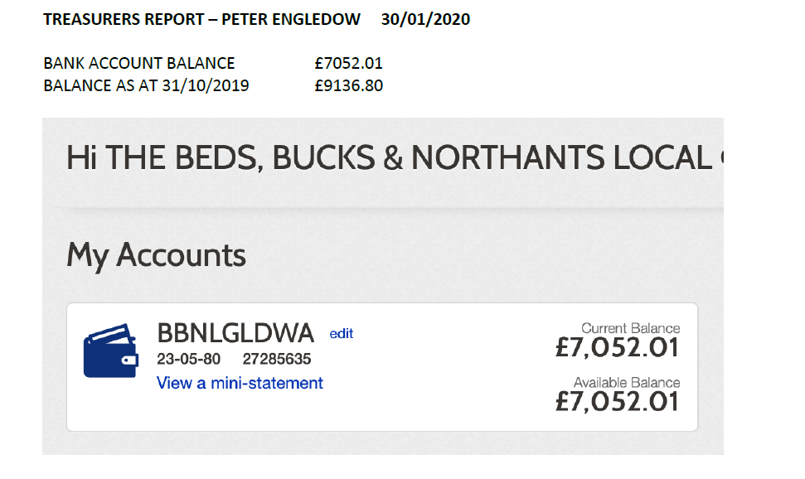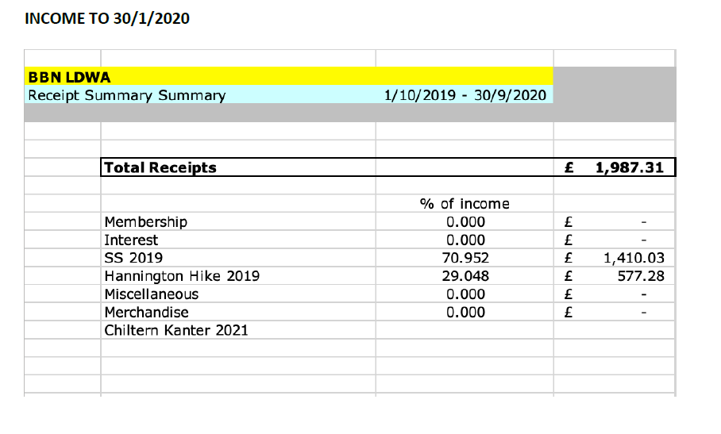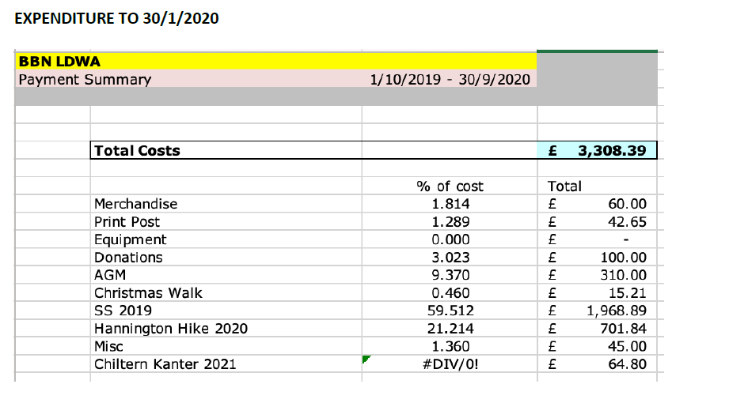
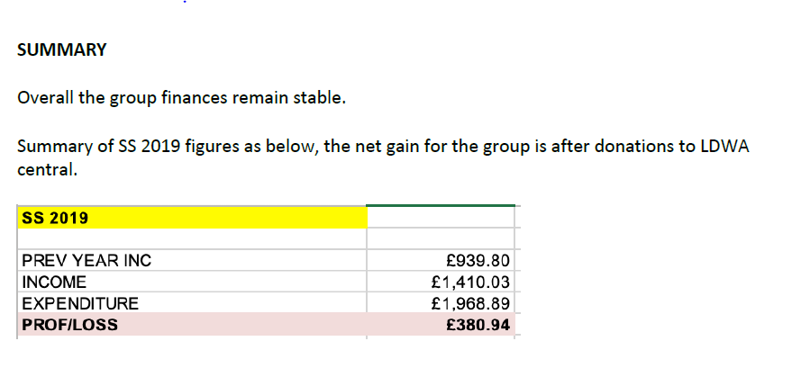

----------------------------------------------------------------------------------------------------------------------------------------------
Item 10(ii) Merrian – First Aid Course

First Aid on our events, at checkpoints and HQ: Following Alan Warrington's stroke/heart attack, or whatever it was, I'm aware that I wouldn't have a clue what to do if that happened to anyone.
Do we know who in the group is trained as a first aider?
Should we provide first aid and emergency procedures for marshals?
I went on a first aid course run by some friends of E&H, but it wasn't really targeted at events, and I didn't get a chance to practice anything. Sue Clements did one for N&S, Michael Fletcher said it was excellent, but not cheap.
I've been in touch with Sue.
To show commitment, I'd suggest that those who attend make a contribution, I'd be happy to.

From: Michael Fletcher < Subject: RE: First Aid Enquiry for BBN
Yes I did go on Sue's course and it was excellent. It covered exactly what Sue has put below in a very professional manner and was very participatory in that we had plenty of opportunity to do things rather than be lectured to. We did the full day and it probably went in to more depth than your average marshal would require - but they did get a proper certificate at the end. The real benefit is that Sue is a walker herself and knows how to tailor it to our needs.
Value for money I can't comment on as I don't know what it cost! We did use someone's house rather than hire a village hall which must have brought the cost down. I gather NandS are doing a refresher course soon for those who have come on stream since, with a different tutor, so we will have a comparison.
--------------------------------------------------------------------------------------------------
From: Susan Clements <susanclements950@btopenworld.com>
Subject: First Aid Enquiry for BBN
I have previously provided training to the LDWA Norfolk & Suffolk Group so I recommend you contact them for their opinion of the course. I can also suggest a regular customer you can contact for a reference if you wish.
In the meantime I can confirm I am fully qualified and insured. I am very keen that organisers and marshals have first aid training. The majority of the courses I teach are bespoke and I'd be delighted to produce one specifically for LDWA BBN members.
Do you have any particular requirements in terms of duration? i.e. Half or whole day?
The day course covers: Casualty assessment, recovery position, calling 999, CPR, AED, heart attack, asthma, major bleeds and shock; fractures; epilepsy, anaphylaxis (how to use an epipen), diabetes.
I usually also add a section that addresses the group's particular needs so in this case: temperature extremes, lone first aider, first aid in areas without a mobile signal, tick bites. The session includes plenty of opportunity to practice. Each attendee receives a book and Certificate of Attendance. If the client provides the venue the 1 day course (7 hours) costs £40.00 per person for a minimum of 6. If the group is financing the training then let's negotiate the price.
A half day course would focus on the essentials of basic life support (as per second paragraph).
If you would like a reference from a regular customer I can arrange that.
Best regards,
Sue 07940 524716

