|  |  |
| --- | --- |
| LDWA Logo black & white | **LONG DISTANCE WALKERS ASSOCIATION AIM: TO FURTHER THE INTERESTS OF THOSE  WHO ENJOY LONG DISTANCE WALKING** |

**BEDS, BUCKS &  
NORTHANTS GROUP**

**NEWSLETTER**

**SPRING 2019**



|  |  |
| --- | --- |
| Dear BBN Members,  Sadly, one of the BBN founder members and a former Group Chairman, Sybil Davies, died early in the New Year having had a fall just before Christmas. In reading the tributes and hearing reminiscences, it is apparent that she was a remarkable lady. She was clearly a huge inspiration, motivator and leader in the Group’s early days, laying the foundation of what makes BBN the wonderful Group it is today. You can read more about Syb in the newsletter. She will be missed and we offer sincere condolences to her daughters, Gill Bunker and Jackie Burnett. |  |

Since the last newsletter we held a successful AGM at Blisworth. The following Officers and Committee were re-elected: myself as Chairman, Peter Simon - Secretary, Peter Engledow - Treasurer, Mary Knight - Walk Secretary, Dave Findel-Hawkins - membership, Gill Bunker – newsletter, Facebook, minute taker, Alan Leadbetter and Roy Carter. We welcomed Sara Waldron to the Committee for the first time – thank you Sara! My thanks to everyone who came and supported the AGM.

We had a Committee meeting recently and covered the usual fare of our social walks programme, this year’s challenge events and our involvement in future LDWA 100 mile challenge events (which is more encouraging than previously reported), and you can read more about these in this newsletter. The meeting minutes will be on our website soon.

We discussed the recent lack of people coming forward to lead social walks which has meant we have some gaps in our May to August programme. We are very keen to expand our pool of walk leaders to avoid this happening in the future. So please don’t wait to be asked personally, if you would like to lead a walk please email Mary Knight on [bbn.walks@ldwa.org.uk](mailto:bbn.walks@ldwa.org.uk). A list of available dates is shown on the website here <https://www.ldwa.org.uk/BedsBucksAndNorthants/W/6128/available-walk-dates.html>

If you haven’t led a walk before we can help and support you to do this so don’t be shy! There are some notes which you might find helpful here <https://www.ldwa.org.uk/library/leading/leading.php>

On the subject of people who help the Group by taking on a non-committee role or doing a specific job, special thanks are due to:

* Merrian Lancaster - who deals with social walk attendee records and data protection matters for our historic challenge walks.
* Mike Hyland - who deals with our challenge event entries and related data protection aspects.
* Norman Corrin - who contacts new members to welcome them and sends information.
* Lynn and Dave Yorston - who look after the BBN equipment list and some of the equipment.

We can always do with some more people to help organise and run our challenge events. Don’t forget as a Marshal you can still take part in the event by doing the Marshals’ walk.

Having seen a great example on the recent Norfolk and Suffolk Winter Poppyline event, we are going to get special BBN Marshal T shirts for those who have helped on at least 3 recent events – so watch out for them!

Happy walking and I hope to see you soon.

**Terry Brown  
Chairman**

-----------------------------------------------------

|  |  |
| --- | --- |
| **GROUP WALKS**  Here are the dates where we are seeking social walk leaders for our next programme, September to December 2019.  There are also some available dates on the May/August programme for a pop up walk:  Thursday 16th May Thursday 22nd August:  Saturday/Sunday 6th/7th July | **C:\Users\gill\Downloads\WP_20171217_16_01_13_Pro (2).jpg** |

Please look at the [Available Walk Dates](https://www.ldwa.org.uk/BedsBucksAndNorthants/W/6128/available-walk-dates.html) on the website – this is updated as soon as I receive an offer of a walk - so please check to confirm that a date is still available.

Below are available dates for **Thursday walks**:

|  |  |  |
| --- | --- | --- |
| May | 16 |  |
| August | 8 | Roy Carter \*\*Pop Up\*\* |
|  | 22 |  |
| September | 5 | Sara Waldron |
|  | 19 |  |
| October | 3 |  |
|  | 17 |  |
|  | 31 |  |
| November | 14 |  |
|  | 28 |  |
| December | 12 |  |
|  | 26 |  |

And these are available dates for **weekend walks.** Please remember walks can be on a Saturday or Sunday – just e-mail me to reserve your date.

|  |  |  |
| --- | --- | --- |
| July | 6/7 |  |
| September | 14/15 |  |
|  | 28/29 |  |
| October | 12/13 |  |
|  | Tue 21/ Fri 25 | Group Trip Isle Of Wight - 74 Mile Vectis Trail |
|  | 26/27 |  |
| November | Sun 10 | Wayne Rowlett |
|  | Sun 17 | SS Challenge Event |
|  | Sun 24 | BBN AGM |
| December | Sun 8 | Santa |
|  | 21/22 |  |

If you would like to lead a walk on any of the available dates please let me know. If you want to arrange a walk on any other date that’s fine too, but please do let me know.

If you would like us to update and communicate your walk information at any time please do not hesitate to let us know. Updates through Facebook, the website and our newsletter can be made quickly and easily.

Best wishes and happy walking.

**Mary Knight**Social Walks Secretary

[maryjknight@hotmail.co.uk](mailto:maryjknight@hotmail.co.uk)

**NEWS OF FUTURE HUNDREDS**

BBN does not have a checkpoint on this year’s Hadrian’s Hundred, but

we are pleased to report there is more positive news for the future.  
Further information will be circulated as soon as it is available.

**2020 100 - Y 100 Sir Fynwy (Monmouthshire)**

BBN have been allocated CP 4 Abergavenny.   
Dave Findel-Hawkins is the current contact and Mary Knight the organiser.

**2021 100 – Trans-Pennine**BBN’s interest in CP 1 has been registered and we are likely to get this.   
DFH is the contact.

**2022 100 – Elephant, Bear and Bull**

Early days, but again we are intending to have a checkpoint and DFH will contact the organisers as soon as information becomes available.

**Beyond 2022:** There is no information about future Hundreds yet.   
DFH will be keeping an eye on developments.

**HANNINGTON HIKE**  
Sunday 9th June 2019

*Routes of 27, 18 and 14 miles through  
Northamptonshire’s undulating countryside.*

*Full details are in the programme at the end of this Newsletter*

***Marshals Needed !!***

*If you want to see how thing work on the other side why not   
help out, we need help at the checkpoints and   
car parking at the start.*

*There will be a Marshals’ Walk on Sunday 12th May*

Please contact Alan Leadbetter at [bbn-hh@ldwa.org.uk](mailto:bbn-hh@ldwa.org.uk)   
if you can help on the day.

Sybil Davies 1929-2019

Syb was active throughout her whole life and had a great many interests, but her great passion was walking. She was already a member of the local Bedford Ramblers (and later the Ivel Valley Walkers) when, as a regular visitor to Ivinghoe Youth Hostel, she heard about the Chiltern Kanter and the Chiltern Marathon, and the whole exciting and wonderful world of the LDWA opened up.

Syb became an enthusiastic walker with the LDWA and an early member of the BBN group, then in its very early days. She went all over the country taking part in LDWA events, enjoying life, and making new friends along the way. Her great pal was John Nickerson who she met on the famous “third BBN walk” when, invited back to Chris Goodman’s afterwards, there was bribery by tea and cake and a whole lot of arm twisting to get walk leaders and to get the group going. Syb and John agreed to get together to organise a walk. John had a car and Syb could read a map! They went on to plan many walks together and John became a great family friend.

BBN and the LDWA became her way of life, and she spent many happy years walking with the group and taking part in challenge events all around the country.

Syb became BBN Walks Secretary and later the Chairman. She was a popular walks leader, she just loved maps and planning walks and helping to organise challenge events. She loved checkpointing both on local events and on the Hundred, travelling all over the country, often taking her friends with her.

In later years ill health forced her to give up the walking she loved, but she still kept her interest and enthusiasm. She would still come and help at checkpoints, and she would look at Dave and Merrian’s photos on the website and know exactly where we had been walking.

Syb died on the eve of her 90th birthday. As one long-time walking friend so aptly said: “She didn't have any more puff left to blow out the candles”.

We would like to say thank you to all our walking friends for the many cards and messages we have received since Syb died and to thank everyone for the happy memories of Syb they have shared with us, and for their sympathy and kind thoughts.

Gill and Jackie

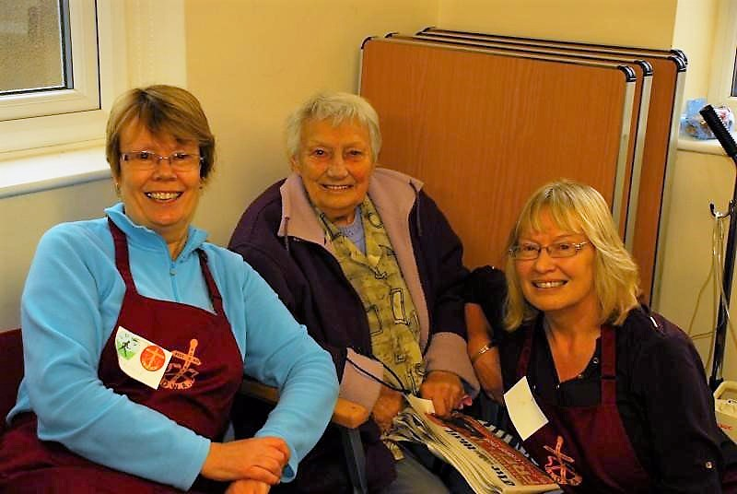

*Shillington Shuffle 2014*

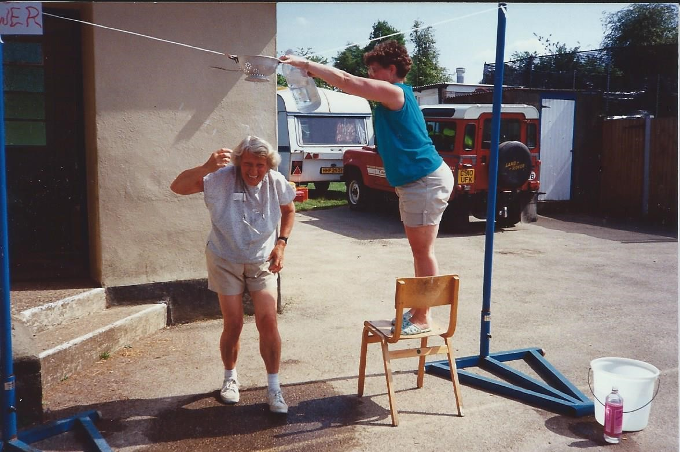

*Invicta Hundred: Knockholt: Testing the Shower*

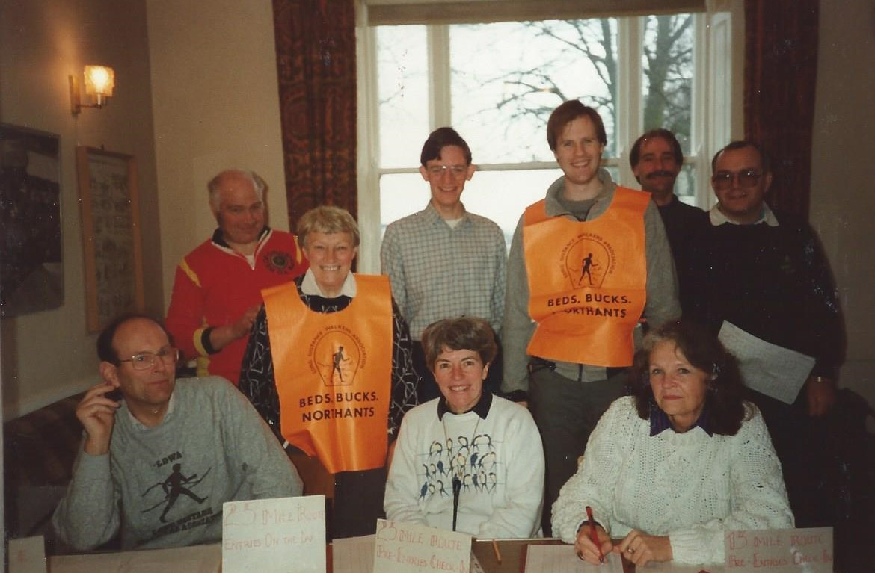

*Chiltern Kanter 1989, Ivinghoe Youth Hostel  
L to R: Standing: Chris Goodman, Sybil Davies,Graham Rowling, James Sneath, Marcus Rogers, Bob Seaton. Seated: Hugh Romer, Renate Romer, Norah Gifford*

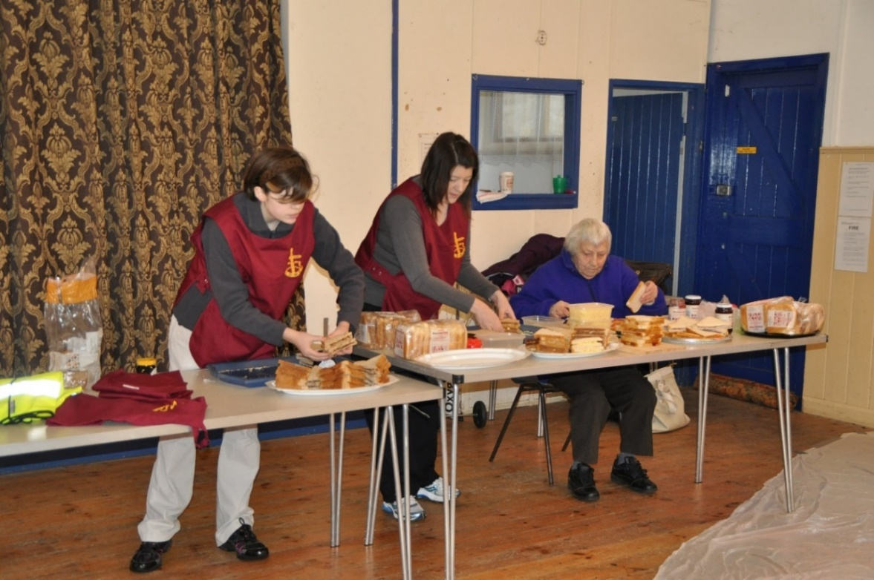

*Family CP : Chiltern Kanter 2013  
Syb with Victoria and Rachel  
(Great Granddaughter and Granddaughter)*

**The Oxon Score : Strider 42, August 1985 (Anon)**

I wandered lonely as a cloud

And scampered high o’er vale and hills

Till all at once I found a clue

Amongst the golden daffodils.

Beside a lake, beneath the trees

I found the trig point ….. on my knees.

Continuous the sun did shine

(No time to eat a Milky Way)

I walked a never-ending line

The margin of the Oxford Way.

…… A thousand marks!! ….. as in a trance

I tossed my head in a sprightly dance.

I wandered lonely as a ghost

And found the castle in the hills.

Then all at once I found my post

Half-hidden in the daffodils.

Behind the church, along the row,

I wandered into Graeme Crowe.

Continuous the sun moved round

And shimmered on the stony pathway

Looking through the clues I found

That I was really only half way round …

…….A thousand marks!! … one more quick glance

I found the waymark just by chance.

Now oft when on my couch I lie

In vacant or in pensive mood

There flash upon my inward eye

All the checkpoints where I boobed

And then my heart with sorrow fills  
…… They don’t give points for daffodils.

*Syb always enjoyed the Oxon Score - a map reading event where you gained points for answering questions, the more distant the clue the more points obtained. But ……. having walked those extra miles, you had to find the answer!*

Sybil

Sybil was an accomplished long distance walker in her own right. Before the BBN Group was formed, she was a member of the now-defunct Anglian Group. She completed the Cambridge 50 on her 2nd attempt with Gill.

Sybil turned up on the 3rd BBN social walk, led by Chris Goodman from Dunstable. Here, with her good friend Iva Barr, she met John Nickerson who was also interested in walking. The rest of the story we know. She was actively involved in the early days of the group and laid the foundations for BBN to continue in its current format. In the Group’s early days, Sybil was always active in organising challenge events and social walks.She was one of the organisers of the Chiltern Kanter from Ivinghoe Youth Hostel, which in those days was organised jointly with Essex & Herts. She was a member of the MBBTY club which was a group name used for entering as a team on events. It stood for My Blister’s Bigger Than Yours …..

A favourite event of Sybil’s was helping on LDWA 100 checkpoints. I met her on the Snowdon 100 and gave her my spare food after retiring from the event. This became a tradition whenever I met her afterwards. At the Vicar of Dibley checkpoint at Turville on the Chiltern Landmarks 100, she donned the cloth along with the other BBN marshals to care for the walkers’ souls (or should that be soles?).

I treasured seeing her on one of the recent Chiltern Kanters when she was sat in a freezing cold hall waiting for entrants to come in. She spoke to Therese Jamin fluently in French and I was lucky enough to get a photograph of the four generations of the Davies/Bunker/Burnett family.

The majority of BBN members knew Sybil through her involvement with the Group but she had many irons in her fire and was involved in lots of other activities. Gill always joked that she had to check with her mum’s diary several months in advance to see if she could come over to meet her. I think the phrase is a polymath, a person of wide knowledge and learning. Sybil also had a very mischievous sense of humour which has passed down the family line!

**Norman Corrin**

**Keith Noble 1929-2019**

We were saddened to hear that we have lost another walking friend, Keith Noble.

Keith passed away in January at the age of 89. He was a longstanding member of our neighbouring group Essex Herts, being their Secretary/Treasurer, and later Walks Secretary. He organised the Herts Hobble for 11 years and devised the walk that was to become the Herts Stroller.

Living in a bordering county, Keith was a familiar face at local events and   
was a regular walker on all BBN challenge walks. So regular in fact that John Nickerson always made him No 1 on all those early SS events.

Keith was a keen photographer and after a walk he would produce immaculate hand drawn maps annotated with notes and photos – these were a lovely souvenir.

When ill health forced Keith to limit and then give up his walking, he was still to be found helping out at EH events, always cheerful, always with a smile and always having time for a word. He was a lovely man and will be missed.

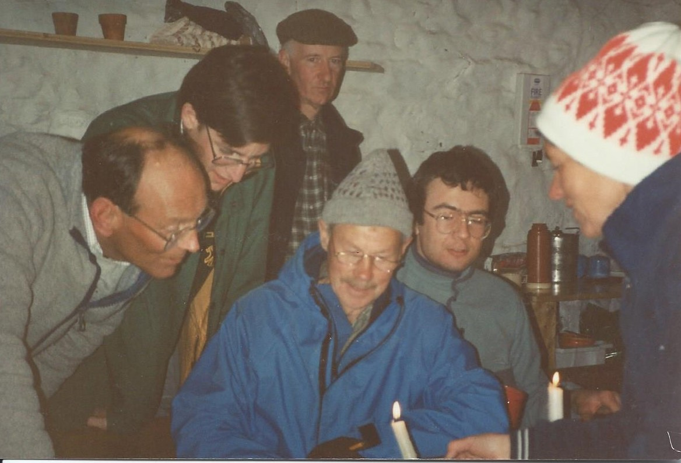

*Keith (centre), the night before the Lancastrian Hundred 1991*

*Downham Camping Barn, checking the route by candlelight.*

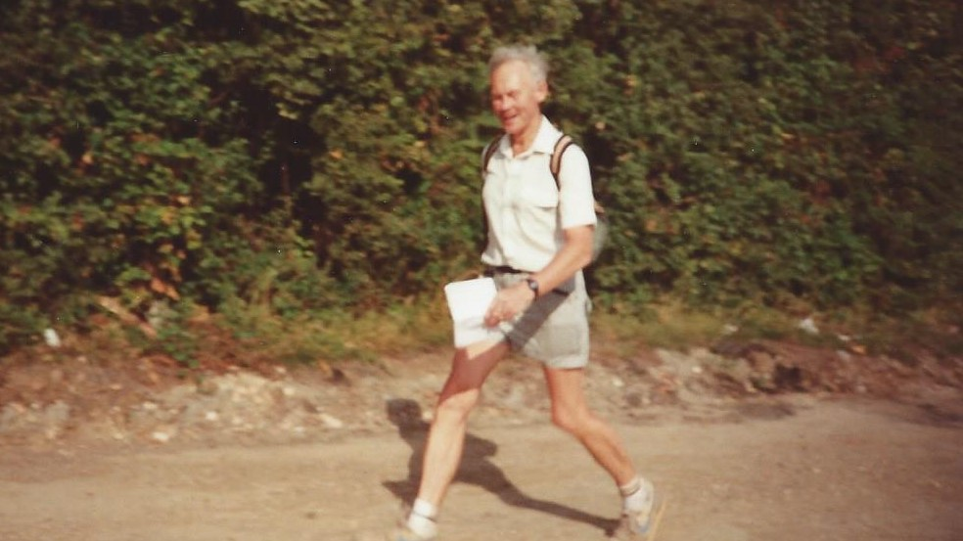

*Striding out: Woburn Wildlife 1989*

Keith contributed the following article to the BBN 20th anniversary newsletter in 2003:

**Keith Noble – “Memories”**

With my LDWA experiences I was otherwise very fit so the recovery period from my bypass operation in June 1989 was very rapid. The first available event was the Woburn Wildlife Walk on September 3rd, exactly 50 years after the start of WW2 when I had joined a train full of children destined for evacuation.

I wanted to test myself with a fast walk but didn’t think a Milton Keynes circuit sounded very appealing. How wrong I was, enjoying every minute of the attractive and varied countryside. This was my first BBN contact and I didn’t know many people in the group, but remember passing Sybil on the way in and being greeted by Gill serving a super meal outside on the grass in the sunshine. I chatted with the Chapmans, the Papworths, the Romers and that incredible and immaculate older man, Henry Bridge. Happy memories mingle with sad thoughts now but that day I went home thinking that the world was a wonderful place.

Steppingley had been the half-way point on the walk and John Nickerson’s first challenge event, the Shillington Shuffle, comes to mind for a second special memory. My father introduced me to the Lilley, Pirton and Telegraph Hill area before the War and I had come to know it well over the years so when John initiated the event I was one of the first to apply, and soon he was regularly honouring me with the Number 1.

Whatever the conditions, I looked forward to it and enjoyed the experience including the friendly welcome and excellent refreshments, but November can be an evil month.

I noted the weather and the number of people completing all the long walks to date:

1991 Thick mist 87   
1992 Very slippery 28

1993 Thick mist 14

1994 Extremely strong winds 12

1995 Sunshine and dry ground 8

1996 Rain for 20 miles, soaked and cold 6

1997 Dull and wet but firm ground 6

1998 Weeks of rain. Dull and muddy 6

1999 Half-hour rain but fairly firm 6

2000 Weeks of rain but sunshine all day 6

In 2000 the remaining 6 were given a free entry which was a kind gesture and then a wonderful surprise on completion when the five men and one lady were awarded an attractive plaque and a very colourful certificate.

Although I am a member of Essex Herts I consider myself very fortunate to have so many friends and links with BBN. Wishing you all well.

**-----------------------------------------------------------------**

.

**THE BBN FOUNDERS’ BENCH AT IVINGHOE**

A plaque commemorating our great friend John Nickerson has been added to the BBN Founders’ Bench on the Green at Ivinghoe.

**Remembering John**.  
A true friend and great walking companion.   
John can truly be said to be one of the founder members of the BBN group. His contribution towards it was immense – he led numerous group walks over the years and took us on so many enjoyable weekends away. He completed 25 consecutive LDWA Hundreds – once flying in from work in America, walking the Hundred, and flying back the next day – in his slippers. He organised 10 Shillington Shuffles and 10 Steppingley Steps. He was a true all-rounder and a great ambassador for the LDWA.

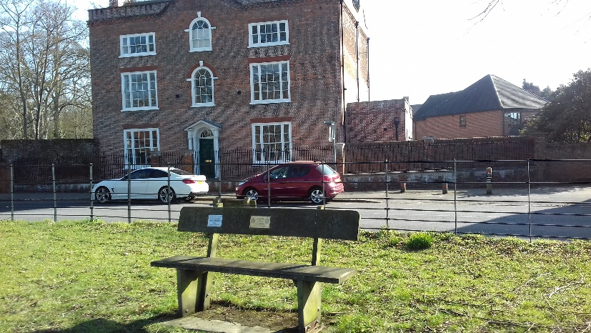

*The Founders’ Bench at Ivinghoe with the former Youth Hostel behind*

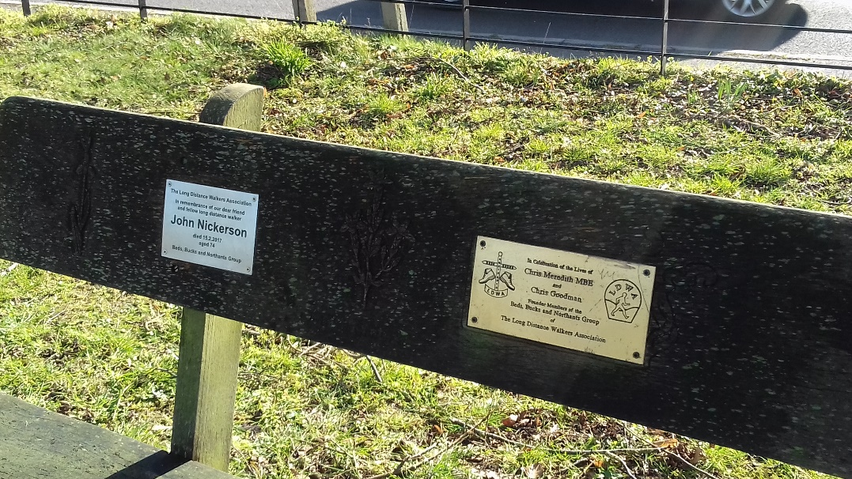

**Chris Meredith and Chris Goodman**

This is turning into a bit of a reminisce-fest, but I thought folk might like to see photos of the two Chris’s – their names are so familiar from the Founders Bench. They were about as different in background, character and outlook as two men could possibly be and if it hadn’t been for their love of walking they would probably never have teamed up. But when the call came for folk to start up a new local group they both responded and laid the foundations for the BBN group as we know it today.

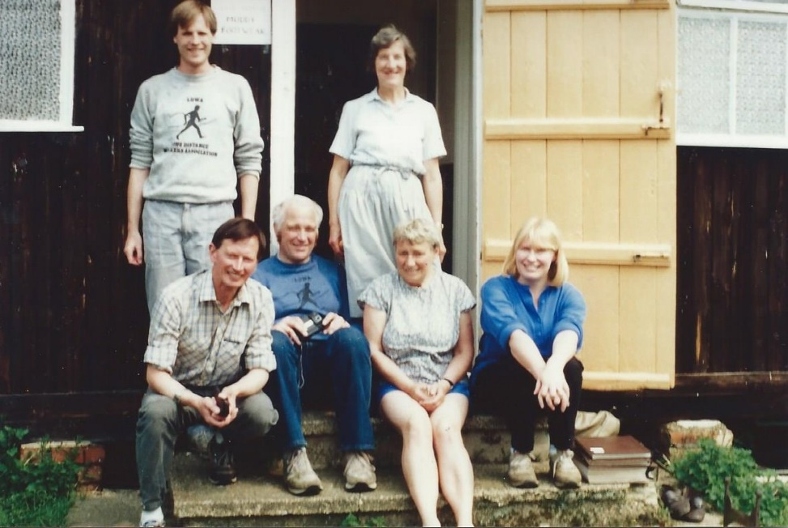 *Nene Valley Kanter 1987*

*Standing: James Sneath, Janet Presland*

*Seated: Roy Presland, Chris Goodman, Sybil Davies, Gill Bunker*

**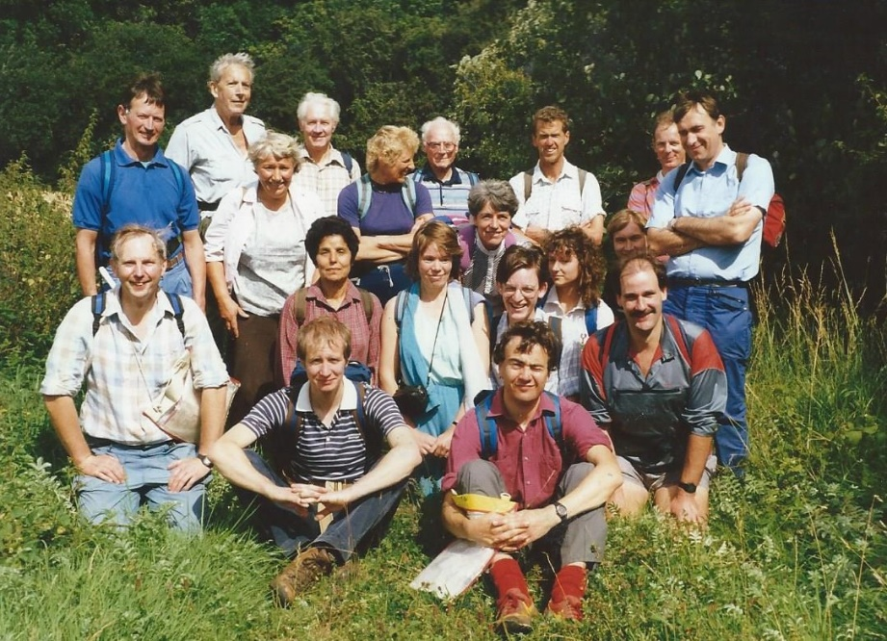** *Three Shires Wood 1988  
Back: Roy Presland, Chris Meredith, Sybil Davies, ??, Pauline Papworth, ??, Herb Papworth, ??, Neil Titmas Middle: John Nickerson, Shamsi Fadei,   
Jackie Burnett, Renate Romer, Graham Rowling, ??, ??,Marcus Rogers,*

*Front: ??, Graeme Crowe*

**Anybody remember the names I can’t??**

**FULDA AGAIN**

**An IML Weekend**

Chris picked me up at 4pm Thursday from the Milton Keynes Coachway with his girlfriend Rachel and we started the long drive to Fulda in Germany via Dover and the 8pm ferry to Dunkirk. Arrived in Dunkirk at 10pm we drove through the night and arrived in Fulda at 1.30pm on Friday afternoon. I didn’t have to pay for B&B this time, there is a sports hall at the venue so for 12 euros a night I set up my thermal rest and sleeping bag on the hall floor, sorted my gear out for the first 20km on Saturday and then got some beers down me after the long drive. (I suppose I should say that Chris does all the driving, I just sit in the front seat enjoying the ride.) After something to eat and a few beers I hit the sack or should I say sleeping bag for the night at around 9.30pm.

The next morning up and showered I got some breakfast (the 12 euros was sports hall and breakfast per day), and set off following the red plastic tape hanging off trees and little arrows that said 20k walk. The walks are mainly on road and forest tracks and through small towns, the checkpoints always have tea and coffee for sale, and beer which always goes down well for a lot of the walkers. I suppose that does include myself later on in the day. Saturday was a warm day but we walked through a lot of built up areas so the Sunday walk was a lot better because we stayed out in the countryside more and there was a lot of forest walking. Not far from the end of the first day we passed a beer garden en route so a lot of walkers head for the bar, and they serve beer in a jug rather than a bottle, they even take your order at the table. You have to see it to believe it – the bar staff come out carrying at least 12 pint glasses at once, (photos on my website if you don’t believe me).

Back at the venue faces I had not seen since Castlebar in Ireland and even longer were enjoying a beer or two, so I had to go and join them. When the compere played his saxophone we joined him on the floor and played with blow up saxophones and put on silver hair wigs, we looked a right state. (Photos on my website). I slept well that night but still got up for the 20k walk on Sunday.

The Sunday walk was a lot more attractive walking through forests and generally more out in the countryside. No getting drunk Sunday night though, after I got back to the venue it was pack the bags, get a shower, jump in the car and head for home. We left Fulda around 5pm on Sunday for the long drive back to Dunkirk and the 2pm Monday afternoon ferry back to Dover. I was back in the Willow Tree Bar on Billing Aquadrome at 6pm on Monday afternoon with a few stories to tell.   
Photos - [www.steveceegalleries.smugmug.com](http://www.steveceegalleries.smugmug.com) **Stevecee**

**RAMBLINGS OF A RANDONNEUR - GR11 - LA SENDA PIRENAICA**

In 2016 I walked the GR10 from Atlantic to Mediterranean on the French side of the Pyrenees. Such was my enjoyment that I was sad to have left no cause to return. In 2017 Graham Dolby and I walked the GR20, approx 200 miles of rugged mountains forming the spine of Corsica. An excellent walk marred by the paucity of food, accommodation and hospitality. Normally I prefer to walk alone but in 2018 when member Steve McMorrow announced his intent to hike GR11

I was tempted to tag along. Having spent 9 weeks solo sailing around GB, a sedentary pastime and being examined by medics for suspected heart disease linked to breathlessness when hill walking I was not best placed. Steve was aware and I was glad of company, it being pleasant to think that your remains may not be left to the 4 species of vulture resident there.

On 2nd Sept a Ryanair flight to Biarritz, bus to Hendaye and walk over the border to Irun saw us away. Route commences at the lighthouse at Cabo de Higuer, Hondarribia. The walk back through the sprawl of Irun is perhaps the least impressive of the journey but is soon superseded by green rolling Basque countryside. There is much history of conflict all along the route. Soon machine gun posts appear, created by Franco’s fascists, commencing in 1939 to keep out the Germans. There were to be 10,000 such fortifications along the border but why they were still being erected in 1952 is not clear.

The first stage ends at Bera where a monument marks the site of action in1813 when 70 British riflemen defended the bridge against 10,000 Napoleonic troops. Apparently Sean Bean wasn’t there and the Brits, being unsupported, were forced to withdraw late in the day suffering losses then. Quality of housing speaks to the wellbeing of Aragon and Navarre. Quality of cattle, sheep and horses grazing free upon the hills identifies a source of wealth. Even recently civil conflict arose with ETA and their murderous acts.

Culture is important and at Ochagavia rehearsals were in progress on the eve of a festival. Red and white costumes, folk bands, fireworks and a parade of giant figurines were in evidence and some of the youth clearly practiced all night.

Landscape changes quickly with the varying geology. Vast tracts of limestone pavement riven by deep gorges give way to high granite mountains. There are boulder fields to cross and steep rugged paths over scree slopes but there is no serious scrambling involved and little exposure (there was over exposure by one hiker wearing only a rucksack). Much of the route is through National Parks and Natural Parks and a great deal has been done to improve access to the most spectacular areas such as the Ordesa and Nuria Gorges, Monte Perdido and some of the great waterfalls. Cicerone guide author Brian Johnston refers somewhat disparagingly to these “tourists”. We are all visitors in this world in my opinion and whether with boots and bag or plimsolls and shorts I try not to judge.

Once into the high Pyrenees long periods are spent above 1,000 metres and many passes are crossed at 2,000m plus, the highest being Col Noucreus at 2,790m. Throughout the journey weather was generally sunny and warm. One becomes so acclimatised that it is a shock to find at Refugio de l’Illa (2,485m) that air temperature is below freezing on a sunny afternoon. Leaving Refuge de la Feixa (over 2,000m) one morning I was blown off my feet twice and the streams were solidly frozen.

**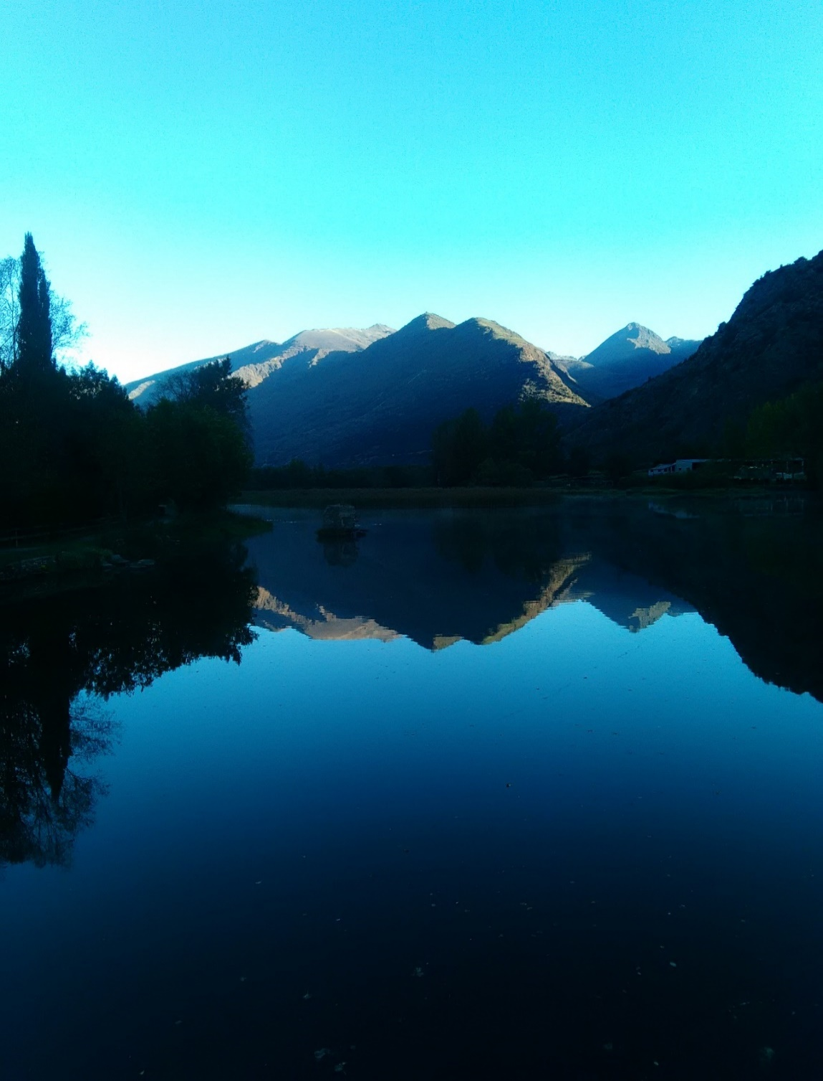**

**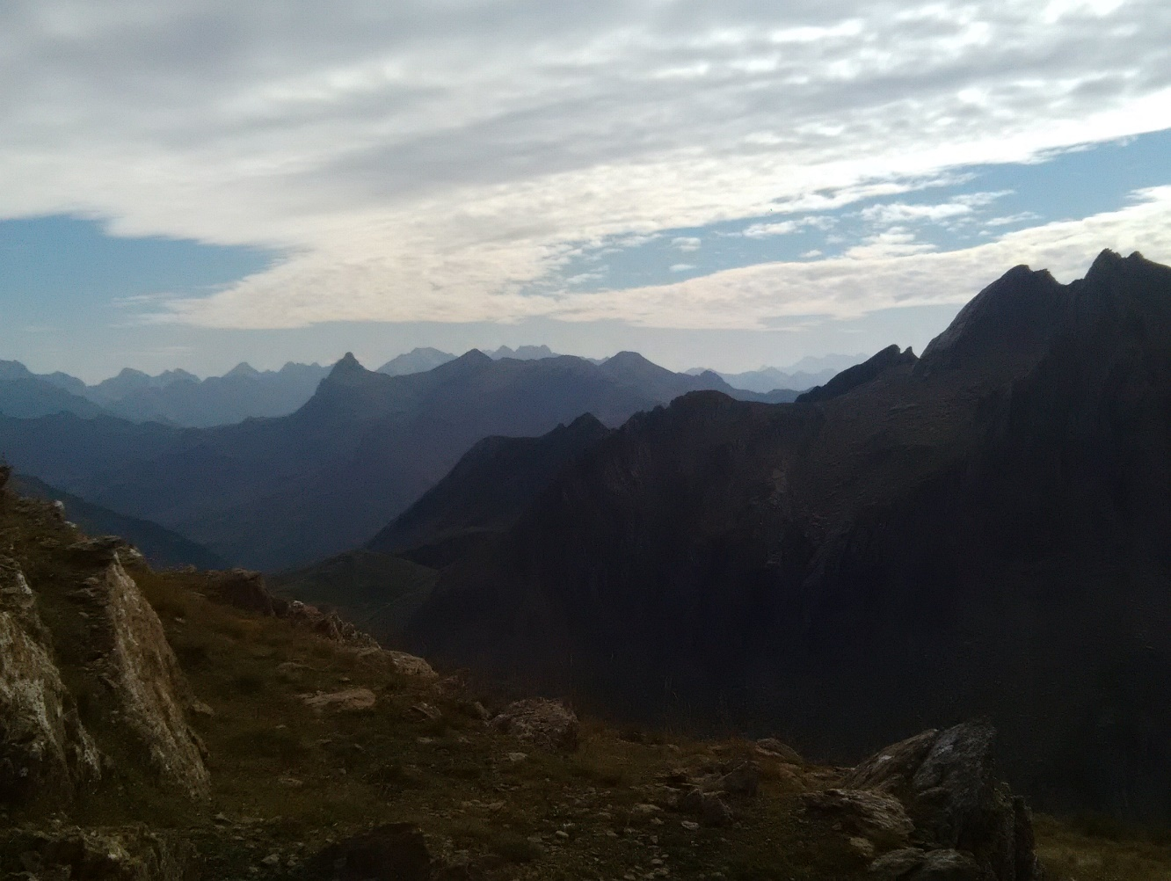**

There were areas where last winter’s snow remained, discoloured grey and pink. On 28th October a heavy fall of snow hit the Pyrenees. Although the highest peak is only 3,404m no-one should be in any doubt that this is a very real mountain range with all the potential for severe weather. 3 thunderstorms were experienced during this tour and I am pleased to report being inside for all.

Aside from manned refuges, resort was made to casa-rural (B&B) Hotels (1-4 star) Hostals (cheap hotels) albergs (youth hostels) and refuges (bothies). To save on weight I left tent and cooking equipment at home but did take bedroll and Bivie bag for emergency. The walking season is short and by mid Sept many hostels are closing. Only 2 nights were spent in unmanned refuges both of which were comfortable and clean. At Taliaxa refuge a notice warned of a friendly fox given to stealing boots, clothes or food left outside. Sitting in the sun the fox (Zorro) duly appeared and after a few minutes of caution approached to sniff my leg.

Steve succumbed to illness at Puente Sant Jaime after 17 days by which time we had detoured twice to find a bed. At refuge de Restanca all dormitories were full and a bed was made up for me on a table. The gardien of Refugio de l’Illa, a 20 million Euro structure built 2017 told me that for the first time 11 weeks the

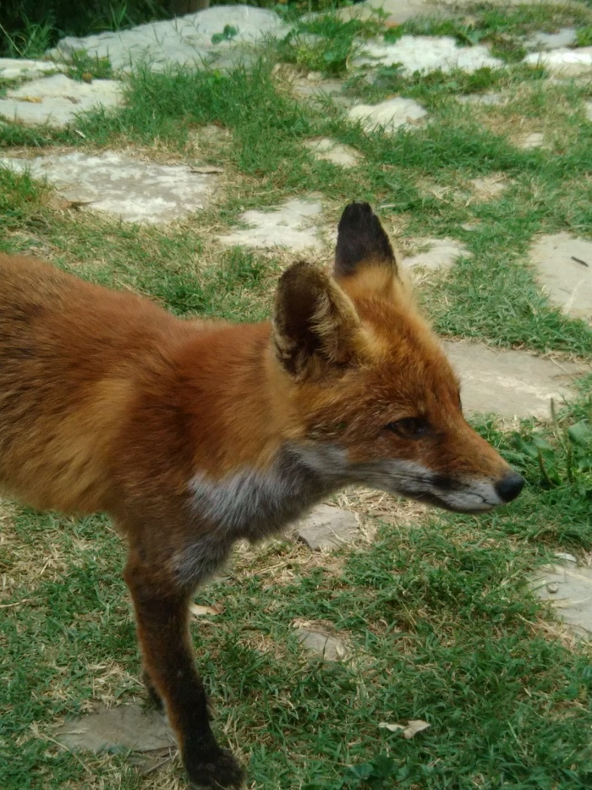

**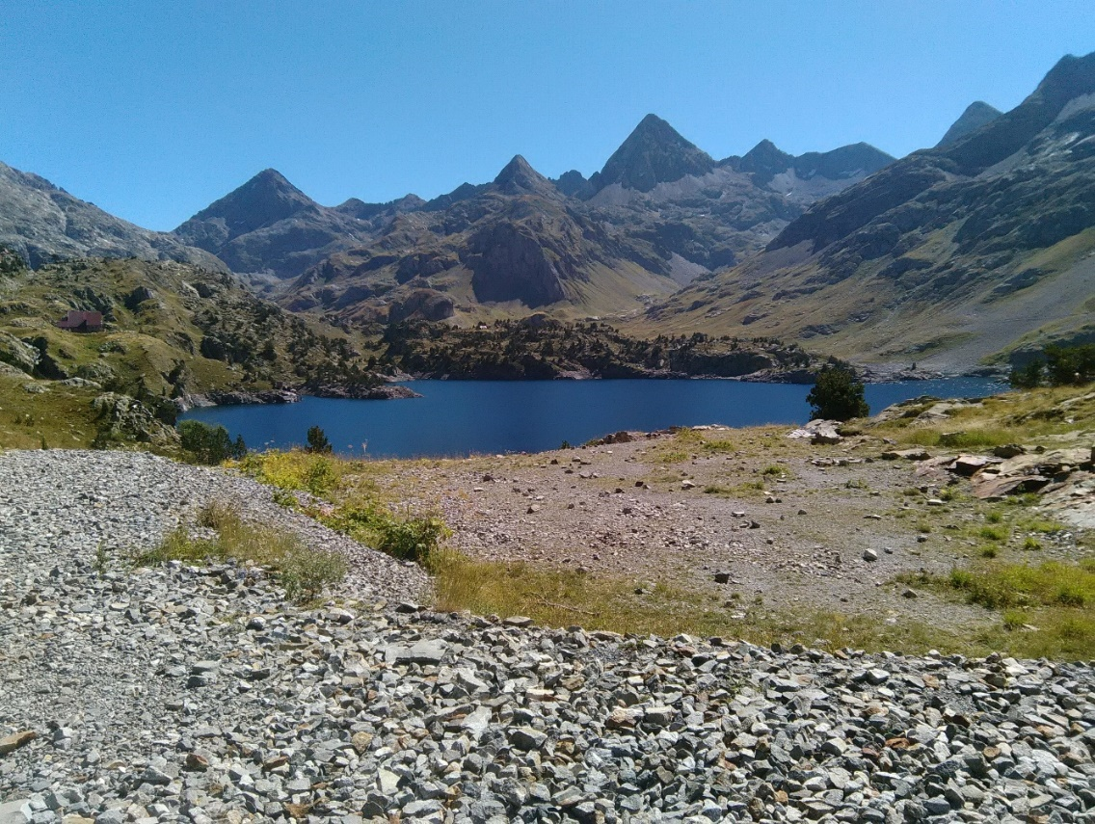**

entire compliment of 50 beds were not occupied. I was the only visitor and such was the case for most of the latter journey. At Planioles the only available bed was in an Alberg at which there were at least 100 young children and a further large party of teens. Many wanted to practice their English on me. 4 star Vall de Nuria hotel was the best lodging with sumptuous buffet dinner a breakfast all for 57 Euro

Unlike GR10 where forests are mainly beech and chestnut woodland on GR11 it’s largely conifers and pines. Whole family groups were to be found high in these forests gathering fungi, ceps, trumpets, wood bluets, whilst further up on the grassland ridges they searched for bolets. Seemingly it was a very good year.

At one point about 4 days away from the end of the walk it is possible to see the Med. From that point daily descent exceeds ascent at least until Llanca where a 500m climb is added. Final few miles along the single track road to the lighthouse at Cap de Creus is congested with cars, buses and bikes all of which find a pedestrian a nuisance. With very mixed emotions I made the last climb to the end. Elation at completing the challenge mixed with sadness that this was probably the last long walk. It had taken 40 days as opposed to the 47 set out in the guide. 700 miles and 160,000ft ascent on Strava readings as opposed to 820km and 46,000m estimated in the guide. Never mind a quick beer, a 6 mile walk to Cadaques, bus to Figueres and train to join the real tourists in Barcelona before returning to the dirty, overcrowded country we call home.

Any long walk is just one step after another the most difficult being the first. I can do no more than to encourage you to go and experience the Pyrenees for yourselves. There are points of access and egress by rail and bus which would allow you to experience sections as opposed to the full trip. Waymarking is so comprehensive that the Cicerone Guide is all that is needed. Walking alone has many advantages the main being that people are eager to engage you in conversation. I found the hospitality on both sides of the Pyrenees to be exceptional and food quite sumptuous.

My copies guides to GR10, 11 and 20 are available to any member intent upon using them.

By the way I returned lighter and much fitter. My friendly GP puts it down to a nightly dose of red.

**Jim Robinson**

|  |  |  |
| --- | --- | --- |
|  | **WALKS PROGRAMME**  **APRIL TO SEPTEMBER 2019** |  |

**Thu Apr 4 2019 Locks, Crocks and a few soaks in apparels**

15ml. 09.30 Bugbrooke Church c.p. Maps: LR 152 Exp 207 (GR SP674573). ***C:*** Colin Stoneman ***T:*** 01327 830889 ***M:*** 07764 684 661.

**Sat Apr 13 2019 A Milton Keynes Marathon**

26/27ml. 08.00 From Stanton Low Park c.p. Newport Road, Oakridge Park, Milton Keynes. Maps: LR 152 Exp 192,207 (GR SP838418). Using the woods, waterways and local LDPs within Milton Keynes. Unsupported, but there will be opportunities to replenish food/drink en route. ***C:*** Gill Bunker ***T:*** 01908 321308 ***M:*** 07790 976090.

**Thu Apr 18 2019 WHACKO**

15ml. 09.30 Ampthill Park c.p. (not football club c.p.). Map: LR 153 (GR TL025382). ***C:*** Roger Skerman ***T:*** 01525 405540 ***M:*** 07757 057440.

**Sat Apr 27 2019 Wakerley Woods Wander**

16ml. 09.00 Wakerley Great Wood c.p. Map: Exp 224 (GR SP961985).   
***C:*** Anne Addison ***T:*** 01780 740414 ***M:*** 07447 616061.

**Thu May 2 2019 Old Tracks to an Abbey**

16ml. 09.30 Bromham Mill c.p. Bromham. Maps: LR 153 Exp 208 (GR TL010507). Pub at lunchtime. ***C:*** Bob Safford ***T:*** 01933 356609 ***M:*** 07531837829.

**Sun May 12 2019 Hannington Hike Marshals' Walk**

***C:*** Alan Leadbetter ***T:*** 07775 887493.

**Thurs May 16 2019** **Leader needed  
Details to be confirmed, please check website**

**Thu May 30 2019 A Wander from Woburn**

16ml. 9.30 Free c.p. Woburn - opposite the church. Map: Exp 192 (GR SP951331). ***C:*** Terry Brown ***T:*** 01462 631057 ***M:*** 07932 627476.

**Sun Jun 9 2019 Hannington Hike Challenge Walk**

27, 18 or 14ml. 10.5 hours. From Wellingborough Grammarians Memorial Sports Field (GR SP856690). The walk follows mainly field paths, tracks and roads in Northamptonshire countryside. Start: Walkers from 08.00 & Runners/Joggers/  
short route from 09.00. Entries close 5th June 2019. Limit 200. On-line entry only. £8.00 Non LDWA £12.00 Under 18 free incl hot & cold drinks & biscuits at start, drinks & snacks at all Cps and light meal at finish, Cert for all finishers, pin badges £1.50. Online entry at: https://www.sientries.co.uk/event.php?elid=Y&event\_id=5084. ***C:*** Mike Hyland. ***E:*** bbn-hh@ldwa.org.uk ***W:*** ldwa.org.uk/bedsbucksandnorthants

**Thu Jun 13 2019 Rest at Wrest**

17.5ml. 09.30 C.p. Ampthill West. Map: LR 153 (GR TL024382).   
***C:*** Sara Waldron ***M:*** 07850 665454.

**Sun Jun 23 2019 Teapots from Olney!**

C15ml. 09.00 From Olney Town Square (car parking in the square). Maps: LR 152 Exp 207 (GR SP889513). Followed by cream tea at Teapots of Olney (www.teapotsolney.co.uk). Cream tea booked at 3.15pm for 15 people . Please let me know if you are attending. ***C:*** Norman Corrin ***T:*** 01908 608667   
***M:*** 07980378656.

**Thu Jun 27 2019 Wendover Gap 15 mile**

15ml. 09.30 From 3 Lodge Lane, Prestwood. HP16 0SS. Roadside parking only - please park legally and with consideration of our neighbours. Map: Exp 181 (GR SP873001). Lunch stop will be in Wendover village where there are also public toilets There are lots of shops to buy lunch from or bring your own.   
***C:*** Dave Yorston ***T:*** 01494 868371 ***M:*** 07808 384670 on the day only.

**Sat/Sun Jul 6/7 2019** **Leader needed  
Details to be confirmed, please check website**

**Thu Jul 11 2019 ALBINO 75**

15ml. 09.30 Ampthill c.p. (not football club c.p.). Map: LR 153 (GR TL025382). Figure of 8 walk. Pub at lunchtime, sandwiches can be eaten in bar if you purchase a drink. ***C:*** Roger Skerman ***T:*** 01525 405540 ***M:*** 07757057440.

**Sun Jul 21 2019 Steeple Chase 3**

28ml. 8.30 Great Cransley Village Hall, 25 Loddington Road, NN14 1PY. Map: Exp 224 (GR SP831769). Option to do 22 miles. Both routes include pub stop. ***C:*** Wayne Rowlett ***M:*** 07388026676.

**Thu Jul 25 2019 Flitwick Moor and More**

15ml. 09.30 Start at Silsoe Park Avenue, near church, Silsoe (MK45 4EH). Map: Exp 193 (GR TL083356). Lunch at Pulloxhill, pub nearby. ***C:*** Dee Brockway ***T:*** 01525 795808 ***M:*** 07742433951.

**Sun Aug 4 2019 Discover Stockwood**

19ml. 09.00 Stockwood Park, Luton LU1 4BH. Maps: LR 166 Exp 193 (GR TL085201). Park in the first c.p. on right hand side after B4540 Farley Hill entrance. No pub stop. ***C:*** Peter Simon ***T:*** 01582 513827.

**Thurs Aug 8 2019** **Ldr: Roy Carter   
Details to be confirmed, please check website**

**Sun Aug 18 2019 Wendover Gap 26 mile**

26ml. 09.00 From public P&D c.p. in Prestwood High Street, next to Co-Op store. Nearest postcode HP16 9EU. At present c.p. is FREE on a Sunday - also toilets there. Map: Exp 181 (GR SP872008). Lunch stop at the c.p. site within Wendover Woods (toilets, café, picnic area. The cafe sells a good range of refreshments, but may be very busy so you are advised to carry full supplies for the day. ***C:*** Dave Yorston ***T:*** 01494 868371 ***M:*** 07808 384670 on day only.

**Thurs Aug 22 2019** **Leader needed  
Details to be confirmed, please check website**

**Sun Sep 1 2019 Oranges and Lemons Again!**

16ml. 09.30 Meet between The Gilbert Scott restaurant entrance and vehicle ramp to the St Pancras Renaissance Hotel (at St Pancras International Station), Euston Road, London. Maps: LR 176,177 (GR TQ301828). A re-run of the circular walk visiting churches mentioned in several versions of the Oranges and Lemons rhyme. Optional Wetherspoons stop on our way back to the station. Plenty of opportunities to shorten the walk. Bring food/drink for breaks/lunch Further details, including notes on the churches and rhymes, will be on the BBN website nearer the time. ***C:*** Terry Brown ***T:*** 01462 631057 ***M:*** 07932 627476.

**DIARY DATES**

**October 21/25 Isle of Wight: Vectis Trail**

**Sun Nov 17 2019 Steppingley Step**

**Sunday Nov 24 AGM**

**BEDS BUCKS & NORTHANTS GROUP**

**COMMITTEE 2019**

**Chair: Terry Brown** *T*: 01462 631057 *E*: [teresa.j.brown@ntlworld.com](mailto:teresa.j.brown@ntlworld.com)

[bbn.chair@ldwa.org.uk](mailto:bbn.chair@ldwa.org.uk)

**Secretary/Local Group Rep:** **Peter Simon** *T:* 01582 513827   
 *E:* [bbn@ldwa.org.uk](mailto:bbn@ldwa.org.uk) [peterandmooi@ntlworld.com](mailto:peterandmooi@ntlworld.com)

**Treasurer: Peter Engledow**  *T*: 07733 323641 *E:*pete@excel121.com  
**Social Walks:** **Mary Knight** *T:* 01295 812857 *E*: [maryjknight@hotmail.co.uk](mailto:maryjknight@hotmail.co.uk)

[bbn.walks@ldwa.org.uk](mailto:bbn.walks@ldwa.org.uk)

**Membership: David Findel-Hawkins**

*T*: 01908 216476 *E*: [davefh@gmail.com](mailto:davefh@gmail.com)

**Newsletter/Website:** **Gill Bunker** *T*: 01908 321308 1 Abbey Way, Bradville,   
 Milton Keynes. MK13 7AN *E*: [gillbunker@googlemail.com](mailto:gillbunker@googlemail.com)

**Member: Alan Leadbetter** *T***:** 07775 887493 *E:* [acleadbetter64@gmail.com](mailto:acleadbetter64@gmail.com)

**Member: Roy Carter** *T:* 01234 301182 *E:* [roycarter367@hotmail.com](mailto:roycarter367@hotmail.com)  
**Member: Sara Waldron**

|  |
| --- |
| ***Please remember to keep your contact details and  e-mail preferences up-to-date on the LDWA Website***  [***https://www.ldwa.org.uk/membership/update/view\_details.php***](https://www.ldwa.org.uk/membership/update/view_details.php) |