LONG DISTANCE WALKERS ASSOCIATION - BEDS BUCKS NORTHANTS GROUP
MINUTES OF COMMITTEE MEETING
HELD ON THURSDAY 31ST OCTOBER 2019 AT
4 BALFE MEWS, OLD PARK FARM, MILTON KEYNES MK7 8QR

The meeting commenced at 8.10pm.

Present: Terry Brown (Chairman), Gill Bunker (Newsletter/Website), Roy Carter,
Peter Engledow (Treasurer), Dave Findel-Hawkins (Membership), Mary Knight (Social Walks),
Alan Leadbetter, Peter Simon (Secretary/Local Groups Rep), Sara Waldron
 |  |  | ACTION
1. | Apologies: None
2. | Minutes and Matters Arising from Previous Meeting (30th May 2019)
 | The Minutes were approved.
Matters arising:
Item 9(b): £60 donation to Beds Walking Festival had not been made – the BWF had not responded to our question asking what the money would be used for.
3. | Reports:
 | (a) | Chairman: Terry Brown
Since the last meeting I have:
- Liaised with Julie Cribb about the number of people BBN have authorised to use the LDWA Membership database. The NEC wanted to reduce this to 3/group but I managed to get them to agree for us to keep 4 named individuals because it suits the way we work. Myself, Peter, Gill, and Dave are now the only people who have logins to the database.
- Responded to several enquiries about the group from prospective members.
- Dealt with several issues raised by current members.
- Organised the memorial plaque for Sybil Davies to be placed on the Group’s Bench at Ivinghoe.
- Initiated production of BBN event marshals T Shirts, although this has been slow progress.
 | (b) | Secretary: Peter Simon
Received and responded to e-mails.
Almost no phone enquiries.
Weekly news updates sent to subscriber members except for when there has been no news to report. Distribution was 717 as of 22 October, 25 higher than in the corresponding week of 2018.
Corresponded with Adam Dawson of NEC about bulk e-mail messages being treated as junk by certain Internet Service Providers - no solution has yet been found.

 | (c) | Treasurer: Peter Engledow

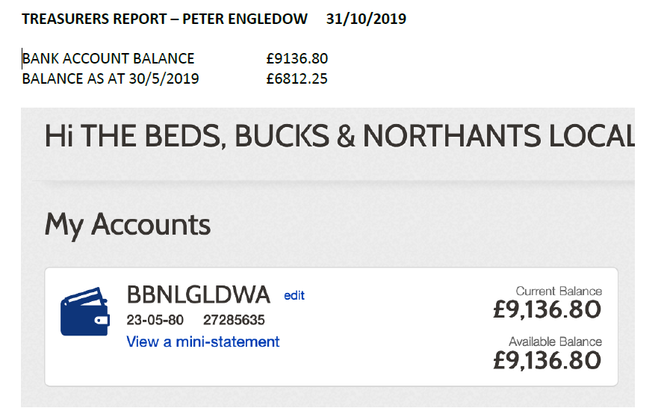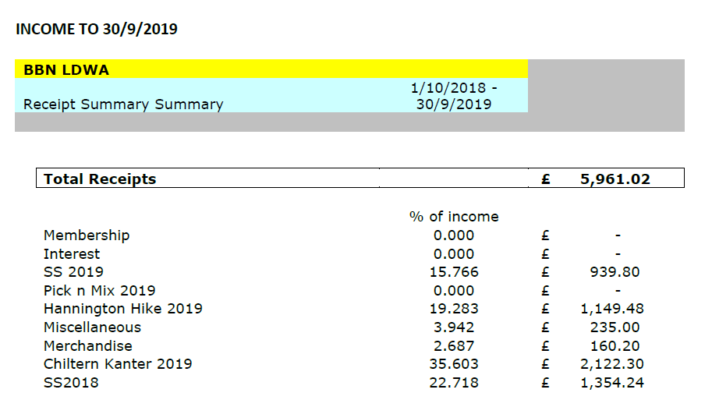


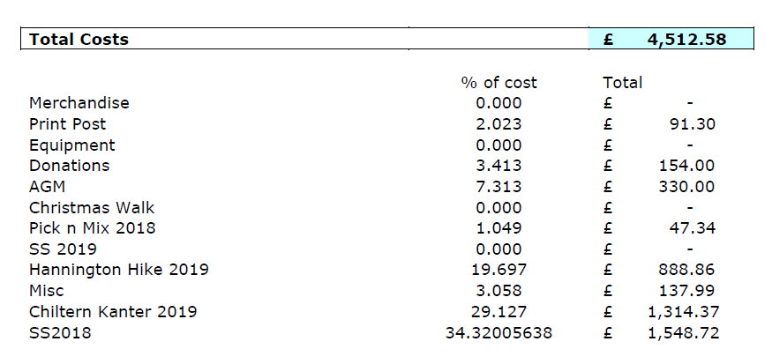
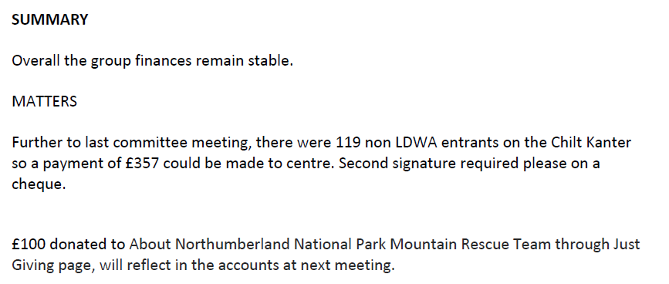

 | (d) | Social Walks: Weekend/Thursday: Mary Knight
Walk Programme January to April 2020:
- All Thursday dates filled
- Weekend dates that need walk leaders
  - 4/5 January
  - 11/12 April (Easter)
For discussion
- Is the difficulty in finding walk leaders to be discussed at LGR meetings?
 |  | Finding walk leaders: PeterS has already referred this to the LGR and hopes it will be included on the Agenda for the forthcoming meeting.
 | (e) | Merchandising:  PECO – Peter Simon
 |  | I’ve has a look at the PECO Website. This does seem to be operational although it's almost impossible to navigate. To get there from the BBN Website one has to open a Word document that Norman created in 2018 and then click on a link in that document. Once inside, it's necessary to follow Norman's instructions on navigating to the desired product. The 2018 prices that Norman quoted may no longer be valid; I looked for price information and gave up, admittedly not having tried too hard. It's no wonder that Norman recommended dealing with PECO over the phone.
 |  | Gill said Norman was looking at the PECO site to check whether the ordering process needs a revamp. | Gill/  Norman
 | (f) | Equipment: Lynn Yorston
 |  | I don’t think anything has changed since my last report. But if anyone knows different, please let me know. I shall send an up to date list to Gill for the web soon after the committee meeting. | Lynn/  Gill
 | (g) | Website: Gill Bunker
Website:
Continue to keep updated, adding photos after group walks and events; thank you to all who contribute photos. Links to photos on the website included in Peter’s weekly updates.
Group walks information updated when advised by leaders. Challenge event information, route descriptions and results added as requested by organisers.
Programme January to April 2020 input for Strider.
 | (h) | Newsletter: Gill Bunker
Autumn Newsletter circulated – Full issue, 32 pages, which is maximum for A5 size letter post. Thank you to everyone who contributed.
Only 20 members now receive a hard copy.
Unfortunately this issue was printed in A4 format by mistake - so it had to be posted as a large letter and was over the minimum weight. I did manage to hand over 4 copies, but the remaining 16 copies cost a staggering £21.12 to post. Luckily the printing is so cheap - £20.92 for 30 copies (the spare 10 copies to go to SS event).
 | (i) | Facebook: Gill Bunker
 |  | 175 members as at 28th October. Mainly used to share photographs. Good to get a conversation going, as with recent photos of Isle of Wight trip when folk responded with comments. Also used in tandem with Peter’s Updates to circulate updated information about group walks, etc.
Twitter: 150 followers, PeterE tweets regularly.
Instagram: Sara has looked into this and thinks it impractical for BBN.
 | (j) | Local Groups Representative: Peter Simon
 |  | Signed up to attend 2019 meeting at Edwinstowe (YHA Sherwood Forest) 15-17 November. Why does it always clash with the SS events? | Peter S
 |  | Finding walk leaders: Hopefully to be discussed at the meeting.  When Peter receives the Agenda he will circulate it to the committee so that any ideas/comments can be sent to him before the meeting.  DFH confirmed the date of the SS events was fixed long before the LGR meetings began. | Peter S  And  ALL
 | (k) | Other Committee Members Nothing additional to report.
4. | Insurance Issues (including Walks Register) - Incident Reports
 | Incident Reports: There have been no reportable incidents.
 | Walks Register: No issues.
5. | LDWA
 | (a) | Internet issues for bulk emails
 |  | Peter had reported bulk email messages being treated as junk by certain Internet Service Providers - no solution has yet been found. Mary said emails to her walk secretary email address were also going to her junk folder.  Adam Dawson, NEC Internet, has circulated a list of possible fixes for members (Terry/PeterS have 14th August email ?). Details of fixes to be included in Newsletter/website, etc. and mentioned to members when walking. | Peter S  Gill  and  ALL
 | (b) | Leaflets – National or BBN  Merrian had forwarded a draft of the updated national leaflet received from Dave Morgan, with new logo and new images. This is going to print imminently. PeterS said this was good for national LDWA advertising but what about local group advertising?  It was agreed the LDWA business cards are a useful size to carry and hand out. Alan had one of the BBN business cards and it was agreed to order further supply. Quantity to be ordered dependent on cost. Gill to contact Norman who ordered the original supply. | Gill/  Norman
6. | LDWA 100s
 | (a) | 2020 100 - Y 100 Sir Fynwy CP {23/25 May 2020)
CP 5 Abergavenny. Opening times are Saturday 22:15 to Sunday 08:30.
Mary confirmed 15 volunteers. She has list of food to be supplied, has checked it and is happy with it.
All OK - only possible complication is the staggered start.
 | (b) | 2021 100 - Trans Pennine CP – BBN now allocated CP2. DFH is the contact.
 | (c) | 2022 100 – Elephant, Bear and Bull CP1 allocated. DFH is the contact.
 | (d) | 2023 100 - Speyside
 |  | No further information at present. Decision whether to offer to run a CP to be made at a later date.

7. | BBN Challenge Events
 | (a) | Hannington Hike 2019 – June 9th 2019 – Alan Leadbetter
This year’s event was held a month earlier in June. The marshals’ walk found a cropped field that had no sign of a footpath through it, this was reported to the relevant authority and the path was in place on the day.
Entries were a bit slow but with a rush of entries in the last two weeks there were 135 entered. 112 arrived on the day and 111 finished their chosen route.

Route | 27 | 18 | 14
Entered | 80 | 19 | 13
Finished | 79 | 19 | 13

Of the 135 who entered 42% were non-members of the LDWA. They came from near and far.
Anytime Anywhere | 7 | Sherwood | 1
Beds, Bucks & Northants | 35 | South Wales | 2
Bristol & West | 1 | Sussex | 1
Essex & Herts | 11 | Thames Valley | 4
Heart of England | 6 | The Irregulars | 1
Lincolnshire | 2 | Wessex | 1
London | 1 | West Lancashire | 1
Norfolk & Suffolk | 3 | Non-members | 58

I would like to thank everybody who helped on the day for without their help we could not hold these events:
Karen Earwicker | Mike Hyland | Peter Simon
Norman Corrin | Sandra Hyland | Mooi Simon
Dave Yorston | Andrew Gilbertson | Steve Clark
Lynn Yorston | Terry Brown | Therese Jamin
Glynn Dimmock | Gill Bunker | Derek Jacob
Helen Crossland | Chris Burns | Gordon Shaughnessy
Sara Waldron | Ian Burns
Next year’s event will be held on Sunday 1st March 2020, the marshals’ walk will be on Sunday 2nd February 2020. Entries are now open and will close Wednesday 26th February 2020.
If you would like to help out on the event then let me know by email at acleadbetter64@gmail.com
Accounts (to be confirmed)
SiEntries | £1,149.48
Halls |  | £432.25
Food |  | £281.32
Certificates |  | £50.40
Van + petrol |  | £125.00
 | £1,149.48 | £888.97

= Surplus £260.51

Alan said the accounts were still to be confirmed.
£232 to be donated to LDWA for the non-members premium.

 |  | Hannington Hike 2020 – March 1st 2020 – Alan Leadbetter
 |  | Entries open. The routes will be the same as last year, possibly with a few tweaks. Marshals will be needed.
 | (b) | Steppingley Step - November 17th 2019 – Lynn & Dave Yorston
 |  | All plans are in place. Thank you to all those who have offered help and a great day’s walking to everyone else.
 |  | Lynn has confirmed this is the last SS she will be organising the food for.
 | (c) | Pick & Mix 2020 and Future – Lynn & Dave Yorston
We have booked this event for 31st May 2020.
The construction of HS2 rail link may still become a problem but we are prepared to alter the routes to fit.
 | (d) | Chiltern Kanter 2021 – 7th March 2021 - Roy Carter
 |  | Roy has booked the event HQ Pitstone Village Hall. Cost £259.20, deposit £64.80 plus £50 damages deposit.. The routes are still to be sorted. | Roy/
 |  | Roy will obtain breakdown of Chiltern Kanter 2019 finances from Norman. | Noman
 |  | Roy to contact Mike Hyland re SiEntries. | Roy/Mike
 |  | DFH will do input for Strider Events. | DFH
 | (e) | Wendover Gap Anytime Challenge – Lynn & Dave Yorston
 |  | We have no new sole completions. However, the two group walks were both a great success – thank you to those who came along.
8. | Equipment
 |  | Marshals’ T shirts
 |  | Terry reported slow progress. Chelle Armour (Norfolk & Suffolk) was happy for BBN to base our T-shirts on the N&S design, and Terry had been in touch with Nick Ashwell who designed the N&S shirt. After circulating samples to the committee the favoured option was a burgundy T-shirt with white lettering. Terry will ask for further samples showing the text both above and below the BBN logo. These can then be circulated for a final decision to be made.  Printing by Metro Signs, Bedford. Terry estimates the cost of each T-shirt will be about £9.00. The total cost will be £500-£700 – including payment for printing and Nick Ashwell. Agreed to purchase 50 in a range of sizes. | Terry
Holders for publicity leaflets
PeterE had obtained some holders.Passed to Terry.
 |  | Banners
 |  | It was agreed to purchase small banners for CPs: 3 of each.  “No dirty footwear in hall”  “Beds Bucks & Northants LDWA Welcomes You”  Gill will check with previous suppliers; Peter said Metro Signs also print banners. | Gill
9. | Donations/Projects
 | (a) | Greensand Ridge Benches
 |  | Roy still in email correspondence with Greensand Country Landscape Partnership regarding the replacement of the benches. The GCLP have suggested Roy arrange a meeting between the parties; Andy Knight, Jon Balaam and BBN. Roy and Terry to attend for BBN. The benches favoured by the committee cost £308; six will cost £1,800.  Terry said before the meeting BBN need to prioritise the benches that are to be replaced, some are still in a reasonable condition. | Roy/  Terry
 | (b) | The Crown, Northill - provision of shelter for enjoyment of mince pies on the Santa Walk. A donation of £20 agreed. This will go to the Church fund.  Alan to check the best way for this is to be paid. | Alan
 | (c) | After the IoW trip Mary proposed replacing a gate on the island with a stile. This would be done through the Replace a Gate scheme – Cost £490.  It was agreed to defer this until the cost of the Greensand Ridge Benches project is known.  It was noted that there are stiles in our area (Tebworth mentioned) that need replacing.
10. | Group Activities/Weekends/Social Events
 | (a) | Isle of Wight  A very successful trip. Agreed to send a thank you card to Jill Green/Jim Catchpole and Dee Brockway. | Gill
 | (b) | Challenge walk centred weekends
 |  | DFH has suggested an event – the Marston Moors Meander, Saturday 9th May (this is now the Bank Holiday weekend). DFH has a commitment on the Sunday afternoon, but could lead a walk in the morning. Walkers to do their own entry and book their own accommodation,  Mary will put a few words together to be circulated.  This would be an opportunity to walk in another part of the country, an opportunity to enter a challenge event not walked before and walk with friends, and it would support a less well known event. | Mary/DFH
 | (c) | Midsummer Meanders
Sara has booked the hall at Milton Bryan, near Woburn for Saturday June 20th (actually the first day of summer!). A “save the date” advertisement was included in the Newsletter.
Still at the planning stage but the idea is that there will be a choice of distances (provisionally 5/6 and 10 miles, plus shorter if needed) in both the morning and afternoon. Tea, coffee and biscuits at the start, with a light lunch provided back at the hall and the day will finish with tea, coffee and cakes. Folk can just walk in the morning or the afternoon, or the whole day as they choose.
 |  | Sara confirmed £45 hall booking fee, though this need not be paid yet. Limited on-site parking but plenty of parking along road. It was agreed the group would fund the event. Undecided whether to make a nominal charge, need to get commitment from walkers in some way. Sara, Terry, Mary, Gill to meet (hopefully before Christmas) to progress. | Sara/Mary/  Terry/Gill
11. | Ideas for the Walks Calendar
 | (a) | Pop-up walks: There have been a few pop-ups. There will be one in December.
 | (b) | Attracting more leaders: Already discussed. Referred to LGRs meeting.
 | (c) | Consistent descriptions for popular start points: | Mary/Gill/
 |  | Agreed we need to be aware of this when inputting walk details. | Terry
 | (d) | Holiday 2020  Roy has spoken to John Chesher and proposes a trip based on Grindleford, North Derbyshire, an area Roy knows well. Walkers to book own accommodation.  It was agreed the August Bank Holiday weekend could be expensive and might well involve transport delays. Midweek dates could be considered, as well as weekends. | Roy
12. | 2019 AGM Update
 | Terry noted that mention of the agreed £10 subsidy for the AGM meal had been omitted from the Newsletter. Peter to include this in an Update with a link to the menu and confirming the deadline for booking. |  | PeterS/  Gill
 | Nominations: The current committee have been proposed and seconded.
 | Agenda to be prepared. |  | Peter/Terry
 | Reports: Written reports (year 1st Oct 2018–30th Sept 2019) to be circulated by Monday 18th November so they can be put in a single document on the website and the link sent to Peter in readiness for his update on Tuesday 19th November.  The AGM is being organised by David Sedgley; Gill to check with him all OK. |  | ALL  Gill/PeterS  Gill
 | Terry confirmed the email from Julie Cribb explaining that an NEC member would like to come to the AGM to talk about the NEC fundraising plans for the LDWA website redevelopment. BBN can claim to be proactive as we are already donating the difference between non-members’ and members’ fees to the LDWA, suggesting this money is used for the website campaign.
13.  (a) | AOB  It was agreed, provisionally pending the AGM, that the next committee meeting will be held on Thursday 30th January at 96 Wardown Crescent, Luton LU2 7JT

The meeting closed at 10pm

