LONG DISTANCE WALKERS ASSOCIATION - BEDS BUCKS NORTHANTS GROUP
MINUTES OF COMMITTEE MEETING
HELD ON THURSDAY 21ST FEBRUARY 2019
AT 1 ABBEY WAY, BRADVILLE, MILTON KEYNES, MK13 7AN

The meeting commenced at 7.50pm.
Present: Terry Brown (Chairman), Gill Bunker (Newsletter/Website), Roy Carter,
Dave Findel-Hawkins (Membership), Mary Knight (Social Walks), Alan Leadbetter,
Peter Simon (Secretary/Local Groups Rep), Sara Waldron
Terry welcomed Sara to her first committee meeting. |  |  |  | ACTION
1. | Apologies: Peter Engledow (Treasurer)
2. | Minutes and Matters Arising
 | (a) | Previous Meeting (25th October 2018)
 | The Minutes were approved. Matters arising would be covered during the meeting.
 | (b) | 2018 AGM
 | Gill has emailed the Minutes to Julie Cribb, LDWA Local Groups Secretary as required.
3. | Reports:
 | (a) | Chairman: Terry Brown
- Followed up with Tony Hill about taking on the BBN 100’s coordinator role (which he declined).
- Chaired the AGM in November.
- Got the memorial plaque for John Nickerson sorted out (but it still needs to be fixed to the Ivinghoe bench).
- Sent National LDWA the names of those who have specific GDPR roles for the Group.
- Responded to various email requests as appropriate.
- Input the May to August 2019 group walks programme for Strider/Website.
 |  | No questions.
 | (b) | Secretary: Peter Simon
Received and responded to e-mails.
Almost no phone enquiries.
Spam filters and unsubscribing seem to be working. There was a problem in December/January when spam filters for Virgin Media (and possibly other) customers were rejecting e-mail messages from all ldwa.org.uk addresses. I took this up with Adam Dawson of the NEC, who appears to have resolved the problem.
Weekly news updates sent to subscriber members except for when there has been no news to report. Distribution was 699 as of 12 February but can be expected to fall in March when non-renewals are eliminated from the members' database. In 2018, distribution fell from 686 in January to 617 in March. Some lapsed members have already been taken off the distribution list, which peaked at 711 on 18 December.
 |  | No questions
 | (c) | Treasurer: Peter Engledow (see report pages 9-10)
 |  | Peter was unable to be present. He had circulated his report, which Terry summarised.
 |  | No questions
 | (d) | Social Walks – Weekend/Thursday: Mary Knight
January to April 2019 programme:
- Weekend dates all filled
  - March 30th/31st – Wayne Rowlett
- Thursday dates all filled

May to August 2019 programme:
- Weekend dates unfilled
  - July 6th/7th
- Thursday dates unfilled
  - May 16th
  - Aug 8th
  - Aug 22nd

It is my recommendation that unfilled dates should be entered in Strider as ‘TBA’ and that newsletter and updates make it clear that no one has yet come forward to lead a walk on these dates. As with 30th March above, walks can be entered onto the LDWA database after Strider publication.
 |  | Mary wants “details to be confirmed, please check website” (or similar wording) instead of no entry at all in Strider for a date when no walk has been offered before the deadline. This was agreed. Mary to confirm wording. |  | Mary
 |  | Gerry Garland has offered a walk from Woburn to fill one of the available dates on the May-August programme. Mary to contact him. |  | Mary
 | (e) | Merchandising:
 |  | Peter S is keeping an eye on the PECO website.
 | (f) | Equipment: Lynn Yorston (Non-Committee)
 |  | I don’t think anything has changed since my last report. But if anyone knows different, please let me know. I shall send an up to date list to Gill for the web soon after the committee meeting.
 | (g) | Website: Gill Bunker
- Lots of photos/links added after group walks and events; thanks particularly to Merrian and Dave for photos of Thursday walks. Steve Clark usually puts a link to his photos on FB.
- BBN challenge walk information, route descriptions and results added as requested by the event organisers.
- Useful to be able to add/amend details of group walks easily and quickly, and to be able to include information that Peter can link directly to for his Updates.
- New page “Available Walk Dates”.
- I would be pleased to receive any comments on how the website can be improved, or turned into a more useful tool, or if someone has looked for something they could not find. Please do say, or pass on any comments others may make.
- Terry and I are share the input of group walks onto the LDWA website and this is working well. Terry input the latest programme.
 | (h) | Newsletter: Gill Bunker
- Spring Newsletter – deadline end of February – to include anything coming out of this meeting, plus anything committee members want included.
- Only two articles to date, one held over from last issue as ran out of space.
- Will include the new programme.
- Now only posted to those members who have asked for a hard copy. Available to all online.
 | (i) | Facebook: Gill Bunker
- 145 members.
- Daniel Jamin, Norman and myself are Admins and Moderators.
- FB mostly used for sharing photos.
- It is great for getting urgent information to (FB) members.
- I am not sure how useful it is as a publicity tool – but there are often a couple of new FB members after one of our challenge events, usually when photos have been put up.
 | (j) | Local Groups Representative: Peter Simon
 |  | Nothing to report beyond what already appears in the 2018 AGM minutes.
 | (k) | GDPR: Terry Brown
 |  | Terry said BBN were required to confirm by the end of February the names of the people with GDPR responsibilities and that all GDPR rules were being adhered do.  She confirmed she has already given Chris Hedley (LDWA Data Manager) the names of those with specific GDPR responsibilities: Terry: Overall responsibility, Dave: Membership, Merrian: Events, Historic, Mike Hyland: Events, Current.  She can also confirm that all GDPR rules are being adhered to by the group and |  | Terry
 |  | that we can now proceed on the basis that that we are doing all that is necessary, unless there is any change in guidance from the NEC, and that GDPR no longer needs to go on the Agenda for committee meetings. |  | PeterS
 | (l) | Other committee members:
 |  | Nothing to report.
 | (m) | New LDWA Members – Norman Corrin  Since the last committee meeting, I’ve emailed or spoken to 20 new LDWA members and sent them a welcome email about BBN and an attachment about ICE.  I still have February’s members to action.  I’ve removed the details from my laptop to avoid the GDPR police getting hold of me……..
 |  | Mary said she gets a few enquiries about the group which she responds to individually. Is there a standard letter which can form the basis of a reply? Gill will ask Norman and put on the website. |  | Gill
4. | Insurance Issues – Incident Reports
 | There have been no reportable incidents.
 | Social Walks Register – Merrian Lancaster (see report pages 11-15)
As we had loads of questions about the social walk registers, I offered to find out more, and report back to the committee. I’ve detailed my findings but, as it’s rather boring, here’s a summary, and my recommendations for what we do next.

1. I sent a load of questions to the LDWA Treasurer, Sandy Gee. He’s the person on the NEC who is responsible for insurance. I’ve had no answers. I spoke to Sandy at Winter Poppyline and he told me the NEC are still investigating and he has no answers for me.

2. I suggest we carry on taking a register on social walks as we’re currently doing. Most people are used to it now, and it’s not really a bother. When we get anything official on the subject, we can respond to that. Please confirm that you’re in agreement with this.

3. When I know I won’t be on a walk, I’ll remind the walk leader and send them the link to our form. If they don’t take a register, so be it. Please confirm that you’re in agreement with this.

4. I suggest we create a “gallery” on the LDWA website and store the scanned documents in it. It’s protected and has no GDPR issues. DFH, Gill and Terry have access to it. The gallery won’t be published. I’ll keep the paper copies. Please confirm that you’re in agreement with this.
 | There was some discussion about Merrian’s report.  Briefly:  The insurers want us to do it, so the bottom line is we do it.  It appears the NEC are not exactly sure how to handle this. Roy said even the brokers don’t appear to be know what is needed as they refer to “recommended” and “due diligence.  Mary said if people choose to be difficult, there should be a standard response. The committee felt Merrian would be able to come up with something apt.  Sara said other non-LDWA groups did not appear to be taking such a register. Roy said “things may be happening with the Ramblers”.  The committee agreed the three items (2,3 and 4 above) where Merrian had asked for agreement.  Dave will handle the scanning and storage of the documents. But do we need to keep a paper copy once the document has been scanned? We need to check with Merrian what her thoughts are.  It was agreed that a written procedure for walk leaders needs to be prepared, ie stating who they send the register to, scanned/hard copy? |  |  | Merrian  Merrian  DFH  Merrian  Merrian?
 | Thank you to Merrian for taking this on and for the impressive summary of the current position.
5. | LDWA
 | (a) | Publicity/Press Releases – see David Holland’s note (pages 16-17)
 |  | Referring to the notes PeterS said he considered there were three principles to consider:
 |  | 1. It may be useful to do some research as to which areas to target, i.e. where there was not already a larger number of members, Northants or Luton for example.
 |  | 2. Timing – Useful to get items in paper just before there is an event in that area.
 |  | 3. Photographs – needs to be photos of mixed groups, not just a lot of old people.
 |  | Terry said she was actioned to prepare a basic editorial that could be used as a template for such newspaper article. |  | Terry
Regarding publicity and attracting new members:
It was commented that there had been plenty of walkers (29) out on the walk earlier that day. The lack of members coming forward to lead walks and take on jobs was referred to. It was noted BBN has nearly 700 people on the mailing list.
 |  | Dave said we need to encourage existing members to come forward to lead walks, Terry said it would be a good idea to work with existing members and get them more involved,
 |  | Mary said when asking for walk leaders in earlier newsletters she always indicated that she would be happy to help any new leader who needed advice or support.
Sara said when she had spoken to people about leading walks they often said “Nobody asked me”.
Mary said she normally managed to talk to people on walks when seeking leaders, but she had not been able to attend any walks before the recent Strider deadline – this is probably why there are the gaps on the new programme.
 |  | Dave said there were other roles with the group that members could take on, not just leading walks.
 |  | Referring to David Holland’s note, Terry said this was a useful guide.  She agreed with the comments regarding getting members more involved and will prepare something for the next Newsletter. |  | Terry
 | (b) | Other social media (excluding Facebook):  Nothing happening on BBN Twitter.  Gill said she would ask “a younger person” about Instagram. |  | Gill
 | (c) | Any other matters – No further matters
6. | LDWA 100s
 | (a) | 2019 100 – Hadrian’s Hundred
 |  | No BBN checkpoint. (Except Dave and Merrian’s own CP.)
 | (b) | 2020 100 - Y 100 Sir Fynwy
 |  | BBN have been allocated CP 4 Abergavenny.  Dave is the current contact. Mary will organise. |  | DFH/  Mary
 | (c) | 2021 100 - Trans Pennine
 |  | BBN’s interest in CP 1 has been registered and we are likely to get this.  Dave is the contact. |  | DFH
 | (d) | 2022 100 – Elephant, Bear and Bull  Dave will contact organisers when information becomes available, |  | DFH
 | (e) | Beyond 2022: Our involvement if any  Too early. No information about future Hundreds available yet. |  | DFH
7. | BBN Challenge Events
 | (a) | Sundon Saunter 2018 – Merrian Lancaster (see report pages 18-21)
 |  | A comprehensive report had been received from Merrian.
 |  | Terry commented on the £300 donation to the National LDWA – this represents the additional event entry fee that has to be levied on non-LDWA members.**  It was agreed this was a good idea and can be done on other BBN events where event income allowed. **NOTE Merrian clarified after the meeting that this is incorrect. Although it is encouraged, we don't have to levy a fee on non-LDWA members. |  | Events
 | (b) | Chiltern Kanter 2019 – Norman Corrin
As at Sunday 17th February 2019 there are 252 entries for the Kanter. Mike has the breakdown of entries by route. The majority are on the long route.
Closing date for online entries is February 22nd.
There were 5 on the Marshals’ event on Sunday 10th February who checked the 13 miles route. Dave and Merrian have checked the long route loop after the Winter Tanners and checked the remainder of the route yesterday.
I’ve emailed all marshals with details of their jobs and the checkpoint managers details of their checkpoints and the food they’ll be serving.
I’ve emailed D squared (Dave Findel-Hawkins and Dave Yorston) with the details of the equipment required.
I think that’s it!
 |  | Roy said he has checked with SiEntries before the meeting, and entries had now reached 282.  He said car parking was still an issue as Safran had declined access to their site this time. Norman has been in touch with Pitstone Museum and they have agreed access to their car park, but only if ground conditions are good. If not, the parish council have advised street parking in the direction of the industrial estate. Notice about parking will be emailed to entrants via SiEntries. PeterS will include it in his update on Tuesday.  It was confirmed that Dave is preparing a map showing the GR points to be displayed at the hall.  Future Chiltern Kanters  Roy asked if the Kanter had a set date, and it was confirmed it is usually the first Sunday in March, and must avoid clashing with the National LDWA.  Roy confirmed he will be shadowing Norman on the day this year. |  | Norman/PeterS  DFH
 | (c) | Hannington Hike 2019 – Alan Leadbetter
Headquarters and checkpoints booked and paid for.
I have been and checked the routes, there will problem 2 field on the short route that might be affected by Oil Seed Rape. The diversion that was used on the other routes will be taken out and the original routes will be used.
Will need about 20 marshals.
As of 18/2/19 22 booked on event.
Can use the car park for marshals’ walk but must use the car park we use on the event as it is the same weekend as the Waendel Walk.
 |  | Alan confirmed that future events will be held in March and will alternate with the Chiltern Kanter.
 | (d) | Steppingley Step 2019 – Lynn & Dave Yorston
The date will be Sunday 17th November 2019. The HQ booking has been confirmed and checkpoint sites are being sourced.
We feel that now is the time for change. So, this will be the last SS challenge that we – Dave & Lynn – will be on the organising team. We will obviously be offering our full support and help to those who take over our places.
 |  | Team for future SS events: Dave said he and Merrian are working on this. |  | DFH
 | (e) | Pick & Mix 2020 and future – Lynn & Dave Yorston
We would like to run this event on a yearly basis as from June 2020
Having been forced to rearrange the 2018 event from the March date, we feel that this very different format worked so well in better, brighter and warmer times.
The construction of HS2 rail link may become a problem but we are prepared to alter the routes to fit.
Would the committee like to consider this proposal and get back to us with their comments?
 |  | Lynn and Dave’s proposal was agreed, with thanks to them.
 |  | Wendover Gap Anytime Challenge - Lynn & Dave Yorston
We have no new completions.
HOWEVER, during 2019 Dave will lead both the short and long routes as group walks – dates as in the BBN diary.
8. | Donations/Projects
 | (a) | John Nickerson Memorial  Terry displayed the memorial plaque for John Nickerson. It is 6” x 4” in stainless steel – she was advised this was best for long term life and condition, and it has been laser engraved. The text came out a bit bigger than she had originally thought but we all thought it looked good.  Cost was £43; Terry will contact Peter E.  Gill said Ian will fix the plaque to the bench, and they will clean the bench at the same time. |  | Terry/  PeterE  Gill
 | (b) | Terry said she would re-running the Oranges & Lemons walk in September and asked for approval for another £25 donation to St Dunstan’s, Stepney for allowing us access to the church and toilets. This was agreed. |  | Terry/  PeterE
 | (c) | BBN Marshals’ tee shirts – Merrian Lancaster
 |  | I helped out on Winter Poppyline at the weekend and, because I'd helped several times before, they gave me a tee shirt. I think it's a brilliant idea and would like BBN to offer them to our marshals please. They give them to folk who have helped three times. If we adopt the same requirement, most of our marshals already qualify. They also give a buff to everyone, entrants and helpers.
 |  | Dave displayed the tee shirt and buffs.
 |  | This was agreed to be a good idea. We liked the footprints on the back of the N&S tee shirt. It was noted they are produced by “Fruit of the Loom” and it was agreed to ask Merrian to ask N&S group for contact details to place an order. We will all consider colour choice and how many tee shirts should be ordered. |  | Merrian  All
 | (d) | Greensand Ridge Benches  The repairs/renewal of the benches remains outstanding.  Roy will contact the Greensand Country Landscape Partnership and report back. |  | Roy
 | (e) | It was agreed to purchase 2 or 3 small BBN banners to use on event CPs, etc.  Gill to ask Norman if he has contact details for the suppliers of the large banner. |  | Gill
9. | Group Activities/Weekends/Social Events
 | (a) | Isle of Wight
 |  | Dee had sent a brief report and will send a note to Peter to include in an Update. She will list those who have already committed and give a deadline for anyone wishing to be included in group transport arrangements. |  | PeterS
 | (b) | Other
 | (i) | Roy is interested in organising a linear walk of the Chiltern Way with minibus back up, over a series of weekends. This was agreed, and Roy will explore how this can be organised. |  | Roy
 | (ii) | Pop up holiday – Roy would like to organise another holiday. He is thinking of Grasmere over this year’s August Bank Holiday weekend. It was felt this might be an expensive time to go the Lakes, and could be too soon to organise. Possible next year?
10. | Pop-up Walks and Other Ideas for the Walks Calendar
 | Discussed already.
11. | 2019 AGM
 | David Sedgley has offered an AGM walk 2019 from Flitton.
I've just checked with booking at our Church Hall and it is free on both 24th November and 1st December. I said at last AGM that I'd be happy to lead walk for this year as it's due to be Bedfordshire. However I did ask if 1st December was possible, as the 24th is likely to clash with a league cross-country race - whereas 1st definitely will not.

The plan will be to have lunch at the White Hart which is adjacent to the Church Hall (same hall as now used as checkpoint for Steppingley Step). We'd meet at the Flit Valley info barn - parking either there or at pub. The walk would take in some of Flit Valley Walk with a circuit around Flitwick Moor.

So I will do either date, but would prefer 1st December.
 | It was confirmed the AGM must be held in November (BBN constitution).  It was agreed to accept David’s offer.  Terry confirmed that as Flitton is local to her, she could help if necessary. |  |  | David Sedgley
12. | AOB:
(a) | It was confirmed that any matter agreed by email between meetings, particularly any matter involving group funds, should also be recorded in the minutes of the next meeting.
 | Via email: 6/9 agreed BBN would pay £40.70 for the current year for the Flickr account used by Merrian to share group photographs.
(b) | The next committee meeting will be held on Thursday 30th May at 7.45 pm at  Beech House, Wentworth Court, Harlington LU5 6HZ
The meeting closed at 9.50 pm

Reports referred to in the Minutes:

- Treasurer’s Report – Peter Engledow – p.9-10
- Social Walks Register – Merrian Lancaster p.11-15
- Local Newspapers – some general advice for getting your stories and photographs
iinto the local press – David Hollands/Graham Smith p.16-17
- Sundon Saunter 2018 Report – Merrian Lancaster p.18-21

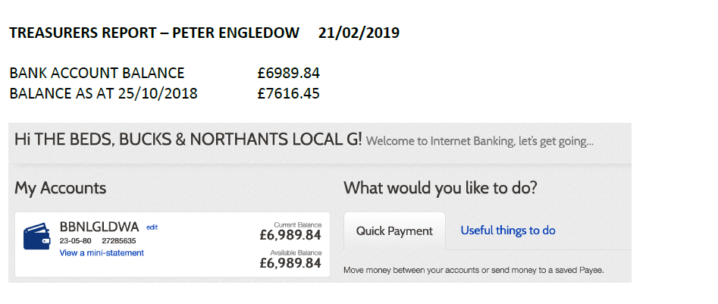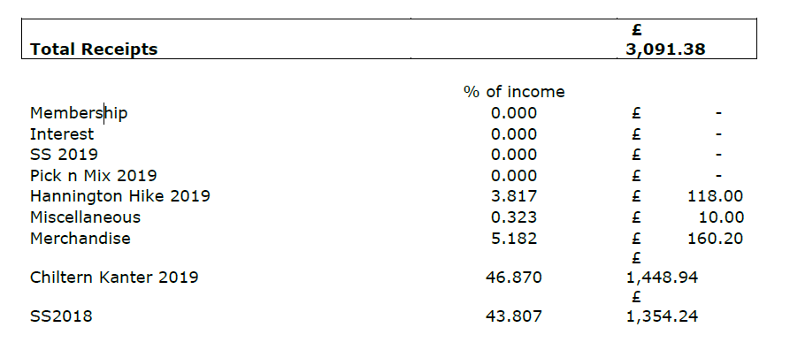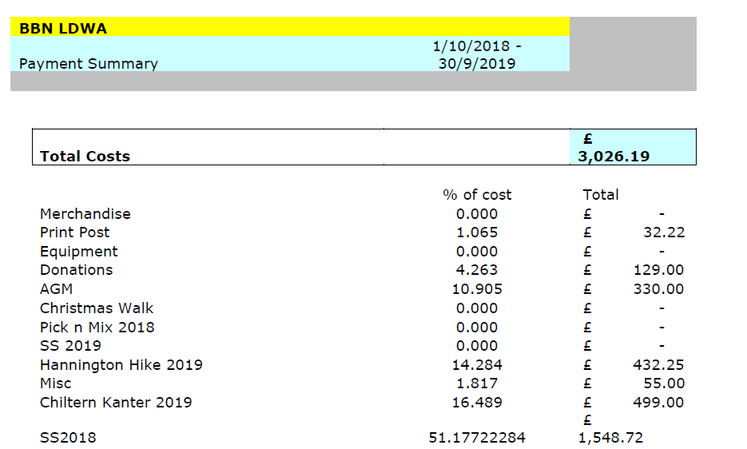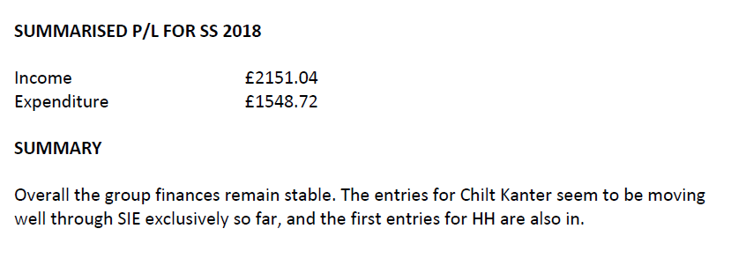
LDWA BBN – social walk register –
for BBN committee meeting 21st February 2019

As we had loads of questions about the social walk registers, I offered to find out more, and report back to the committee. I’ve detailed below my findings, but, as it’s rather boring, here’s a summary, and my recommendations for what we do next.

1. I sent a load of questions to the LDWA Treasurer, Sandy Gee. He’s the person on the NEC who is responsible for insurance. I’ve had no answers. I spoke to Sandy at Winter Poppyline and he told me the NEC are still investigating and he has no answers for me.

2. I suggest we carry on taking a register on social walks as we’re currently doing. Most people are used to it now, and it’s not really a bother. When we get anything official on the subject, we can respond to that. Please confirm that you’re in agreement with this.

3. When I know I won’t be on a walk, I’ll remind the walk leader and send them the link to our form. If they don’t take a register, so be it. Please confirm that you’re in agreement with this.

4. I suggest we create a “gallery” on the LDWA website and store the scanned documents in it. It’s protected and has no GDPR issues. DFH, Gill and Terry have access to it. The gallery won’t be published. I’ll keep the paper copies. Please confirm that you’re in agreement with this.
Merrian Lancaster
18th February 2019

On 18th December, I sent the following to the LDWA Treasurer, Sandy Gee. He’s the person on the NEC who is responsible for insurance.

LDWA BBN – social walk register

We’ve had a few social walks now since our secretary, Peter Simon, came back from the LGR weekend with the following message:-

- Insurance - This is by far the most important issue raised at the meeting. The LDWA is covered by an insurance policy for third-party damages - for example, if a farmer sues the LDWA for damages to livestock. The LDWA's insurance policy now requires that we keep a record of the name and membership number of every member who participates in a social walk or challenge event. Non-members are permitted to join Group social walks up to three times and would be required to provide contact details. The forms must be kept for three years and then destroyed. This policy is to go into immediate effect. Damage claims are exceedingly rare but, if uninsured, could ruin the Association.

Peter also brought a document called LDWA Insurance Information. The document I’m referring to is here:- https://www.ldwa.org.uk/lgt/downloads/BedsBucksAndNorthants/Insurance_1118.pdf

In this it says:-

This covers the LDWA (and therefore groups and members who organise events and group walks) against cIaims resulting from LDWA′s negIigence -e.g. for a cIaim by a walker for an incident that can be shown to be the LDWA′s fault.

It also says:-

Name, address and phone number are seen as the minimum records by the insurers. Additionally, LDWA request that either membership number or, for non-members email address are taken. This will enable the LDWA Group to ask if the member is interested in joining.

In the November chair’s update, it says:-

At the local group representatives’ weekend a new process was introduced to our members. It’s not going to be popular and the NEC is very aware of that fact. Due to the requirements placed upon us by our insurers, it is necessary for geographical groups to record the details of all social walk attendees. This is because our insurer requires the details in case a claim against our public liability insurance is made in the future. Trust me, we have spoken with the insurer several times and have no choice but to undertake this change. In the long term the data that is collected will be saved to the LDWA secure server, but in the short term the data will need to be collected and stored safely on a password protected computer. More details will be sent to social group representatives soon.

As we have a number of questions and comments about all this, I’ve offered to bring everything to your attention and to report back with your response to the BBN committee meeting in February 2019. Here goes...

- For years we at BBN have been following LDWA instructions and have been collecting names and emergency contact details for each non-member who joins us on a social walk. I have walked with every other LDWA group and have yet to be asked if I’m a member.
- We haven’t been told to stop collecting emergency contact details for non-members, should we continue?
- What does the insurance cover, is it “if a farmer sues the LDWA for damages to livestock” or “a cIaim by a walker for an incident that can be shown to be the LDWA’s fault”, or both?
- Why do we need to collect address and phone number for members, surely the LDWA membership number is sufficient….and a darn sight easier to collect when it’s chucking it down at the start of a walk? Fortunately we have some weather-proof clipboards but we aren’t going to send those to every walk leader. I appreciate that it would be easier to sit in a car and wait for people to register, but that isn’t reliable.
- Our members are jolly good and most come ready with their numbers. Our membership secretary can fill in missing number but does he need to check all the numbers?
- The leader of our walk this weekend, took names, and numbers where people knew them. He scanned the document and emailed it to me. A few numbers were missing so I had to print the document, give it to our membership secretary to complete, then scan it again to store it. Hmm, there must be a better way that I haven’t thought of….yet.
- If someone from another group joins us, and doesn’t know their number, our membership secretary can’t look that up. What should we do?
- “This will enable the LDWA Group to ask if the member is interested in joining.” Surely this should be “non-member is interested in joining”. Also, it is irrelevant and has nothing to do with insurance, so shouldn’t be in the document.
- One member asked if GDPR gives him the right to withhold his name and number. How should I respond?
- The same member, sigh, said he was happy just being a member of the public, walking on public rights of way and saw no need to give his details.
- Should we take a register on reccies and marshals’ walks? A good few years ago there was some sort of instruction that walks not in Strider has to be input on the Local Group/LDWA website to be covered by LDWA insurance. We do this by default now with our pop-ups etc, but there was also something along the lines of a recce having to be referred to in an email as a LDWA recce to be covered. Does this still apply?
- If one of the reasons is to prove someone was on a walk, do we need to make a note if someone joins late or leaves early?
- The form we’re using is here https://www.ldwa.org.uk/BedsBucksAndNorthants/W/1045/document-store.html. Walk leaders print off a copy.
- One of our committee has looked at policy schedules which are published on the LDWA website and has now asked for a copy of the LDWA insurance policy so we can see exactly how things are being interpreted. Glad I haven’t volunteered for that.
- “In the long term the data that is collected will be saved to the LDWA secure server, but in the short term the data will need to be collected and stored safely on a password protected computer.” At the moment, if I’m on a walk, I’m collecting names and numbers, scanning and storing the forms on my password protected computer. If I’m not on a walk, the walk leader is taking names and numbers, scanning and emailing the form to me. What if that information is lost, or I’m “lost”? Until the LDWA secure server is provided, is anyone at HQ willing to take this responsibility from me please?

I really don’t know why folks are getting so worked up about a logo, when this is far more of a nuisance and could put people off volunteering to lead walks.

Merrian Lancaster
LDWA BBN
17th December 2018

I had no response.
Since then, I’ve added the following notes.

We tried doing one register where people signed themselves in and put their number, but many of the names were illegible, as were the email addresses of two non-members. 29 Dec 2018

I asked Steph for a few missing numbers. Understandably he doesn’t have time to supply missing numbers and told us just to take the names. If that is acceptable, why bother to collect any numbers? 29 Dec 2018

What if a walk leader fails to take a register? 20 Jan 2019

What if an individual doesn’t want to be on the register? 23 Jan 2019

On 14th January, I contacted Sandy and asked him to confirm that he’d received my email. He replied confirming he had, and saying he’d get back to me. I’ve heard nothing.

On 11th February, John Esslemont sent me the following.

Merrian,
Last Thursday's walk was too far north in Northamptonshire for me but, as we have previously discussed this matter, I thought you might be interested in what I have unearthed. I recently (and reluctantly) became Chair of Thames Valley and then made contact with David Morgan on various matters including this. What follows is an extract from what I have reported to the TV committee.
I have been sent a copy of the LDWA insurance policy, with Sportscover Europe Limited, (though it seems not the most recent version: it is dated 2015 and refers to the 1998 Data Protection Act rather than GDPR, for example). I have not, however, seen whatever undertakings the NEC may have been required to give to our insurance brokers, Endsleigh. Much of it is more relevant to sports clubs with their own premises than to us.
With regard to the listing of names for social walks, the situation seems to be more complicated than implied by what we have been told by the NEC. Sandy Gee, who has been responsible for policy negotiations, informed me "Broker is keen that records of attendees are taken as best practice and to support the underwriter. It's not something that's noted in the insurance Ts & Cs, and neither are our other risk management processes." That makes it sound rather less "compulsory" than we have been told (but on the other hand we are constitutionally obliged to comply with "reasonable directions" from the NEC). David told me "Our broker has asked for the additional work to be done for one of two reasons. 1. We might not be able to get insurance.
2. The insurance would be very expensive and this process reduced our premium."
I should make it clear that what follows is my interpretation and I cannot guarantee that I have got it right! (In any case it is probably all fairly academic, as the likelihood of claims arising seems rather low.)
I think there may actually be some basis in the policy for the requirement to list names. There is a general condition that "The insured must use due diligence and do and concur in doing all things reasonably practical to avoid or diminish any loss under this policy". If the broker has advised that the listings constitute "due diligence", then I think we may be obliged to cooperate, at least to the extent "reasonably practical".
Though I am not sure how "due diligence" is interpreted in legal terms I'd have thought that the NEC, and we as a group, have done what we reasonably can and, if a list isn't made for a particular walk for some reason, or if a name is omitted (either accidentally or because an individual refuses to be listed) it probably wouldn't invalidate any claims arising from that walk.
As to who is covered, there is some scope for interpretation of the definitions in the policy. The "insured" can include, if requested by the NEC, employees and members. The definition of an "employee" includes voluntary helpers, so might apply to walks leaders. The definition of "member" is, to an extent, circular: "Member means any Member, temporary player or other person actively engaged in and appropriately registered for the purpose of playing the Sport or activity specified in the Schedule." This implies to me that a non-member ("other person") on a walk would ONLY be covered if listed ("appropriately registered") whereas a member (in the sense we would understand it) could well remain covered even if not on the list.
The cover is "to indemnify the insured for their legal liability to pay compensation" as a result of "accidental bodily injury", "accidental property damage", trespass (and various other contingencies that seem improbable in the context of social walks). ANY participant in a walk (whether or not listed) could potentially make a legal case for compensation for injury or property damage against any other participant. Whether that other participant would be covered by the insurance, if not listed, is open to question, but my feeling would be that it MIGHT only be a non-listed non-member who would not be covered. (In any case the claim is only applicable if the claimant does not have cover under any other policy.)
Whether or not a leader is regarded as an employee does have some bearing. If so there might be a possibility of claiming for bodily injury, however caused, under a different section of the policy.
Apart from this there is no direct individual cover for bodily injury (or property damage) in the policy: the injured individual would have to make a legal case that the injury had been caused by the negligence of somebody else. In the context of our insurance policy being relevant the "somebody else" is perhaps most likely to be the leader. The Ramblers insurance guide contains the following advice, which seems equally applicable in our case: "From the point of view of the insurance cover in the event of a claim being made, leaders who can demonstrate that they acted responsibly and followed good practice are in a much stronger position to counter claims of negligence."
See you soon, no doubt,
John

On 4th February, Chris Headley posted the following in The Bothy on the LDWA forum.

Thanks for your posts on walks registers. As the data manager for the Association, at least for the next month, nothing would please me more than abandoning the social walks register. However, we can't if we want to stay insured, according to our current insurer and another we have asked. Sandy Gee is researching yet other insurers to see whether any of them would cover us without knowing who has been on the walk. But our current understanding is that we have to keep a register of members and potential joiners for each event for three years to satisfy the insurance company that we have a system that would show that a particular individual had been on the walk or attended another type of event.
In my volunteering experience most organisations require me to register on the day. This is not really a problem. When I am leading social walks I WOULD WANT all participants to register to ensure that the event is covered for public liability. If it is not, I would be concerned that both I and my group would be liable in the unlikely event of something going wrong. Let’s be honest, the first thing that assessors ask, if there is a claim, is “have the terms of the insurance contract been complied with?”. From that point on, they will be trying to escape or reduce their liability.
But why do we need insurance? The public liability insurance covers us for claims resulting from negligence by the LDWA in its events management. The problem is that the costs could be very high even though the chances of this happening are very small. The costs could wipe out the organisation altogether. For that reason we need insurance cover.
Lastly we have the possibility that people might refuse to declare their names on the walks register. I would point out that:
1. It is a very minor act to put your name on the Register. After all, walkers have already announced this to everyone else on the walk when they turn up.
2. The proposed system for scanning walks registers centrally on the LDWA website will be highly secure and will not be searchable by name.
3. The Walk Leader, the Group and LDWA as a whole would be put in a difficult position where our insurance company might not allow a claim, which would threaten the finances and the existence of the Group and LDWA as a whole. Does this shy walker really want to run this risk?
Groups, I submit, should realise that our public liability insurance policy and walk registers are required for their benefit and the benefit of their leaders as well as of all LDWA members.
Please contact me on datamanager@ldwa.org.uk if there are particular issues affecting your groups or any individual. Otherwise, I am happy to answer general questions on the Forum – until March 10 at least.

Merrian Lancaster
12th February 2019

Local newspapers – some general advice for getting your stories and photographs into the local press
Background
Local newspapers remain the most important, and the most influential, part of the media. Social media is starting to catch up, but it has a long way to go. The local newspaper in any town will inevitably be read by more people than any of the nationals. You will often find that when a politician makes an announcement about his or her future, it will be made via the local newspaper – because that’s the outlet which will be read by more of his or her electors than anything else, and it therefore has the most influence.
But local newspapers are having a hard time at the moment. The internet has had a big impact on newspaper sales and advertisements – the lifeblood of local newspapers (although many local newspapers are riding the storm and are starting to exploit the huge new internet market by putting stories online, developing online content and seeking online advertisements).
Because revenues for local newspapers have been affected by the internet, there has been cost-cutting in the regional press, with resulting job losses. And local newspaper journalists are now not only writing stories for their papers, they are also writing and putting stories online – so they are very busy people.
Getting your stories and photos into your local paper
The following are a few tips from someone who spent almost his entire career working in local newspapers, with 24 years as an editor.
- When writing a press release, try not to make it too long – 250 words at the most, better still 200. Try to make the intro (the first paragraph) no more than 25 words, and try to make the intro tell the whole story – what, who, where and when. Type it on a sheet of A4 paper, and try not to make it spread over onto a second sheet. You will not be expected to write the sort of crisp, clear copy which journalists are trained to write – but a huge mass of type, with hundreds of words, will be very off-putting. The reporter will be very busy, and won’t have much time to turn your press release into a story – so you need to make it as easy as you can for him or her. Using 12pt is a good point size for the text of press releases.
- Your press release should say clearly at the top who it is from (for example, Kent LDWA in large letters), and ideally the header should incorporate your group’s logo.
- Make sure your name and contact details are at the bottom of the press release. The journalist dealing with it may well want to get some more details, so he or she will want to contact you as soon as possible.
- Pictures. Try to send a picture with your press release. Ideally this should have a few faces of your members in it (‘Faces sell papers’ is still a regular saying in the local newspaper industry). Photos with backs of heads will probably not be used. And include a photo caption, giving the full names of the people in it and saying where it was taken. Ensure the photo is of decent quality – good quality photos can fill a hefty chunk of space on the page of a local newspaper.
- Before sending a photograph, try to ensure that the people in the picture are aware that the photo may be used for publicity purposes. A good way to do this is for the people in the picture to be told, when they lining up for the photo, that the picture will be sent to the local newspaper and/or Strider. And if children are in the photo, you must ensure that their parents or guardians are informed (usually there will be no objection, but occasionally there may be, so you must check).
- Get a contact name and email address of a reporter on a newspaper you are targeting. Try not to just send a press release to the newspaper’s general email address, and try to establish personal contact. Reporters’ email addresses can often be found alongside their names on stories.
- If your press release, and photograph, is used, try to email your reporter contact with thanks, saying that your members really enjoyed seeing their story in print. People are often quick to criticise things they don’t like in local newspapers, so it can be quite refreshing to get some praise. It all helps to build a relationship with your local newspaper contact, and should also make it more likely that your next press will be used.
- If your press release is not used, contact your reporter contact and politely ask why. If may be that there was not enough space so the story is being held over. If it is not used in a particular week, you can politely ask if it is going to be used the following week.
- Deadlines. Find out when the deadline is for sending your press release, and also when the paper is printed. Do this by emailing or – better still – telephoning – your reporter contact. It is best to send your press release either the day your local paper comes out or the day after, as this is when the reporters will be less busy, and there will be more time to get your story planned for the next edition. Try not to contact him or her anywhere near deadline, as he or she will be very busy and will find it hard to even acknowledge your email, let alone act on it.

Graham Smith

Sundon Saunter – Sunday 18th November 2018
Rocky start to the day when DFH’s car, containing all the paperwork and some of the equipment, broke down just before the motorway. Thanks to Graham Missing for rescuing M and some of the stuff. Thanks to Lynn for calmly sorting out Alan to rescue Dave and the rest of the stuff. It was a broken cambelt fly wheel.

Route:
27 mile route
Some slight changes around Sundon & Fancott due to change of CP.
Slight change at Tebworth due to not using pub as CP.
Main change (due to using Milton Bryan VH as CP) meant we did whole length of Battlesden Avenue, then went into Woburn Park at Paris House entrance. So we did about a mile more in the park.
Route from Eversholt to Harlington as previous.

18 mile route
Due to change to Fancott CP route from Toddington was along the Monmouth Way - joining the 27 route much earlier than it did - with some glorious views (& less X-field path than previously).

12 mile route
Due to losing Sundon as CP we had to use Harlington - which meant split was 8 miles before CP & 4.3M after.
Route was changed after Sundon Hills to include more of village & less of the quarry.

All routes
The route was changed through last part of Sundon Hills to include the steps on north edge.
The route after Harlington was changed to go past Bunyan’s Oak & north before rejoining the old route.
This (as well as being more interesting) eliminated what is usually a very muddy path below Harlington.

Entries:
338 entries, 299 active, 27 cancelled, 11 waiting list (no invitation)

Entry rate - this section shows the rate at which people made an entry.

Month | No. of Entries | % of Entries
Jun 18 | 48 | 14.7
Jul 18 | 20 | 6.1
Aug 18 | 46 | 14.1
Sep 18 | 94 | 28.7
Oct 18 | 99 | 30.3
Nov 18 | 20 | 6.1
Total | 327

Entry source - this section shows where the people who made an entry came from before they arrived at SiEntries.

Source | No. of Entries | % of Entries
This Event Link | 8 | 2.4
Links from Another Site | 10 | 3.0
SiEntries Website | 300 | 89.0
SiEntries Events Email | 7 | 2.1
Administrator Entries | 12 | 3.6
Total | 337

Event page views - this section shows where the people who have viewed our event page came from before they arrived at SiEntries.

Source | No. of Views | % of Views
This Event Link | 559 | 22.7
Other Event Links | 5 | 0.2
Links from Another Site | 77 | 3.1
SiEntries Website | 1519 | 61.8
SiEntries Events Email | 98 | 4.0
SiEntries Twitter Feed | 182 | 7.4
Administrator Entries | 18 | 0.7
Total | 2458

Menu:
We simplified the menus this year to fit with the rotation of checkpoints. Fewer sandwiches / wraps but still good wholesome munchings. The end of walk meal was again soup and french bread, then a pudding of mixed fruits which seems to be very popular. We must have calculated correctly how hungry people would be as there was almost nothing left over.

Tracking:
2 people with the same name. Nothing unusual in that, but they’re both runners, both from the same town, both doing the same distance, both middle name starts A. Hard to differentiate between them.
Despite all the conditions included in the entry details several people turned up on the day, either claiming to have entered, asking to enter or asking to take someone else’s place. We told them all that we couldn’t stop them going round but that they couldn’t, in any way, participate in the event.
Several people didn’t bring a route description. We told them to buddy up with someone who did have one.
When Duncan Gedge had missed two checkpoints, we contacted his wife who assured us there couldn’t be a problem and gave us permission to ignore him. Alan, who was still waiting at CP1, was able to return to HQ. The other checkpoints were told not to expect him. When Duncan finished, he explained that he’d downloaded the wrong route description to his ‘phone. He couldn’t let us know because he didn’t have a Sim card in his ‘phone. We should have given him a right-old telling off but was so relieved he’d turned up. He should have made more effort to contact us, even if he’d had to ask a member of the public to help. We worked out he’d done the Step Step route. To try to prevent this happening again (fat chance) details from previous events have now been moved to the Event Archive.

4 people lost their tallies.
Only 8 certificates weren’t collected.

 | Entries | Expected | Non-starters | Starters | Retired | Finished
 | 12 mile | 37 | 0 | 37 | 0 | 37
 | 18 mile | 54 | 3 | 51 | 0 | 51
 | 26 mile | 205 | 17 | 188 | 6 | 182
 | overall | 296 | 20 (6.76%) | 276 | 6 | 270

S-S-S triples | Marshals | Main
1sttriple | 0 | 27
2ndtriple | 0 | 14

Finances:

Finances | Income |  | Expenditure
Entries | 2216.44
Tea donations | 57.60
Total Income | 2274.04 | Expenditure on walk | 1206.32
 |  | Donation to Air Ambulance | 100.00
Total Expenditure | 1606.32 | Donation to LDWA | 300.00
Surplus | 667.72 | Total Expenditure | 1606.32

We tried to find out why people don’t join the LDWA. The only reasons we can remember are that they’re happy to pay the non-member supplement and that they don’t want Strider because they can look up events on SiEntries. We did explain that the membership fee goes towards the cost of maintaining the website and list of entries. Given that we had a healthy surplus, we made a donation to the LDWA of the non-member supplements.
Marshals:
The Marshals’ Walk took place on Sunday 28th October. 16 people did the marshals’ walk on the day, or thereabouts.
Alan Leadbetter, Alison Roberts, Derek Jacob, Gill Bunker & crew, Roger Skerman, Margaret Skerman, Gordon Shaughnessy, Mike Hyland, Sandra Hyland, Christine Burns, Terry Brown, Ian Sage, Roy Carter, Andy Carpenter, Eric Cartwright, Christine Bramley, David Yorston, Lynn Yorston, Karen Earwicker, Merrian Lancaster, David Findel-Hawkins, Graham Missing, David Sedgley, Tony Hill, Colin Rees

We would like to thank everyone who helped on the day. The whole event went very well and was fully subscribed.

Next:
The next SS event is Steppingley Step on Sunday 17th November 2019, the marshals’ walk is probably on Sunday 27th October 2019. If you’re willing to marshal on the event, please contact Dave Yorston.
Merrian Lancaster, Dave Findel-Hawkins, Lynn Yorston, Dave Yorston, Mike Hyland
February 2019

Badge and certificates:
We’d run out of the first version of the badge, so re-ordered with the addition of the tractor.

