|  |  |
| --- | --- |
| LDWA Logo black & white | **LONG DISTANCE WALKERS ASSOCIATION AIM: TO FURTHER THE INTERESTS OF THOSE  WHO ENJOY LONG DISTANCE WALKING** |

**BEDS, BUCKS &  
NORTHANTS GROUP**

**NEWSLETTER**

**SUMMER 2018**

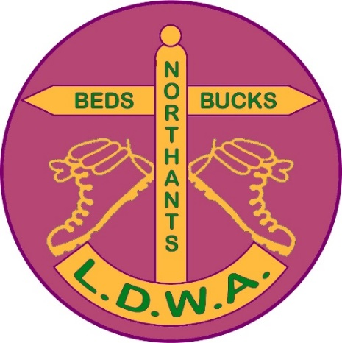

|  |  |
| --- | --- |
|  | Dear BBN-ers In my short time as Group Chair it is apparent that our Committee members work very hard on everyone’s behalf. They are a great mix of experienced ‘old hands’ and relatively ‘new blood’. They are passionate about BBN LDWA and committed to make sure that the Group is active and has a full programme of social and challenge walks that members want to enjoy and take part in. |

As well as the elected Committee, there are also those members who do ‘jobs’, take on roles and lead walks because they want to give something back to the Group in a more informal way. This is all great but we could always do with more people to get involved There are some members who have been doing a BBN job for many years and would like to be able to hand over to someone else. It’s important that we aren’t complacent and get to a point where we’ve lost all our resilience, knowledge and experience. Never forget that the LDWA and Groups are run by members who are all volunteers without whom the LDWA simply wouldn’t exist!

It would be wonderful to have a succession of new volunteers to learn how the Group works, how we do things and to generate new ideas. We have several hundreds of Primary and Associate members who I know have talents and skills we could use. Please do get in touch if you would like to be more involved, such as leading a walk, being an event marshal, helping to do the catering at our challenge events, or if you have any ideas or suggestions for what we could do.

We had a Committee meeting at the end of May. We covered, amongst other things, our forthcoming walks programme and challenge walks, publicity, our involvement in future LDWA 100 events, social events and other group activities, the LDWA’s new policy and guidance about data protection and privacy. The minutes of this meeting will be available on our website soon, please do have a look.

May I wish you all a wonderful summer of walking.

**Terry Brown**

-----------------------------------------------------------------------------------------------------------

|  |  |
| --- | --- |
| *Please remember to keep your contact details and  e-mail preferences up-to-date on the LDWA Website* | **C:\Users\gill\Pictures\untitled.png** |

|  |  |  |  |  |
| --- | --- | --- | --- | --- |
| **GROUP WALKS**  Form an orderly queue!   Here are the next dates we need to find walk leaders for :  Below are available dates for **Thursday** walks: | | | **C:\Users\gill\Downloads\WP_20171217_16_01_13_Pro (2).jpg** | |
| January 2019 | 10th |  | |
|  | 24th |  | |
| February | 7th |  | |
|  | 21st |  | |
| March | 7th |  | |
|  | 21st |  | |
| April | 4th |  | |
|  | 18th |  | |

And these are available dates for **weekend** walks. Please remember walks can be Saturday or Sunday – just e-mail me to reserve your date.

|  |  |  |
| --- | --- | --- |
| January 2019 | 5th/6th |  |
|  | 19th/20th |  |
| February | 2nd/3rd |  |
|  | 16th/17th |  |
| March | 3rd | Chiltern Kanter Challenge Walk |
|  | 16th/17th |  |
|  | 30th/31st |  |
| April | 13th/14th |  |
|  | 27th/28th |  |

If you would like to lead a walk on any of the available dates please let me know. If you would like to arrange a walk on any other date that’s fine too, but please do let me know.

One final plea – after your walk please e-mail me with your walk stats (distance and number of walkers). Thanking you in anticipation.

Best wishes and happy walking.  
**Mary Knight  
Social Walks Secretary (maryjknight@hotmail.co.uk)**

**CINQUE PORTS HUNDRED 2018**

Congratulations to all BBN members and friends who  
completed the Cinque Ports Hundred

Anne Addison Retired 49.2 miles

Dee Brockway 42:42

Luis Broz 43:06

Andy Carpenter 33:25

Helen Crossland Retired 44.7 miles

Gerald Davies 47:01

Glyn Dimmock 39:58

Philip Friede 42:42

Andrew Gilbertson 38:48

Peter Hamson Retired 58.1 miles

Gareth Hay Retired 58.1 miles

Tony Hill 32:09

Andy Hoddle Retired 58.1 miles

Frank Hodgson Retired 58.1 miles

Paul Kitson 39:47

Matthew Lane 41:23

Martin Lawson Retired 58.1 miles

Brian Layton 46:07

Alan Leadbetter Retired 44.7 miles

Sue Leonard Retired 64.0 miles

John Manning 32:09

Chloe Ratcliffe 46:57

Kim Reed 33:39

Jared Walbridge 24:38

Lisa Joanne Walbridge 24:38

Jill Green 42:42

John Esslemont 46:19

Jim Catchpole 42:42

**BBN GROUP CHECKPOINT ON 2020 LDWA 100 “Y 100 SIR FYNWY”**

The LDWA 100 in 2020 is being organised by the South Wales Group in Monmouthshire. It is called the “ **Y100 Sir Fynwy**”. Exactly!!!!

BBN has a checkpoint at Aberavon Guide Hall which is at the 40 miles point. This is an important checkpoint as it is just before the walkers set off into the Black Mountains. More importantly, it is indoors and means we will be dry!   
For those of us who’ve not been to Wales before an illustration of the difference between Winter and Summer.….

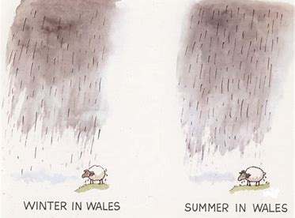

The hall is provisionally booked from 16.00 Saturday to 08.00 Sunday - it won't be open anything like that long, but we will need plenty of time to set up / clear up as required. I imagine it would be scheduled to open around 19.00 and to shut around 6.00am or a bit earlier.

Ideal numbers for a 100 checkpoint are 15 people but the more the merrier. Many hands make light work, but too many cooks spoil the broth. That’s always confused me!

Joking aside, if you’re interested then please contact me. Someone already has!

**Norman Corrin**

.**Brewery Walk – Saturday 18th August**

Full details in the programme at the end of the Newsletter

Please check wih John to see if there are places still available

**CHILTERN KANTER 2019**

The 20th Chiltern Kanter will be held on Sunday 3rd March 2019 with the usual choice of 3 distances, either 26, 18 or 13 miles. See the Walks Programme at the end of the Newsletter for full details.

This is the last event that Mike Hyland and I will be doing. With assistance from Dave & Lynn Yorston and Mike & Sandra, I’ve been involved with organising eight.

If anyone else wishes to take it over then it would be great for the event to continue. If not, then it will join the other LDWA events that have disappeared into history.

It is time consuming, but on the day when it all comes together it is very satisfying to look back and think “We did that and provided a lot of people with some great fun”. I’m sure all the participants were thinking how much fun they were having on top of Ivinghoe Beacon in March 2017!

For anyone who is interested in taking this over and wanting advice, please email me at my address on the Newsletter. I’ll be only too happy to chat.

**Norman Corrin**

**THE BEDFORDSHIRE WALKING FESTIVAL   
8TH TO 16TH SEPTEMBER 2018**

Join in the Bedfordshire Walking Festival 8th to 16th September 2018.

Come and explore our surprising little county.

This year’s walking festival offers a wide variety of walks from our short child friendly activities and interest walks, through our Ramblers led half day and full day walks, all the way up to our long distance challenge walks.

With over 50 walks and activities on the programme there is something   
for virtually everybody.

<https://www.bedswalkfest.co.uk/>

Welcome to the 2018 Bedfordshire Walking Festival

BBN made a donation of £60 to the Beds Walking Festival, which has been acknowledged by Barry Ingram, the Festival organiser:

*Hi Peter,*

*As organiser of the Beds Festival may I take this opportunity of saying a big thank you to the LDWA for their generous contribution towards the annual Bedfordshire Walking Festival which this year is 8th to 16th September.*

*One of your members Roy Carter is leading a long walk on Sunday 9th and there will be another long walk on Tuesday 11th, both in the North Bedfordshire Area. We will be holding the annual Greensand Challenge over the weekend of 15th & 16th September.*

*I have given the LDWA a paragraph in the programme describing what you do etc as the festival encompasses health walks through to the LDWA type walks.*

*Thank you again for the donation and your good wishes for the festival.   
Best Regards*

*Barry Ingram*

**-----------------------------------------------------------------------------------------------------------**

**THE FIVE-MINUTE TEA BREAK**

When I first joined the BBN Group more than a quarter century ago, the rules for breaks in social walks were fairly straightforward. We would have a 10-minute tea break around 11 in the morning, followed by a half hour around 12:30 or 1 o'clock for lunch. In mid-afternoon we would have a second 10-minute tea break. There were some exceptions to the rules, for example, if the lunch break was extended to permit a pub meal, but in general the walk leaders adhered to this schedule.

Recently, I have attended walks with five-minute afternoon tea breaks or even no tea break at all. I can understand why breaks might be curtailed between the start of November and the end of January, in order to maximise the hours of daylight available for walking. I can also accept the elimination of the afternoon tea break, especially on walks in cold or wet weather over exposed terrain. However, a five-minute tea break is to me the worst of both worlds. My view, of course, may not necessarily be shared by the Committee or Officers of the BBN Group, or by members of the Group at large.

When we stop for a tea break, I have to do things that ought to be done in approximately the following order:

1. Remove gloves (if wearing them)
2. Unhitch chest strap on rucksack
3. Unhitch waist strap on rucksack
4. Remove rucksack
5. Open drinks compartment
6. Remove drinks container
7. Open main compartment
8. Remove food container
9. Open drinks container
10. Open food container
11. Unwrap contents of food container
12. Eat food
13. Consume drink
14. Replace food wrapper in food container
15. Close food container
16. Replace food container in rucksack
17. Close drinks container
18. Replace drinks container in rucksack
19. Close main compartment of rucksack
20. Close drinks compartment
21. Put rucksack on back
22. Hitch chest strap
23. Hitch waist strap
24. Put gloves on (if necessary)

Steps 1-11 and 14-24 may take me up to five minutes, leaving me little or no time for steps 12 and 13. I admit that my movements may have slowed with age, but as long as I can keep up with the group on the walk itself, I can see no reason why the walk leader cannot show a bit of consideration.

On a recent walk, the leader announced a five-minute tea break and five minutes later set off without further warning, leaving me somewhere around step 14 above. One moment the group was there, and the next minute I was on my own. Although I did catch up with the group fairly quickly, I could do so only by taking steps 14-23 on the trot. As for step 24, I can only hope someone has come by later and taken home a wholly serviceable pair of used gloves.

**Peter Simon**

**BBN BRANDED GARMENTS**

It’s been some time since I wrote the user guide to ordering BBN branded garments and Merrian pointed out that the Peco website had changed.

To simplify ordering the person I’ve been in contact with has quoted prices for the garments with one logo including postage or with two logos including postage.

The range of garments is shown below.

**Fleeces**

|  |  |  |
| --- | --- | --- |
| **Fleece Code** | **Gender** | **Description** |
| RE36A | Unisex | **PolarTherm jacket** |
| 8740M | Unisex | **¼ zip outdoor fleece** |
| 8700M | Male | **Full-zip outdoor fleece** |
| 8700F | Female | **Women's full-zip outdoor fleece** |

**Beanies**

There are 3 types of Beanies available shown below. All available in burgundy.

|  |  |  |
| --- | --- | --- |
| BC426 | BC044 | BC045 |
|  |  |  |
| Original Pom Pom Beanie | Original Pull | Original Cuffed Beanie |

The badges may have to be reduced in size slightly to fit onto the beanies as you only have a certain area to play around with.

When personalising these items the location of the badge on the beanie is Front Centre. To be clever you could have the group logo on the front and the SSS logo on the back.

**T-Shirts**

|  |  |
| --- | --- |
| JC001 Cool T | JC005 Girlie Cool T |
| [http://peco.yourwebshop.com/images/Catalog/Product/0329910_232.jpeg](http://peco.yourwebshop.com/product/jc001-cool-t?SearchTerm=jc001) | [http://peco.yourwebshop.com/images/Catalog/Product/0329946_232.jpeg](http://peco.yourwebshop.com/product/jc005-girlie-cool-t?SearchTerm=jc005) |

The reference number for the garments and the prices for either one or two logos are as below.

GARMENTS WITH JUST ONE LOGO INCLUDING POSTAGE

Fleece RE36A £19.30+vat = £23.16 each

Fleece 8740M £22.45+vat = £26.94 each

Fleece 8700M/8700F £23.30+vat = £27.96 each

Beanie BC426 £8.35+vat = £10.02 each

Beanie BC044 £7.85+vat = £9.42 each

Beanie BC045 £8.50+vat = £10.20 each

T-Shirts JC001/JC005 £9.10+vat = £10.92 each

GARMENTS WITH TWO LOGOS INCLUDING POSTAGE

Fleece RE36A £22.15+vat = £26.58 each

Fleece 8740M £25.30+vat = £30.36 each

Fleece 8700M/8700F £26.15+vat = £31.38 each

Beanie BC426 £11.20+vat = £13.44 each

Beanie BC044 £10.70+vat = £12.84 each

Beanie BC045 £11.35+vat = £13.62 each

T-Shirts JC001/JC005 £11.95+vat = £14.34 each

Reference code for Logos

For the BBN logo quote *SD3475*, for the SSS logo quote *SD3476*

The website is [www.peco.ltd.uk](http://www.peco.ltd.uk)

To view the garments

1. Click on Catalogue
2. In the search box headed “I’m searching for” put in JC001 for a male T-shirt or JC005 for a female t-shirt
3. Click on the magnifying glass
4. This will display the T-Shirt headed JC001/Cool T or JC005 Girlie cool T.
5. Click on the picture
6. The list of available colours will appear to the right of the picture of the screen (within the catalogue not the windows screen)
7. The T shirt is displayed in burgundy

To order the garments

Instead of using the customisation section on their website it is easier when purchasing a garment (or garments) from Peco to order it as follows

Click on Contact Us

Click on [info@peco.ltd.uk](mailto:info@peco.ltd.uk)

Below is a sample order. This can be used for ordering a T-Shirt or Fleece or Beanie.

I'd like to order the following:

*8740M fleece in Burgundy, SD 3475 (Left Chest), SD 3476 (Right Chest). This should cost £30.36*

Please supply the size of the garment and your full name and postal address.

The delivery time is between 7/10 full working days on receipt of payment**.**

Good shopping!

**Norman Corrin**

**-----------------------------------------------------------------------------------------------------------**

**LUTON HOO**

Luton Hoo is privately owned but you can drive up through the gate and see the magnificent building or stop to have afternoon tea or even arrange for a very stylish wedding! In fact it was the site of one of the weddings in the film “Four Weddings and a Funeral“ with Hugh Grant.

The last private owner of Luton Hoo, Mrs Phillips and her family, sold off the big mansion in the 1990’s but retained the farm, numerous houses and the walled garden which was designed by Capability Brown and is now being restored by a group of volunteers of which I am a member. The walled garden and woodland are open to the public every Wednesday from May to September. The cafe is open all year round. There is a plan to arrange tours of the estate, including the site of the estate's own railway station, which we passed on Peter Simon’s recent walk. No date for this to take place yet, but I will let you know.

Please see the following link for more information:

<https://www.lutonhooestate.co.uk/walled-garden>.

**Therese Jamin**

**-----------------------------------------------------------------------------------------------------------**

**NOTICE OF AGM  
SUNDAY 25TH NOVEMBER 2018**

Blisworth Village Hall, Stoke Road, Blisworth NN7 3BZ  
The AGM starts at 14.00

**PROPOSED BUCKINGHAMSHIRE WAY**

Rupert Barnes, a councillor of Three Rivers District, is trying to develop a Buckinghamshire Way and hopes to find a person to talk to regarding possible routes, especially concerning the southern end of the historic county. If any of our members can offer some advice, please contact Rupert at [rupert.barnes@threerivers.gov.uk](mailto:rupert.barnes@threerivers.gov.uk).

Rupert has gone out to explore if it is a practical proposition and concluded that it is. His goal is to draw a walking route, with as little road as possible, from the southernmost point of the historic county of Buckinghamshire to its northernmost point. He claims that northern section does work - the North Bucks Way provides a good route as far as Milton Keynes, and north of Wolverton there are sufficient, good paths to get to Northey Farm at the northernmost point of the county. (From Northey Farm you'd have to trek back to Lavendon for the bus). Rupert believes that the middle section should work too. While a good deal of the prospective route is on paths he has walked on occasion before, it still needs checking.

The proposed southern starting point does not work. The southernmost point of the county is on the Thames at Hythe End, a village full of dead ends and inaccessible, private closes. Paths Rupert expected to join up did not. A stretch across to Wraysbury station turned out to be a narrow path neck-high in nettles.

-----------------------------------------------------------------------------------------------------------

*Hi*

*I entered the Oxon 20 in May 2018, as a runner, in preparation for an Ultra Marathon. I’m not a quick runner, and thought the Challenge event would be good experience. I found the Oxon LDWA such a warm and welcoming group, from arriving at the car park, to leaving at the end of the day. Everyone was so friendly.*

*Off the back of this, I have now joined the LDWA, the Bucks branch, with the view of not just enjoying their Challenge events, but also in volunteering, giving back, to what is such an excellent Association for those interested in long distance walking and running. Thank you.*

*Alison Roberts*

**WALK LEADERS**

*Please remember ….. Please remember ……. Please remember*

***to take an Emergency Contact Details sheet to your walk***

**All forms can be found on the BBN Website :** [**BBN Documents**](https://www.ldwa.org.uk/BedsBucksAndNorthants/W/1045/document-store.html)

Walk leaders- please print off the form  
***Emergency Contact Details - Non-LDWA participants*** from the BBN website.

Before the walk starts non-LDWA members should fill in their emergency contact details. Following data protection rules, the form must be destroyed at the end of the walk if there have been no reportable incidents involving the non-members.

**Reportable incidents**Walk leaders/event organisers should familiarise themselves with the LDWA's advice on what constitutes a reportable incident and what needs to be done if such an incident should occur. Please look at the *Accident & Incident Form* on the LDWA website [www.ldwa.org.uk/library/library.php](http://www.ldwa.org.uk/library/library.php). (Keep scrolling down, it is near the end.)

**BBN members** are urged to carry their own emergency information.

You can use the ICE form on the BBN website

****

**-----------------------------------------------------------------------------------------------------------**

***BBN HOLIDAY - HARTINGTON   
24th – 27th AUGUST 2018.***

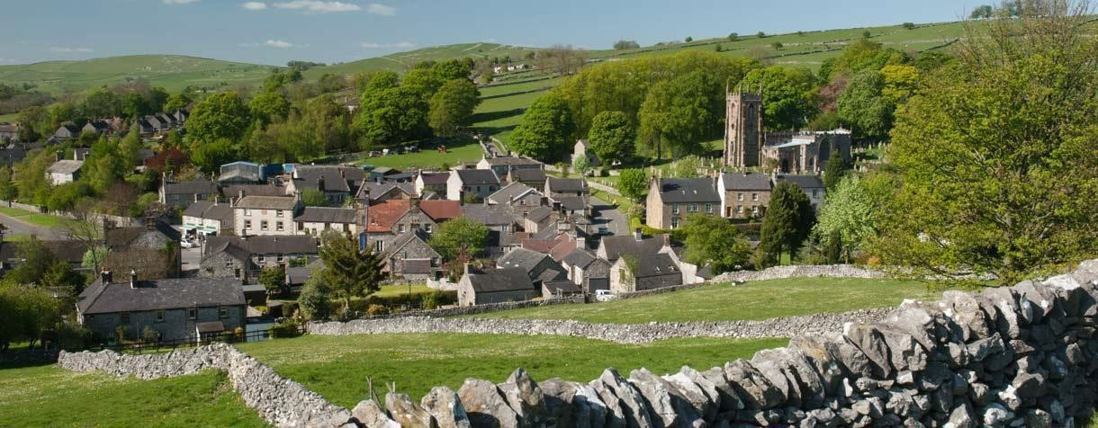

A fabulous weekend of walks in beautiful countryside.  
Join Roy for one, two, three or all four days !

See full details on the BBN website [Hartington Weekend](https://www.ldwa.org.uk/BedsBucksAndNorthants/W/5686/hartington-we-24th27th-aug-2018.html)   
and in the programme at the end of this Newsletter.



**Bit of a sporting theme…..**

Seen on Facebook two days before the Champions League Final from a Liverpool Fan:

*“I've got 2 Tickets for the CL Final Saturday but forgot I'm getting married*

*So I can’t go.*

*The Church is St Philips in Kensington. The wedding is at 3 pm and the bride’s name is Sarah. She’s the one in the white dress at the altar*.”

---------------------------------------------------------------------------------

1981:

1. Prince from England married

2. Liverpool wins the Champions League

3. The pope dies

2005:

1. Prince from England married

2. Liverpool wins the Champions League

3. The pope dies

2018:

1. Prince from England gets married

2. Liverpool keeper saves the Pope

----------------------------------------------------------------------------

Wayne Rooney went to visit Sir Alex Ferguson in hospital.   
“He still slurs his word but he can string a few sentences together“ said Ferguson.

-----------------------------------------------------------------------

A horse is in a pub having a few beers when he spots a donkey in the corner so he goes over for a chat.

The donkey asks “What do you do for a living?”

The horse says “I run on the flats in the summer and do the jumps in the winter.”

And the donkey says “I work with the kids on the beach.”

He asks the horse “Did you win anything?”

The horse replies “Yes, on the flats I won the Oaks, St Leger and the Derby. And over the jumps I won the Grand National and the Gold Cup.”

They arrange to meet at the donkey’s house the following week and the donkey thinks “I really need to impress this guy…he's done everything”. So he goes out and buys a big picture of a Zebra and hangs it above his fireplace.

The horse arrives and says “Lovely place you have here, who’s that in the picture on the wall?”

The donkey replies “That’s me when I used to play for Juventus”.

**Norman Corrin**

**……………………………………………………………………………………………**

**LAND'S END TO JOHN O' GROATS, AND HOW 4 PENSIONERS DID IT.**

**BY ANDY PIKE (29630A), AND MEG PIKE (29630B)**

Towards the end of 2009, we received an email from our friend Bob- “How about Land's End to John O' Groats for our next project?” Thinking he was joking Meg replied “Why not, when shall we start?”

We had previously walked the Offa's Dyke path with Bob and Lynne and it had been a great time. It is the logistical problems that arise when attempting a linear walk, that need a good solution. We had solved this by using our two cars and two small touring caravans.

Both the Caravan Cub and the Camping and Caravanning Club have a national network of both Club Sites and also small privately run 5 van sites. Our plan was to park the caravans at one of these, in the centre of a 60 mile section, and then to use our cars to walk the two sections to site and the two sections on from site. (If there was any suitable public transport this was to be utilised.) The fifth day would be spent moving the vans onwards to the next suitable site, washing clothes and stocking up with supplies.

As there is no official route for this walk, we planned our route to coincide with suitable sites. We also wanted to avoid all major roads wherever possible and to complete the walk entirely on paths. We agreed that Bob and Andy would plan alternate 'three week' sections of the walk. We wanted to include as many long distance paths and National Parks that were practical with our aims. So we went over Bodmin Moor, crossed the corner of Dartmoor (near Okekampton), crossed Exmoor and the Quantocks. Then on to Bath via the Somerset Levels.

After this it was the Cotswold Way to Chipping Campden and onwards on the Heart of England Way towards the Peak District. At Edale we joined the Pennine

**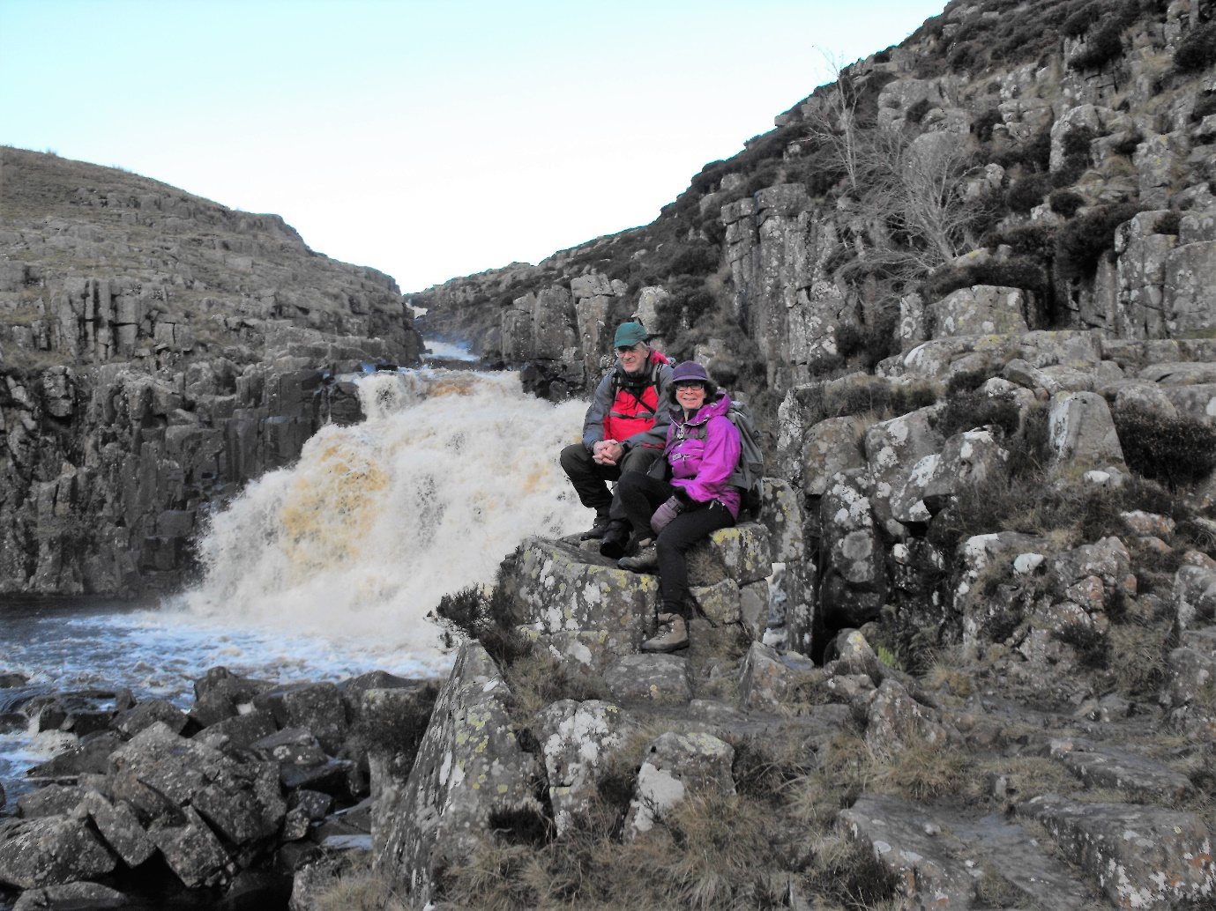**

*Andy and Meg at Cauldron Spout*

Way in its entirety to Kirk Yetholm. Wanting to include the West Highland Way we then crossed Scotland using both the St. Cuthbert's Way and the Borders Abbey route. We wanted to see the Falkirk Wheel, so used the Union Canal and some railway paths. Following on from this it was the East Highland Way to Aviemore. From here the onward route is more problematic; but apart from a short section of the A9 (but not the huge bridge north of Inverness) we got to John O' Groats on tracks and paths.

Highlights of the walk include Land's End, High Willey (on Bodmin Moor), Dunkery Beacon (Exmoor), Bath Abbey, Litchfield, Dovedale, Hollin's Cross, Kinder, Malham, Great Shunner Fell, Tan Hill, High Force, Cauldron Snout, High Cup Nick, Hadrian's Wall, Windy Gyle, Kirk Yetholm, Melrose, Peebles, Falkirk Wheel, Loch Lomond, Glencoe, Ruthven Barracks, Burma Road (Aviemore), Dingwall, Brora, Forsinard, Killimster and John O' Groat's. In total we walked

1,443 miles through some of Britain's loveliest countryside. This journey was an amazing experience!

Some of the problems encountered included: non-existent paths in Cornwall (inland), bogs in Scotland (Moss of Killimster), deer fencing across tracks, trees blown down and bridges swept away.

Meg has produced an illustrated book (over 900 photos and 112 daily logs). This is available from Amazon UK, and the ISBN number is 978-190752-731-9.

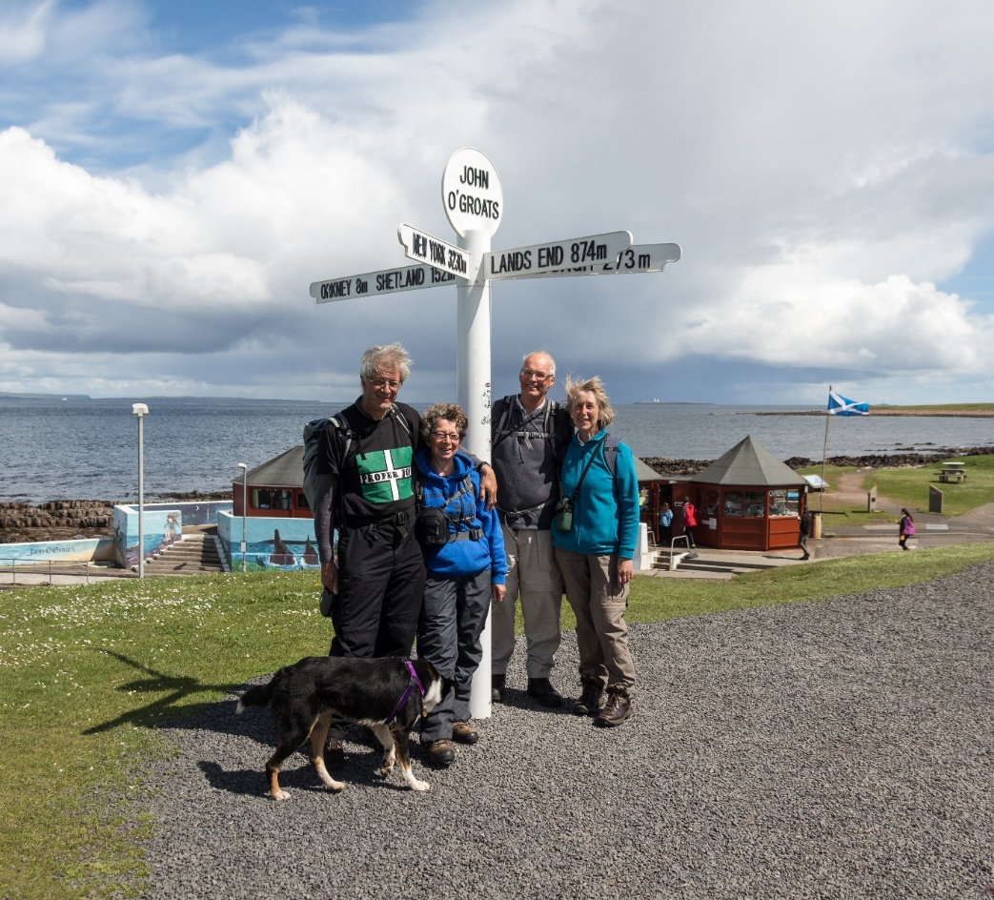

*The four of us at John O' Groats   
 (LtoR) Andy, Meg, Bob, Lynne & Dexter the dog*

As well as Land's End to John O' Groats we have also used the same method of travel to complete several other Long Distance Walks.  We have just returned from Yorkshire having walked the Dales High Way from Saltaire to Appleby in Westmorland. Previously (last year) it was the Cross Britain Way from Boston to Barmouth (this is a Macmillan Way Route). We have also walked the Cross Cotswold Path and Offa's Dyke. We have given illustrated talks about our adventures, and any monies raised have been given to Macmillan Cancer.

**Andy & Meg Pike**

**BBN AT THE MOON WALK**

For quite a while Pearl had wanted to do the Moon Walk, a night walk round the streets of London to raise money for research into breast cancer.

It was on a BBN walk not long after last year’s walk that she got talking to Gill who arranged to get a BBN team together. It was decided that we would do the Half Moon as the full 26 mile route was a bit far for Pearl. In fact Pearl wanted to do it this year as it was just before her 65th birthday and she had three friends who had survived breast cancer. When I entered us over the phone, as well as the usual questions, I was then asked “What is your wife’s bra size?” As I didn’t know I had to phone her to find out. Although it is nearly all women, they do accept a few men, who also have to wear a bra, so I ordered a big one!

As the day of the walk got nearer we started doing some longer walks, including the 17 mile distance of the Bath Beat which we did with Norman Corrin on a beautiful sunny day with great scenery. We also started fund raising.

It soon became apparent that May 12th would also be the date of the Vanarama National League play-off final. Tranmere Rovers, the team I have supported since I was about 8 years old (and that’s an awfully long time ago!), would be in the final. As the final was at Wembley, starting at 3 pm, there would be plenty of time to get from there to the start of the Moon Walk, even if they played extra time.

So on the morning of the 12th we set off for Wembley each carrying a change of clothes for the Moon Walk. The game was very eventful. Tranmere had a player sent off in less than a minute, then took the lead for about six minutes and were hanging on until just before half time when Borehamwood equalised. I really thought then that we would lose but amazingly we got the winner just about 12 minutes before the end. Those last few minutes seemed to last for ever, but finally the whistle blew and we were jumping up and down. So we are now back in the football league after an absence of three years.

We finally left the stadium after watching the players get the trophy to find it was pouring down with rain. We then had to make our way to Clapham Common for the start of the Moon Walk. Once we got there we had a bite to eat and then had to get changed. I went to a cubicle in the Gents. Here the transformation would begin from football supporter with a blue and white scarf round my neck to something that looked like it had come from the Rocky Horror Show. As I had to wear a bra (which had been nicely decorated including flashing lights by Pearl’s sister), I decided to go the whole way. I got a mini skirt from a charity shop and

an old pair of yellow tights, a blue wig and the cowboy hat which they had sent

us. I also had a pair of plastic inflatable false boobs which I put under the bra. Unfortunately one of them developed a slow puncture on the way round!   
Luckily I managed to sneak out of the Gents without anyone noticing.

We met Gill at the tube station about 8.15. There were ten of us altogether, including Gill’s sister Jackie and some friends. John Davies would join us later as he had been delayed with a puncture (a bit like my right boob!).

We walked to Clapham Common in the pouring rain to this giant marquee. Here we went to our start area, which was Blue 5. There was plenty of entertainment and warm up exercises, including taking part in the world’s biggest line dance. We had a pasta meal and some water before we started. Apparently there were 15,000 people taking part, nearly all women with just a few men. Those doing the 26 miles wore pink cowboy hats, while we had white ones for the Half Moon. It should have been 13 miles, but for logistical reasons it was 15.

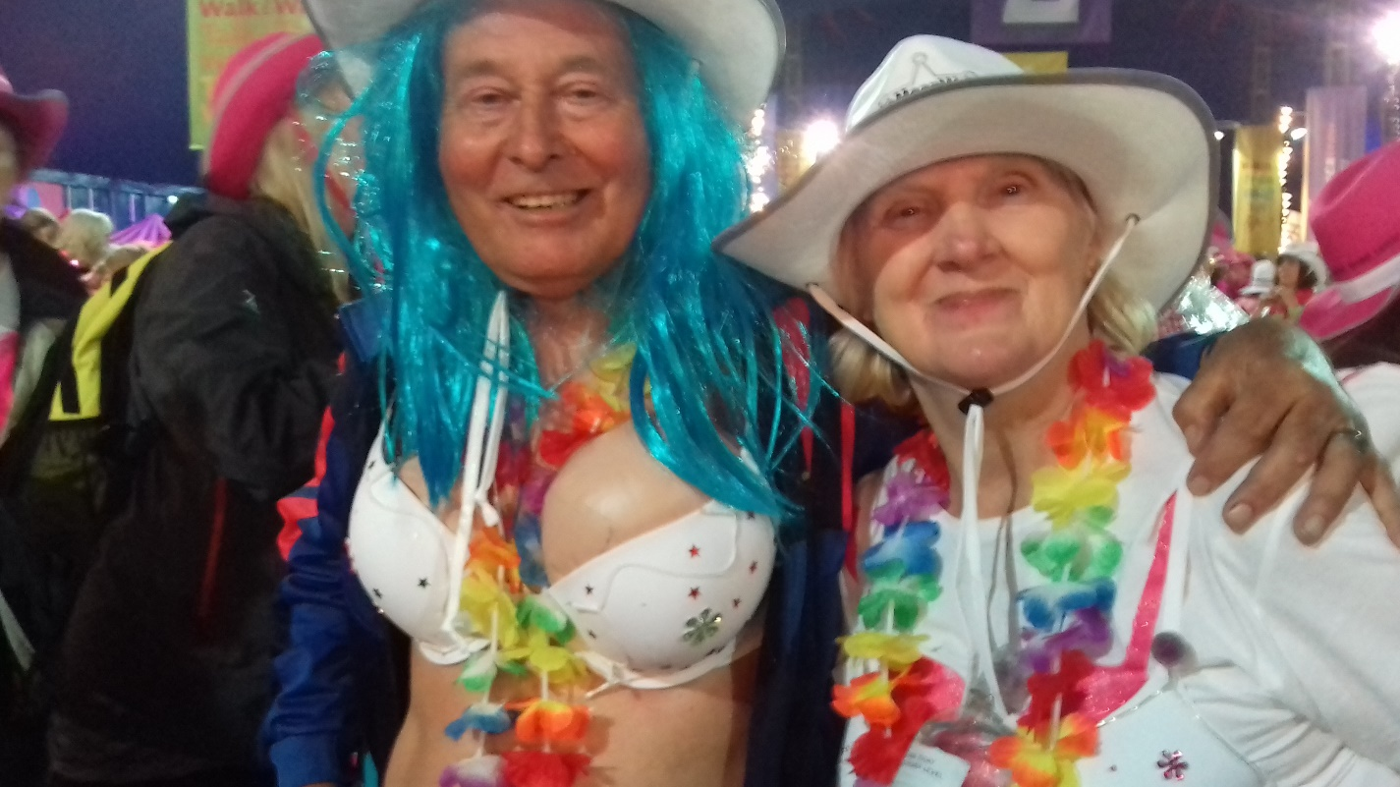

We all set off in waves with long gaps between each group to avoid bottlenecks. As we were group 5 out of 6, we were the second last to go. Luckily by the time we started, at about midnight, the rain had stopped. We walked across the Common and out on to the streets. At first we all more or less stuck together. We headed north, around Battersea Park and up towards the Thames. It was at this point that Gill fell off the side of the pavement. Luckily she wasn’t hurt. As we got up to the river we saw the London Eye which was lit up pink just for the

walk. It was a magnificent sight, so Pearl and I stopped to take a picture. It was at this point that we lost touch with the rest of the group but we didn’t want to push it to try and catch them. We followed the south bank of the river with some great sights of St Paul’s Cathedral and, when we crossed London Bridge, of Tower Bridge. We then headed through the City of London, passing St Paul’s and on to St James’ Park.

By now Pearl was getting quite tired as she’d never done a night walk before. At Hyde Park Corner we headed south, while those doing the 26 mile route set off round Hyde Park and Kensington Gardens. We finally crossed Chelsea Bridge, the last few miles seemed to take an age. Eventually the 15 mile marker came up, but it was still about another half mile back to the finish.

Pearl was quite exhausted but elated to have finally finished and get her medal. She has walked further, but not at night with no sleep and not all on pavements and roads. I felt quite tired at the start. I think I felt a bit drained after the excitement of the football match. Though I have walked through the night a few times on the 100, those events start in the morning and not at midnight. Still it was great to finish.

I think Pearl and I raised well over £300 between us and I think the rest of the group raised nearly £2,500, and the event itself made a few millions. We had a quick coffee, got changed and headed home. We had finished at 5.15 exactly, five and a quarter hours.

It was just getting light about two miles from the end and we could hear the dawn chorus. We finally got home and straight to bed at about 9.45am for a few hours sleep. The end of a great day and a great night.

**Steve Smith**

**-----------------------------------------------------------------------------------------------------------**

**Moonlight and Stetsons**

Seems long ago and far away - in fact, ‘twas just last year

That cousin Gill said she had had a brilliant idea.

“Why don’t we do the Half-Moonwalk to help people in need?”

We had a think and, very soon, we said that we agreed.

“We need a name to register” said our team leader Gill.

Bras, Blisters and a Good Old Natter seemed to fit the bill.

We duly filled in all the forms and so our fate was sealed.

We bought ourselves some walking gear and had our boots re-heeled.

“It’s only fifteen miles” she’d said. “So it will be a breeze.

Just go out walking every day, then you’ll do it with ease.”

We pounded paths in Beds and Bucks - there was no stopping us.

We walked in snow and rain and sun, and cheated with a bus!

In six short months we got in shape and started feeling fit.

It soon was May and, OMG, now this was really it.

We went right down to London, dressed up in Wild West clothes

With frilly skirts around our waists and Compeed on our toes.

Some chilli rice, some Dolly songs, a warm up in the tent.

A cheer went up, the whistle blew and on our way we went.

We’d reached the start in heavy rain with storm clouds in the sky

But, luckily, throughout the walk we managed to stay dry.

We crossed the Thames so many times and saw the London Eye.

Cars tooted us and people clapped as we walked quickly by.

The queues for loos were really long and that was quite a blow.

A muscle pulled – it slowed us down. But onward we did go.

For hours we walked right through the night. Then we were back at base

With tired legs and aching feet and slightly flushed of face.

Bright medals hanging round our necks. A change of clothes put on.

Hot tea and food to warm us up. And, after that, we’re gone.

So glad we did it and survived. So pleased we raised some dough.

Though next time Gill has bright ideas, we might just tell her “no!”

But, honestly, we had good fun. And, just to keep things short,

We’d like to say a HUGE BIG THANKS to you for your support.

PS

If anyone has any need for Stetsons pink and white,

Please let us know and they are yours – to get them out our sight!

**Beryl Bowley & Valerie Hayward**

(long-suffering cousins of Gill Bunker)

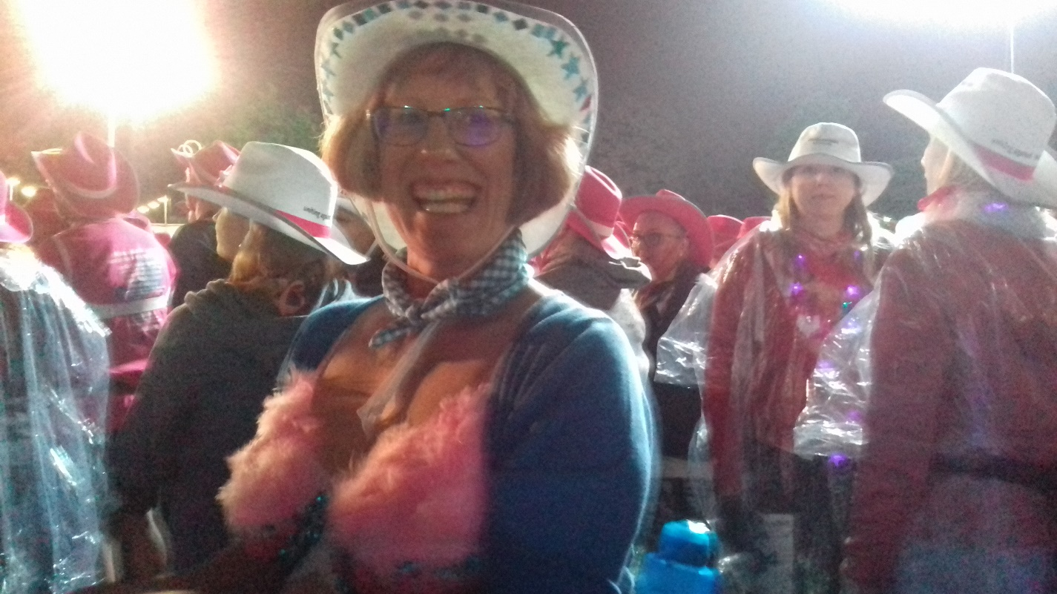

*(Sorry the photo is a bit dark, it was coming   
up for midnight, outside, great excitement,   
we were about to start walking)*

*On 12 May I was part of a group of 11 who participated in the London Moonwalk.  
I had decorated my bra and hat and was ready for the off. To be one of 15,000 taking part was such an experience with everyone in some sort of attire decorated. It was such a great atmosphere with everyone having great fun in raising money for a great charity Walk the Walk. We started the walk minutes before midnight and completed all 15 miles of it by 5.00 am.   
I was proud to be part of this great fundraising event and would like to say thank you to the BBN for donating towards our joint fundraising total.*

***Karen Earwicker***

*We did ithttps://static.xx.fbcdn.net/images/emoji.php/v9/fa8/1/16/1f396.png The rain stopped just in time and my feet held out (the inventor of Compeed needs a medal too). A great atmosphere and unforgettable experience. Thank you so much to everyone for your support.https://static.xx.fbcdn.net/images/emoji.php/v9/f7f/1/16/1f60a.png*

***Claire Beagent***

*15 mile power walk through London they said. You'll be fine. It will be fun! Stomping through London in your bra. At midnight. OK, I said. I'm sure it will be fine, as long as I have enough sweets to help power me along. And I remember to actually get some training in beforehand...*

*Just a few days to go and my silly old skin and blister had overdone the flip-flops in the hot weather and gone and covered her feet in blisters, so there was a fair chance the team would be carrying her round just to add to the challenge!*

*Thanks to everyone who has sponsored us and helped me and some of my fabulous female relatives raise some money for local and national breast cancer charities. Your support is really appreciated!!*

***Sarah Bowley***

The BBN team: Claire Beagent, Beryl Bowley, Sarah Bowley, Gill Bunker,   
Jackie Burnett, John Davies, Karen Earwicker, Valerie Hayward, Pearl Smith, Steve Smith, and Rachel Martin (not able to walk with us this time).

Thank you to BBN for your generous donation. Our team raised nearly £3,000 and the 2018 Moon Walk has raised over £4,500,000 to date.

**WINTER TANNERS 1976**

The story in the April Strider re the Winter Tanners touched a nerve with me.   
I took part in the inaugural event on 11 January 1976.

|  |  |
| --- | --- |
| To be honest I don’t recall much about the event. I think we started around 8.00am with view to getting everyone home in daylight. I think there was some form of post box where the late finishers could post their finishing time. It certainly was very muddy and I think Mike Powell-Davies did most of the navigation. My excuse was that I’d run the Mitcham Athletic Club’s 25km road race the day before. | C:\Users\gill\Downloads\003 (2).jpg |

Lots of interesting names in the results: Alan Blatchford and Chris Steer, founders of the LDWA for example. Alan was obviously organising whilst walking, otherwise he could have easily run quicker than we did.

**The history of the Winter Tanner by John Westcott (LDWA 679)**

A 30 mile challenge walk in the middle of Winter with the start/finish in an open car park (no nearby toilets) and only two open air checkpoints at which cold drinks were served.

No 21st century LDWA walk organiser would dare to suggest such an event, yet this is the basis of the Winters Tanners, an event set up in the LDWA pioneering days which, after 40 events, is still very popular.

The first Winter Tanners was held in 1976 as an informal first walkout of the proposed route for the 17th Tanners Marathon. The following entry under “Future Events” was in the November 1975 (number 13) LDWA National Newsletter (predecessor to *Strider).*

***JANUARY 11th – WINTER TANNERS- Mid-Surrey***

*When the Tanners Marathon was originally planned, the first Sunday in July was chosen because there would be plenty of daylight and the ground would be dry and firm.   
Now there is to be a preview walk over the 1976 route (30 miles) when conditions are expected to be at their worst and daylight minimum. The event will be informal but only strong walkers should contemplate coming. Start and finish at Leatherhead, Surrey.*

At some stage that summer I must have chatted with Alan Blatchford about organising an event in the Chilterns. Hence the following March saw the inaugural Chiltern Kanter from Ivinghoe Youth Hostel. 12/20mile map-reading courses with no support. Tea and cakes back at the Hostel.

**Brian Graves**

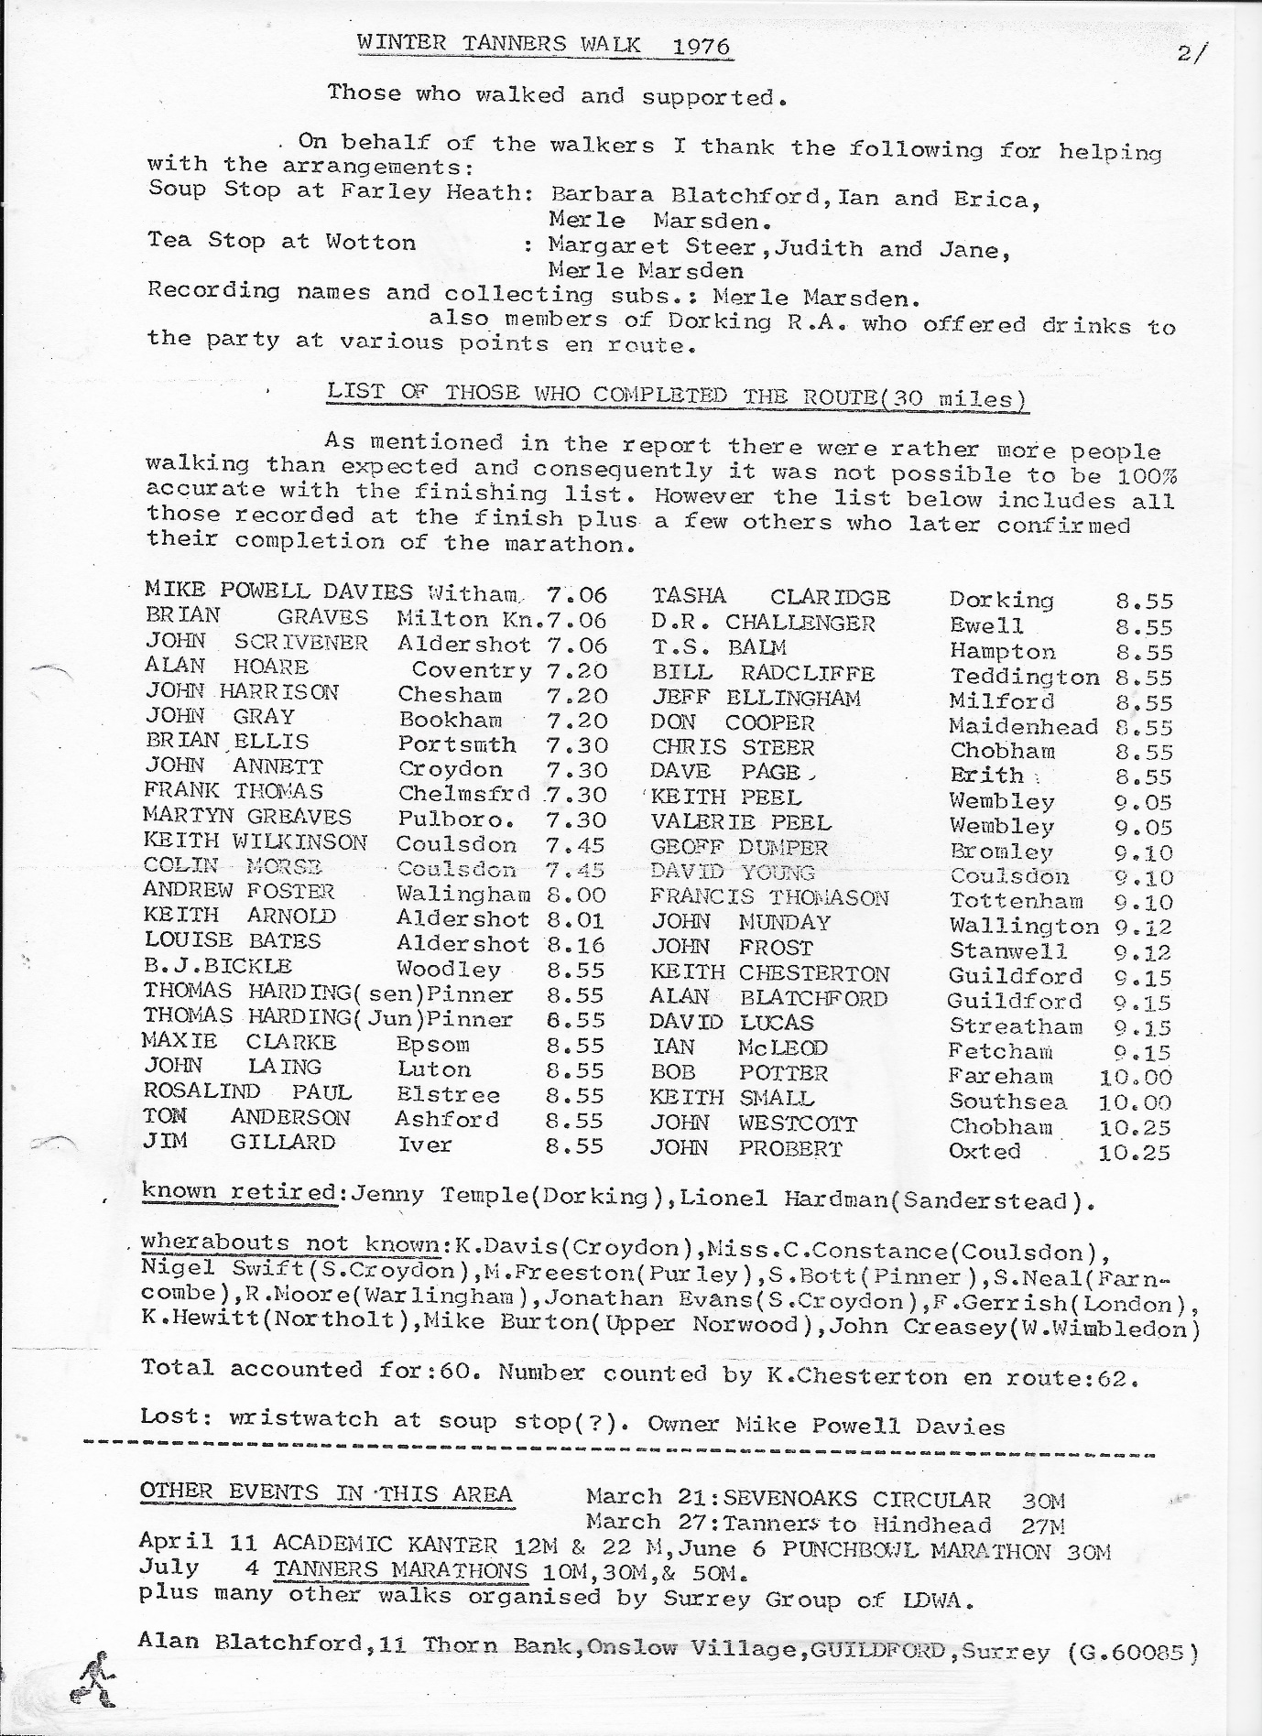

|  |  |  |
| --- | --- | --- |
|  | **WALKS PROGRAMME**  **JULY TO DECEMBER 2018** |  |

**Sun Jul 8 2018 Cr3am T3a Trot to Stow3**

18ml. 09.00 From Chackmore c.p. area, just off Stowe Avenue. Maps: LR 152 Exp 192 (GR SP685357). Cream Tea 'lunch' at Stowe Café. Obviously the more calories consumed the longer the walk. ***C:*** Norman Corrin ***T:*** 01908 608667 ***M:*** 07980 378656 on the day.

**Thu Jul 12 2018 Roger’s Birthday Walk**

15ml. 09.30 From Ampthill Park c.p. (not football club). Map: LR 153 (GR TL025382). Figure of 8 walk. If you buy a drink you can eat sandwiches in the pub. ***C:*** Roger Skerman ***T:*** 01525 405540 ***M:*** 07757 057440.

**Sun Jul 15 2018 Hannington Hike Challenge Walk**

27, 18 or 13ml. all to finish by 18.30. Hall closes 19.00. From Wellingborough Grammarians Memorial Sports Field, Sywell Road, Wellingborough NN8 6BS (GR SP856690). A walk around the Northamptonshire rolling countryside. Start: Walkers from 08.00, Runners and fast walkers and all short route from 09.00. Entry Limit 200. No entries OTD. No Dogs. YOU MUST DOWNLOAD & PRINT YOUR OWN ROUTE DESCRIPTION. Route description will be on website from 5th July 2018. If you are unable to do this, please include SAE size C4 with a large letter stamp with your entry marked ‘route description’. We recommend you wear suitable footwear & clothing, also to have maps LR152 or Exp 223 & 224, waterproofs, your own drinking mug (no mugs will be supplied at Cps) & a compass. SIentries close on Sat 7th July 2018. Postal entries must reach us by Tue 3rd July 2018. Entry: £8, non LDWA £12, under 18s free (No entries OTD) incl refreshments at Cps (3 on 27ml, 2 on 18ml, 1 on 13ml), light meal at finish, cert & badge. Chqs payable to LDWA BBN Group. Entry form downloadable from event website. Online entry at: <https://www.sientries.co.uk/event.php?elid=Y&event_id=4028>   
***C:*** Mike Hyland, 55 Broadlands Ave., Chesham, Bucks, HP5 1AL ***T:*** 01494 774154. ***E:*** [mike.hyland@ntlworld.com](mailto:mike.hyland@ntlworld.com) ***W:*** <https://www.ldwa.org.uk/bedsbucksandnorthants>

**Sat Jul 21 2018 Stepping out to Stoke Bruerne**

18ml. 09.00 From Watermill Lane c.p. Stratford Road, Wolverton Mill, Milton Keynes. Maps: LR 152 Exp 207 (GR SP796408). Lunchtime p.h, café and toilets. ***C:*** Gill Bunker ***T:*** 01908 321308 ***M:*** 07790 976090 on day only.

**Thu Jul 26 2018 Another Stroll From Shefford**

16ml. 09.30 From Old Station Way free c.p, Shefford. Map: Exp 193 (GR TL143391). ***C:*** Terry Brown ***T:*** 01462 631057 ***M:*** 07932 627476.

**Sat Aug 4 2018 Cakes, Coffee and Ice Cream from Rushmere**

17ml. 09.00 From Rushmere Country Park Visitor Centre c.p. Map: Exp 192 (GR SP912284). 3 loops (8, 5 and 4ml), pub stop. Parking £3 pay on exit, refreshments available.. ***C:*** Peter Engledow ***T:*** 07733 323641.

**Thu Aug 9 2018 Bash it! Beat it!....All Bound from Barton!**

15ml. 09.30 From Old Road, Barton Le Clay. Please park considerately near entrance to recreation ground. Maps: LR 166 Exp 193 (GR TL083305). Lunch stop near pub in Silsoe. ***C:*** Dee Brockway ***T:*** 01582 881809 ***M:*** 07742 433951.

**Sat Aug 18 2018 Brewery Walk – Booking Needed**

12ml. 10.00 From junction of Barlow Road and Woollerton Crescent E of B4009, NE of Wendover, HP22 6HS. Maps: LR 165 Exp 181 (GR SP875081). Saturday walk with a late start, limited numbers. Cost £10, £5 deposit required. .Please check with John to see if places still available. Later finish than normal because of the brewery tour timing. A small amount of food will be supplied with the various different beers, but you still need to carry food for the lunch stop. ***C:*** John Davies ***T:*** 01442 874875 ***M:*** 07949 796470.

**Thu Aug 23 2018 Saints and Cobblers – Where’s Greavsie?**

15ml. 09.30 From Great Houghton Village Hall (Parsons Memorial Hall), off Leys Lane, Southern end of village NN4 0AN. Maps: LR 152 Exp 207 (GR SP795583). A sport themed walk also visiting sites associated with WW1. There will be some urban walking through Northampton. ***C:*** Adrian Moody ***T:*** 01993 314134 ***M:*** 07788 684394.

**Fri-Mon Aug 24-27 2018  
\*\*POP UP\* BBN Weekend – Hartington  
*C:*** Roy Carter [roycarter367@hotmail.com](mailto:roycarter367@hotmail.como)***T:***01234 301182 ***M:*** 07784208997.

*Accommodation will need to be obtained in Hartington or in the surrounding villages. There are many Guest Houses, B&B’s, Rental Properties, Campsites and Youth Hostels in the area but they do get booked up early – please contact the organiser Roy Carter to indicate interest.*

**Walk Itinerary:**

**Friday 24th August @ 1:30pm 9 miles**

The walk starts from the centre of Hartington by the Duck Pond and crosses the River Dove to climb uphill to the hamlet of Sheen. Passing the church and staying on the ridge between the Dove & Manifold valleys, we descend to Crowdecote for an afternoon stop at the Pack Horse Inn. Afterwards we follow the River Dove down to the remains of Pilsbury Castle – an Iron Age fortification used by the Normans – then onwards to Hartington.

**Saturday 25th August @ 9:30am 17 miles**

The walk starts from the centre of Hartington by the Duck Pond and heads south

to Beresford Dale, above Narrowdale before descending to Hopedale. The walk gradually climbs back up to Castern Wood and Castern Hall where there are lovely views of the Manifold Valley before dropping into Ilam Country Park (NT) and Hall (YHA) for lunch. After lunch we cross the stepping stones over the River Dove and follow the valley up to Milldale for afternoon tea. We then continue up Dovedale to Hartington via Wolfescote Dale.

**Sunday 26th August @ 9:30am 17 miles**

It is a 25 minute drive north to the start of the walk from White Lodge Car Park (charge), situated just off the A6 near Monsal Dale. We walk up Monsal Dale and cross the Monsal Trail to Cressbrook Mill – a textile mill built by the father of the Industrial Revolution, Richard Arkwright. Then follow the River Wye through Miller’s Dale to Litton Mill keeping to the valley floor and pass through Tideswell Dale to Tideswell for a break. After we make our way to Monk’s Dale and descend to Miller’s Dale again for lunch at The Angler’s Rest. In the afternoon we walk the Monsal Trail to Ashford in the Water – a former Midland Line rail link from Manchester to London closed by Barbara Castle (not Beeching) in 1968. Returning beside the River Wye to the carpark.

**Monday 27th August @ 10:00am 13 miles**

The walk starts from the pond at Monyash, just 15 minutes north of Hartington. It follows the Limestone Way over fields and past farmyards before a steep climb out of Cales Dale. We walk round to Middleton and descend to the River Bradford and follow it to Youlgreave for a break. The walk continues further down river to Alport and up Lathkill Dale - one of the finest limestone dales. Leaving it we ascend to Over Haddon to enjoy lunch and views down the dale from the Lathkill Hotel. In the afternoon we return to Lathkill Dale and follow it back to Monyash for tea in the café before the homeward journey.

**Sun Sep 2 2018 Ousehug Wander**

18ml. 09.00 Bromham Mill c.p. MK43 8LP. Map: Exp 208 (GR TL010507). Bring provisions, but additional food/drink may be available during the walk. ***C:*** Christine Bramley ***T:*** 01234 822557 before 8.30pm.

**Thu Sep 6 2018 Last of the Summer ?**

15ml. 09.30 Summer Leys Nature Reserve c.p. Map: LR 152 (GR SP886633). Lunch stop in Earls Barton. Easy shortcut after lunch cuts off 4 ml. ***C:*** Geoff Curnock ***T:*** 07941 413318.

**Sun Sep 9 2018 North Bedfordshire Wolds**

19ml. 09.00 Keysoe Row, Village Hall, MK44 2JE. Meet at the village hall c.p. There is a suggested donation charge for parking of £1. Maps: Exp 208,224,225 (GR TL081611). This BBN walk is part of the Beds Walking Festival. ***C:*** Roy Carter ***T:*** 01234 301182 ***M:*** 07784 208997.

**Sun Sep 16 2018 Beyond the Far Side of Dunstable**

18ml. 09.00 From right-hand bend in French’s Avenue, Dunstable (public

footpath sign). Ample on-street parking. Maps: LR 166 Exp 193 (GR TL004227). No pub stop. ***C:*** Peter Simon ***T:*** 01582 513827.

**Thu Sep 20 2018 Let’s Find the Planes**

16ml. 09:30 On Minor road off A422 south of Astwood. Park on grass verge. Map: Exp 208 (GR SP953471). ***C:*** Chris Bent ***T:*** 07837 367575.

**Sun Sep 30 2018 Quainton and Waddesdon**

14/15ml. 09.30 Park on the Aylesbury side of Waddesdon in lay-by. (Note 9.30 start time). Maps: LR 165 Exp 181 (GR SP748168). Lunch stop at cafe near the stables in grounds of Waddesdon Manor. ***C:*** Terry Penny ***T:*** 01280 815512 ***M:*** 07963 043220.

**Thu Oct 4 2018 Not Gliding, Just Walking**

15ml. 09.30 London Gliding Club, Dunstable LU6 2JP. Meet at club c.p. off B489. Maps: LR 166 Exp 193 (GR TL002202). Toilets facilities available at start. ***C:*** Therese Jamin ***T:*** 01582 571455 ***M:*** 07779 227675.

**Sun Oct 14 2018 Steeple Chase**

21ml. 09.00 From Wakerley Great Wood c.p. Map: Exp 224 (GR SP961985). First of a series of walks exploring the Northamptonshire countryside using churches as guides. ***C:*** Wayne Rowlett ***T:*** 01536 460984 ***M:*** 07388 026676.

**Thu Oct 18 2018 Copse Chase but Only After Olney**

15ml. 09.30 Memorial Hall, 7 Northampton Rd, Yardley Hastings NN7 1EX. Maps: LR 152 Exp 207 (GR SP864568). Pub stop in Olney or Clifton Reynes. ***C:*** Mick Smith ***T:*** 01933 778805 ***M:*** 07941 679269.

**Sun Oct 28 2018 Sundon Saunter Marshals' Walk**

27, 18 or 12ml. 08.00 From Barton Village Hall. Parking at rear of hall on rough part of c.p. (GR TL083306). ***C:*** Dave Yorston ***T:*** 01494 868371.

**Thu Nov 1 2018 Timberland Trail**

15ml. 09.30 Ampthill Park West c.p. Map: Exp 193 (GR TL024382). Lunch at the Forest Centre, Marston Moretaine. ***C:*** Linda Marsh ***T:*** 01908 669698 ***M:*** 07885 181422.

**Thu Nov 15 2018 Off to find Buckingham**

15ml. 09.30 Park in long lay-by Near Folly Fields Farm, north west of Deanshanger. Map: Exp 192 (GR SP750403). ***C:*** Chris Bent ***T:*** 07837 367575.

**Sun Nov 18 2018 Sundon Saunter**

27, 18 or 12ml. in 10.5hr. From Barton-le-Clay Village Hall postcode MK45 4JY (GR TL083306). The walk follows mainly field paths, tracks, woods & some roads through undulating countryside with good views from the hills traversed. Start: Walkers from 08.00; Runners/Joggers/Fast Walkers from 09.00. Entries open 1st Jun & close 11th Nov, or when full. Limit 300. This walk is part of BBN triple challenge. Online entry only. Entry: £7.00, Non LDWA £10.00 & Under 18s free. Incl hot & cold drinks & biscuits at start, drinks & snacks at all Cps and a light meal at finish. Cert for all finishers. Badge free on request while stocks last. Online entry at: https://www.sientries.co.uk/. ***C:*** Mike Hyland. ***E:*** bbn-sswalks@ldwa.org.uk ***W:*** ldwa.org.uk/bedsbucksandnorthants

**Sun Nov 25 2018 Walk and AGM**

c.9ml. 09.00 Blisworth Village Hall, Stoke Road, Blisworth NN7 3BZ. Park in hall c.p. Map: LR 152 (GR SP727534). Morning walk followed by lunch. Lunch details in Autumn newsletter/e-mail. The AGM starts at 14.00. ***C:*** Mary Knight ***T:*** 01295 812857 ***M:*** 07554 661519.

**Thu Nov 29 2018 Stanton Low to Stoke Goldington**

15ml. 09.30 Free c.p. (Stanton Low Park), Newport Road, Oakridge Park, Milton Keynes (c.p. is immediately E of Grand Union Canal, between canal and Asda store). Maps: LR 152 Exp 207 (GR SP838418). ***C:*** Gill Bunker ***T:*** 01908 321308 ***M:*** 07790 976090.

**Sun Dec 9 2018 Wonderworld Wander**

15ml. 09.00 Deene End, Weldon. Map: LR 141 (GR SP931898). ***C:*** Graham Dolby ***T:*** 07840 300989.

**Thu Dec 13 2018 Walk to be confirmed**

Details of a walk on this date will be circulated via email and on website.

**Sun Dec 16 2018 The Holly Hobble**

12/15ml. 09.00 C.p. off Queens Avenue (behind Boots Chemist), Coopers Yard, Newport Pagnell. Maps: LR 152 Exp 207 (GR SP874440). Bring a wrapped gift value of £1. Carol singing at churches en route. Mince pies and refreshments on walk. Santa will be there. ***C:*** Norman Corrin ***T:*** 01908 608667 ***M:*** 07980 378656.

**Thu Dec 20 2018 Xmas at Wetherspoons**

14ml. 09.30 From c.p. at end of Duston Mill Lane. Maps: LR 152 Exp 207 (GR SP730597). Annual Christmas walk to include extended lunch at a Wetherspoon. ***C:*** Dave Findel-Hawkins ***T:*** 01908 216476.

**Sun Dec 23 2018 Oranges and Lemons**

13/15ml. 09.30 Meet at the vehicle ramp entrance to St Pancras Hotel (at St Pancras International Station), Euston Road, London. Maps: LR 176,177 (GR TQ301828). A circular walk visiting every church mentioned in all the Oranges & Lemons rhymes. Optional Wetherspoons stop on our way back to the station. Plenty of opportunities to shorten the walk. Bring food/drink for breaks/lunch. Further details, including notes on the rhymes and suggested train times, will be on the BBN website nearer the time. ***C:*** Terry Brown/Gill Bunker ***T:*** 01464 631057 ***M:*** 07932 627476.

**Thu Dec 27 2018 Christmas Amble**

11ml. 09.30 Radwell Meadows Country Park c.p. Norton Bury Lane, just north of Baldock/Letchworth, Hertfordshire. Nearest post code SG6 1AN. Note: NOT accessible via Radwell village. Map: Exp 193 (GR TL233349). . Slightly slower than usual pace, just under 3mph. Morning walk with extended tea break mid-way. ***C:*** Phil Hastings ***T:*** 01763 853744 ***M:*** 07716 992847.

**Sun Mar 3 2019 Chiltern Kanter Challenge Walk**

26, 18 or 13ml. From Pitstone Memorial Hall, LU7 9EY (GR SP937155). Please note this is a map reading event. Circular routes through the Chilterns. Maps: LR 165/166 or Exp 181. Start: 08.00-8:30 for 26 &18ml; 8.30-9.00 for 13.5 ml; runners 09.00-09.15 (all to finish by 18.00). Postal entries close Sat 23rd Feb. Event parking at Safran Power Systems, Pitstone Business Park, Westfield Road, LU7 9GT (GR SP933154). Follow direction of marshals. Entry: £7, non LDWA £10, under 16s £3 (no entries OTD) incl refreshments at Cps; hot meal & cert at finish. Online entry opening soon at: <https://www.sientries.co.uk/>. ***C:*** Mike Hyland, 55 Broadlands Avenue, Chesham HP5 1AL ***T:*** 01494 774154 (not after 21.00, please). ***E:*** [bbn-ck@ldwa.org.uk](mailto:bbn-ck@ldwa.org.uk) ***W:*** <https://www.ldwa.org.uk/bedsbucksandnorthants>

-----------------------------------------------------------------------------------------------------------

**BEDS BUCKS & NORTHANTS GROUP**

**COMMITTEE 2018**

**Chairman: Terry Brown** *T*: 01462 631057 *E*: [teresa.j.brown@ntlworld.com](mailto:teresa.j.brown@ntlworld.com)

[bbn.chair@ldwa.org.uk](mailto:bbn.chair@ldwa.org.uk)

**Secretary/Local Group Rep:** **Peter Simon** *T:* 01582 513827   
 *E:* [bbn@ldwa.org.uk](mailto:bbn@ldwa.org.uk) [peterandmooi@ntlworld.com](mailto:peterandmooi@ntlworld.com)

**Treasurer: Peter** Engledow *T*: 07733 323641 *E:*pete@excel121.com  
**Social Walks:** **Mary** Knight *T:* 01295 812857 *E*: [maryjknight@hotmail.co.uk](mailto:maryjknight@hotmail.co.uk)

[bbn.walks@ldwa.org.uk](mailto:bbn.walks@ldwa.org.uk)

**Membership: David Findel-**Hawkins *T*: 01908 216476 *E*: [davefh@gmail.com](mailto:davefh@gmail.com)

**Merchandise: Norman Corrin** *T*: 01908 608667 *E*: [norman.corrin@gmail.com](mailto:norman.corrin@gmail.com)

bbn.merchandise@ldwa.org.uk

**Newsletter/Website:** **Gill Bunker** *T*: 01908 321308 1 Abbey Way, Bradville,   
 Milton Keynes. MK13 7AN *E*: [gillbunker@googlemail.com](mailto:gillbunker@googlemail.com)

**Member: Alan Leadbetter** *T***:** 07775 887493 *E:* [acleadbetter64@gmail.com](mailto:acleadbetter64@gmail.com)

**Member: Roy Carter** *T:* 01234 301182 *E:* [roycarter367@hotmail.com](mailto:roycarter367@hotmail.com)

***Thank you to everyone who contributed to this Newsletter,***

***especially those who responded to my plea for articles,***

***and I hope you have all enjoyed reading it.***