LONG DISTANCE WALKERS ASSOCIATION - BEDS BUCKS NORTHANTS GROUP
MINUTES OF COMMITTEE MEETING
HELD ON THURSDAY 31ST MAY 2018
AT 4 BALFE MEWS, OLD PARK FARM, MILTON KEYNES MK7 8QR

The meeting commenced at 7.45.

Present: Terry Brown (Chairman), Roy Carter, Norman Corrin (Merchandise), Peter Engledow (Treasurer), Dave Findel-Hawkins (Membership), Mary Knight (Social Walks), Peter Simon (Secretary/Local Groups Rep), Alan Leadbetter
 |  |  | ACTION
1. | Apologies: Gill Bunker (Newsletter/Website)
2. | Minutes of Previous Meeting (1st February2018) and Matters Arising  Approved, with no matters arising.
3. | Reports:
 | (a) | Chairman: Terry Brown
Since the last meeting I have:
• Responded to a National request for comments on the draft new data protection policy and other notes. I made general comments on plain English and readability aspects which Chris Hedley appreciated. I have been asked if I would be able to do more of this type of work on other national documents when they are reviewed and I have agreed.
• Responded/contributed to general email queries from BBN Officers and members and from non-members.
Gill requested that the new data protection rules are put on the agenda – the national documents are now issued and on the website here https://www.ldwa.org.uk/library/environmental/gdpr.php- The one of most interest to us is the Briefing Note for Officers https://www.ldwa.org.uk/website/downloads/LDWA_DPP_Briefing_Notes_040518.pdf
 | (b) | Secretary: Peter Simon
Twelve surplus copies of each issue of Strider are now routinely distributed to Committee members for distribution as they see fit.
Received and responded to e-mails.
Almost no phone enquiries.
Spam filters and unsubscribing seem to be working.
Weekly news updates sent to subscriber members except for weeks during which there has been no news to report. Following the abolition of the annual subscription, all members are now receiving BBN news updates unless they have specifically opted out. Distribution fell from 679 copies in February to 617 in March but has rebounded to 641 as of 22nd May.
 | Gill commented in writing that Peter’s Updates work really well and members clearly read them. But we need to keep reminding members that they must keep their contact information on the LDWA website up-to-date. |  | Peter S/Gill
 | Following the meeting, Dave commented that BBN has 730 members - 409 primary and 321 associate. The discrepancy with Peter's figures comes from members who have opted out of receiving bulk e-mails or have no e-mail address. Some of those who have opted out are spouses or partners of members who have opted in. They have chosen to receive only a single copy of each e-mail per household.
 | (c) | Treasurer: Peter Engledow
Summary of activity from accounts.
Income
BBN LDWA
Receipt Summary Summary |  | 1/10/2017 - 30/9/2018
 | Total Receipts |  | £ 3,171.11
 |  | % of income
 | Membership | 0.221 | £ 7.00
 | Interest | 0.021 | £ 0.68
 | SS 2017 | 47.426 | £ 1,503.92
 | Pick n Mix 2018 | 34.309 | £ 1,087.99
 | Hannington Hike 2018 | 8.247 | £ 261.52
 | Miscellaneous | 8.987 | £ 285.00
 | Merchandise | 0.788 | £ 25.00

Expenditure

BBN LDWA
Payment Summary |  | 1/10/2017 - 30/9/2018
 | Total Costs |  | £ 3,947.65
 |  | % of cost | Total
 | Print Post | 11.825 | £ 466.80
 | Merchandise | 4.650 | £ 183.56
 | Equipment | 7.669 | £ 302.75
 | Donations | 6.333 | £ 250.00
 | AGM | 5.320 | £ 210.00
 | Christmas Walk | 0.595 | £ 23.50
 | SS 2017 | 0.127 | £ 5.00
 | Pick n Mix 2018 | 42.143 | £ 1,663.66
 | Hannington Hike 2018 | 19.737 | £ 779.14
 | Misc. | 1.602 | £ 63.24

Metro bank transfer has now completed. Savings account underway should be completed by 7th June.
Exceptional items;
2 x Charitable donations made as agreed at the last meeting, £50 and £100
£10 received from Margaret Skerman as deposit for Brewery Walk, Need to advise John but not sure of email address.

 | (d) | Membership: Dave Findel-Hawkins
 | This item should be deleted from future agendas. The requirement to comply with GDPR means that there is nothing of interest to report. |  |  |  | Peter S
 | Norman has not contacted the new members Dave sent him in February with respect to welcome packs. |  |  |  | Norman
 | (e) | Social Walks – Weekend/Thursday: Mary Knight
September to December 2018 programme complete and sent to Gill/Terry for input into Strider
- 22 walks in total
- 12 weekend (all Sunday) including weekend in the Peak District organised by Roy Carter, Sundon Marshals' and Sundon Saunter main event
  - 10/11 November still available
- 9 Thursday walks
  - 13 Dec still available
January to April walk dates will be item in next newsletter
Although walk leaders were not found for all dates, as there is only one date not filled for Thursday programme and one date for weekend programme it is highly likely that these will result in pop up walks
Sunday May 13 – identified on Facebook that there were no attendees for this walk.
 | Gill reports that Input of new programme has been done for August Strider download.
 | (f) | Merchandising/Equipment:
 |  | Equipment: Lynn Yorston (Non-Committee)
 |  | I don’t think anything has changed since my last report but if anyone knows different, please let me know. However, at Merrian’s suggestion, I have added the gazebo dimensions to the list
 | The equipment list needs updating. The BBN flag is now with Dave, instead of Norman. |  |  |  | Lynn
 |  | Merchandising: Norman Corrin
 |  | I’ve sold a mug and a buff at the National AGM. To be honest I used them as prizes for the quiz.  I lost my original pink buff at the Waendel Walk so will be purchasing one of the newer ones.  I’ve had pricing and instructions from PECO ref the range of merchandise we have available from them. As with the new members I’ve been very remiss on this and not put that into a reasonable format  I’ll get these over to Gill soon |  |  | Norman/Gill
 | (g) | Website: Gill Bunker
Continue to keep updated.
I would pleased to receive any comments on how the website can be improved, or turned into a more useful tool.
 | (h) | Newsletter: Gill Bunker
The deadline is 18th June (similarly to last year, this is slightly delayed due to husband’s cycling tour and to allow time for anything coming out of the committee meeting to be included).
It will include:
New programme, Hundred results.
Contributions still needed. Anything to come from committee members?
It will be interesting to see how many members have opted in to receive a hard copy
 | This needs mentioning in the next Update. |  |  |  | Peter S
 | (i) | Local Groups Representative: Peter Simon
 |  | Nothing new to report.
 | (j) | Other Committee Members: Roy Carter, Norman Corrin, Alan Leadbetter
 |  | John Nickerson Memorial – Norman Corrin
I’ve had a quote ref the 3 options and they are as follows.
For the plaque below £206
This would be with the LDWA logo on it. The BBN logo would be more difficult to carve.
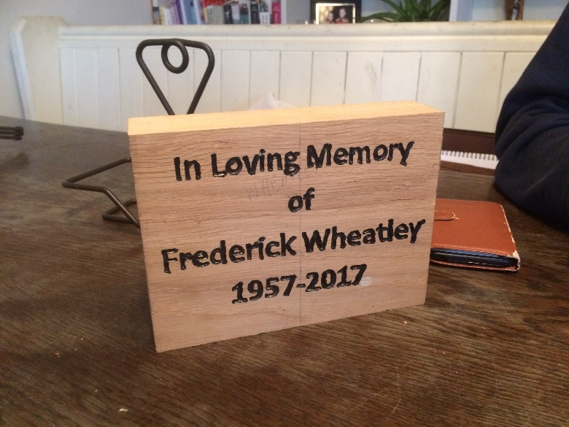
The 3- plank bench is £ 600-650 plus delivery and installation. The exact price depends on how much the oak boards cost and how large the logos are carved.
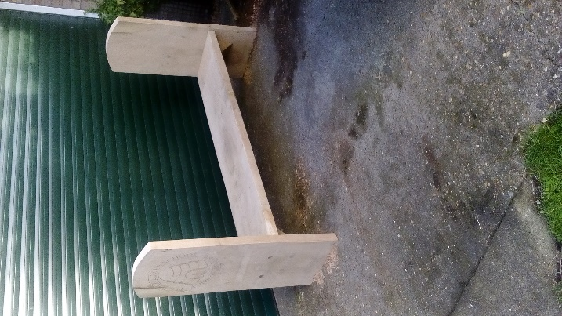
For this bench below it would be £466 plus delivery and installation if needed.
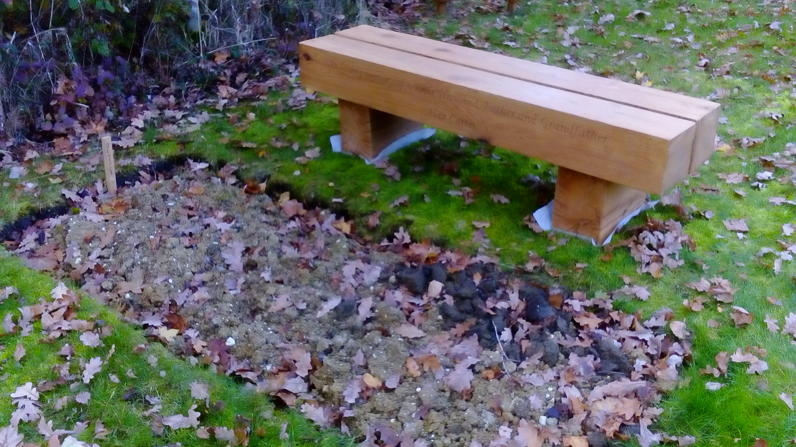
Installation will be more expensive if the benches need to be fixed to the ground.
 |  | After reviewing the quotes, the Committee agreed that a brass memorial plaque would be more appropriate. The plaque would go onto the existing BBN bench at Ivinghoe. |  |  | Norman
4. | Insurance Issues – Incident Reports
 | (a) | Recent Incidents
 | With regard to the previously reported incident on January 18th, the relevant form was sent to Sandy Gee, the LDWA Treasurer, as required. Pleased to say the walker is back out with us again.
 | (b) | Procedural Issues
 | The form for non-members on social walks is available on the Website, but it is proving difficult to enforce its use. The Newsletter should contain a hot link to the Website page. Mary to remind walk leaders of their responsibility. |  |  |  | Gill, Mary
5. | LDWA
 | (a) | Publicity
 | Terry has contacted Jean Bowers to discus the Essex Life article on the Essex & Herts Group discussed the response to the article. They also discussed an event that E&H put on at Chelmsford Library. The responses to these efforts appears to have been inconclusive.
 | Norman to explore the possibility of getting publicity on Three Counties Radio. |  |  |  | Norman
 | (b) | Facebook & Other Social Media
Gill reported that there were 105 Facebook members as at 22.5.2018
FB mostly used to circulate photos and urgent information. It works well for this.
It would be good to get a bit more interaction on FB, though Gill appreciates a lot of folk “don’t do FB”.
 | Not clear if Daniel Jamin is still updating the Facebook page. Gill to check. If not, Peter E is willing to take this on. |  |  |  | Gill
 | Peter E to pursome information about Twitter into the Newsletter. |  |  |  | Peter E
 | (c) | GDPR
 | Terry to take a more detailed look at NEC policy document to help establish:  1. What must we do;  2. What should we do;  3. What would we like to do. |  |  |  | Terry
 | Gill to liaise with Mike Hyland with respect to GDPR compliance on challenge events. |  |  |  | Gill
 | Terry to check to find out whether Gill is happy to keep the lead on GDPR. |  |  |  | Terry, Gill
 | (d) | Any other matters arising
 | Nothing further to discuss.
 | 6. | LDWA 100s
 | (a) | 2018 100 – Cinque Ports
 | Lynn and Dave Yorston represented BBN at the marshals' event, both at CP4 in Tenterden and at CP14 at Sandwich. The weekend weather was if anything a bit too hot but a great time was had by all.
 | Dave Findel-Hawkins to obtain list of finishers. (Sent to Peter S, Gill and Norman on 1st June.) |  |  |  | Dave
 | (b) | 2019 100 – Northumbria - Hadrian’s Hundred
 | Norman to contact the organiser to ask what additional help might be needed. |  |  |  | Norman
 | (c) | 2020 100 - Y 100 Sir Fynwy
 | Norman has contacted Shirley Hume ref this. He asked for an indoor checkpoint after our tented experience on the Valleys in 2014. He asked if any other checkpoint was available before that. The options are shown below.  Checkpoint 1 at around 5 miles. Outdoor, drinks and biscuits only. It’s in a council car park and not even a tent is being planned. Although if the weather is bad they might erect a tent  Checkpoint at the Guide Hall at Abergavenny at 40 miles. This is an indoor checkpoint and is the one before the entrants head into the Black Mountains. Hall is provisionally booked from 16.00 Saturday to 08.00 Sunday although that includes setting up time.  It was decided to offer help at Abergavenny but not at Checkpoint 1. |  |  |  | Norman
 | (d) | 2021 100 - Trans Pennine.
 | No new developments.
 | (e) | 2022 100 - Do we wish to offer ourselves as host?
 | Norman to contact NEC to find out what they need in terms of presentational materials and deadlines for submission. He would need to get an application form to give to Tony Hill and Chris Bent. They would then need to assess whether this provides syfficient basis for an outline of their proposals. In principle it is attractive but we would need a strong committee to carry it out - whether the chief organiser is Tony, Chris or someone else. Chris's suggestion of basing the route on the Leicestershire Round was not well received because the organiser needs to be in the area full time. Phil Butler, who helped to organise the Cinque Ports 100, has moved to our area and could be a useful source of help. |  |  |  | Norman
7. | BBN Challenge Events
 | (a) |  | Pick & Mix 2018 – Dave Yorston
 |  |  | We are all set to re-run the event on June 10th after having to cancel at the last moment due to the snow in March. Everything will be previously as set. The entry numbers did go down as the offer of cancelling was implemented but since then, we have had extra entries and the final numbers seem to be back to the original level.
 |  |  | Gill to check with the Yorstons to see if they still need help. If so, to be included in next Update. |  | Gill
 | (b) |  | Hannington Hike 2018 - Alan Leadbetter
Checkpoints booked and paid for, need a couple more marshal’s
(need one more at booking in/ finish)
All route description have now been written, Long route loop has been checked, Middle routes checked. Short route to be checked.
Badges have arrived
Certificates printed.
As of 30/5/18 --59 entered so far, need to push for more.
I might not be there at the start of marshals' walk as will be in London on the Saturday (birthday treat) but will be there some time during the day, might do some nibbles at one checkpoint if there is a few walking.
Need to know which marshals will be walking on the 17th June and which route they will be walking by Pick and Mix.

 | (c) |  | Sundon Saunter 2018 – Lynn Yorston
The date will be 18th November 2018 and preparations are well in hand
David Sedgley is still dealing with the routes
We will send out help requests after the Pick & Mix is done and dusted.
 | Kitchen help is still needed.
 | (d) |  | Chiltern Kanter 2019 - Norman Corrin
Details have been sent to Tim Glenn via Dave in time for Strider deadline. The date is Sunday 3rd March. There will be 3 distances 26, 18 or 13 miles. Starting venue and CPs will be the same and have been booked.
Mike and I will start recceing routes soon.
This is the 20th Kanter. With assistance from Dave and Lynn, Mike and Sandra it’s the 8th I’ve done.
It’s the last one Mike and I will be doing, it’s time to hand it over to someone else.
 | Norman to appeal new organisers in forthcoming Newsletter. |  |  | Norman, Gill
8. | Donations/Projects
 | (a) | Requests for assistance on charity walks, etc in our area
 | Nothing new to report.
 | (b) | Donations
 | Gill wishes to thank members for the two items of sponsorship – the Moon Walk (to date we have raised almost £2500 online and Steve and Pearl have a substantial sum to add from their “paper” sponsorship) and Isabel’s Monopoly Walk for her Romania Challenge
 | Mary to make payment to Yorkshire Three Peaks and claim back from Peter E. |  |  | Mary
 | Roy to pay Bedfordshire walking festival and claim back from Peter E. |  |  | Roy
9. | Group Activities/Weekends/Social Events
 | (a) | Roy’s August bank holiday weekend in Hartington
 | 12 members have said they are coming. More can be expected, including some who would travel to Derbyshire for just a day.
 | (b) | The Brewery Walk: Saturday 18th August
 | It is preferable for participants to pay electronically into the BBN bank account using "Brewery walk" as the reference. Need to put into Newsletter and News Update. Mary to forward John Davies's e-mail to the Committee (done). |  |  | Peter S, Peter E, Gill, Mary
 | (c) | Norman’s Cream Tea Walk – Sunday 8th July.
 | Nothing new to report.
 | (d) | Blankenberge
 | Next year (May 2nd-6th) is the 50th anniversary of the Tweedaagse, a 2-day walking event at Blankenberge, near Zeebrugge on the Belgian coast. Do we want to put this on the programme?
10. | Pop-up Walks and Other Ideas for the Walks Calendar
 | Chris Bent's 2-day pop-up walk on the Norfolk Coast needs to be publicised in an update. (June 21st-22nd). |  |  | Peter S
11. | 2018 AGM
 | To be held Sunday, November 25 at Blisworth village hall. Parking at village hall. Lunch at the Royal Oak will be subsidised up to £10 per person. Dave Findel-Hawkins will lead the walk.
12. | AOB
Gill has stopped sending birthday cards:
- We have more and more active members – could be sending out up to 50 or so – I think it would be better to send “occasion” cards now rather than birthday cards.
- Not sure how new GDPR impacts on the keeping of a list of birthdays?
The meeting closed at 10.00.
Next Committee meeting
Thursday 11th October 2018 at 4 Balfe Mews, Old Farm Park, Milton Keynes MK7 8QR
at 7.45pm, conditional on agreement by Gill |  |  |  | Gill

