*

|  |  |
| --- | --- |
|  | **LONG DISTANCE WALKERS ASSOCIATION AIM: TO FURTHER THE INTERESTS OF THOSE  WHO ENJOY LONG DISTANCE WALKING** |

**BEDS, BUCKS &  
NORTHANTS GROUP**

**NEWSLETTER**

**SPRING 2016**



HAVE A GREAT DAY OUT, WALK WITH BBN

[www.ldwa.org.uk/bedsbucksandnorthants](http://www.ldwa.org.uk/bedsbucksandnorthants)

**NEW MEMBERS\***

A very warm welcome to our new members:

Karen Earwicker, Wingrave

Bob Safford, Rushden

Liz Sheffield, Northampton

Ian Townsend, Chicheley

Cheryl White, Bedford

**REMINDER**

The BBN Administration Fee of £1 for 2016 is now due and can be given to any member of the committee.

Those few still to pay will have received an email reminder from me.

If you don't wish to renew please let me know so I can remove you from our list.

Otherwise please ensure you pay by the end of March or you will be removed automatically.

Dave Findel-Hawkins

**WALK LEADERS**

**Please remember to email the number of   
walkers on your walk to Mary.**

maryjknight@hotmail.co.uk

Contact details for all committee members are shown

on the last page of the Newsletter.

**CHAIRMAN’S CHATTER**

My last column ended mentioning the 2015 AGM and the pending debate about the new Group Constitution. I’m pleased to say that this was adopted by the members present, with the queries raised by previous BBN Chairmen Adrian Moody and Nigel Schofield being dealt with by Merrian Lancaster over the coming year.

We said farewell to Merrian, Dee and Lynn (although Lynn remains Merchandising and Equipment Officer in a non-committee role) and thanked them for their efforts over the past years.

I would like to welcome Peter Simon as our new Group Secretary, and also Mary Knight as Social Walks Secretary and Chris Bent as a committee member. I hope you all enjoy your time on the committee and are able to put something back into the group. I know Peter would have loved to attend the AGM but the jet lag experienced from his return journey from the USA might have left him even more disorientated!

Merrian’s stepping down has entailed a slight re-organisation of the workload of the committee, and thanks to Teresa Brown for offering to help Gill with the website.

A fortnight previously we had the Sundon Saunter which attracted over 250 starters and was well organised by Merrian and Lynn’s group of helpers. (Thanks for the cake Merrian, much appreciated!) From what I remember all enjoyed the event despite the wind, and it was good to see a group of Loughborough University students taking part. Hopefully they will have spread the word about the LDWA amongst campus members.

Santa paid us his usual visit on Sunday 13th December and although he was unable to lead the walk he did at least get the chance to show off his new suit. We had a good attendance at the New Year Lunch at The Anchor Inn at Great Barford, and this will be the venue of the 2016 BBN AGM.

With the festive season becoming a fast fading memory and nature unsure of what season it is, what do we have to look forward to this year? To paraphrase Julie Andrews in the Sound of Music ………. it is full of my favourite things …..then I hope you don’t feel so bad ……

The first event coming up is the fourth running of the Pick and Mix Challenge Event organised by Dave & Lynn Yorston and Mike & Sandra Hyland on Sunday 20th March. This unique combination of loops has proved very successful on the last three occasions.

Dave and Lynn have said that they could do with a few helpers and if anyone is interested please contact Lynn. They’ve stated that anyone who does offer to help will still be able to do a few loops of the walk if they so wish. Lynn’s details are at the back of this newsletter.

The LDWA 100 this year is in Dorset and promises to be a rollercoaster of an event (not literally I hope). Our BBN members in exile John Chesher and Jan Williams have been heavily involved with this and look forward to seeing us all down there in May, whether on the Marshals’ 100 or main event.

Speaking of the main event, our group is on Checkpoint 1 and we currently have 10 members on the checkpoint who are me, DFH & M, Pearl & Steve Smith, Milly Bones, Mary Knight, Nigel Schofield, Alan Leadbetter and Michelle Amour.

Ideally we need at least 15 as the first checkpoint is always pretty busy. If you’ve offered your services and I’ve not listed your name then apologies, please contact me again. We won’t turn you away!

With the new Multi Channel Media packages (Sky, Virgin, BT Television) there are only so many times you can watch Skyfall, The Bourne Trilogy of films, Die Hard 37 or Rocky 52………… You might wonder what this has to do with Long Distance Walking but a repeat well worth watching or doing this year is the re-running of the 2014 Greensand Ridge Social Walk.

Nigel has decided to take a back seat this year but will still handle the entries and a small committee of Gill Bunker, Mary Knight and I will be organising the event which will be on the 10th July. The second running of the FHtT&B the weekend before means that July will be a busy month for BBN!

At this year’s National AGM there will be a contested election for the national committee (7 into 6 won’t go……….although when I did maths at school it always worked!) and with the December Strider you will have received a proxy form with the list of candidates. As with the other elections taking place this year (Police Commissioners, possible EU referendum) voting is important, so please return your form to the address given on it. If you’ve lost it and want a replacement then please contact the LDWA National Secretary Phil Heneghan at secretary@ldwa.org.uk

That’s all I’ve got to say for now so as I said in my last column, please remember that when you’re out with BBN friends on a national trail, social walk or Challenge Event that you might walk on but YNWA ……..



**Good Walking!**

**Norman Corrin**

**At the 2015 AGM we said farewell to three committee members ……..**

The first of these was our outstanding Secretary/Web Mistress Merrian. I suppose you could say that this was the second fall of the House of Lancaster last year. The first was at Twickenham in October. That was a distinct possibility but not expected to happen in such a dramatic fashion. The second we have known about for some time since Merrian made it clear she did not wish to carry on. To paraphrase the politician’s turn of words, she wants to spend more time with her walking family!

Merrian took over at short notice in 2012 and quickly realised the job was quite time consuming. Having recently retired she did not wish to spend more time in front of a PC and quickly reorganised the workload so that it was spread amongst several committee members. With her regular updates, enthusiasm, dry pithy comments and excellent organisational skills she has brought the BBN website up to date and set a standard for her successor to follow……. We wish her well in her proper retirement!

The second committee member to stand down was Lynn Yorston who has been our Merchandising and Equipment Officer since 2006. Lynn has really come up with an excellent range of new merchandise (25th Anniversary T-Shirts, Sweatshirts) and group equipment (Hi Vis Jackets, tabards for kitchen staff, “Beware Walkers” notice boards for events).

I could go on (and frequently do!) but Lynn and her husband Dave have been the backbone of the group on events such as the SSS, the Pick & Mix and the Games 100 walk. They have also represented BBN on several Marshals’ 100s. Lynn will

continue to look after the Merchandise/Equipment as a non-committee member until someone volunteers to look after it. I believe Lynn does not have any intention to spend more time with her family as she does a lot of that already!

The third of our trio to say goodbye was our Social Walks Secretary Dee Brockway. Dee took over from Sylvie Eames in 2006 and since then has cajoled, pleaded and encouraged old and new members into leading social walks, both in our group’s catchment area and also taking us to places far and wide such as the Peak District and Dorset. Although these places are geographically some distance apart the one thing they did have in common was the up and down terrain! With her love of mathematics Dee compiled entertaining statistics for the AGM and with her love of socializing has provided us with entertaining stories for the 100s, weekends away and numerous social walks.

Dee has combined all this committed training (which enabled her to complete 6 x LDWA 100s) with holding down a job in Waitrose and looking after her family which included regular visits to her son in the finest city in the North West………….and I don’t mean Manchester either! I’d like to thank her for all of her efforts and wish her a happy retirement (from the BBN committee) and all the best to her and Phil.

**Norman Corrin**

Thank you to all my friends in BBN

The glass candle ornament is beautiful – it will “light up my home”. Totally unwarranted - but much appreciated.

Love Dee

**To all my friends at BBN**

**As most will now know, I decided to stand down from the   
committee after near on 10 years. I send many thanks   
for my gift of a clock presented to me at the AGM.   
It is hanging on the wall in our office at home.**

**A big thank you to you all.**

**Lynn Yorston**

**Now available – dates for weekend walks!**

No sooner is one programme completed than the next one starts. But the good news is there is loads of time to reserve your date and then check out your route, so don’t miss out, book early to avoid disappointment - that includes you Santa!

Remember walks can be Saturday or Sunday.

|  |  |  |
| --- | --- | --- |
| September | 3rd/4th | Gill & Dee |
|  | Sun 11th | Beds Walking Festival BBN walk – Roy Carter |
|  | 17th/18th |  |
|  | 24th/25th |  |
| October | 1st/2nd |  |
|  | 8th/9th |  |
|  | 15th/16th |  |
|  | 22nd/23rd |  |
|  | Sun 30th | Steppingley Marshals’ |
| November | 5th/6th | Jim Robinson |
|  | 12th/13th |  |
|  | Sun 20th | Steppingley Step |
|  | Sun 27th | AGM |
| December | 3rd/4th |  |
|  | 10th/11th |  |
|  | 17th/18th |  |
|  | 24th/25th |  |
|  | 31st/1st Jan |  |

Roy has asked that we remind you that the Bedfordshire Walking Festival this year will be held in September from the 10th to the 18th inclusive, that's 9 days!

Sunday 11th September 2016 will be a BBN walk, Roy has offered to lead, but if you have any ideas for a walk and would like to lead one for the festival and BBN on this date please let us know.

Best wishes and happy walking.

**Mary Knight**

**Walks Secretary**([maryjknight@hotmail.co.uk](mailto:maryjknight@hotmail.co.uk))

**“Normal people do this in two days …….. ”**

**The Greensand Ridge Walk in a Day: 10th July 2016**

Back by popular demand – an opportunity to walk the 40 mile Greensand Ridge in a day – as a BBN social walk.

The day will have the same format as last time - we will leave Baker Street car park, Leighton Buzzard at 6am by coach which will drop us in Gamlingay for a 7am start on our 40 miles. The walk will be led by Gill Bunker (Gamlingay to Northill), Dee Brockway (Northill to Woburn) and Dave Findel-Hawkins (Woburn to Leighton Buzzard). All three leaders are walking the entire route and we hope to be walking into Leighton Buzzard between 10 pm and 11 pm.

The cost of the day is £22 – this includes coach travel, breakfast (Northill), lunch (Ampthill) and tea (Woburn). There will be hot and cold drinks at all stops, and also frequent water points on the way – so we only need to carry our usual “emergency stuff” and a mug.

We all enjoyed the fantastic day out Nigel organised last time, helped by lovely and much-missed Kathy. But planning such a day is a lot of work - and this year a small team of us are organising the event – Mary, Gill and Norman.

The coach is booked, the halls are booked – we just need you to register for the walk. You’ll find the registration form on the BBN website.

Nigel is taking the entries so get your registration form off to him, but if you have any questions about the day please have a chat with one of the team. We will try and help - we want you to come along and have a great day.

Planning is still at a very early stage, but please address any queries about the route, distances, timings etc to Gill ([gillbunker@googlemail.com](mailto:gillbunker@googlemail.com)) and any questions about food, catering etc to Mary ([maryjknight@hotmail.co.uk](mailto:maryjknight@hotmail.co.uk)). If you have any special dietary requirements please let Mary know – we will do our best to help. Norman will be Chief Marshal on the day.

Further information about the walk will appear on the BBN website (Under “Group Activities”) and via email nearer the day.

**Anyone not walking - but would like to be part of the day ??**

We have people in place to organise the three meal stops – Northill, Ampthill and Woburn - but as ever a few more pairs of hands would be welcome.   
Let us know if you can spare a few hours to help on the day.

Everybody who walked last time agreed it was a great day out – so here’s looking to this year’s event! For most of us it is a challenge to walk 40 miles, but we will be well supported and looked after all day and we will be walking through some lovely countryside.

**Mary, Gill and Norman**

**Eager to start: Gamlingay 2014**

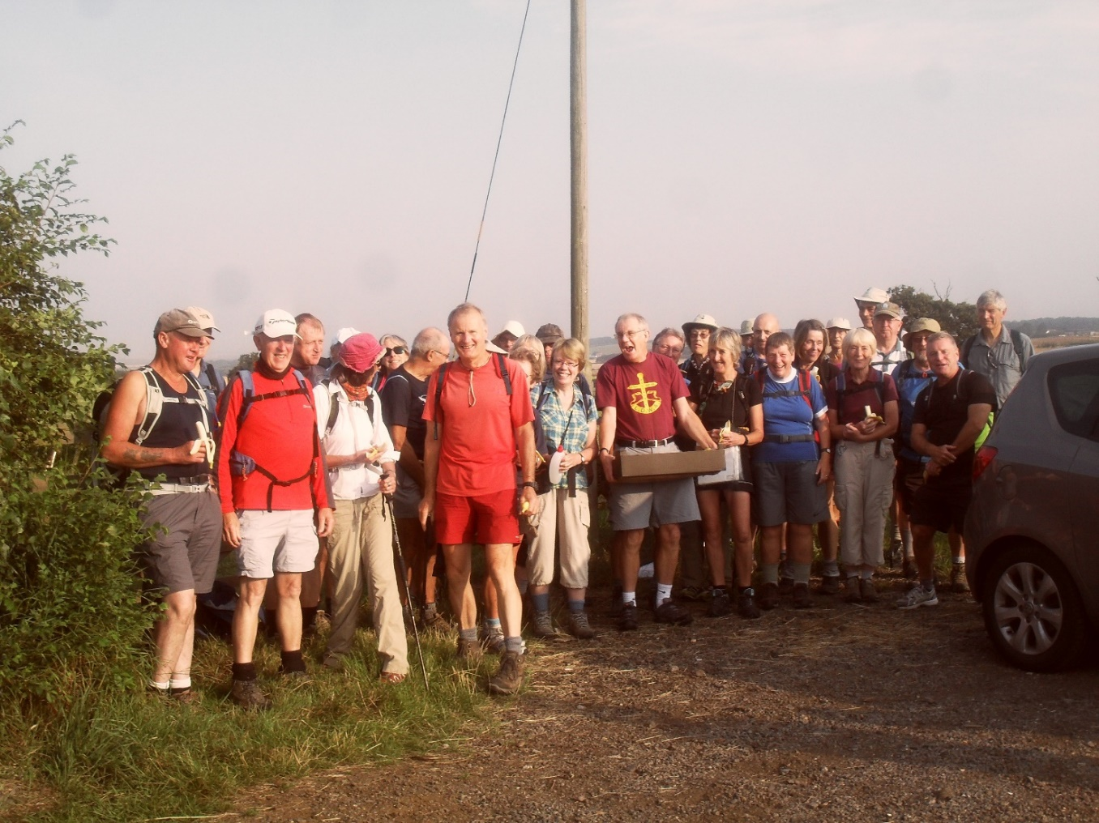

Look at the BBN website for more photos and comments on a great day.

Greensand Ridge in a Day 2014

<https://www.ldwa.org.uk/BedsBucksAndNorthants/M/332/pictures.html>

**ORGANISED GROUP WALKS:  
Guidance Notes for Day Walks/Guidance Notes for Walking Holidays**

Gabriel Newfield has prepared two interesting reports on the subject of walking in organised groups. They both contain good advice and suggestions - some of which - such as remaining behind the leader, control of walking poles and dogs etc - are essential reading.   
  
The Guidance Notes are rather long to reproduce in the Newsletter but can be read on the BBN website <https://www.ldwa.org.uk/BedsBucksAndNorthants/W/1045/document-store.html>

Topics covered include:

Starting On Time, Keeping Up and Dropping Out, Falling Behind A Little - Falling Badly Behind, Becoming Detached, Going Ahead, Backmarking,

Losing Things, Dogs on Walks, Complaints, Feedback and Keeping Silent

*I hope BBN members will find at least some of these notes interesting although I think they will be most useful for people who are new to walking or new to walking in organised groups. I intend to amend them regularly in the light of feedback I receive. (They have already benefited in this way.)*

*Feedback that would help to make them more useful will be gratefully received, especially constructive criticism, suggestions for additional topics, and comments on presentation, emphasis or content.*

***Gabriel Newfield,*** [**gabrielnewfield@tiscali.co.uk**](mailto:gabrielnewfield@tiscali.co.uk)

oooooooOOOOOOOooooooo

|  |  |
| --- | --- |
| ***Santa’s New Suit***  ***December 2015*** |  |

**A “STYLISH” CHRISTMAS PRESENT**

I have two daughters, Vikki Kemp, who is a BBN member and walks with me,  
and Joanne, who does not walk but comes to the Hundred and visits many of the  
checkpoints to offer support and running repairs, or should that be walking  
repairs.

On the Red Rose 100 there were a reported 236 stiles. Being tall, ancient and not very flexible I had great difficulty with many of the stiles, especially the rickety or narrow ones. I remember falling backwards off one close to a canal, luckily being saved from injury by the queue behind me. In view of this the girls decided I needed practice so they had a full sized stile made for me for Christmas

….……………. Little darlings.

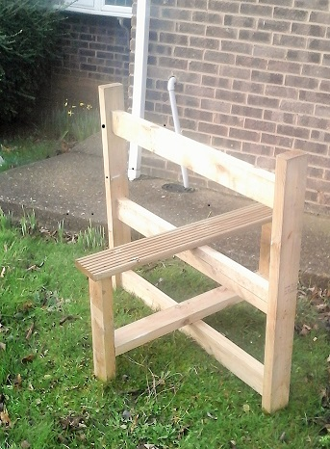

Incidentally, if there were 230 stiles that is around 750 feet of climbing. Was  
that included in the route description totals?

**Graham Bayes**



**With thanks to Tim Vine**

I phoned the local gym and I asked if they could teach me how to do the splits. He said, "How flexible are you?" I said, "I can't make Tuesdays."

He said “I'm going to chop off the bottom of one of your trouser legs and put it in a library”. I thought “That's a turn-up for the books”.

And the back of his anorak was leaping up and down, and people were chucking money to him. I said “Do you earn a living doing that?” He said “Yes, this is my livelihood”.

So I was getting into my car, and this bloke says to me "Can you give me a lift?"  
I said "Sure, you look great, the world's your oyster, go for it”.

So I went down my local ice-cream shop, and said “I want to buy an ice-cream”. He said “Hundreds & thousands?” I said “We'll start with one.” He said “Knickerbocker glory?” I said “I do get a certain amount of freedom in these trousers, yes.”

I went to Millets and said “I want to buy a tent.” He said “To camp?” I said [butchly] “Sorry, I want to buy a tent.” I said “I also want to buy a caravan.”

He said “Camper?” I said [campily] “Make your mind up.”

I was stealing things in the supermarket today while balanced on the shoulders of vampires. I was charged with shoplifting on three counts.

I bought a train ticket and the driver said "Eurostar". I said "Well I've been on telly but I'm no Dean Martin?” Still, at least it's comfortable on Eurostar, it's murder on the Orient Express…..

I bought some Armageddon cheese today, and it said on the packet 'Best Before End…..'

So I went to buy a watch, and the man in the shop said "Analogue." I said "No, just a watch."

I went into a shop and I said, "Can someone sell me a kettle." The bloke said "Kenwood". I said "Where is he?"

So this bloke says to me, "Can I come in your house and talk about your carpets?" I thought "That's all I need, a Je-hoover's witness".

So Batman came up to me and he hit me over the head with a vase and he went T'PAU! I said "Don't you mean KAPOW??” He said "No, I've got china in my hand”.

So I got home, and the phone was ringing. I picked it up, and said “Who's speaking please?” And a voice said “You are”.

So this cowboy walks into a German car showroom and he says "Audi!"

So I fancied a game of darts with my mate. He said, "Nearest the bull goes first" He went "Baah" and I went "Moo". He said "You're closest".

So I met this bloke with a didgeridoo and he was playing Dancing Queen on it.   
I thought, that's aboriginal.

I was in the army once and the Sergeant said to me: "What does surrender mean?" I said: "I give up!"

**Norman Corrin**

**BEDS AND BUCKS COUNTY CROSS-COUNTRY CHAMPIONSHIPS 2016**

BBN was well represented at this year's cross-country championships held at Shuttleworth on January 9th.

Competing in the Male Vet 60+ 8k race, Brian Layton led the BBN contingent home followed by Ian Sage and then Dave Sedgley who retained his MV75 Beds County Champion crown.

Also present in an official capacity was Brian Graves but nobody recognised him as he was wearing a tie.

**Ian Sage**

**FOR SALE**

A friend has given me 4 pairs of walking trousers to sell, with money going to Willen Hospice. They look in good condition.

1. Craghoppers UK 38" R, lined, black

2. Craghoppers UK 18 R, lined, blue

3. Craghoppers UK 18 R, unlined, blue

4. Regatta UK 38" R, inside leg 32.5", unlined, blue

Any takers?

Contact Merrian

[merrian22@gmail.com](mailto:merrian22@gmail.com)

oooooOOOOOooooo

**EVER THE BEST FOOT FORWARD**

For certain 2015 proved to be a pinnacle year of my walking career in that 3610 miles passed under my boots/trainers as eleven other targets were reached. These included:

1. The equivalent of 2½ times around the earth at 62182 miles in 20 years 9 months was walked on one pair of legs and feet, plus a few toe nails and blisters!
2. Twenty pairs of walking boots/trainers costing £1,065 were depreciated down to 1.7p/mile at 62647 miles. Five pairs are still walking on to 1.6p/mile.
3. The 21 years walking day average distance is over 14 miles in 4479 days, a figure chosen as it’s greater than half a marathon.
4. Walked miles exceeded those driven by car at 893 miles. This figure was up to 1200 prior to walking The Roman Way which involved greater car use.
5. The Roman Way of 174 miles was recce’d, waymarkers renewed and secateured. As the route was walked solo some 304 miles were walked, plus bike, bus and train were utilised too.
6. The Oxford Half Marathon was completed on behalf of AG UK Oxon by walking the 13.1 miles at Centurians 1911 speed in 3hrs 7½ minutes. Of the 7500 starters, I was not the last to finish either!
7. Horton-cum-Studley village fete’s Otmoor Challenge of half a marathon was completed over roads and fields in 3½ hours.
8. The Remembrance Day Marathon from/to Bicester Airfield took place for the tenth year on a route which passes by over 100 war graves of RAF personnel who were killed in air crashes in this area in WWII.
9. An annual re-enactment of a walk made by Ramblers on 3rd September 1939, when WWII started, was completed by being made into a 23 mile triangle via Burford, Bourton-on the-Water, Windrush Airfield, Burford with a group of Centurion 1911 members. (See Oxfordshire at War Chapter 1.)
10. A 21 year average of 3,000 miles per year was reached at 63,000 miles in those 20 pairs of boots/trainers. I reached this target on 7th January 2016, two weeks before 22nd January, which is the anniversary of my first walk with the Ramblers on 22nd January 1995.
11. During a national campaign week on 23rd/29th November to encourage people out from their cars on to foot or bicycle, my input was to walk 100 miles in and around Bicester. The whole event seemed to be unnoticed – so be it! By accident I’d walked 100 miles in the previous week too.

As for 2016’s walking challenges. Well, it’s a wet day outside so I’m working on that problem, and there’s a cat asleep on my lap! Sssh!

Ever the best foot forward.

**Norman Smith**

***The Roman Way*** *is a 174 mile triangle – Bicester-Cirencester-Silchester-Bicester – on or close to Roman Roads, with an amphitheatre on two corners.*

**From Here to There & Back**

**Sunday July 3rd 2016**

*A few more marshals are needed*

*Please contact Alan if you can help*   
E: acleadbetter64@gmail.com

**SINCE THE LAST NEWSLETTER**

|  |  |  |  |  |  |
| --- | --- | --- | --- | --- | --- |
| **Rain and mud** …… *AGM walk November 2015* | |  | | | |
|  | | | **Rain and mud and celebrations** *Santa’s New Suit December 2015* | |
|  |  | | |

|  |  |  |  |
| --- | --- | --- | --- |
|  | | | *‘Spoons Xmas Walk – December 2015* |
| *New Year Lunch January 2016* | |  | |
|  | |  | |
|  |  | | |
| *Whittlebury Wandering in the sunshine*  *February 2016* |  | | |
|  |  | | |

**BACK TO THE SUTURE**

This is an article I wrote wearing my Essex & Herts hat but thought it would also be of interest to us in BBN.

On Saturday 17th October, four days before Back to the Future Day on the 21st, our friends in Essex & Herts Group held a Basic First Aid Course organised by two of their members, Dave Evans and Lynn Doersam.

Spookily enough Merrian and I were overtaken by a DeLorean on the M25 on the journey down. I had to check her Sat Nav and my Smart Phone to reassure both of us that we had not travelled back to 1985!

The course was held in the Old Friends Meeting Place in the village of Stebbing (would we be dealing with the after effects of a stabbing I wondered?).

After the all-important functions of tea and biscuits Dave and Lynn explained the first objectives when giving First Aid:

1. To prevent a person from dying
2. To prevent their condition from worsening
3. To promote their recovery

We were very quickly disabused of the notion that an objective was to enable the walker to finish the walk………

The teams were then split into two groups (Black and Green) to enable us to carry out various exercises during the day. The first problem arose when we found out that one of the Green team did not have an opposite number on the Black team. Re-checking the numbers given to each team I’d put myself into the wrong group……



This probably gave Dave cause to think; “It’s going to be a long day”.

The first exercise was the correct method of checking someone’s pulse (three fingers on the neck) and I was mightily relieved when my opposite number Eddie Short proved to be alive and well!

This was followed by explaining a possible scenario that could easily happen and how to prioritise treatment following accidents to several walkers in the same group.

The answer is to remove anyone from immediate danger and then check on the consciousness states of the rest. The noisy screaming ones are alive and can be treated last. The quiet ones are the ones to worry about, which is true in so many walks of life!

Dave demonstrated how to carry out a Chest Compression on Lynn as Mouth to Mouth Resuscitation is no longer advised.

The course was proving to be a much needed refresher and the next practical exercise included putting the casualty (moi in this case) into the recovery position which prevents you choking on your own vomit.

Dave was flinging out questions to each of the teams and awarding points for each correct answer (and what do points earn…….prizes, in this case Haribos and Lollies!). But there was definitely some favouritism in the marking to his team!

We covered the circulation system of the body….Arteries and Veins and the type of blood flow from either type (Gushing from the former and Flowing from the latter) and in the same vein (sorry!) identified the different types of Blood such as Bright Red & Frothy (Punctured Lung) and Black Blood (from the Heart).

Along with a session on Hazard Warning Signs and Poisons, this gave us a healthy appetite for lunch (or in Dave, Lynn and Merrian’s case a pint at the pub).

For 30 minutes or so it was nice to relax with the various E&H members and catch up on the tales from the recent Shotley 50 (at the BBN committee meeting the Thursday night before Shotley I was the only one not going! ☹) and the forthcoming Blackwater Marathon. Refreshed by Lemonade, Tea, Coffee, Ginger Cake from Judith Jolly and whatever poison The White Hart was serving, it was back to work!

We moved onto the hot subject of treating burns (anything larger than a £2 coin you should seek medical advice on) and told that you don’t burst blisters on these but leave them be. Piercing the blister will result in plasma leak which is part of the body’s defence mechanism.

From here we moved onto dealing with objects in eyes, ears and nose. Of the two objects shown one is called an IPad and the other is an Eye Pad. Do you know which one should be used to treat an eye injury?



There was still quite a bit to cover in the remaining time.

Soft Tissue damage refers to injuries to muscles, ligaments, tendons and sprains. If you didn’t know, ligaments hold bone to bone and tendons hold bone to muscle. From her experience on the Farthingstone Foot Fest this year Merrian was able to explain to the group how painful and debilitating these can be……..

The answer to these injuries are an Ice Pack, Compression, Elevation and something we are not good at in the LDWA……………….Rest!

Reference Bruising, the natural reaction when you bang something such as your elbow against a table (not very humerus at all) is to rub it. This expands the area of the bruise which I was unaware of. I was learning something all the time.

The next subject covered was Choking with Dave explaining the difference between coughing and choking. A glass of water is enough to normally clear a cough but for choking the person will go white and then Ashen Grey and a Blue Tinge will appear round the lips. He demonstrated on Lynn the 2 methods of clearing a blockage for an adult and then demonstrating how you should do it for a child under 7 years.

The last part of the syllabus dealt with Fractures (Upper and Lower Limbs) which are identified by their irregular shape, swelling and if the patient is unable to bear weight on the limb.

Dave and Lynn gave a practical demonstration of bandaging for lower and upper arm injuries which the teams then carried out on their opposite numbers.

For lower limbs you immobilise and treat for shock but do not raise. This part of the syllabus prompted me to mention to Merrian on the way home the famous Tommy Cooper joke “Doctor I’ve broken my leg in 2 places”, “Well don’t go to those 2 places!”

At the end of the course there was a multiple choice exam of 12 questions which I’m pleased to say we all passed and received a certificate for.

This was a worthwhile basic refresher course useful for those situations which we may come across in everyday life and not just when we’re out on the hills.

For anyone who wants a course to cover First Aid situations in the outdoors the Outdoor Centre in Plas Y Brenin holds several -  
<http://pyb.co.uk/courses-first-aid.php>

Dave did also provide his idea of the basic First Aid Kit either a walk leader or anyone out for the day should carry with them. He said this is not written in stone but, based upon his experience of which we’d been the beneficiaries, this is a good as anything..…. Makes you think.

|  |  |
| --- | --- |
| **Walk Leaders First Aid Kit** | |
| Protective Gloves – 2 or 3 pairs | Hand Sanitiser |
| A few antiseptic wipes | Small Pair of Scissors |
| Eye Pad | Medium size Wound Pad |
| A Triangular Bandage | Assorted Plasters |
| Tweezers | Safety Pins |
| Crepe or Elasticated Bandage | Foil Sheet |
| Resuscitation Face Sheet (optional) | Micropore fastening tape |
| Swiss Army Knife |  |

**Norman Corrin**

|  |  |
| --- | --- |
| *Some Chalfonts November 2015* |  |

***Oxford Mail, Jan 2016***

Activist Norman Smith dumps piles of rubbish around Bicester in protest against littering

|  |  |
| --- | --- |
| A PENSIONER is waging war against litterbugs and abandoned estate agent boards by leaving piles of rubbish everywhere. It may sound a bizarre way to tackle the issue, but Norman Smith decided that presenting people with what they abandon might shame them into clearing up after themselves. |  |

Mr Smith, of Macaulay Close, Kings Meadow, set himself to a “two-day campaign” to make people aware of the rubbish cluttering Bicester’s streets.

The 72-year-old set out on Sunday and Monday and gathered bags of rubbish that had been strewn over an eight-mile route. To make his point, the retired pilot then left them in piles around the town to show people just how much they chuck away. The avid walker said: “I am absolutely disgusted by the number of drinks cans and bottles littering the streets.

“I knew there was an enormous amount of litter but found much more than I imagined, mainly cans and drinks bottles where people throw them out the car window or children drop them to and from school. “So I decided to do a two-day campaign so that people can see them. Last year I picked up the odd can or two while out walking but nobody knew so this year I thought I would make a public spectacle. I am a one-man band.”

Mr Smith walks five times a week, totalling 3,000 miles a year. While out walking last week the pensioner spotted Cherwell District Council doing a litter blitz in Kings Meadow, inspiring him to do something about the issue himself. He said: “I have pulled things out of hedgerows eight miles around the town. There is nothing like direct action. “I want to educate people to take responsibility because at the moment people just throw things out their windows and litter the countryside.”

**ME, THE DRIVER AND NOBODY IN THE BACK**

Two years ago I was in Seefeld, Austria, one of those international walking events, and a friend of mine Chris said to me, “Fulda’s next Steve, it’s in Germany, if you fancy it there’s room in the car, let me know if you want to go”. Well I had been putting in a lot of hours, so I booked the holidays and the first weekend in October 2013 I went to Fulda for the first time. I had a great time, so about July 2015 I asked Chris if he was going to Fulda in 2015, he said yes and so at 8pm on Thursday 1st October I was picked up at my work, which is conveniently on top of junction 15 of the M1 by Chris and off we tootled south on the M1 towards Dover.

We stopped at Thurrock services for a break then headed for Dover and the 2am ferry to Dunkirk. The ferry takes approximately two hours to get to Dunkirk and we arrived safe and sound at about 4am on Friday morning. I bought some beers on the ferry, £5 for a 6pack, pretty good deal eh? They went down pretty good with the rest of the beer to be consumed over the weekend. It’s a long way to Fulda, and we arrived at Fulda at about 14.00hrs on Friday. We could not park the car at the usual car park because it had been turned into a refugee camp but where we parked was only just round the corner.

Now in 2013 we had to drive 5km down the road to a sports hall, which meant Chris had to drive there and back and could not drink, but this year Chris wangled two spaces at the venue which meant he could have a drink and not worry about the driving. We unrolled our bedding on the floor of the hall and then went and had a few beers with faces that I recognised.

Up the next morning bright and early. Saturday’s walk was going to be a linear walk and we had to catch buses to our start point 20kms away. The trouble with that was the buses that left to take the 42km walkers to their start point were the same ones that were to take us to our start point so we had to wait for them to come back to pick us up. This of course caused a few moans. Eventually the buses arrived for us and off we jolly well went to our start point for the day.

The walk went well, following little arrows on trees and posts to show us the way. At the checkpoints though the beer always flowed, so at every checkpoint we all had a round so by the end of the walk I had already had my fill. But Saturday night there was music and dancing so more beer was consumed. I woke up on Sunday morning thinking “Oh God, not another 20kms to go”.

Sunday’s walk was a circular from the sports hall, so no coaches to catch today. I set off at around 8am. The walk went well and I met up with Marcus a couple of time at the checkpoints and had a couple of beers with the guys. Sunday

afternoon was award time and walkers got awards for this and that. Monday morning up and packed, bags in the car we set off for home, with the usual stops for beer and baccie, and we caught the 2pm back to Dover and home.

Photos at <https://www.flickr.com/photos/131244540@N07>

Stevecee x

**ooooooooOOOOOOOOoooooooo**

**BASTOGNE**

**TO COMMEMORATE THE SIEGE OF BASTOGNE IN WW2**

After Fulda in Germany, it was Bastogne in Belgium. Myself and Chris were driving back towards Dunkirk and he was going on about Bastogne, only a one day walk, 21kms or 42kms on Saturday, a lazy weekend and on the Sunday we would chill out at Jerry’s house. So 10pm on the Thursday Chris picked me up in the carpark of my works and we drove down to Dover for the 2am ferry across to Dunkirk. The drive to Bastogne went without any problems and we arrived at Bastogne at about 2pm on Friday. Chris knew the Dutch crowd who came by coach and we got into their sleeping arrangements for the weekend. Sleeping again was thermo-rest and sleeping bag on the floor of a sports hall. Bedding sorted, we walked into Bastogne to have a look around. There were some very good shops and Bastogne was an attractive place, even in the rain. We headed back to the sports hall to come back down to town again later that evening for Beef Stroganoff and a beer before hitting the sack for the night.

Saturday morning was murky and drizzling with rain, it wasn’t raining hard but enough to make you wish you never wore specs. Chris was meeting up with faces that he knew (who Chris doesn’t know is not worth talking about), so I started on my merry way in the drizzle. Now as the weekend was all to do with the siege of Bastogne in WW2 there were American vehicles and re-enactments all over the place. Walk through a wood and you would come across a machine gun post manned by Yankee troops, and old army vehicles being driven all-around you. The terrain was much like good old Blighty, most of the walking was done on hard road though, but great scenery. The checkpoints were manned, with burgers and beers (to buy of course) to be consumed and loads of commemorative plaques to read. After watching the DVD set of the Band of Brothers where the American forces at Bastogne were called the “Battered Bastards of Bastogne” it felt good to actually be there.

21kms later back at the hall there was burgers and beers and a certificate to collect. The walkers you met on the walk are all there sharing their stories.

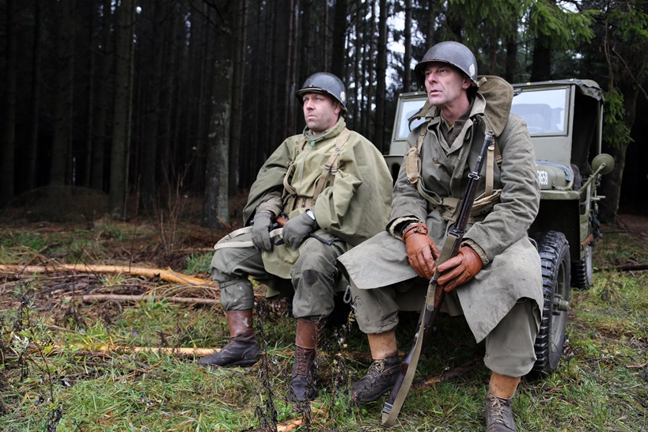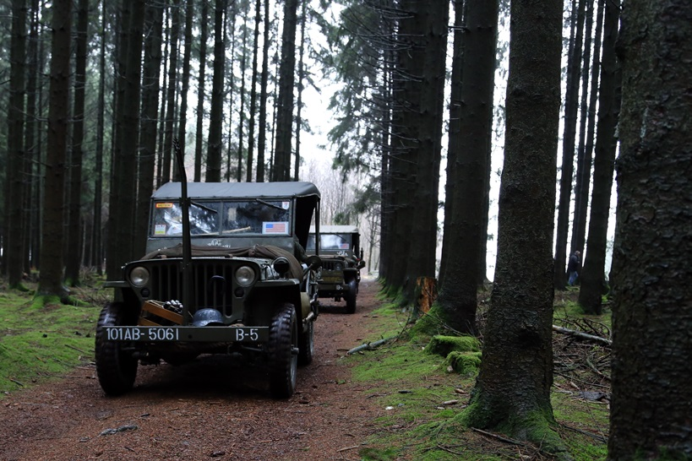

Burgers down my throat washed down by beer, I headed back to my pit to relax with a glass of wine, Mmmm …… well maybe the bottle. The Dutch walkers were all in a circle chatting and laughing about the day, all enjoying themselves. Chris and I went into town Saturday evening again for a meal, we went to the same place. It was packed out with walkers sharing their stories and the locals enjoying themselves.

Sunday morning bags were packed and we packed the car with our gear, goodbyes said we headed for a friend’s house a couple of hours away. Jerry was going to work for 1pm Sunday and Chris and I got to his house just after 1pm so as Chris had a key we let ourselves in and made a brew. We had decided to go into Ghent for the afternoon to have a look around and do some Xmas shopping. Chris said that he was not going to take his car into Ghent, it’s a nightmare he reckoned, so we took the car so far then caught a tram into Ghent.

Ghent is a great place, full of life, trams coming and going in all directions, and loads of shops to look around. There was a big wheel like the London Eye in the middle of Ghent and Chris and I had a ride. It was a spectacular ride, we went above the tall magnificent churches and could see all around for miles. We stayed in Ghent for around three hours. Chris bought some Xmas presents and I got some chocolate, then decided to make our way back to the car, so we had to work out which tram to catch and where. Back at the car, then back to Jerry’s. We had decided to eat when we got back to Jerry’s house, there was a chip shop just down the road. We had chicken and steak on skewers and chips, it was very good and a good price too. There was a little village pub opposite so I had a few beers and Chris went back to the house. Jerry got home just after 10pm, he cracked a bottle of red, we shared a few stories then we hit the sack.

We were up around 7am Monday morning, a bit of breakfast, a goodbye to Jerry, and Chris and I hit the road again, this time heading for Dunkirk and the ferry back to Dover. We always call into the hypermarkets for booze and baccie and usually visit a garden centre before we get to the ferry. I bought some wine and chocolates but Chris I’m sure bought the whole market, where he put it all in the car I’ll never know, then on to the ferry. We had no problems with the ferry back across and the traffic was good back to Northampton, so I got home at about 6pm Monday afternoon after another great weekend.

Photos at <https://www.flickr.com/photos/131244540@N07>

Stevecee



***Has our boy been moonlighting ……..?***

ooooooooOOOOOOOOoooooooo

**DISCOUNTS FOR LDWA MEMBERS**

When you log onto the LDWA website, scroll down to the bottom of the screen and you will see *Discounts.*

Click on this and it will take you into the section showing those companies and shops that offer discounts to LDWA members on production of their LDWA membership card.

One to bear in mind is Cotswolds Outdoors Stores. Go into any of their stores produce your membership card and quote the code “AF-LDWA-L2”. This will get you 15% discount.

Happy shopping!

**Norman Corrin**

**WALKS PROGRAMME**

**APRIL TO AUGUST 2016**

**Sun Apr 3 2016 Lanes & Villages of North Bucks**

18ml. Start 09.00 From free c.p. behind Waitrose in Buckingham. Map: Exp 192 (GR SP698340). Pub near lunch stop. ***C:*** Terry Penny ***T:*** 01280 815512 ***M:*** 07963 043220.

**Thu Apr 7 2016 A Bit of Cross Bucks**

15ml. Start 09.30 From the Globe Inn, off Stoke Rd, nr Leighton Buzzard LU7 2TA. Maps: LR 165 Exp 192 (GR SP913263). ***C:*** Jim Morrison ***T:*** 01908 665300.

**Sun Apr 10 2016 Royston Figure-of-Eight**

19ml. Start 09.00 From outside Heath Café, off Baldock Road, Royston. Free c.p. toilets and café. Map: LR 154 (GR TL348405). Longer morning, shorter afternoon. Slower paced walk. Picnic lunch near Heath Café which sells beer, hot and cold drinks. Joint walk with Essex & Herts. ***C:*** Tim Alcock & Phil Hastings ***T:*** (Tim) 01763 242289 (Phil) 01763 853744 (before 9pm) ***M:*** (Phil) 07716 992874 on day only.

**Thu Apr 21 2016 Gayton Locks**

15ml. Start 09.30 From Bugbrooke Church. Map: LR 152 (GR SP674573). ***C:*** Colin Stoneman ***T:*** 01327 830889 ***M:*** 07764685661 on day.

**Sun Apr 24 2016 Thornborough & Buckingham**

15ml. Start 09.00 From Thornborough. Pls park considerately in streets close to the p.h. Map: LR 165 (GR SP745336). ***C:*** Sylvie Eames ***T:*** 07788 287701 (5pm to 8pm).

**Thu May 5 2016 Northants Icons**

16ml. Start: 09.30 From junction of Sudborough Rd/Barnards Way, Brigstock. Map: LR 141 (GR SP950848). Toilets near start. Pub at lunch stop. ***C:*** Jim Robinson ***M:*** 07845 909750 on day only.

**Sat May 7 2016 A Medium Shuffle SATURDAY** **WALK**.

18ml. Start: 09.00 From Old Road, Barton-Le-Clay (off B655). Please park at side of road adjacent to park. Maps: LR 166 Exp 193 (GR TL083305). ***C:*** Gordon Shaughnessy ***T:*** 01582 518791 ***M:*** 07518 364036.

**Thu May 19 2016 Sundon Hills & Beyond**

15ml. Start: 09.30 From Sundon Hills Country Park free c.p. Map: Exp 193 (GR TL045285). ***C:*** Paul Keech ***T:*** 07753 560412.

**Sun May 22 2016 Offley Again**

18ml. Start 09.00 From Salusbury Lane, Great Offley, 200 metres west of church. Maps: LR 166 Exp 193 (GR TL143267). ***C:*** Peter Simon ***T:*** 01582 513827.

**Thu Jun 2 2016 Back to Willow Brook**

16ml. Start: 09.30 From Bulwick Main Rd north of village. Maps: LR 141 Exp 224 (GR SP960955). Break at Green in Barrowden nr p.h. ***C:*** Anne Addison ***T:*** 01780 740414 ***M:*** 07747 616061 on day only.

**Sun Jun 5 2016 From Here to There and Back Marshals' Walk**

***C:*** Alan Leadbetter ***E:*** [acleadbetter64@gmail.com](mailto:acleadbetter64@gmail.com)

**Thu Jun 16 2016 Toddington, Tebworth, Tingrith**

15ml. Start 09.30 From south end of Market Square, Toddington. Map: LR 166 (GR TL008288). ***C:*** Peter Simon ***T:*** 01582 513827.

**Sun Jun 19 2016 Peter, Paul & Lawrence in Herts**

21ml. Start: 09.00 From free c.p. Lockleys Drive, off Welwyn bypass (A1000), Welwyn village. AL6 9NT. Maps: LR 166 Exp 182,193 (GR TL233162). Picnic lunch in churchyard at St Paul’s Walden, pub nearby. Joint walk with Essex & Herts. ***C:*** Gabriel Newfield ***T:*** 01727 832696 ***M:*** 07868 507565 on day only.

**Sun Jun 26 2016 Tripping Up in Toddington**

15ml. Start 09.00 From Toddington village green. Map: Exp 193 (GR TL009288). To visit local paths and villages. ***C:*** Sylvie Eames ***T:*** 07788 287701 between 5pm to 8pm.

**Thu Jun 30 2016 Into Ashridge**

15ml. Start: 09.30 From free c.p. at Ivinghoe Hills on minor road from B489 towards Ringshall. Map: LR 165 (GR SP962163). ***C:*** Gordon Shaughnessy ***T:*** 01582 518791 ***M:*** 07518 364036 on day only.

**Sun Jul 3 2016 From Here to There & Back Challenge Walk**

27, 18 or 13ml. all to finish by 18.30. Hall closes 19.00. From Wellingborough Grammarians Memorial Sports Field, Sywell Road, Wellingborough NN8 6BS (GR SP856690). A walk around the Northamptonshire rolling countryside through the villages of Mears Ashby, Sywell, Overstone, Holcot, Broughton & Pytchley. Start: Walkers from 08.00, Runners (27ml & 18ml only) and fast walkers from 09.00. Entry Limit 175. Entry form on website. Entry: £7, non LDWA £10, under 18s free (OTD £12 if limit not reached) incl refreshments at Cps (3 on 27ml, 2 on 18ml, 1 on 13ml), light meal at finish, cert. Chqs payable to LDWA BBN Group. Online entry at: https://www.sientries.co.uk/. ***C:*** Mike Hyland, 55 Broadlands Ave., Chesham, Bucks, HP5 1AL ***T:*** 01494 774154. ***E:*** mike.hyland@ntlworld.com

**Sun Jul 10 2016 The Greensand Ridge in a Day**

40ml. Another chance to walk this LDP, Gamlingay to Leighton Buzzard, as a linear group walk, led by BBN members. Registration form and further information on BBN website. £22 to cover coach transport, breakfast, lunch & tea. ***C:*** Nigel Schofield ***T:*** 01462 442338 before 21.00.

**Thu Jul 14 2016 The Albino Walk 2**

15ml. Start 09.30 From Ampthill Park c.p. Map: LR 153 (GR TL025382). ***C:*** Roger & Margaret Skerman ***T:*** 01525 405540.

**Thu Jul 28 2016 Fares Please!**

15ml. Start: 09.30 From Caldecote Arms public c.p. (free) off A4146 eastbound, MK7 8HP. Map: Exp 192 (GR SP888354). A linear walk using train from Bow Brickhill to Lidlington. Break at Woburn Sands near p.h. ***C:*** Mike Bowley ***T:*** 01908 616589 ***M:*** 07933 066784 on day only.

**Sat Aug 6 2016 The Chairman’s Cream Tea Trot SATURDAY WALK**

18ml. Start: 09.00 From c.p. on minor road off B488 towards Aldbury, about 1 mile from turning off B488. Maps: LR 165 Exp 181 (GR SP955149). Lunch at Brownlow Café near Bridgewater Monument where cream teas and other delicacies are available. There is no truth in the rumour that the Chairman will be buying Cream Teas for everyone. ***C:*** Norman Corrin ***T:*** 01908 608667 ***M:*** 07980 378656 on day.

**Thu Aug 11 2016 Summer at Wetherspoons**

14.5ml. Start: 09.30 From Pegsdon (park in dead end rd beside B655 Hitchin to Barton rd). Map: LR 166 (GR TL118302). Extended lunch at Hitchin Wetherspoons, The Angel Vaults (has a very nice garden). Can’t walk - then join us for lunch. ***C:*** Dave Findel-Hawkins ***T:*** 01908 216476.

**Sun Aug 14 2016 Step Backwards...The Steppingley Pets**

18ml. Start: 09.00 From Old Road, Barton-Le-Clay. Pls park considerately near entrance to recreation ground. Map: Exp 193 (GR TL083305). A chance to be led around a BBN challenge walk backwards! It will all look different. ***C:*** Dee Brockway ***T:*** 01582 881809 ***M:*** 07742 433951 on day only.

**Thu Aug 25 2016 A Shorter Wildflower Wander**

15ml. Start: 09.30 From The Red Lion, Upper Sundon, LU3 3PE. Please park quietly in c.p. behind pub. Map: Exp 193 (GR TL045278). Lots of wildflowers - including Chiltern Gentian at Sundon chalk pit. ***C:*** David Sedgley ***T:*** 01525 714961 ***M:*** 07583 091770 on day only.

**Sun Aug 28 2016 A Wander from Old Warden**

15ml. Start 09.00 From St Leonard’s Church, Old Warden. Donation to the church for c.p. use appreciated. Map: Exp 208 (GR TL136443). ***C:*** Linda Marsh ***T:*** 01908 669698 ***M:*** 07885 181422 on day only.

**DIARY DATES**

**Sun Oct 30 2016 Steppingley Step Marshals' Walk**

**Sun Nov 20 2016 Steppingley Step Challenge Walk**

**Sun Nov 27 2016 AGM Walk**

**Wendover Gap Anytime Challenge**

The 26 and 15 miles routes of the Wendover Gap are available as an Anytime Challenge. The routes can be printed off from the BBN website, where there is also information on how to claim a certificate and badge.

**oooooooOOOOOOOooooooo**

**BOOTS FOR SALE**

Hotter Keswick size 6.5

Karen Earwicker is looking to sell an unwanted pair of boots.

The boots are Hotter Keswick size 6.5, brown, and have been worn once or twice.

Price £50.

Please contact Karen Mobile 07436005325   
or Email [Karen-earwicker@hotmail.co.uk](mailto:Karen-earwicker@hotmail.co.uk)

|  |  |
| --- | --- |
|  |  |

**BEDS BUCKS & NORTHANTS GROUP: COMMITTEE 2016**

|  |  |  |
| --- | --- | --- |
| **Chairman:** | **Norman Corrin** *T*: 01908 608667  *E*: [norman.corrin@btinternet.com](mailto:norman.corrin@btinternet.com) | |
| **Secretary:** | **Peter Simon**  *T:* 01582 513827  [peterandmooi@ntlworld.com](mailto:peterandmooi@ntlworld.com)  *E:* [bbn@ldwa.org.uk](mailto:bbn@ldwa.org.uk) | |
| **Treasurer:** | **Ian Sage** *T*: 01582 661256  *E*: iansage49@gmail.com | |
| **Social Walks:** | **Mary Knight** *T:* 01295 812857 *E*: [maryjknight@hotmail.co.uk](mailto:maryjknight@hotmail.co.uk)  [bbn.walks@ldwa.org.uk](mailto:bbn.walks@ldwa.org.uk) | |
| **Membership:** | **David Findel-Hawkins** *T*: 01908 216476  *E*: [davefh@gmail.com](mailto:davefh@gmail.com) | |
| **Newsletter/Website:** | **Gill Bunker** *T*: 01908 321308  *E*: [gillbunker@googlemail.com](mailto:gillbunker@googlemail.com) 1 Abbey Way, Bradville, Milton Keynes. MK13 7AN | |
| **Local Group Rep:** | **Alan Leadbetter**  *E:* [acleadbetter64@gmail.com](mailto:acleadbetter64@gmail.com) | |
| **Member:** | **Chris Bent** *T:* 07837 367575  E: [chrismbent@me.com](mailto:chrismbent@me.com) | |
| **Non-Committee** | | |
| **Thursday Walks:** | | **Gordon Shaughnessy** *T*: 01582 518791 *E*: [gordon_shaughnessy@hotmail.com](mailto:gordon_shaughnessy@hotmail.com) |
| **Merchandise/Equipment:** | | **Lynn Yorston** *T*: 01494 868371  *E*: [lynn.yorston@btinternet.com](mailto:lynn.yorston@btinternet.com) |

***Thank you to everyone who has contributed to this Newsletter.***

***Please let me have items for the Summer Newsletter   
by 28th May 2016***

***Gill Bunker***