|  |  |
| --- | --- |
|  | **LONG DISTANCE WALKERS ASSOCIATION AIM: TO FURTHER THE INTERESTS OF THOSE  WHO ENJOY LONG DISTANCE WALKING** |

**BEDS, BUCKS &   
NORTHANTS GROUP**

**NEWSLETTER**

**FEBRUARY 2013**

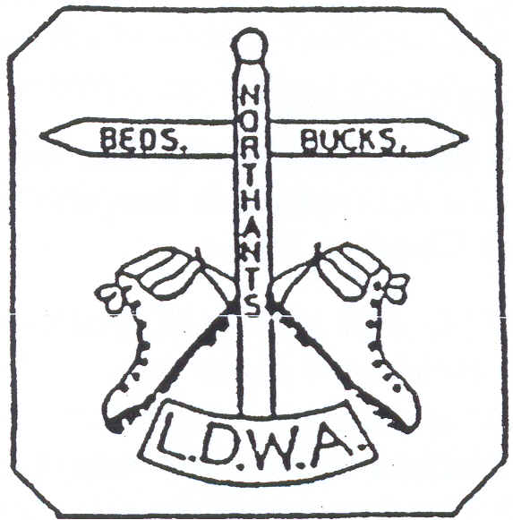

HAVE A GREAT DAY OUT, WALK WITH THE BBN

[www.ldwa.org.uk/bedsbucksandnorthants](http://www.ldwa.org.uk/bedsbucksandnorthants)

**New Members**

A very warm welcome to our new members who have joined BBN since the last Newsletter:

|  |  |
| --- | --- |
| Angela Atherley, Leighton Buzzard | Mark Lawrence, Milton Keynes |
| Beryl Bowley, Newport Pagnell | Sarah Mann, Newport Pagnell |
| Ian Chattington, Bozeat | Sheila McCarthy, Towcester |
| Jill Green & Jim Catchpole, Isle of Wight | Peter Richards, Luton |
| Alan Kindon, Towcester | Jan & Ian Richardson, Hartwell |
| Michael Trolove, Great Gidding, Huntingdon | |

**Chiltern Kanter Marshals Required**

The Chiltern Kanter is on Sunday 3rd March (one week before Dave Findel- Hawkins becomes National Events Secretary!), with the marshals’ walk on the previous Sunday 24th February.

Presently I have 21 people marshalling. Ideally I would like 25 including someone for the all-important job of the catering at the walk HQ Pitstone Memorial Hall.

As I’ve said before and will, no doubt, say again it’s great fun being the other side of the desk. If the weather is similar to last year’s Pick & Mix and the previous year’s Kanter an advantage to marshalling is that you’ll be dry………..unless you get the tent of course!

If anyone is interested in helping on the event please contact me as per my details on the last page of the Newsletter.

**Norman Corrin**

**Membership Reminder**

**If you have not already paid, your membership fee of £1 a year is now due.   
A renewal form is available on the BBN Web site in Document Store   
under Group Activities.**

Names and contact details for all **committee members** are shown

on the last page of the Newsletter.

**Letter from the Chairman**

**Big News, Big News** – 2013 is the 30th Anniversary of the founding of BBN within the LDWA. We owe a debt of thanks to the founder members and all who have served on the BBN Committee, the walk leaders and event marshals – without this volunteering the club would not be what it is today.

Thanks to Norman Corrin and Gill Bunker for organising the 2012 AGM and particular thanks to Norman for his 10 years as BBN Secretary. Welcome and thanks to Merrian Lancaster for taking on the Secretary role. With Merrian’s agreement I will step down as Local Groups Representative and Merrian will take over.

I hope that you all had a good festive season and were able to get out and about and enjoy the Boxing Day Walk in and around Woburn.

Please support the forthcoming 30th anniversary events if you can, either a walk or, with a walk attached, a brewery visit, a boat trip on Grand Union Canal with meal, three 30 kilometre walks, one in each BBN county, The John Bunyan Trail over four days, Milton Keynes Boundary Walk over three days, a quiz and a 30 mile social walk led by Chris Bent. Details and dates in future editions of BBN Newsletters and Strider (April and August Edition). And to celebrate the anniversary we hope to give all BBN members a commemorative souvenir.

Our next event is the Chiltern Kanter on 3rd March starting from near Pitstone and the route will take the entrants past the BBN Founders’ commemorative bench in Ivinghoe. The marshals’ walk takes place on Sunday 24th February. Please contact Norman Corrin if you are able to help on the event and intend to do the Marshals Walk – thanks.

BBN will be in charge of Checkpoint 3 on the Devon 100 and if you are able to marshal please let Merrian know – thanks.

As always your Committee and others work tirelessly on your behalf to organise events and arrange a very full social walks programme and Thursday programme. Dee and Gordon will always love to hear from you to propose a walk.

I hope that you all have good walking this late winter and forthcoming spring and stay healthy. Please think what you could do for BBN and not necessarily what the BBN can do for you and don’t forget ‘to have a great day out on a walk with BBN’.

**Nigel Schofield**

**Chairman**

**BBN 30TH ANNIVERSARY EVENTS**

**The Great BBN Brewery Visit - Saturday 18th May**

**The Chiltern Brewery, Terrick near Aylesbury**

15ml. Start 10.00 From Woollerton Crescent, E of B4009, NE of Wendover. Maps: LR 165 Exp 181 (GR SP875081). Limited numbers!

We will start walking later than normal at 10am and walk about 10 miles, having lunch at the usual time. We will reach the Chiltern Brewery (<http://www.chilternbrewery.co.uk/>) in the early afternoon and, after a complimentary drink, be shown around the brewery. We will then sit down and be given a presentation with several different beers with different foods. After the presentation there is the opportunity to buy beer, etc. The afternoon walk will be about 4 miles and fairly flat if you are thinking of carrying beer back to the car. We should be back at the cars by 17.30.

If you would like to go on this visit, please claim your place via myself with a £5 deposit. The total cost will be £11.50 so we will need £6.50 on the day.

Happy Quaffing,

**John Davies   
Tel: 01442 874875**

**ooooOOOOoooo**

**30th Anniversary Canal Boat Cruise - Sunday 18th August 2013**

One of our 30th Anniversary events is a two hour Canal Boat Cruise from Pitstone Wharf along the Grand Union Canal to Marsworth and back with a Fish and Chip supper being served. You won’t have to sing for your supper but will have the option of walking 15 miles beforehand for it.

There will be a vegetarian option and you don’t have to eat either, you can just pay for the cruise and enjoy your time at the bar!

At the last committee meeting we agreed the cost would be £10 per head for those eating and (pending approval) for cruisers only £5 per head, with the balance for both coming from group funds. (The full cost is £18 for the supper and cruise and £12 for the cruise only.)

The cruise company Glebe Cruises wish to know how many people will be attending so they can go fishing. They’ve asked for the numbers by the end of February. A bit early I know but that’s what they’ve stated.

So if anyone is interested please let me know either by email or phone by end of February. If anyone does book late Gill has said her husband Ian will take his fishing tackle and catch a meal live!

**Norman Corrin**

**ooooOOOOoooo**

**30 Mile Walk – Saturday 22nd June**Chris Bent is leading a 30mile circular walk from Whittlebury.

**ooooOOOOoooo**

**3 x 30km group walks - one in each of our three counties**

**Beds - Sunday 30th June** –Leader: Sue Leonard from Ravensden.

**Bucks - Saturday 27 July** - Leaders: Dave and Lynn Yorston from Prestwood. - Everyone will be invited to stay for tea and snacks in their back garden, weather permitting, afterwards. There may also be the opportunity to visit ‘Malt, the Brewery’ which is located at the end of the road.

**Northants - Sunday 22 September** - Leader: Martin Lawson from Hartwell.

**ooooOOOOoooo**

**Walk the John Bunyan Trail over 4 days**

Roy Carter has worked out the logistics for walking the John Bunyan Trail over two weekends. All four walks are linear and Barry Ingram (Beds Festival) is organising the transport for each day. The likely charge for transport is £10 per weekend.

The following plans are still provisional – though the Trail **will** be walked over these two weekends. Further information will follow but if you are interested in walking all or any days please let Gill Bunker know – particularly if you are not on the BBN email list.

**1st Weekend: Saturday 31st August/Sunday 1st September***Meet at HARLINGTON village hall (9am each day)*  
*Saturday: CRANFIELD to HARLINGTON (21 miles) - transport to Cranfield and walk back to Harlington. Leader: Eric Cartwright  
Sunday: BARTON to HARLINGTON (17 miles) - transport to Barton and walk back to Harlington. Leader: Dee Brockway*

**2nd Weekend***:* **Saturday 7th September/Sunday 8th September** *Meet in ELSTOW at Moot Hall (9am each day)*

*Saturday: CRANFIELD to ELSTOW (22 miles) - transport to Cranfield and walk back to Elstow. Leader: Derek Jacob*

*Sunday: BARTON to ELSTOW (18 miles) - transport to Barton and walk back to Elstow. Leaders: Therese and Daniel Jamin*

**ooooOOOOoooo**

**Quiz – October** Norman is planning a morning walk followed by a quiz, hopefully at the Paradise Hall, Newton Longville. He is inviting the Air Ambulance people to give a talk, and we will organise a raffle for their funds.

**ooooOOOOoooo**

**Walking the Milton Keynes Boundary Walk** **over three days -  
Saturday 19th, Sunday 20th, Monday 21st October**Led by Sylvie Eames, Steve Clark and Gill Bunker

------------------------------------------------------------------------------------------------------------------------------------------

**MERRIAN’S MISCELLANY**

**Contact me at:** [**merrian22@gmail.com**](mailto:merrian22@gmail.com) **01908 642803**

**Badges**

Please let me know if you want a BBN badge. Someone (sorry, I can’t remember who) suggested that it would be a good idea to put your ICE (in case of emergency) contact telephone number on the back.

**BBN website**

We’ve got loads of pictures from Thursday walks, but very few from weekend walks. If you have some on Flickr, Picasa, or whatever, that you’re happy to share with us, please send me a link and I’ll pass it on to members. Alternatively, please send me a memory stick with them on and I’ll load them onto the BBN website, and return the stick to you; a few comments about the walk would be good too*.*

**Camel-Teign Ivor's Dream 100 Saturday 25th – Monday 27th May 2013**

On this year’s 100, BBN has checkpoint 3 in a farm barn **at Candra, St. Breward, Bodmin PL30 4NP,** grid ref SX 1191 7797. There’s a map and some pictures at

<http://www.ldwa.org.uk/BedsBucksAndNorthants/W/2133/2013-100-cp3-candra.html>

The opening hours are from 1345 to 1800 on Saturday 25th May. Its 4.7 miles, and 824 feet in ascent, from CP2, and its 16.6 miles into the route.

No hot food. It will be cold bite size pieces of food e.g. sausage rolls, pork pie portions, cheese biscuits, cherry tomatoes, crisps, assorted cakes, bananas. If a gas urn can be organised then hot drinks will be offered. Cold drinks available too. More food will be added to give a bigger variety on the savoury side but that's as far as the organisers have got at the moment.

So far, 11 people have volunteered to help, but we need a few more please. If you’d like to join us, please let me know. There’s more information about the event at <http://www.ldwa.org.uk/2013Hundred>

**Latest news**

I send news updates to everyone on our email distribution list. If you don’t have an email address, see if there’s another BBN member who’ll keep you up to date. Everything important will be included in Newsletters, so you won’t miss out, but last minute changes, like additional walks, will only go to those on the email list.

Please let me know if you’re not on the list and want to be added, or if you’re on the list and want to be removed. I’ve put the details of the news updates under Latest News on the website, so you can catch up if you’ve missed anything. Our email distribution list is maintained separately from the LDWA mailing list.

**LDWA membership preferences**

Please check your membership preferences by going to “View / Edit Your Details”, under Membership on the LDWA website. Here you can Change your password, Update your membership details, Update your local group memberships and Update your email preferences (see the screen dumps on p.9 and the email from Simon Leck, the LDWA Internet Officer, on p.10).

Please note that BBN aren’t currently referring to these email preferences because we’ve found some mismatches between what members have told us and what is on the LDWA database.

**Photo Competition**If/when we use the LDWA bulk email, I can put a BBN specific photo in the header for the email. Please send me suitable photos, especially if you have something that reflects all 3 counties, and I'll ask the committee to choose one at the next committee meeting. There will be a prize!

**AGM 2013**

Milton Keynes is near the middle of our area (Olney is nearest) and it’s easy for most people to get to, so I could look for a suitable venue close to home and I know several people who could lead the walk – job done. I could be really lazy and choose Cosgrove again, very tempting. Alternatively, you could suggest somewhere. We need a shortish (8-9 miles) walk, somewhere to eat (preferably somewhere that serves cask ale) and somewhere to have the meeting. In 2012 28 had a meal and 35 attended the meeting. If you have any suggestions, please let me know*.*

**Secretary**

I don’t really want to be secretary; I didn’t retire from a job with responsibilities to take on job with responsibilities so soon after. I was the obvious person to take over from Norman and I’m happy to carry on; so far, it’s been very easy and Norman is still doing loads. I just want you to know that I’m already looking for someone to take over. Please think about it and get in touch if you fancy  
having a go*.*

**Merrian Lancaster**

[***merrian22@gmail.com***](mailto:merrian22@gmail.com) ***/ 01908 642803***

***Have you forgotten your LDWA password??***

*Can I just add to Merrian’s notes – how easy it is to get a new LDWA password if you have forgotten yours. I needed to change the email address the LDWA had for me but because I forgot my password a long time ago I kept putting off sorting it out. But it is so simple …….*

*On the LDWA website under Membership, there is a “Reissue Password” link. You just need to enter your LDWA number, your last name and your email address. If these details match those held on the LDWA membership database you will be sent an email confirming your NEW password.*

If, like me, your email address has changed (or you have never registered an email address), on the same page there is a direct link to the [*LDWA Internet Officer*](mailto:internet@ldwa.org.uk). Give your membership number, name and address and your password will be re-set and emailed to you.

Couldn’t be easier – and the good news is that now you can access your membership details, you can alter your password to something you can remember!!!

***Gill Bunker***

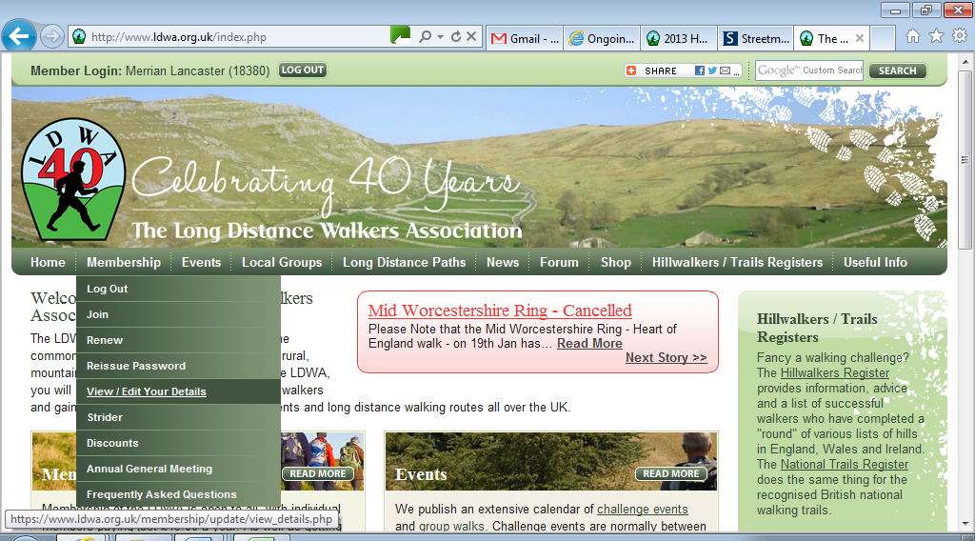

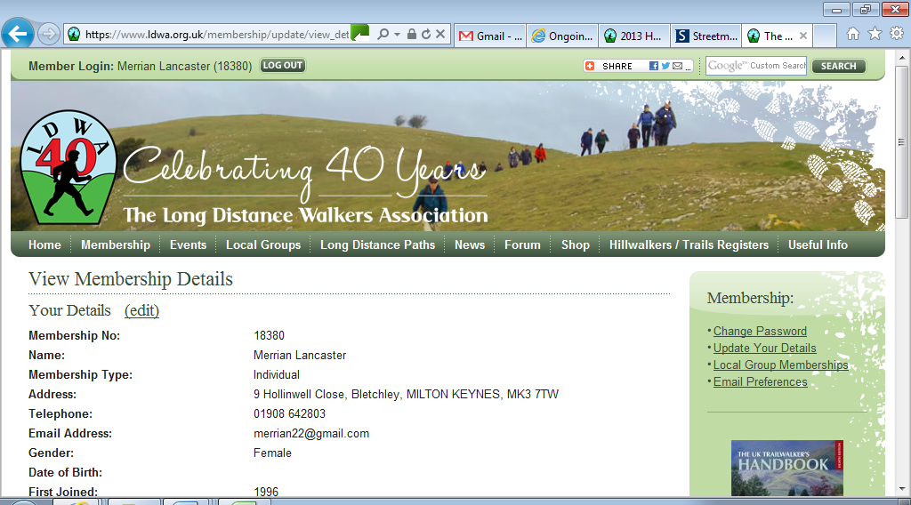

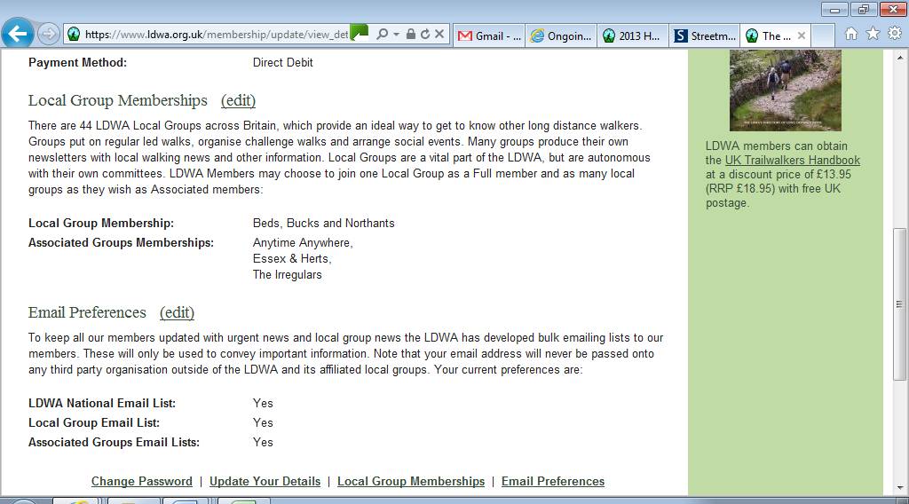

|  |  |  |  |  |
| --- | --- | --- | --- | --- |
| |  |  |  |  | | --- | --- | --- | --- | | |  | | --- | | The Long Distance Walkers Association | |  | | Hi Folks,  Simon Leck the LDWA internet officer here, I’m sorry for the intrusion, but I’d like to tell you about a new feature that we’re currently developing for the LDWA membership.  It will now be possible for the LDWA National Committee and your Local Group to send you important information via email. Obviously with this kind of facility there needs to be some sort of control and if you do not wish to receive email from the LDWA you can opt out.  You may have noticed on the ‘Membership / View Edit Your Details’ screen the following email preferences:   * LDWA National Email List – *This allows you to receive emails from the LDWA National Committee.* * Local Group Email List – *This allows you to receive emails from your Local Group*. * Associated Groups Email Lists – *This allows you to receive emails from other Local Groups that you may have an interest in*.   These have been defaulted to ‘Yes’, but if you no longer wish to have any form of email communication from the LDWA then you can change these to ‘No’.  Also you can now elect to be a member of more than one LDWA local group. By default you have a *primary* local group, as before but you now can select all the other groups with which you wish to be *associated* with. To add extra local group(s) use the ‘Local Group Memberships’ edit button and choose the local groups you want.  Note: The ‘Membership / View Edit Your Details’ screen can be quickly accessed via the following link: <https://www.ldwa.org.uk/membership/update/view_details.php>  Regards, | | |

Simon

**Group Walks**

BBN is 30 years old this year and I really feel we are offering our members a fantastic programme of walks, many directly celebrating this special anniversary. It is the enthusiasm and dedication of our walk leaders that has made all this possible. I am constantly amazed by the variety of ideas I receive.

We have a visit to a brewery (which includes the right food for the right ale), a group weekend away in a bunk house on the North Norfolk coastal path, a canal boat trip which includes a meal, a 30 mile walk and 3 separate 30km walks, one in each of our 3 counties. Coming up later in the year the celebrations continue with 2 x two-day weekends spent walking our local 80 mile Bunyan trail and a 3 day long weekend enjoying the Milton Keynes Boundary Walk.

The programme for April to August is complete, and contains the usual two Thursday walks each month and at least two weekend social walks. Thanks to Gordon for co-ordinating the Thursday programme and to Gill and Merrian for proof reading and, I am sure, correcting my silly mistakes, and for inputting the information onto the web, from which the information will be extracted for inclusion in Strider.

As always, I am now starting on the programme for the final four months of our anniversary year, from September to December. Let’s make this special year go out with a bang. Please contact me asap to book a date to lead a walk, with the usual final details required by 10th May please.

**Dee Brockway**

**------------------------------------------------------------------------------------------------------------------------------------------**

**Sundon Saunter - 18th November 2012**

When I first suggested that I would be happy to plan a new route for our November event I didn’t realise just how enjoyable it would be. I had a rough idea for the route – we had walked some of it on a social walk I’d led the previous winter. So I spent much of last winter jogging around the route writing the route description – most memorably some sunny days with snow on the ground, and spectacular views from the ‘Toddington Alps’.

There was a path through a farm on the long route which in winter was deep in gluey mud - and foul smelling as the farm is also a slaughter house! It was fun working with Richard, the Rights of Way officer, to get the path diverted on to a

more walker friendly line. On the day of the event, though, there was still a tricky double gate with 12” deep quagmire to wade through where the path went from the old line.

With Gemma, another ROW officer, we also got a line of stiles, in Harlington on the short route, changed to kissing gates – the work finishing just three days before the event. We didn’t have the same success, though, with the lines of stiles around Tebworth.

And so to the Marshals’ Walk – a dank, dire, wet and gloomy day. Thanks again to Dave and Merrian for their support. My main memory is that I seemed to do most of the second half in the dark – despite finishing by 3.30pm. And that it was so wet underfoot that despite all the mud my shoes were clean at the end!

On the day of the event the checkpoints seemed to work well. At Tebworth we’d planned to use a hall, but were denied the use of a permissive path to the back of it, and other routes were not suitable. But we were offered instead the use of the Queen’s Head where, though the bar was small, it was cosy.

At Eversholt we weren’t able to use the carpeted village hall and were offered the cricket pavilion. During one of my recces in the winter I’d noticed a rushing sound as I passed it, and investigating saw deep water on the grass in front – then looking inside a flood on the floor – one of the pipes had burst! Running round the village I eventually found someone to tell.

The day of the event was bright sunshine and blue skies – so all could enjoy the views on the route. After putting out some notices, and taping through the quarry, I eventually ended up at Eversholt and helped with doling out the fruit pies and custard – which seemed very popular. It was great to see all runners and walkers at one point - and get their feedback from the day so far.

Then when the last walker arrived I walked with him back to Barton, and he was happy, particularly when dark, to follow my lead rather than having to read instructions. The feedback was that most people had a great day – I certainly did.

Thanks to all on the SS committee, and all the checkpointers, who helped to make it a memorable event.

**David Sedgley**

**Sundon Saunter 2012**

The walk was a resounding success. We had to close entries and could not take any ‘on the day’ walkers. After covering all our expenses and making a donation of £150 (over £60 from tea box) to BOB Air Ambulance, we made an excess of £732.84.

The feedback was brilliant – The route went down well with paths that had not been used before and wonderful views. The checkpoint staff were great and the food was said to be very good. We send a big thank you to all who helped.

The marshals’ walk on Sunday 4th November was VERY wet. 18 people turned out and all were so very pleased to reach our impromptu checkpoints manned by Dave Findel-Hawkins & Merrian. Many thanks to them both.

Five others (including DFH & M) went out on different days to complete the routes.

**Steppingley Step 2013**

We have secured the hall at Barton for November 3rd 2013. This date had also been confirmed as OK for the extra parking at the Arnold Academy. We have visited and booked both Steppingley Village Hall and Pulloxhill Church Hall. We have approached the Scouts at Harlington but await their response. Thanks to his early work, Dave Findel-Hawkins has the route well in hand.

**The Triple Challenge**

We have drawn up a list of those who would be eligible for the award on completion of the SS in 2013. There are 135 names on this list. We now need to work on the designs for the badges and certificates. It has previously been agreed that there will not be any further charge to the walkers for this award.

**Lynn Yorston**

**Committee Meeting: 25th January 2013**

I have included officers’ reports and relevant information from the committee meeting in this Newsletter but it is impractical to reproduce the Minutes as they would take up too much space.

The Minutes can be viewed on the BBN website, but if anyone would like a hard copy please let me know.

The next committee meeting takes place on Thursday 16th May at Merrian’s. Please contact Merrian or any committee member if there are any items you would like to raise.

**Gill Bunker**

**PROGRAMME – APRIL TO AUGUST 2013**

**Sunday April 7 From the Source of the River Lea**

18ml. Start 09.00 From c.p. Bramingham p.h. near Sainsbury’s (corner of Quantock Rise & Whitehorse Vale), Luton. Map: Exp 193 (GR TL076254).   
***C:*** Therese Jamin ***T:*** 07779 227675.

**Thursday April 11 Greyhound and Badgers**

15ml. Start 09.30 From Ashridge c.p. on the L of rd to the Monument. Map: LR 165 (GR SP975128). Figure of 8 walk.   
***C:*** Roger & Margaret Skerman ***T:*** 01525 405540.

**Sunday April 14 A Lover’s Knot**

20ml. Start 09.00 From Gaddesden Row (road) in parking area alongside Gaddesden Row Primary School. Maps: LR 166 Exp 182 (GR TL050130). Picnic lunch near p.h. Joint walk with Essex/Herts.   
***C:*** Gabriel Newfield ***T:*** 01727 832696 ***M:*** 07868 507565 (on day only).

**Thursday April 25 A Totter from Totternhoe**

15ml. Start 09.30 From c.p. in Totternhoe. From main rd take lane signed Totternhoe Knolls, NE, to reach c.p. Maps: LR 165 Exp 192 (GR SP998218).   
***C:*** Ruth Bowles ***T:*** 07901 565863.

**Sunday April 28 Stewkley and Cross Paths**

15ml. Start 09.00 From St Michaels & All Angels Church, High St, Stewkley. Pls park considerately on nearby rds. Map: Exp 192 (GR SP852261).  
***C:*** Sylvie Eames ***T:*** 07788 287701.

**Thursday May 9 Clay Way to Coachway**

15ml. **Start BY BUS** Stagecoach No.40 at **09.15** From Milton Keynes Coachway ‘Park & Ride’, off A509 or A5130 at M1 jnct 14 (free c.p.). Map: Exp 192 (GR SP892405). Linear walk back from Bromham. Break at North Crawley village adjacent to p.h. Aim to finish by 16.00.   
***C:*** Mike Bowley ***T:*** 01908 616589 ***M:*** 07933 066784 on day only.

**Saturday May 18 Chiltern Brewery Walk**

15ml. Start 10.00 From Woollerton Crescent, E of B4009, NE of Wendover. Maps: LR 165 Exp 181 (GR SP875081). Limited numbers and a deposit of £5 will be needed towards the full cost of the Brewery visit of £11.50. Please book via leader. We will finish later than normal because of the timing of the tour.

A small amount of food will be supplied with the various beers, but we will still need to carry some food for lunch.   
***C:*** John Davies ***T:*** 01442 874875 ***M:*** 07949796470 on day only.  
***Special 30th anniversary event – see p.4 for further details***

**Thursday May 23 In the Steps of Lady Di**

15ml. From Great Brington Church. Please park considerately in nearby streets. Maps: LR 152 Exp 223 (GR SP667652). ***C:*** Martin Lawson ***T:*** 01933 678594.

**Sunday June 9 The Silverstone Slip**

15ml. Start 09.00 From c.p. in Chackmore (not NT c.p. in Stowe Ave). Map: Exp 192 (GR SP684357). ***C:*** Sylvie Eames ***T:*** 07788 287701.

**Thursday June 13 Baldock Bimble**

15ml. Start 09.30 From village green in Weston (near Baldock). Pls park considerately in nearby Maiden St. Maps: LR 166 Exp 193 (GR TL259301). Pub & café at lunch stop.  
***C:*** Phil Hastings ***T:*** 01763 853744 ***M:*** 07716 992847 on day only.

**Sat June 22 Celebrating BBN's 30th**

30ml. Start 09.00 From Whittlebury. Map: Exp 207 (GR SP693446). Expected finish time 19.00. ***C:*** Chris Bent ***T:*** 07837 367575.

***Special 30th anniversary walk***

**Thursday June 27 The Wootton Wander**

15ml. Start 09.30 From Wootton Village Hall c.p. Please park in ‘bottle bank’ area. Map: LR 153 (GR TL007452). ***C:*** Derek Jacob ***T:*** 01234 767759.

**Sunday June 30 30km in Beds**

30km. Start 09.00 From Ravensden Village Hall. Map: LR 153 (GR TL074539). First in a series of three 30km walks, one in each of our 3 counties, to celebrate BBN’s 30th anniversary. ***C:*** Sue Leonard ***T:*** 07432 140345. ***Special 30th anniversary walk***

**Sunday July 7 Pootle to Park Lane**

19ml. Start 09.00 From Heath Sports Centre, off Baldock Road, Royston. Free c.p, café and toilets. Map: LR 154 (GR TL348405). Lunch stop at picturesque village green next to p.h. Joint walk with Essex & Herts. ***C:*** Phil Hastings   
***T:*** 01763 853744 before 9pm please ***M:*** 07716 992847 on day only.

**Thursday July 11 The Old New G.R.**

15ml. Start 09.30 From Ampthill Park c.p. Map: LR 153 (GR TL025382).   
***C:*** Margaret & Roger Skerman ***T:*** 01525 405540.

**Thursday July 25 A Covert Walk**

15ml. Start 09.30 From School Lane on S side of church at Harpole. Map: Exp 223 (GR SP691608). ***C:*** Roger Story ***T:*** 01604 751576.

**Saturday July 27 30km in Bucks**

30km. Start 09.00 From Lynn and Dave’s house, 3 Lodge Lane, Prestwood, HP16 0SS. Map: Exp 181 (GR SP874001). Second in a series of three 30km walks, one in each of our 3 counties, to celebrate BBN’s 30th anniversary. Please bring a packed lunch.   
***C:*** Dave & Lynn Yorston ***T:*** 01494 868371 ***M:*** 07798 767787 on day only.

***Special 30th anniversary walk – see p.5 for further details***

**Sunday August 11 Wheathampstead Walkabout**

18ml. Start 09.00 From Wheathampstead East Lane public c.p. on lane adj to Bull p.h. Map: LR 166 (GR TL179141). Joint Walk with Essex & Herts. ***C:*** Gordon Shaughnessy ***T:*** 01582 518791 ***M:*** 07518 364036.

**Thursday August 15 A Walk from Wilstead**

15ml. Start 09.30 From Wilstead village c.p. (220yds from crossroads towards Cotton End – on rhs). Maps: Exp 193,208 (GR TL066435).   
***C:*** Colin Scargill ***T:*** 01234 740361.

**Sunday August 18 BBN 30th Anniversary Canal Boat Cruise**

15ml. Start 09.00 From Grebe Cruises c.p. Pitstone Wharf LU7 9AD. Map: Exp 181 (GR SP927160). Walk followed by 2 hour cruise and Fish & Chip Supper along Grand Union Canal from Pitstone to Marsworth Reservoir and return. Please contact leader if you wish to sail.   
***C:*** Norman Corrin ***T:*** 01908 608667 ***M:*** 07980 378656 on day.

***Special 30th anniversary event – see p.4 for further details***

**Sunday August 25 To Mellow Yellow and Beyond**

20ml. Start 09.00 From church in Hargrave. Pls park considerately in village. Map: Exp 224 (GR TL036706). Visiting Catworth, Spaldwick, Stow Longa, Tilbrook and Upper Dean. Please bring packed lunch. ***C:*** John Ledger ***T:*** 01933 387645.

**Thursday August 29 Northampton Round – Cogenhoe to Holcot**

18ml. Start 09.00 **Note early start**. From Memorial in Ecton at jnct of High St and Wellingborough Rd. Street parking available nearby. Map: LR 152 (GR SP827637).. ***C:*** David Findel-Hawkins ***T:*** 01908 216476.

**Comedy Corner**

I’ve just been to a funeral of a close friend who died when he was hit on the head with a tennis ball. Great Service!

A top hotel in London has changed the name of its top floor suite to “The Rafa Benitez Suite”. They say this is perfect for short stays.

Tesco’s are bringing out a new range of beef burgers called Fernando Torres……………100% pony.

The man who just had the recent hand transplant has been caught shoplifting in Tesco. It turns out the donor was a Scouser!

Tesco Horse Meat Jokes

I’ve had so many of these I thought I would give some of them free rein………………..Sorry!

What should you do if someone offers you a Tesco burger? Just say “Neigh”.

My wife keeps pestering me to buy Tesco burgers. I told her to stop being a nag.

Why does South Africa import so many Tesco burgers? Because their best customer is Whinny Mandela.

How can you tell someone’s eaten a Tesco burger? They’ve got the trots.

Just had a Tesco burger, enjoyed it - but still got a bit between my teeth.

Just went to check my burgers from Tesco in my fridge... Aaaaaaaaaaannnnddd they’re off!

The best way to eat horse burgers is with a nice glass of red rum!

Whatever next? My Lidl pony?

I expect this only relates to those mini-burgers you have as snacks. You know, the horse d'oeuvres.

I think that will do!!

**Norman Corrin**

**In the Footsteps of a Saint** - **The John Schorne Peregrination**

***Michael Mooney writes:***

***On the Boxing Day walk I was wearing a fleece with the badge of the John Schorne Peregrination. A lady asked me who John Schorne was, saying that she had never heard of him. Perhaps some information would be of interest to members. The following is taken from an article which appears in Buckinghamshire Life, Feb/ March 2010.***

*It was while undertaking his own pilgrimage along the famous Way of St James to Santiago del Compostela in northern Spain in 2006 that Michael Mooney had what you could almost describe as ‘an epiphany.’*

*Michael, a risk assessor from Hoggeston, near Winslow, recalls: “I began to understand the nature of pilgrimage when I made my own and following my return to “normal life” I determined to develop a pilgrimage route in honour of John Schorne.” The result is a newly created Buckinghamshire walking route, The John Schorne Peregrination, which it is hoped will revive interest in the once famous, but now little known, local ‘saint’. (A peregrination is defined as travelling from one place to another, especially on foot.) The 27 mile circular route has just been published by the famous ‘Marathon Hiker’, John Merrill.*

*John Schorne, Rector of North Marston between 1290 and 1314, was recognised in his lifetime as a devout and holy man. One year, after a prolonged drought, he struck the ground with his staff, and like Moses, he was rewarded with fresh water that gushed forth. Pilgrims flocked to bathe in the waters of this well, which, they believed, could banish evil and had healing powers. Schorne and his well were said to have effected many miraculous cures for common ailments such as gout and toothache. Indeed, his reputation for holiness was such that he was believed to have banished the devil by tricking Satan into a boot and keeping him captive there. Schorne is often pictured holding a boot with a devil in it, supposedly the origin of the child’s jack-in-the-box toy. Says Michael: “Whether or not you believe the stories associated with Schorne, the medieval importance of North Marston (a local Lourdes as it was recently described) and John Schorne, is a part of local history which deserves to be better known than it is.”*

*Although never formally canonised, Schorne was popularly regarded as a saint and, whether or not you believe the legends attached to his name, he must have been a man of considerable charisma. Like many medieval rectors, Schorne was eventually buried before the high altar of the church where he served as rector. But he was not allowed to remain at North Marston. In 1478, his remains were*

|  |  |  |
| --- | --- | --- |
| C:\Users\ian\AppData\Local\Microsoft\Windows\Temporary Internet Files\Content.IE5\9256JW13\CIMG0043.JPG | | Michael on his  An Architect, Assassin, Angel and Devil walk  at the Schorne Well in North Marston with the devil in the boot.  April 2011  *Pics: Merrian* |
|  | C:\Users\ian\AppData\Local\Microsoft\Windows\Temporary Internet Files\Content.IE5\MH6W78XV\CIMG0042.JPG | |

*moved (by Royal command and with papal sanction) to the new St George’s Chapel, in Windsor. His shrine became one of the most important pilgrimage sites in the south of England. Schorne’s cult, together with his remains, did not survive the Reformation, but his name continued to be remembered and honoured at his home village of Marston. A wall painting of the ‘saint’ and the niche where his bones were probably originally laid may be seen in St Mary’s Church, North Marston. Schorne’s Well lies about 200 yards from the church. It was restored and a new well house built in 2004-2005. If you pump the handle the devil appears in the boot! The circular walk of 27 miles begins and ends in Winslow and visits Addington, Padbury, Hillesden, Claydon House, Quainton, North Marston (taking in St Mary’s Church and Schorne’s Well), and Verney Junction.*

*Michael concludes philosophically: “A pilgrim is a wanderer with purpose. In the Middle Ages thousands came to North Marston with the purpose of being cured and of obtaining grace. I developed this walking route and walking guide with the purpose of making better known the importance of North Marston.”*

**Alan’s Grand Canal Hike  
Alan Leadbetter will be   
Walking the Grand Union Canal from London to Birmingham  
8th – 14th June 2013 In aid of**

**  
Sponsor me at**[**www.bmycharity.com/AlanLeadbetter**](http://www.bmycharity.com/AlanLeadbetter)Event Number: 201207-4875-0564

|  |  |  |
| --- | --- | --- |
| June 08th | Little Venice to Uxbridge | 17.5 miles |
| June 09th | Uxbridge to Tring | 26.0 miles |
| June 10th | Tring to Milton Keynes | 22.5 miles |
| June 11th | Milton Keynes to Blisworth | 15.5 miles |
| June 12th | Blisworth to Stockton | 28.0 miles |
| June 13th | Stockton to Kingswood | 17.5 miles |
| June 14th | Kingswood to Gas Street Basin | 17.5 miles |

**Buckinghamshire and Bedfordshire County Cross Country Championships**

|  |  |
| --- | --- |
| BBN members were out in force at the recent combined Buckinghamshire and Bedfordshire County cross country championships held in Campbell Park, Milton Keynes. A 2.8Km lap making the most of the hilly nature of the park was completed 2, 3 or 4 times depending on age group. | |
| C:\Users\ian\Pictures\DFH for Newsletter | Pride of place goes to Sarah Thorne who finished in 15th place in the Bedfordshire Ladies race but first in her age category.  The young – well compared to the rest of the men – Paul Keech and Martin McPheat had to do four laps. Paul still had energy for a sprint at the end that gave him 4th in his age group and 56th overall in Bedfordshire. While Martin was 63rd and 6th in his age group in Buckinghamshire.  The older men ‘only’ had to complete 3 laps but were still all lapped by some of the higher placed youngsters. Dave Findel-Hawkins led home the quartet followed by Jonathan Venning, Brian Layton and Dave Sedgley who was first (and only one) in his age group.  *This was DFH’s 35th Bucks County XC Championships!* |

Words DFH  
Photo: Brian Graves

----------------------------------------------------------------------------------------------------------------

**Kevin Lamming is looking for marshals for the MK Marathon on Monday 6th May. Offers of help to Kevin at 01908 6 55262 /** [**kevin.lamming@open.ac.uk**](mailto:kevin.lamming@open.ac.uk)

***Dave Sedgley writes:***

*Several BBN members, who came on my Two Moors Walks a couple of years ago, have recently asked me how things are progressing on the Moor. So here is some information, extracted from our village magazine, on what’s been happening recently.*

|  |  |
| --- | --- |
|  | **Bedfordshire wetland project**  **WINS national award!**  For the past five years the **Friends of Flitton Moor** have been working hard to increase the biodiversity of Flitton Moor – a project funded by a Biffa Award landfill tax grant. |
| The project had been short-listed for a prestigious national award at the 2012 Biffa Awards, a ceremony which recognises the people who transform their communities and improve the environment through Biffa Award funded projects.  Selected from nearly 100 hopeful applicants, the **Flitton Moor – Action for Biodiversity** project was to compete against four other organisations from across the country to be named winner of the ‘Rebuilding Biodiversity’ category, and receive a £2,000 prize.  The project received more than £30,000 in funding from Biffa Award to restore this wetland area in the Flit Valley, which has been identified as one of seven Wildlife Priority Areas in the county by an English Nature and Bedfordshire County Council study. We spent the money on: A stock bridge, so the cattle could be brought in more easily; repairing the dams to raise water levels - one of them twice; managing the ponds, ditches and woodland areas; having ancient willows pollarded; school visits for pond dipping and working in the osier bed; producing a new leaflet; installing a pond-dipping platform and a new notice board; and monitoring the biodiversity of the site, which has increased significantly.  After being short-listed for this prestigious national award myself and Sue Raven from the Greensand Trust went to the Chatham Historic Dockyard in September to the Awards Ceremony. All the finalists were invited to attend a day celebrating the enthusiasm and commitment of those who dedicate their lives to making a real difference to their community and the environment. Category winners at the Awards receive a trophy and prize money of £2,000, which can be used to further develop their project. Each winner then has the chance of being crowned the Overall Winner for 2012, receiving a further £1,000 prize.  There were five categories, and when the winner for the first (Recreation) was announced, the lady gave such a professional speech that I then thought that all the winners had been told before. When it came to our category (Rebuilding Biodiversity) our judge, Tony Richardson of the RSPB, who had visited Flitton Moor in May, said how much he was impressed by all five of the short listed. | |
|  | |
| projects. The runner up was the restoration and creation of ponds throughout Glasgow, which I thought sounded an excellent project. Then he announced the winner, and it was us: **Flitton Moor – Action for Biodiversity.** I was flabbergasted - and I then had to make a speech! Sue said it sounded OK.  After the last category was announced, each winner then had the chance of being crowned the **Overall Winner for 2012**. The chairman of Biffa announced this: and **it was us again!** Afterwards, Tony told me that, apart from our success at increasing the biodiversity of the site, what impressed him was that the project had been led by volunteers and that we organised many events - including the **Fun Run** to raise funds for the site.  We have plans to spend the prize money on refurbishment of an old barn on the site, and use it as a Wildlife Gallery and information centre. If you would like more information on Flitton Moor, or would like to join our group of 'Friends' please contact David Sedgley on 01525 714961. | |

|  |
| --- |
| *(Photo copyright John Pitts)* |

**Castlebar International 4 Days Walks, County Mayo, Eire,   
Thursday 4th July 2013 to Sunday 7th July 2013**

After last year’s trip to Castlebar with Gordon and Lucy some of us are planning to go again. However this year there won’t be any Euro 2012 football matches to distract us from watching the backward ticking clock in Johnny McHales bar…….

This year the dates of the walk are from Thursday 4th July to Sunday 7th July 2013.

For those of us who've not done an international event before this is part of the International Marching League calendar of events which encourages mass participation events at varying distances. It’s an ideal opportunity to get a flavour of how relaxed and enjoyable and carnival- like the big events can be abroad. I’ve done several of the big walks but there is something deliciously chaotic and friendly about the Castlebar 4 days.

The walking is not particularly strenuous but the craic is awesome!

This is what can truly be called a walking holiday, there is no pressure… …to be sure to be sure.

As with all IML events there are several distances available such as 10 or 20 km road walks. Sadly for health and safety reasons the 40 km road walk has been dropped. However unique to Castlebar are the 30 km rambles which are led walks over the delightful Irish countryside. The terrain is fairly rough in places but the views from the top of the mountains (when you get there!) are well worth the effort.

The rambles attract up to 250 people each day and safety for such a large amount of people on the hillsides at the same time is paramount. It is anything but chaotic. There is someone carrying a stretcher in case anyone injures themselves which has happened.

There are several accommodation options available such as a hotel, guesthouse, B&B, self-catering, or for those of us on a budget but keen to take part there is camping or sports halls. I will enquire about provisional bookings at the Nephin Halls which are 2-bedroom self-catering apartments. They sleep a maximum of 4 people for a minimum of 5 night stay. The rate for 5 nights is € 330. The link to the halls is <http://www.nephinhalls.com/>

There is a Tesco supermarket close by where we can buy food in and self-cater for a few nights. So the trip can be done fairly cheaply.

The itinerary is for us to travel over on Wednesday 3rd July from Luton Airport to Knock International Airport and return Monday 8th July. The airline will be Ryanair and there is only one flight each day by this airline. From Knock we’ll be taken by taxi to Castlebar and by the same method for the return journey for which we’ll have to pay. The fee is approx 10 euros each way. This is arranged by the walk organisers who will request our flight details when we enter for the walk.

I’ve attached the links to the Castlebar walks website: <http://www.castlebar4dayswalks.com/> plus the International Marching League. <http://www.imlwalking.org/>

The construction of Knock International Airport is a tale in itself and below is the link to the book that was written about it. I bought it as a Xmas present for Sylvie and its heavy going! <http://www.amazon.co.uk/On-Wing-Prayer-Airport-Ireland/dp/0955369908>

If anyone is interested in the trip can they please contact me by my email address or telephone number 01908 608667.

**Norman Corrin**

**------------------------------------------------------------------------------------------------------------------------------------------**

**A Remembrance Day Marathon**

Sunday 11th November 2012 was just the grandest day in November to be spent out and about on foot in the great outdoors under a clear sky. Early morning frost and shallow banks of fog soon dispersed as the sun’s rays of warming light took effect. In the afternoon a few cumulus clouds marked the tops of thermal currents under which gliders launched from Bicester Airfield soared upwards. A rare pleasure for glider pilots in November!

We five walkers: myself as leader, Chris Flint, Secretary of Centurions 1911, Steve Slater, Chairman and Secretary of the Vintage Aeroplane Club, Tim Freegarde, past Chairman of Oxford University Gliding Club, Bicester and Dave Hoben, LDWA member since the early days, set off on route from Bicester Airfield at 07.30 hrs in good spirits with the task of passing through six local churchyards on a 24 mile circuit, where there are located over 100 WWII graves of military personnel who were killed in aviation related accidents, and also to reach Upper Heyford to be part of the Remembrance Day wreath laying service. This was done!

Our first stop was in Bicester churchyard where Portland stone grave stones were briefly studied before we pressed on with good speed towards Middleton Stoney, where a short tea break was taken at a seat beside the graves of those WWII aircrews who had succumbed to their injuries in Middleton Stoney Park Field Hospital. Onwards to Upper Heyford in time to see the brass band followed by flag bearers and about 100 villagers attending. The names of the parish fallen were called prior to the sounding of “The Last Post” by a lone lady trumpeter, followed by the two minutes silence, which was broken with the sounding of “Reveille”.

A Tiger Moth biplane flown by Garry Binney from Bicester Airfield flew overhead, high enough not to be intrusive but nevertheless created the need for everyone in attendance to look upwards to that flying relic of WWII aviation. We five walkers lingered amongst the 39 war graves at Upper Heyford whilst the villagers went off behind the band towards the village hall.

Onwards we walked, northwards then east around the perimeter fence of Upper Heyford Airfield which closed at the end of the Cold War. Past the crash site of a USAF FIII fighter which killed its two man crew, who are remembered with a gravestone in Upper Heyford Churchyard and also by a rose bush planted at the airfield fence close to the crash site.

On an earlier recce of our walk route I’d discovered a half mile section of very overgrown bridleway. A report made to Oxford CC Rights of Way Office produced the necessary clearance to facilitate our passage.

Approaching Ardley village, Steve Slater who’d been the prime promoter of this year’s Remembrance Day Walk was becoming stressed out and decided to retire at half a marathon distance, to be collected by Dave Peck who was flying his glider at Bicester when I called for his rescue services. Dave returned to Bicester with Steve who set off for home and a long soak in very hot water.

We now four walkers carried on route to cross the busy M40 motorway towards Hardwick where there is a WWII grave of one soldier, and also the village farm shop which was about to close for the day. After making our purchases we bade the staff farewell, stating that we’d be returning on the same Sunday and the same time next year! That broke the suspicion and ice created by four strangers walking in at closing time. Most customers arrive at the shop in 4x4s.

On crossing a stile out of Hardwick, Chis Flint slipped off the wet stile in his green wellies, but was none the worse for his calamity. Tough souls are members of the Centurions 1911.

In Hethe we paused at the WWII graves of three catholic air crew. Our final collection of war graves was at Caversfield where the Bicester Airfield WWII crash victims are interred within a pocket of evergreen trees that provide insulation from the busy A4100 road outside.

Now only one mile to Bicester Airfield through the old RAF Bicester domestic site, prior to reaching the comforts of the Windrushers Gliding Club’s members kitchen, where our energy supplies were topped up. As the gliders returned to their hangers, the sun set below the western horizon. Our marathon walk was completed with a circuit of the now empty airfield in twilight into darkness. The location of the airfield ghost was pointed out, no contact with our ghost being made due to the early evening hour!

Our day was concluded with a beer in the Windrushers Gliding Club bar. Leadership of the 2013 Remembrance Day Marathon was handed over to Tim Freegarde, past chairman of Oxford University Gliding Club, Bicester.

Do support Tim next year!

**Norman W Smith**

**BEDS BUCKS & NORTHANTS GROUP: COMMITTEE 2013**

|  |  |
| --- | --- |
| **Chairman:** | **Nigel Schofield**  *T*: 01462 442338 *E*: [nicelegs.schofield@btinternet.com](mailto:nicelegs.schofield@btinternet.com) Nigel.Schofield@north-herts.gov.uk |
| **Secretary/ Website/ Local Group Rep:** | **Merrian Lancaster**  *T*: 01908 642803 *M*: 07933 735338 9 Hollinwell Close, Bletchley, MK3 7TW *E*: [merrian22@gmail.com](mailto:merrian22@gmail.com) / [bbn@ldwa.org.uk](mailto:bbn@ldwa.org.uk) |
| **Treasurer:** | **Ian Sage** *T*: 01582 661256 *E*: iansage@waitrose.com |
| **Social Walks:** | **Dee Brockway** *T*: 01582 881809 *E*: dmrbrockway@ntlworld.com |
| **Membership:** | **David Findel-Hawkins** *T*: 01908 216476 *E*: davefh@gmail.com |
| **Merchandise/ Equipment:** | **Lynn Yorston** *T*: 01494 868371 *E*: lynn.yorston@dsl.pipex.com |
| **Newsletter:** | **Gill Bunker** *T*: 01908 321308 *E*: gillbunker@googlemail.com |
| **Thursday Walks:** | **Gordon Shaughnessy** *T*: 01582 518791  *E*: gordon_shaughnessy@hotmail.com |
| **Member:** | **Norman Corrin** *T*: 01908 608667 *E*: [norman.corrin@btinternet.com](mailto:norman.corrin@btinternet.com) |
| **Member:** | **Martin Lawson** *T*: 01933 678594 *E*: jimranit@btinternet.com |

***A big thank you to everyone who has contributed to this Newsletter.  
Please let me have items for the June Newsletter by 31st May please   
E:*** [**gillbunker@googlemail.com**](mailto:gillbunker@googlemail.com) ***1 Abbey Way, Bradville, Milton Keynes, MK13 7AN***