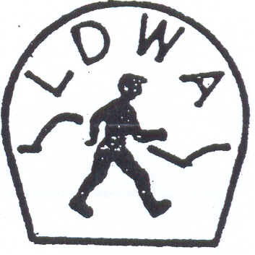 | LONG DISTANCE WALKERS ASSOCIATION  AIM: TO FURTHER THE INTERESTS OF THOSE  WHO ENJOY LONG DISTANCE WALKING

BEDS, BUCKS &
NORTHANTS GROUP

NEWSLETTER
FEBRUARY 2012

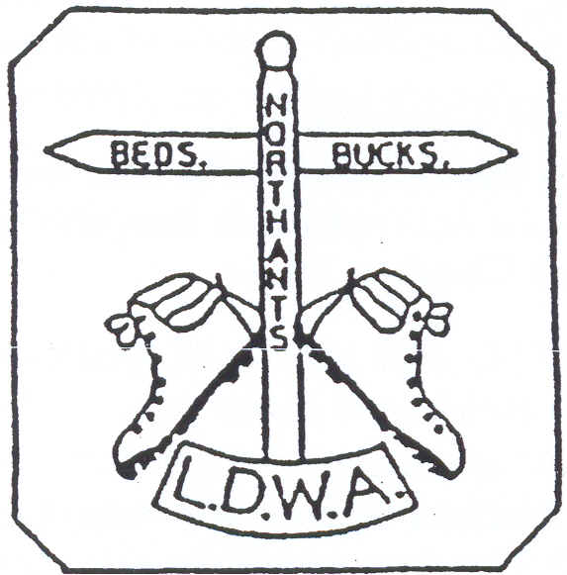

HAVE A GREAT DAY OUT, WALK WITH THE BBN
www.ldwa.org.uk/bedsbucksandnorthants

CONTENTS
Chairman’s Corner | 2-3
News and Diary Dates | 3-9
Walks Programme: April to August 2012 | 10-12
Chatting with the Chairman …….. and the Treasurer | 13-15
How to Behave on a Social Walk | 15-16
An Opportunity to Walk the Isle Of Wight Coastal Path | 17-18
LDWA40: The Yorkshire Dales Hundred 1996 | 18-21
When I’m Not Walking … … … | 21-24
BBN Committee 2012 | 24

New Members
A very warm welcome to the following who have joined BBN since the last Newsletter:
Anne Addison, Stamford Mary Knight, Banbury
Ildiko Patasiova, Milton Keynes Paul Rattenbury, Milton Keynes
David Thompson, Stamford Sarah Thorne, Eaton Bray
Nick Vanson, London W13

BBN New Arrival
Kevin Lamming is now a Dad. His partner Sara gave birth to a boy Rohan Oliver Wayan on Tuesday 24th January. Rohan weighed in at a healthy 7lb 8oz. Congratulations to Dad and Mum.

CHAIRMAN’S CORNER
First of all a very Happy New Year to you all and thanks to everyone who attended the AGM last November – you are always welcome to the AGM – there is a walk before and then lunch if you wish. It is not all administration but we are required under our membership of LDWA to hold an AGM. It is your walking club, please support it, not only by attending the walks.

There is not a lot to say at the moment other than this is the big year and not just for HM Queen or The Olympics. LDWA celebrates its 40th Anniversary in 2012.

If you are able to volunteer on the London Games 100 marshals’ walk please contact Lynn and Dave Yorston. If you are able to help on the main event please

contact Merrian Lancaster about Checkpoint 3 or myself to be a driver or helper with the collection and delivery of retirees to the Western HQ at Windsor.

A first in 2012 for me was to attend the Thursday walk on 12th January – 33 walkers! And at the start it was my privilege to present John Nickerson with a commemorative salver that recorded his immense contribution to BBN and indirectly to the LDWA for organising 10 Shillington Shuffles, 10 Steppingley Steps and eight years as BBN Treasurer. This was a remarkable example of the volunteering ethic and on behalf of everyone in BBN I offered him our congratulations.

I hope that you all have a good walking year and stay healthy.

As always your Committee and others work tirelessly on your behalf to organise events and arrange a very full social walks programme and Thursday programme. Dee will always love to hear from you to propose a walk.

Please think what you could do for BBN and not necessarily what the BBN can do for you, and don’t forget ‘to have a great day out on a walk with BBN’.

Nigel Schofield

2012 SUBSCRIPTIONS ARE NOW DUE
BBN subscriptions of £1 were due on 1st January. If you have paid for 2012 you will have received an email confirmation from me, or a note with this Newsletter for those who don’t do email.
I’m on most Thursday walks and the odd Sunday walk. I will also be at the Pick and Mix on 4th March. I’m happy to take your cash/cheque at any of these.
Cheques can be sent to me at 13 Runnymede, Giffard Park, Milton Keynes MK14 5QL. Please include any change to your details.
Anyone who has not paid by 31st March will be removed from the BBN membership list.

Printed Version of the Newsletter
The Newsletter is now available in the BBN web page: http://www.ldwa.org.uk/bedsbucksandnorthants
If you’re getting a printed copy of the Newsletter but are happy to view it via the web page we can arrange to email you when it is loaded. Just let me know

Dave Findel-Hawkins
Email: Davefh@gmail.com

NEWS *** DIARY DATES*** NEWS

Future Committee Meetings: Friday 18th May 2012 and Friday 28th September 2012
Annual General Meeting: Sunday 25th November 2012 - venue still to be confirmed.
Please speak to any committee member if you have an item you would like raised at one of the committee meetings or at the AGM. Contact details for the committee are shown on the last page of the Newsletter.

Sundon Saunter 18th November 2012

LDWA 40th Anniversary
The LDWA’s 40th anniversary year starts officially at the National AGM in March. The National Committee has asked all local groups to organise a social or challenge event ideally in September 2012, focusing on the weekend of 22nd/23rd September 2012 to celebrate the anniversary and to try to get publicity for the Association. Martin Lawson has agreed to lead BBN’s anniversary walk, a 20 mile walk from Hartwell, Northants on Sunday 23rd September 2012.
A special Strider, commemorating and celebrating highlights of the Association’s history will be published in September 2012.

September to December 2012 Walks Programme
Dee is now touting for business for the September to December 2012 walks programme. November will, as usual, be filled with our challenge walk, the Sundon Saunter (18th November), and our AGM (25th November). No doubt Santa will want his usual spot before Christmas, otherwise all dates are free! Dee asks that volunteers please book their date with her as soon as possible, with final details required by 10th May.

Offers to lead Thursday walks to Gordon Shaughnessy please.

Thursday Walks Gordon has indicated that there is some interest in 2 or 3 Thursday walks in the summer months being longer than 15 miles. When Martin Lawson started the Thursday walks, the start at 9.30am and 15 miles distance were agreed simply to avoid the busiest times for traffic on a weekday. Gordon is going to canvass Thursday walkers to gauge what interest there would be in a few longer Thursday walks.

BBN Clothing: A reminder that Lynn Yorston has a selection of BBN clothing for sale - including T-shirts, polo shirts, rugby shirts, sweat shirts and baseball caps

all embroidered with our group logo. Lynn will have the clothing at the Pick & Mix if you want to try a garment first. Merrian will put pictures of the clothing on the BBN website following the Pick & Mix.

Steve Smith has recently been on a Rock & Roll weekend in Great Yarmouth – walking in the day and then brilliant entertainment in the evening. He thinks this would be a great idea for a group weekend. The weekends are in April, October and December. Anyone interested please speak to Steve.

The Bedfordshire Walking Festival will be held on 8th-16th September 2012. Gordon is arranging for a Thursday walk that week to be included as part of the Festival.

BBN’s 30th Anniversary 2013
Plans for our 30th anniversary in 2013 are now being made. Martin Lawson is organising the BBN 100K (30+30+30+10) Challenge comprising 3x30K social walks, one in each BBN county, one each month (provisionally August, September and October 2013) with a 10K walk (within the AGM morning walk) to make the 100K challenge. A commemorative mug will be given to all who complete the challenge. Planning is at a very early stage – although it has been agreed that catch up walks will be allowed – and more details will follow.

PRESENTATIONS TO JOHN NICKERSON AND STEVE CLARK
John decided to step down as Treasurer at the recent AGM. Without his efforts over the years the group would not have had the Shillington Shuffle or the Steppingley Step which really did put the group on the challenge event map.

In addition to these two events John also completed 25 consecutive 100s, led numerous social walks, checkpointed on all BBN events and organised the Thursday walks programme. He was also nominated to be one of the LDWA representatives to be an Olympic torch bearer. He was only beaten to it by Ann Sayer who is one of the LDWA elite. That goes to show how highly esteemed John is throughout the Association.

We owe him an incalculable debt of gratitude and for that reason have awarded John BBN Life Membership. This is the highest honour the group can bestow and will save him the princely sum of £1 per year!

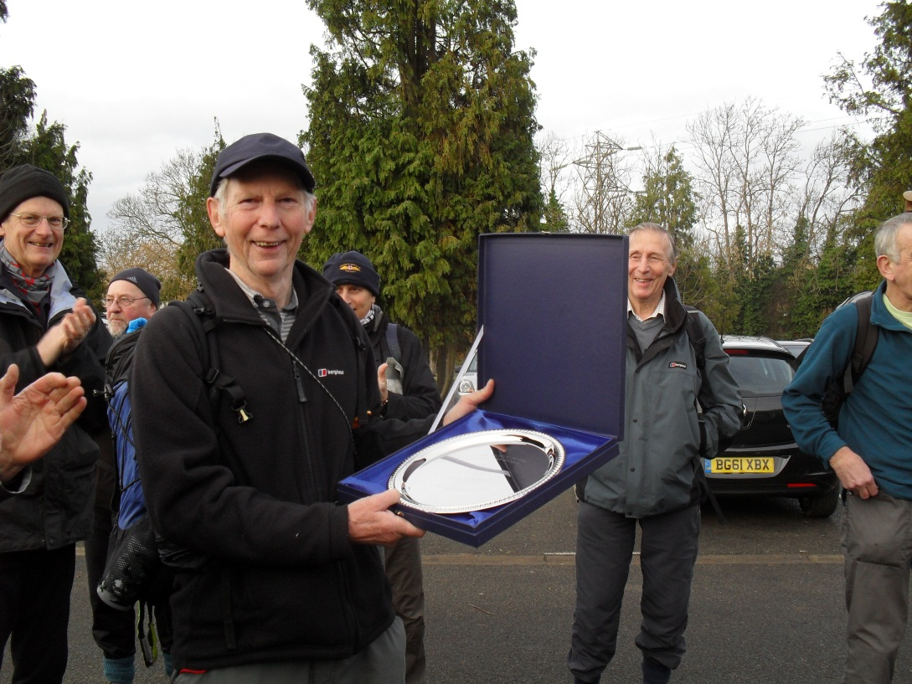 | 12th January  Before 32 walkers!  Nigel presented  John Nickerson with a commemorative salver that recorded his immense contribution to BBN

Hi to all on the BBN Committee and to all other members,
I would like to thank you all so much for the wonderful silver platter you presented to me for the service you think I gave to BBN over the last 25 years or more. I have enjoyed doing these things. I see from the engraving on the platter that I am a life member, thanks for that also.
I know that BBN will continue to go forward even though I have stepped back a bit.
Best wishes to all.
Judy and John

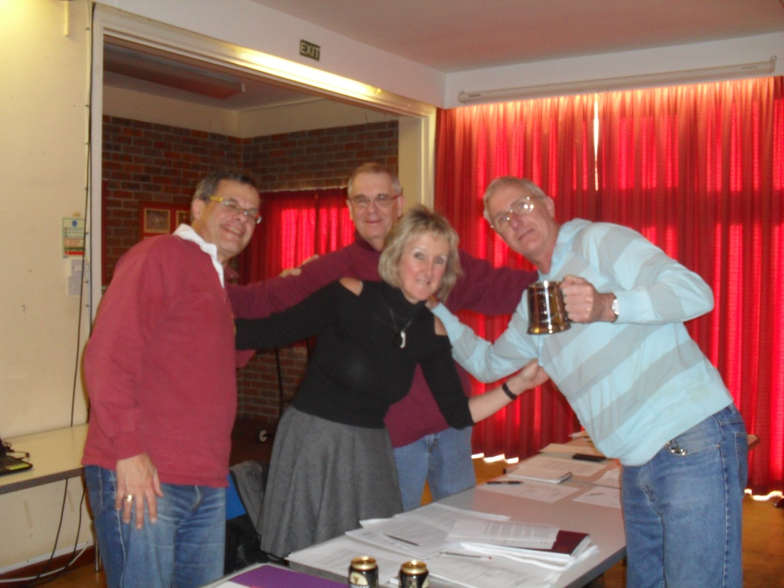 | Steve Clark was presented with an engraved tankard at the AGM in recognition of his work as Webmaster and Newsletter Editor

DONATIONS

Although the LDWA is a company limited by guarantee and not a charity, local groups do build up healthy financial reserves over the years from careful management of surpluses from their challenge events. BBN has been particularly successful in organising events since it was founded and has at times made donations to organisations or good causes that have a relevance to the group or our local area.

Amongst these has been the following:
- Installation of 6 benches along the Greensand Ridge in Bedfordshire
- Installation of kissing gates in Northamptonshire and Buckinghamshire
- BBN memorial bench to our founder members on the green at Ivinghoe

At the 2011 AGM we decided to donate funds to the following three organisations:

- Berkshire, Oxon and Buckinghamshire Air Ambulance http://www.tvacaa.org/ £250

- Chiltern Society Donate a Gate http://www.chilternsociety.org.uk/support-donatagate.php £150 (for the installation of a new kissing gate)
- Wendover Arm Canal Trust £150 (restoration of the Wendover Arm canal)

These are all examples of groups that BBN has had contact with through its members, although thankfully I cannot recall any of us having need of the Air Ambulance. I hope we never do.

In addition, following last year’s Shillington Shuffle a donation of £100 was given to the Critical Care Unit of Bedford Hospital in memory of Sylvia Foster, John Nickerson’s sister, who always helped at all the November events.

If any member can suggest a good cause they would like the group to support, please contact any member of the committee.

Norman Corrin

HERTS STROLLER 11TH/12TH AUGUST 2012

Essex & Herts are holding the 2nd Herts Stroller on Saturday and Sunday 11th/12th August. The event was a great success last time despite the best efforts of the English summer….e.g. rain, rain and yet more rain.

As per last time BBN are manning Checkpoint 1 at Montgrove Farm which will be open for 2-3 hours on the Saturday morning. We will be serving refreshments which I assume will be cold drinks, biscuits, cake and dried fruit.

As with all events, these could not be run without volunteers so I’m asking for help for one of our neighbourly groups with whom we have close ties. Helping and seeing how events are run from the other side of the desk is great fun and not as time consuming or as painful!

So if anyone would like to help out on this please contact me for further details.

Norman Corrin

MERRIAN’S MISCELLANY

Badges

You may have noticed that some people have name badges pinned to their rucksacks. Something like this:

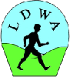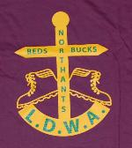
Merrian Lancaster

I’m slowly working my way through the membership list, initially for people who are first-claim BBN, and handing them out whenever I can. The idea is to publicise the LDWA and BBN, and to save embarrassment when you’ve (I’ve) been introduced to someone several times but keep forgetting their name. I have a bag of badges yet to be handed out, so if you see me and haven’t had your badge yet, please let me know.
BBN Website

Our website has now taken on the latest LDWA “corporate” look. It still has the same content, it’s just laid out differently. One advantage is that the LDWA has loads of room to store pictures, at no cost to us. I’ve loaded some of Steve Clark’s pics onto the LDWA storage, you can view those under “Group Activities”, “Pictures”. I’m not going to move anything from the existing Flickr site. We’d like to include a gallery for some light-hearted, possibly non-walking pictures, please send me something to get that started.

Games 100 – CP3 – Mottingham

On this year’s LDWA Games 100 BBN has checkpoint 3 at Mottingham Scout Hut, Court Farm Road, Mottingham, London SE9 4JW.

The opening hours are from 1300 to 2200 on Saturday 2nd June and the hut is booked from noon to 2300. It is 18.7 miles into the route.

So far, 11 people have volunteered to help at Mottingham, and a few for some of the time. If you’d like to join us, please let me know. merrian22@gmail.com
01908 642803
Merrian Lancaster

WALKS PROGRAMME : APRIL TO AUGUST 2012
Sun Apr 1 The Buntingford Buffoon Bonanza
18ml. Start 09.00 from Buntingford High St. (free c.p.). Map: LR 166 Start GR TL360295. Leader: Steve Smith T: 01767 220307 M: 07817 041621.

Thu Apr 12 Over the Border Down Foxton Way
15ml. Start 09.30 from Marston Trussell. Please park considerately near the church. Map: LR 141 Start GR SP693860.
Leader: Roger Story T: 01604 751576.

Sun Apr 15 Escapade From Sundon
19ml. Start 09.00 from Sundon Hills Country Park – free c.p. Map: Exp 193 Start GR TL048287.
Leader: Therese Jamin T: 01582 571455 M: 07779 227675.

Sun Apr 22 Wheathampstead Wander
18ml. Start 09.00 from public c.p. behind The Bull p.h. Wheathampstead. Map: Exp 182 Start GR TL178142.
Leader: Lucy Tink T: 01582 832023 M: 07947 412215.

Thu Apr 26 Cadsden Caper
15ml. Start 09.30 from small roadside c.p.½ mile E of Lower Cadsden (nr Princes Risborough). Maps: LR 165 Exp 181 Start GR SP833046.
Leaders: John & Judy Nickerson T: 01234 301817.

Thu May 10 Royston Ramble
15ml. Start 09.30 from Heath Sports Centre off Baldock Road, Royston. Free c.p. café & toilets. Map: LR 154 Start GR TL348405. Picnic lunch near a pub. Leader: Phil Hastings T: 01763 853744 before 9pm M: 07716 992847 on day only.

Sun May 13 The Lagoon, the Lookout and the Lavender
20ml. Start 09.00 from Wilbury Hill picnic area c.p. Letchworth. Maps: LR 153,166 Exp 193 Start GR TL201326.
Leader: Philip Nice T: 01462 490867 M: 07922 093968.

Sun May 20 Stoke Hammond Hobble
15ml. Start 09.00 from (& park in) Bragenham Lane, opp Dolphin p.h. near sports field. Map: Exp 192 Start GR SP886294.
Leader: Sylvie Eames T: 07598 395724 (before 8pm).

Thu May 24 An Ouse Valley Amble
15ml. Start 09.30 from picnic area c.p. ½ mile North of Wolverton Railway Station. Maps: LR 152 Exp 207 Start GR SP817422.
Leader: Gill Bunker T: 01908 321308 M: 07790 976090.
Thu Jun 14 Roxton
13ml. Start 10.00 from Roxton High St. Please park considerately along High Street near Village Hall. Maps: LR 153 Exp 208 Start GR TL152545.
Leader: Adrian Moody T: 01296 395146 (before 8.30pm).

Sun Jun 17 Manors, Mottes and a Most Unusual Toyshop
18ml. Start 09.00 from St Michaels and All Angels Church, High St N, Stewkley. Please park considerately on the road. Map: Exp 192 Start GR SP852261. Leader: Michael Mooney T: 01296 715598, M: 07704 310167.

Thu Jun 28 The Little and Large Walk
15ml. Start 09.30 from Manor Fields, Bletchley. Entrance opp Dobbies Garden Centre, Watling St. Park at far end of c.p. nr canal bridge.
Map: Exp 192 Start GR SP885335.
Leader: Brian Graves T: 01908 631013 M: 07563 728633.

Sun Jul 1 Tadlow Toddle
19ml. Start 09.00 from Heath Sports Centre, off Baldock Road, Royston. Free c.p. toilets and café. Map: LR 154 Start GR TL348405. Picnic lunch near pub. Joint walk with E & H.
Leader: Phil Hastings T: 01763 853744 M: 07716 992847 (on day only).

Sun Jul 8 Stowe Saunter
15ml. Start 09.00 from (and park in) layby near Stowe Ave. Map: Exp 192 Start GR SP684357. Leader: Sylvie Eames T: 07598 395724 (before 8pm).

Thu Jul 12 Loops to Eat and Drink
15ml. Start 09.30 from free c.p. in Sharpenhoe Rd between Sharpenhoe and Streatley. Map: LR 166 Start GR TL065296.
Leaders: Roger & Margaret Skerman T: 01525 405540.

Sun Jul 22 From Maulden Wood
20ml. Start 09.00 from Maulden Wood lay-by, off northbound carriageway of the A6, just North of Clophill. Map: LR 153 Start GR TL072395. Leader: Gordon Shaughnessy T: 01582 518791 M: 07518 364036 on day only.

Thu Jul 26 The Tunnel Walk
15ml. Start 09.30 from old railway c.p. near Maidwell/Draughton. Map: LR 152 Start GR SP755772. Visiting Loddington and Arthingworth. Bring a torch for disused tunnel.
Leader: Peter Bearne T: 01780 444362 M: 07761 036108 on day only.

Sun Jul 29 Several Parishes Circular
16ml. Start 09.00 from free c.p. opp St Mary’s Church, Woburn. Map: Exp 192 Start GR SP951332. Leader: Christine Bramley T: 01234 822557.

Thu Aug 9 A Daventry Round
15ml. Start 09.30 from The Green, Badby. Please park considerately. Map: LR 141 Start GR SP559590. Leader: Roger Story T: 01604 751576.

Sun Aug 12 Circling the Quarry
19ml. Start 09.00 from Hicks Road c.p. Markyate, just West of A5 footbridge. Maps: LR 166 Exp 182 Start GR TL064164.
Leader: Peter Simon T: 01582 513827.

Thu Aug 23 Just a Stone’s Throw
15ml. Start 09.30 from Stonepit c.p. off Wolverton Rd, Milton Keynes. Map: Exp 207 Start GR SP844422. Leaders: Jenny Greatbatch & Ian Turnbull
T: 01908 607215 M: 07891 683422 on the day.

Sun Aug 26 The Millbrook Warren Walk
20ml. Start 09.00 from Wilstead Village c.p. (220yds from crossroads towards Cotton End on rhs). Maps: Exp 193,208 Start GR TL066435.
Leader: Colin Scargill T: 01234 740361.

Sun Sep 23 Hartwell Hearts of Oak
BBN's LDWA 40th Anniversary Walk
20ml. Start 09.00 from Hartwell Church (Northants). Please park courteously on nearby roads. Map: LR 152 Start GR SP786504. Packed lunch required but may be a pub stop. Leader: Martin Lawson T: 01933 678594.

CHATTING WITH THE CHAIRMAN - Nigel Schofield
Nigel, what started you walking? How did you find out about the LDWA?
I have been an active 'athlete' since primary school, football, hockey, swimming, cycling, running, squash, Duke of Edinburgh's Award Scheme. But after a six month 'out of action’ I did not have the bottle to start running again and was weary of damaged knees. My very first walk was the Essex and Herts Jubilee in Spring 2000, not that I knew anything about the LDWA. On the 14 Greens Kanter I met Graham Busch who told me all about LDWA and BBN - and the rest is history!

What’s your favourite piece of equipment?
My sixth pair of Scarpa boots.

Favourite Event?
I don't really have a favourite as all are usually very good, but the Stansted Stagger is a good blow out post-Christmas and New Year. I like the Flower of Suffolk for its variety and the South West Triple Challenge.

Favourite Walk?
Any walk is a favourite, but any put on by BBN will do!

Best mile (anywhere in the world)?
Got to be the first and last on any Challenge Event.

What's your lunchtime snack?
Nothing fancy, carbos, protein, fruit, homemade scone or fruit cake (Dave Yorston knows what I mean!)

What luxury item do you carry with you that you don’t need to?
Luxury? What is that, maybe a spare bandana? Spare torch.

Who would you most like to walk with?
Kathy LoRaso and all my mates in BBN.

And as I know another big love is the theatre – who is your favourite actor, best performance, favourite play, who would get your "Olivier "?
I like anything that the luvvies do for a living.
Funniest Plays -Noises Off and Passion Play, Best Drama: War Horse, Jerusalem, Alan Bennett’s The Lady in the Van (but many others).

Best Actor/s Mark Rylance, Derek Jacobi, Kevin Spacey, Best Actress/s Eve Best, Helen Mirren, Vanessa Redgrave.
Anything written by August Wilson or Alan Bennett, not that the Bard is to be dismissed.

Other passions?
Like baking (and eating) homemade cakes.
Like to travel (not just getting on an aeroplane).
Like marshalling on the 100 every year and doing what I can to support BBN as one of the 'prime' groups in the LDWA.

… …. AND THE TREASURER - Ian Sage
Ian, what started you walking? How did you find out about the LDWA?
I’ve been a member of Dunstable Road Runners since 1989 and one of the members organised a weekend away to the Real Ale Ramble in Wales in 1993. This involved a 25 mile walk which I thoroughly enjoyed. Then in 1995, I ran the Chiltern Kanter which was my first LDWA event. It was refreshing doing a long run without bothering with mile markers and stopwatches – just enjoying the day. I also came across a copy of Strider which I still think is a very impressive and interesting magazine. So I joined up and became a joint member with Pat after we got married in 2000 (the same day as the Holy Hobble!).
Your favourite piece of equipment?
My growing collection of OS maps
Favourite Event?
The Heart of Scotland 100 – a personal triumph after heart surgery the year before and enjoying the companionship of Gordon, Dee and Betty amongst others.
Your Favourite Walk?
The Inca Trail including camping at the snow line and seeing a llama strolling through the campsite first thing in the morning.
Best mile (anywhere in the world)?
Cave Dale in Castleton, Derbyshire

What's your lunchtime snack?
Boiled egg sandwiches
Who would you most like to walk with?
Albert Einstein, a genius who developed his theories without the means to test them with scientific apparatus.
I remember you being very good at the music rounds at the BBN quizzes and I know you are learning to play the guitar – what piece of music would you most like to play? Favourite song? Favourite piece of music?
My ambition is to be able to play slide guitar in the style of the Mississippi Delta bluesmen – I’ve got a long way to go and have just signed up for my Beginners Plus course. Strangely, my favourite piece of music is classical, Beethoven’s 9th Symphony which has everything. I don’t really have a favourite song but go through phases of listening to different singers. At the moment I am listening to Stephen Stills and James Taylor, mainly for their guitar playing.
I also know you have volunteered to help at the London Olympics – what job are you hoping for?
Pat and I are waiting to hear the results from our recent interviews for jobs assisting the security staff. If I had the choice I would be assisting on the athletics track doing anything but I imagine that, quite rightly, these jobs will go to members of athletics clubs.
If you could live anywhere in the world where would you chose and why?
England! I love the climate which might mean that you can wear shorts in the winter and have to wear gloves in the summer. Also, you are able to get to just about everywhere that you can see.

HOW TO BEHAVE ON A SOCIAL WALK

The idea for producing this article came from the Bedford Road Cycling Club and is very loosely based on their Club Riding Etiquette and Rules. If everyone followed these few rules I’m sure we would have a safer and more pleasant walk.

The walk leader is controlling the pace. Please do not overtake the walk leader. Anyone going ahead of the group will be assumed to be on another walk of their own devices. They will not be called after or chased after if they miss a turn or take a wrong turn. We wait for people who go off the back of the walk. We do NOT

wait for people who go off the front. Ensure the front knows if those at the back are struggling with the pace.

When on a road never walk more than two abreast and change to single file if a car is approaching. Note: when changing to single file it is normal for the walker on right to go forward, and the walker on left to drop behind.

On tight bends and narrow lanes call out "car down" or "car up"; remember that cars go down your throat and up your a**e. Communicate with the other walkers by pointing and calling out holes, low branches, brambles, cyclists, joggers, parked cars and horses. Repeat calls up and down the line

Slow down for horses, give them lots of room. Call ahead "walkers-up" if approaching horses from behind, so as not to startle them.

Whenever there is a change in direction make sure the person behind has seen where you have gone. Don’t assume they have seen the change. If you’re the one behind acknowledge you have seen where those in front have gone

If you need to answer a ‘call of nature’ drop to the back of the group and make sure you let one of the group know.

Only on significant gradient climbs should you break away as all people have a different comfortable climbing pace. In this case, always wait at the top of the hill to allow a re-group and a short recuperation.

If you are at the front (but obviously behind walk leader) when a gate needs opening then offer to stay and close it after all the group have been through. You’ll probably have seen how it opens and be in a better position to close it. Clearly, if you were at the front you’re a strong walker so you can easily catch up again having closed the gate.

Do not litter. If you eat on the move put the wrapper in your pocket. Do not throw it on the side of the road. This includes banana skins.

Follow lines across crops, in single file if necessary. Do not cross locked gates if there is a stile available.

Walking poles are a dangerous weapon. Do not dangle the pointed end behind you. At stiles put the walking stick over first.
Dave Findel-Hawkins

AN OPPORTUNITY TO WALK THE 72 MILE ISLE OF WIGHT COASTAL PATH
WALKS LED BY JILL GREEN

As some of you know, in November 2011 I, along with a few other friends from BBN, joined the Essex and Herts walking weekend in the Isle of Wight. The walks were wonderfully led by Jill Green and Jim Catchpole who live on the island and are both well known in the LDWA. This introduction to walking on this beautiful island made the idea of walking the 72 mile island coastal path very appealing. When Jill and Jim kindly said this could be done in 3 full day and one half day’s linear walking, (they have done it before with groups, know where to park the cars each day etc) and gave us 4 days they were available to lead the walks, it was too good an opportunity to miss.

The hotel we used was excellent, fabulous food (ask anyone who went!), evening entertainment, and Jill said it was a good location to be based for the 'project'. So, if you would like to be a part of this great walking opportunity, it would involve booking the hotel directly yourselves. The hotel will book the Red Funnel ferry of your choice, and send the tickets with your confirmation. I think it would involve a minimum of 4 nights stay (as we are doing) but obviously, anyone wishing to stay longer (or even only do a couple of days walks) could book accordingly. Jill's only stipulation is that those wishing to complete the whole thing are available to leave the hotel (in our cars) for 3 full day walks early on Fri, Sat and Sun 19th, 20th and 21st October 2012 and leave early on Mon 22nd October for a walk that will finish mid-afternoon.

So, details are as follows. I have included the times and dates we have chosen (with prices), and anyone who wishes to do anything else is free to do so. Please let the hotel know you are with the walking group when you book. It is not half term, so it should not be busy but obviously once the hotel is full it is full. The Red Funnel Ferry timetable for the period is already on the web site and they are practically every hour. Our prices include one car with three passengers, so this will obviously change depending on how many in the car. If you do book please let me know, as I will create a group email list, ensure we have enough cars/drivers/spare places for the logistics of cars parked at both ends of each walk and obviously liaise with Jim and Jill. To date, and it is early days, 11 people have already booked.

Hotel: Wight Montrene Hotel
Avenue Road, Sandown, IOW PO36 8BN
Tel: 01983 403722
www.wighthotel.co.uk
Red Funnel Ferry from Southampton to East Cowes

Prices we have been quoted and booked for 3 people and one car ferry ticket for 4

nights stay dinner, bed and breakfast from 18th October all in is £236 per person.
We have booked the ferry from Southampton at 11am on Thursday 18th October, returning from East Cowes at 18.30 on Monday 22 October.

Would love to see you there.
Cheers,
Dee (T: 01582 881809 E: dmrbrockway@ntlworld.com

*********************8Getting to know Rachel Evans:-
LDWA40*** LDWA40***LDWA40
THE YORKSHIRE DALES HUNDRED 1996

With the celebration this year of the LDWA’s 40th anniversary and as talk on our walks is beginning to turn to the Hundred, I thought it would be interesting to reproduce this clever piece written by Steve Smith about the 1996 Hundred. The twist is that it contains 56 song titles. How many can you find?
In 1996 BBN had 11 entrants – with 8 successfully finishing, (one completing the marshals’ walk the previous August). Two members who walked in 1996 are also walking this year – Dave Yorston and Mike Hyland. There are at least 34 entrants from our area this time and many members are also involved in the planning of the event or have offered to help.
Good Luck to all our walkers, especially the first-timers and those on the marshals’ walk.

I travelled up to Yorkshire on the Friday night and stayed with a friend who lives just outside Wetherby. Needless to say, we went down the pub that evening and after a few beers staggered home wide-eyed and legless. Well, almost. Not exactly the best way to prepare for a Hundred.

The next morning I woke early to drive the short journey to Settle. It was pouring with rain on the way up but luckily by the time I got there it had just about stopped. The registration was in the local school where I soon met up with a few other people I knew were taking part. It was quite noisy as everybody’s talking at the same time. I just had time to get ready when by 9.45 it was school’s out as we milled onto the road and started lining up. I was intending to run the event, but would no doubt walk the hills and probably most of the night section. I have great admiration for some of the slower walkers who wouldn’t finish till Monday.

Monday was the day, hopefully, when I’d be heading home after a good night’s sleep.

I can’t explain the attraction of the Hundred, maybe it’s the challenge and the great camaraderie of the event. It’s an event where everyone’s a winner, not just the first one over the line. Also, you get the same old feeling of anticipation. But it’s a great event and I like it. As we lined up I was certain it was going to pour with rain. There was certainly something in the air. It was soon 10 o’clock and we were off. Some of the runners set off like a bat out of hell but I was going to take it easy for the first few miles. After all I thought, we’ve only just begun and there’s an awful long way to go.

We headed off for the nearby village of Clapham and then the long climb up to the summit of Ingleborough where I met someone I’d run with for a long time in the Dartmoor Hundred. I can’t stand the rain in the early hours of these events, give me sunshine any time.

The food at the checkpoints was getting better at each one. Starting with biscuits, then sandwiches, hot dogs, ravioli. You just help yourself to what you want. It was easy to stay longer than you should but you just had to force yourself away.

Just before dark we had a steep climb up to Wild Boar Fell. Up to now I’d mostly been running alone but it’s a lot nicer to be with someone else through the hours of darkness and you can help each other to find the way. It was here I met up with Pete and we decided to stay together. When we got to the top of the ridge we were able to see a beautiful sunset. It would have made a great photograph. When we got to the summit, it was very cold with thick mist and starting to get dark.

At the nearby checkpoint we had a kit check. Pete didn’t have a proper waterproof and I didn’t have a bivvy bag but luckily they didn’t notice that. We could have been disqualified, which would have been very frustrating. Ain’t no stopping us now, I thought.

It was now getting dark as we descended the other side of the mountain and we soon had to put our head torches on. At the bottom we found another checkpoint and then a long farm track before meeting the road. In some ways it was good to be on the road again after all the rough terrain on the mountain. After a couple of miles, mostly on the uphill sections, I noticed Pete was starting to drop back. At the top of quite a steep hill I decided to stop and wait for him. There I was, standing in the road, looking up at a starry, starry night with the hint of a bad moon rising. Quite a sight.

Eventually Pete caught me and said he wasn’t feeling too well and that I should
push on without him. Just then another runner came past and I followed him, telling Pete to make sure he kept going. A quick glance at my watch told me it was now into the midnight hour. Well, that was yesterday, I thought. Hopefully, I can say I’m going to finish today. We were now twisting and turning our way down the mountainside and back on the footpaths. It was during a treacherous, rocky descent through a stream that I hurt my ankle. I took it very slowly and was glad to get to the bottom. At about 1.15am we were at the breakfast stop. Some people also decided to have a lay down but there was no way I’d do that. You’d find it very difficult to start me up and get me going again.
At breakfast I got talking to another runner who suggested we stay together. He said he’d wait outside for me while I went and changed my socks. This only took a few minutes but when I got outside he’d gone on. Must have got tired of waiting, I thought. A few minutes later, where the route left the road, I caught up with him. We were now on very rough ground with no proper path and ended up getting lost. It’s going to be one of these nights I thought, but after a few minutes we managed to pick up the route. We’re now on the way back, I thought, having noticed the outline of Ingleborough in the distance, while we gingerly picked our way through some sleeping sheep.

Just before it started to get light we caught some other runners. It’s four in the morning, I thought, looking at my watch and morning has broken. I can see clearly now. My ankle was getting more painful and it was a job to keep up with the others. A couple of hours later Pete caught me up. “How are you?” I asked. “I’m all right now” he said. “In fact I feel fine”. With that he pushed on.

At the next checkpoint, with about 25 miles to go, I was told I was 22nd, but after that my ankle was getting more painful and it was a job to keep on running. I was determined to finish, however, as I’d been going all day and all of the night and it would be a tragedy to pack up now. Nevertheless, it’s a heartache when you’re going well then pick up an injury and find runners you’ve overtaken going past you.

For about the last 20 miles I find I’m walking most of the way. Mind you, a lot of it was very hilly, especially the climb up and down to Malham Tarn at about the 93 mile mark. I think some of these route planners have no soul. Man, that was a tough climb. I will survive, I thought, as it came on to rain, as long as I don’t do something stupid and get lost. The last few miles were a real struggle. It’s hard to imagine the end of the event, but I find myself dreaming about it.

After a final climb it was down to Settle and back through the streets. There were a few shouts of “Come on” but otherwise not many spectators as I got back to the school, right back where we started from. At the check-in desk the man said

“Congratulations. It’s all over now.” “This could be the last time”, I thought, though after a tough event it’s not unusual to think this way.

In the end I finished 43rd, but the Hundred is a tough event! You’ve got to respect the distance. It’s never plain sailing. After a meal, a shower and a few hours’ sleep it was back to my friend’s house for a hobble down the pub using his umbrella as a walking stick! I’m a believer in the healing powers of alcohol!!

Steve Smith

NORM’S COMEDY CORNER

Anthony Worrall Thompson stealing cheese? How dairy?

Someone just threw a bottle of Omega3 pills at me. Don’t worry though …. I only suffered super fish oil injuries

I had a dream that there was an ocean made out of fizzy drinks. But then I realised it was a Fanta sea.

I’ll never forget my childhood summers. We would climb inside old tyres and roll down the hillsides……They were goodyears……..

Liverpool sign a new striker from Nigeria. On the first day of training Kenny Dalglish picks up a ball and says "Ball". Then he does a kicking motion & says "Kick". Then he points to the goal and says "Goal - Understand? KICK, BALL, GOAL . . . GOOOAAL!" and the Nigerian says 'Excuse me Mr Dalglish, but I speak perfectly good English' Dalglish says "Sit down son, I'm talking to Andy Carroll".

WHEN I’M NOT WALKING . . . . . . . .

1. On Being a Milton Keynes Parks Trust Volunteer - Jim Morrison

Milton Keynes Parks Trust (MKPT) was established and separated from MK Council control as part of the dissolution of the original MK Development Corporation in 1992. The population of MK in the designated area has since grown to around 250,000, with more expansion planned. Parkland is required to be incorporated in all new development, so new areas of park are handed over to the Trust on a regular basis, together with sufficient property to produce rental income to cover the ‘running costs’ of the new parkland. Two rivers and a canal run through MK, plus a few long brooks, and there are parks adjacent to almost

the whole length of each. There are 4 ‘large’ lakes (each a backup reservoir for flood control), 3 large and several smaller woodland areas.

MKPT volunteers do a range of work – examples are work parties (eg. pond clearing, shrub control, hedge laying etc.), assistance at outdoor events (eg. pond dipping, moth trapping, bird watching), and patrolling. I’ve been involved with all types over the last 14 years, but my main work has been patrolling. There are more than two dozen parks in MK which are large enough to require formal inspection a couple of times a month, and this is best done by patrolling, which involves looking at the general state of paths, furniture, plants, lake and river banks, safety equipment, signage and litter, and reporting problems. When I first started, there were only a handful of volunteers, but numbers now are well in excess of 100.

For me it’s a weekly pleasure to walk or cycle round one or more parks, taking binoculars to get a better look at some of the wildlife, particularly birds. Some volunteers confine their activities to parks local to their home, but I prefer to go wherever necessary – so I see most of the parks at least two or three times each year. I get annoyed when I find litter, fly tipping or vandalism of plants or furniture – sadly these are all too common, but vandalism at least seems to be reducing.

Oh, and I’m a bit selfish, so I don’t do it out of a sense of community spirit, but because I enjoy it.

2. 63 Countries In 63 Years? - Steve Smith
I was going to write about my interest in tennis but couldn’t think of much to say – so instead I’ve written of my interest in travelling as I know many BBN members share that interest!

As well as walking, one of my main interests has been travelling. I remember as a boy looking at an atlas and thinking of all the places I’d like to go to.

My first trip abroad was when I was 15. I went with my father and brother on a camping trip to France. I spent a year in Canada when I was 21 working and travelling - including a job at a gas (petrol) station in Toronto during the winter, which included having to get the snow plough out when it snowed. I was working the night shift and it got very cold!

In my early twenties I did a lot of hitch-hiking round Europe. One year I got a lift from someone who worked for the Common Market (as it was then) in a Mercedes all the way from Italy to the UK. He even bought me meals on the way. Another year I got as far as Gibraltar where I got a job as a hotel receptionist.

My biggest overland trip was in 1978 when I went on the “hippy trail” to India. We travelled on local buses through Europe and Asia and then spent 2½ months travelling mostly on steam trains around India. Things that I remember include:

- Getting shot at in Iran during the revolution in the last days of the Shah. Luckily they missed!
- Travelling through Afghanistan – a beautiful country with friendly people. I remember getting to Kabul just before it got dark, when there was a curfew, passing a burnt-out tank and seeing a sign in English “Disco Open till 2am”. A bit dodgy when you could be shot if caught on the streets after dark!
- Being at the Taj Mahal for the full moon. Fantastic.

By the 1980’s I was in steady employment so most of the trips were holidays, though in 1984 I was between jobs and spent the winter hitch-hiking around South Africa at a time when there was still apartheid. I even got lifts off black people, some in quite new cars.

By the late 80’s I’d got into walking so a lot of the trips were walking holidays. The ones I remember most include the Inca Trail in Peru and climbing Kilimanjaro. I know quite a few BBN members have also climbed it. I remember being totally exhausted at the summit but felt a great sense of achievement. Other great trips included spending the night of the Millennium in Turkey, spending another New Year in the Sahara Desert in Tunisia, climbing Kinabalu in Borneo and also being attacked by leeches in the jungle and walking part of the Great Wall in China. The only bad trip I can remember was recently trekking in the Atlas Mountains in Morocco when I hurt my leg and had to be rescued by a mule!

Since meeting Pearl I’ve got her interested in travel. In the 2½ years I’ve known her we’ve had 7 trips abroad. The most recent one was January this year when we went to Malta. I remember at the age of 61 I’d been to 61 countries, so Malta became number 62 at age 62, but as I’ve had my 63rd birthday, I’m still one behind. Shucks!

I’m often asked about my favourite country. Hard to say, but probably Nepal. I ran the Everest Marathon there in 1991. At the start of the race it was -25ºC. A bit chilly! I also walked the Annapurna Circuit there three years later. Not quite so cold and some fantastic views.

New Zealand must be a close second. Again, great views and friendly people. We walked the Routeburn Track in South Island and I spent my 40th birthday jet boating at Queenstown.

Third, probably Brazil where I saw a football match at the Maracana.

I hope I’ve inspired some BBN members to go travelling though I know some of you have also been to many countries. This summer we are hoping to go to Croatia which will be my 63rd country and I can finally catch up with my age!

BEDS BUCKS & NORTHANTS GROUP: COMMITTEE 2012

Chairman: | Nigel Schofield  T: 01462 442338 E: nicelegs.schofield@btinternet.com  Nigel.Schofield@north-herts.gov.uk
Secretary: | Norman Corrin  68 Montgomery Crescent, Bolbeck Park, Milton Keynes  MK15 8PS T: 01908 608667  E: norman.corrin@btinternet.com / bbn@ldwa.org.uk
Treasurer: | Ian Sage  T: 01582 661256 E: iansage@waitrose.com
Social Walks: | Dee Brockway  T: 01582 881809 E: dmrbrockway@ntlworld.com
Membership: | David Findel-Hawkins  T: 01908 216476 E: davefh@gmail.com
Website: | Merrian Lancaster T: 01908 642803 M: 07933 735338  E: merrian22@gmail.com
Merchandise/Equipment: | Lynn Yorston  T: 01494 868371 E: lynn.yorston@dsl.pipex.com
Newsletter: | Gill Bunker  T: 01908 321308 E: gillbunker@googlemail.com
Thursday Walks: | Gordon Shaughnessy  T: 01582 518791 M: 07990 971323  E: gordon_shaughnessy@hotmail.com
Member: | Martin Lawson  T: 01933 678594 E: jimranit@btinternet.com
A big thank you to everyone who has contributed to this Newsletter.
Please let me have items for the June Newsletter by 31st May please
E: gillbunker@googlemail.com
1 Abbey Way, Bradville, Milton Keynes, MK13 7AN

