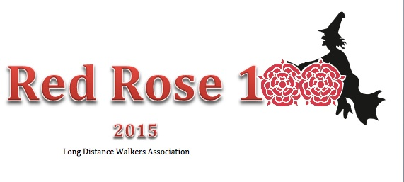
MARSHALS WALK - ENTRY FORM
2 – 4 MAY 2015

YOU DO NOT NEED TO COMPLETE THIS FORM IF YOU ENTER
VIA SPORTIDENT

PLEASE COMPLETE IN CAPITAL LETTERS
Surname
Forename (as you would like it to appear on certificate)
Gender
Date of Birth
Address
Email Address (please print clearly)
LDWA Membership No

LDWA Group
Main Contact Telephone Number (including STD code)
Mobile Phone Number (if carried on event)
Emergency Contact Name
Emergency Contact Telephone Number
Emergency Contact Address
Is Emergency Contact also on event? | YES / NO  If Yes please indicate in what capacity ie walking, marshalling or supporting
Qualifying Walk (see list attached)
Number of previous Hundreds completed
Please confirm what marshalling duties you will be undertaking on the main event to be held 23-25 May 2015.
Vegetarian meal at finish? | YES / NO
Car parking required at The Anderton Centre for duration of event? | YES / NO
Car Registration No:
What time do you intend starting the event? Please make a note of checkpoint opening times as these will be STRICTLY adhered to. |  | 10am / 2pm
Privacy Data Protection and Personal Information

For operational and safety reasons we need to store your personal details on a computer. This is a pre-condition of entry and by submitting this entry form you agree to this storage.
Do NOT show my name on the Results list

Do NOT include my personal details in the Hundred Database

Please advise of any medical conditions or allergies. This information will be treated in the strictest confidence

EVENT ENTRY FEES

Entry Fee: LDWA Family or Individual Member
TOTAL PAYABLE : £35.00

Make cheques payable to: LDWA Red Rose 100

Notification that your entry has been confirmed will be emailed to you. If you do not have an email account please include a stamped addressed envelope marked “ENTRY CONFIRMED”. Your cheque will then be cashed.
Route Description

The route description will be available for download from the “Red Rose 100” website. If you do not have access to a computer than a copy will be sent to you. Please include an A4 sized stamped addressed envelope marked “ROUTE DESCRIPTION” if you wish to have a paper copy sent to you.
If you do NOT wish to have the route description posted to you and are happy to collect it when checking in at the Anderton Centre, please tick this box.

I agree to the Rules of the Event and understand that no liability is accepted by the organisers or LDWA for any injury, damages or loss sustained by me during “The Red Rose 100 2015” event, or in connection with the event.
I confirm that I am in good health and have no medical condition that may cause undue concern or inconvenience to others.

Please send this completed entry from to the Entries Secretary:

JULIA GREENWOOD, 16 GLENTHORN GROVE,SALE,CHESHIRE,M33 3AG

Qualifying Events for Red Rose 100, 2015:-
A 50 miler to have been completed within 12 month period : November 2013 to October 2014 (inc)

Date | Event | Distance | Organisers
LDWA Events
April 2014 – 12th | The Woldsman | 50 miles | East Yorkshire LDWA
April 2014 – 12th | The Wellington Boot | 62.5 miles | Cornwall & Devon LDWA
May 2014 – 3/4/5th | The Valleys – Marshals Event | 101 miles | South Wales LDWA
May 2014 – 24/25/26th | The Valleys – Main Event | 101 miles | South Wales LDWA
June 2014 – 14th | 3 Rings of Shap | 100k (62 miles) | Cumbria LDWA
July 2014 – 19th | Wenlock Olympian Walk | 50 miles | Marches LDWA
July 2014 – 26th | The Wealden Waters (100k event) | 100k (62 miles) | Kent LDWA
Aug 2014 – 16th | Herts Stroller | 54 miles | Essex & Herts LDWA
Sept 2014 – 21st | Surrey Tops | 50 miles | Surrey LDWA
NON LDWA
April 2014 – 26/27th | The Fellsman | 62 miles | Scouts
July 2014 – 26th | Lakeland 50/100 | 50 or 100 miles | Montane
August 2014 – 29th | Ultra Trail du Mont Blanc | 168 km & 9,600m (46 hours) | North Face
September 2014 – 6/7th | Bullock Smithy Hike | 56 miles | Scouts
October 2014 – 18th | Rowbotham’s Round Rotherham | 50 miles | Rotherham Harriers
October 2014 – 4/5th | The Long Mynd Hike | 50 miles | Scouts

