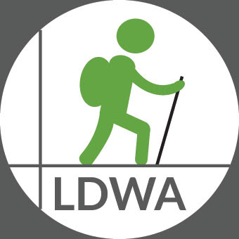
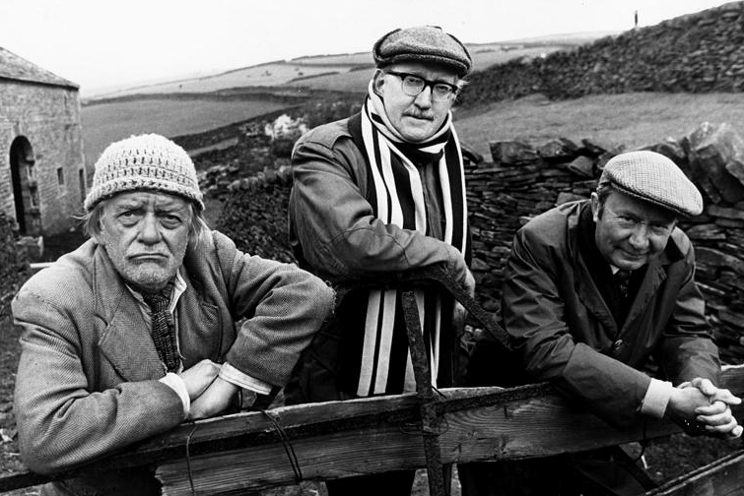


The 17th REGULAR IRREGULAR
Saturday 5th December 2020

Walk or run one or more of three loop routes of 11.6 miles; 7.2 miles; 4.2 miles: (18.5km, 11.5km and 6.7km) in the Holmfirth surrounds

Registration/Start & Finish: Brockholes Village Hall, Brockholes, Holmfirth HD9 7EB.
(GR SE153109).

Start time: Mass start at 8.30am. Registration opens from 7.30am.

Route descriptions are available to download from www.ldwa.org.uk/TheIrregulars
or at registration on the day. Maps required – Explorer 288.

Entry fee: Advance entry £8. (SI Entries + £1.20). On the day £10. U-16s free.

Entrants: Both LDWA & non-LDWA entrants welcome. Limit 150. Wait list when full.
U-18s must be LDWA members or walk with parent/guardian. U-16s must walk with parent/guardian. Dogs: Allowed but under constant control.

Entry includes: Tea and toast at start, snacks and drinks at checkpoint on 11 mile route and between loops at Brockholes, meal at finish, badge and certificate.

Equipment: As this is a winter event, please ensure that you carry adequate equipment, including waterproofs, warm clothing, suitable footwear, map, compass, whistle and torch.

Please bring your own mug to use on the event.

Our other events in 2020 are:
The Hangover Hike (Wed 1st January)
The Marsden Moors and The Marsden Moors Marathon (Sat 9th May)
AFoot in Two Dales (The Yorkshire 50) (Sat 4th/Sun 5th July)

The 17th Regular Irregular 2020

Name: …………………………………………………………………………LDWA Number: …………….….……….

On the day Mobile contact Tel: ………………………………………………………………………………..........

Emergency Contact Home & Mobile Tel: …………………………………….………………………………….

Email: ……………………………………………………………………………………………….………………………………

Car (used on the day) Registration: ......................................................................................

Vegetarian/Gluten Free etc: ....................................................................................................

Number of previous completions of this event -

I understand that particular terms & conditions apply to this event, which can be found at https://www.ldwa.org.uk/TheIrregulars and that it is my responsibility to familiarise myself with them before I start.

Signature: ……………………………. Date: …..……..………

Entry Fee: Advance entry £8.00. (SI Entries + £1.20). On the day £10.00.
(U-16s accompanied by an adult are welcome and entry is free).

Cheques payable to “The Irregulars ”.
Send to: Jeff Coulson, 11 Long Ridge Drive, Upper Poppleton, York YO26 6HD. Telephone: 07842 708133.

Please include email address or send SAE for confirmation of entry by post.

Form Rev 13/12/2019 NEF

