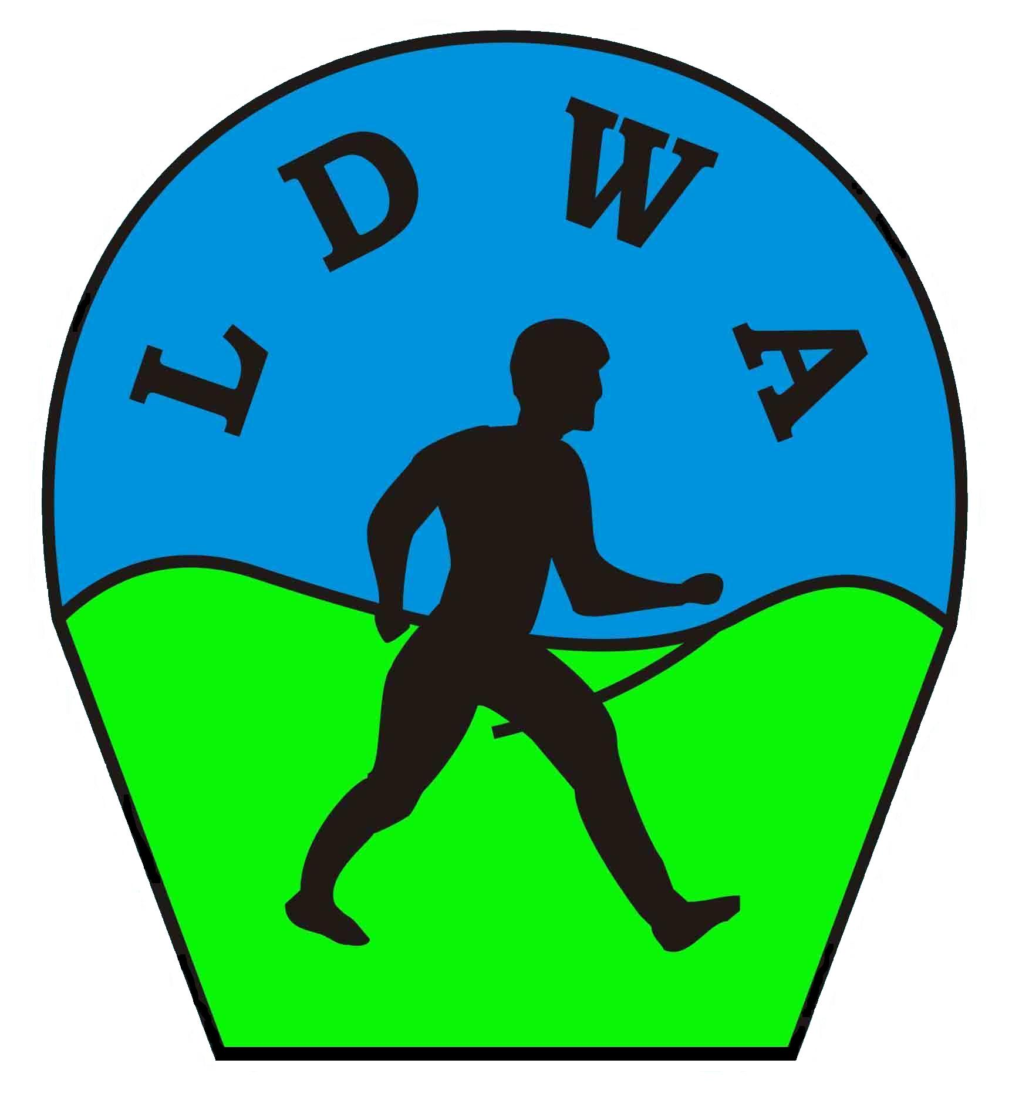
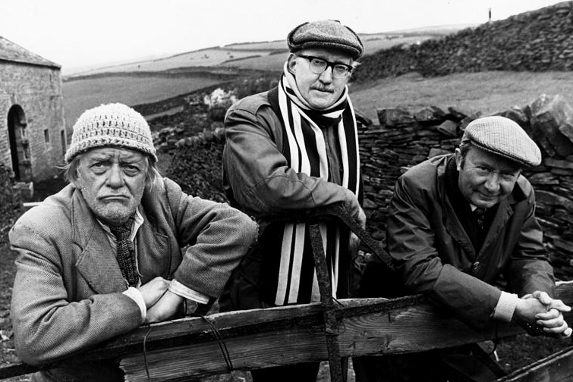


The 15th REGULAR IRREGULAR
Saturday 8th December 2018

Walk or run one or more of three loop routes of 11.6 miles; 7.2 miles; 4.2 miles: (18.5km, 11.5km and 6.7km) in the Holmfirth surrounds

Registration/Start & Finish: Brockholes Village Hall, Brockholes, Holmfirth HD9 7EB.
(GR SE153109). Registration opens from 7.30am.

Start time: Mass start at 8.30am.

Route descriptions are available to download from www.ldwa.org.uk/TheIrregulars
or at registration on the day. Maps required – Explorer 288.

Entry fee: Advance entry £7. (SI Entries + £1.20). On the day £10. U-16s free.

Entrants: Both LDWA & non-LDWA entrants welcome. Limit 150. Wait list when full.
U-18s must be LDWA members or walk with parent/guardian. U-16s must walk with parent/guardian. Dogs: Allowed but under constant control.

Entry includes: Tea and toast at start, snacks and drinks at checkpoint on 11 mile route and between loops at Brockholes, meal at finish, badge and certificate.

Equipment: As this is a winter event, please ensure that you carry adequate equipment, including waterproofs, warm clothing, suitable footwear, map, compass, whistle and torch. Please bring your own mug to use on the event.

Participants who retire from the event, must do so at a checkpoint. Marshals have the right to withdraw participants if their fitness is in doubt or they are behind schedule.

Our other events in 2018/19 are:
The Marsden Moors Meander (Sat 5th May)
AFoot in Two Dales (The Yorkshire 50) (Sat 7th/Sun 8th July)
The Hangover Hike (Tue 1st January 2019)

The 15th Regular Irregular 2018

Name: …………………………………………………………………………LDWA Number: …………….….…………

Address: ………………………………………………………………………………………..……………………………………

…………………………………………………………………………………..………………………………………………………

Home & On the day Mobile contact Tel: ………………………………………………………………………………

Emergency Contact Home & Mobile Tel: …………………………………….…………………………………………

Email: ……………………………………………………………………………………………….………………………………

Number of previous completions of this event:

I agree to abide by the rules of the event, and to observe the Country Code at all times. I have sufficient knowledge, experience, equipment, and navigational skills to take part in a long distance challenge event in all conditions. I confirm that I am in good health, and have no medical condition, that may cause concern or inconvenience to others. I confirm that I participate at my own risk, and that no liability is accepted by the organisers for any injury, damage or loss sustained to me during or whilst travelling to and from the event.
I understand that particular rules may apply to entrants taking part in this event and I understand that it is my responsibility to familiarise myself with these rules before I start.

Signature: ……………………………. Date: …..……..………

Entry Fee: Advance entry £7.00. (SI Entries + £1.20). On the day £10.00.
(U-16s accompanied by an adult are welcome and entry is free).

Cheques payable to “The Irregulars ”.
Send to: Jeff Coulson, 11 Long Ridge Drive, Upper Poppleton, York YO26 6HD. Telephone: 07842 708133.

Please include email address or send SAE for confirmation of entry by post.

Form Rev 03/01/18 NEF

