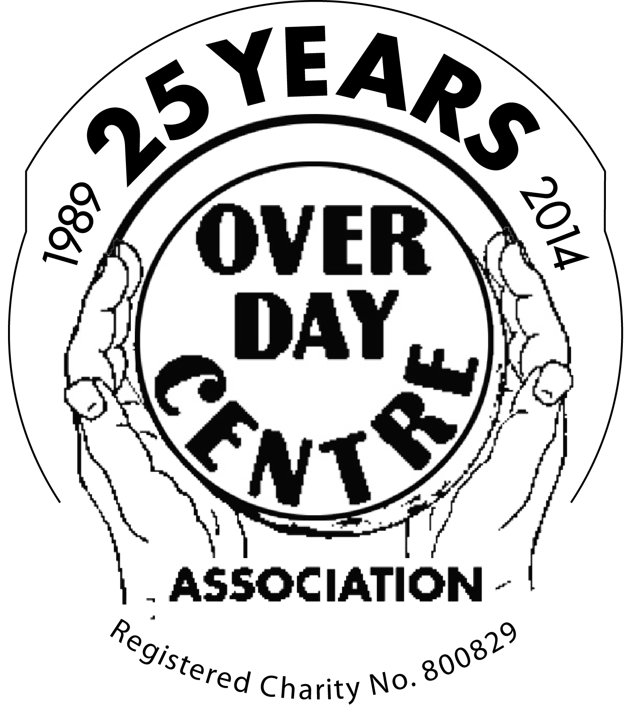 REGISTRATION FORM

Sunday 13th May 2018

FIVE PUB CHALLENGE PLEASE TICK CHOICE
10.30am start from The Over Day Centre
12.5 Miles

MERIDIAN MEANDER
8.00-9.00am start from The Over Day Centre
18 Miles
or
26 Miles

I am WALKING / RUNNING (Meridian Meander only) *please circle

Title / Surname (Mr/Mrs/Ms/Miss)……………….………………………………………………………………………..……

Forename …………………………………………………………………………………………………………………………………….

Address ………………………………………………………………………………………………………………………………………

…………………….…………………………………………………………….. Postcode……………..………………………………….

Phone…………….…………………….…………………………. Mobile……………………………………………………………….

Email ……………………………………………….......Emergency contact (during event).....................................

CONDITIONS OF ENTRY
One registration form must be completed and signed by each participant (or by parent/guardian of under 18’s)
Cheques made payable to ‘The Over Day Centre’ and returned with this registration form to:
Five Pub Challenge - The Over Day Centre, 1 Drings Close, Over, Cambridge CB24 5NZ
Meridian Meander – Allison Box, 2a Willingham Road, Over, Cambridge CB24 5PD

- Five Pub Challenge: minimum donation of £10 per adult & £5 per under 18. Registration can be made on the day for a minimum donation of £12 per adult & £6 per under 18.
- Meridian Meander: donation of £10 per person. Pre-entry only: by Wednesday 9th May 2018.

If you are a UK tax payer please tick the box ‘Gift Aid’ below to cover your donation (or where you are donating for someone under 18 years old):

Donation amount £_______ Gift Aid (please tick)

Bacon rolls, coffee & tea will be on sale at the Over Day Centre prior to walks commencing.
Five Pub Challenge: Free soup and bread roll at the Ferry Boat, Holywell between 12 and 2pm. Free cone of chips (before 2.30pm) at the Three Tuns on purchase of a drink, Fen Drayton. Free choc ice at the White Horse, Swavesey*. Certificates will be issued to all finishers at The Admiral Vernon and a complimentary slice of cake.
Meridian Meander: Free refreshments available at all checkpoints*. Certificates will be issued to all finishers at The Over Community Centre and a complimentary slice of cake.
*All food is subject to availability on the day

Unfortunately, due to the terrain and stiles, all routes are unsuitable for people with limited mobility. Please be aware participants are responsible for their own medical condition ensuring they are fit to complete the route chosen. Please consult your doctor if you suffer from heart, joint, back or breathing problems or any other medical condition that may affect your ability to take part, as the organisers can take no responsibility for any injuries incurred. Ensure the Countryside Code is respected.

DECLARATION: I confirm that I have read and accept the Conditions of Entry and enclose my non-refundable donation.

Signed …………………………………………………………………………………………………………………………………………

Age (if under 18) …………. Signed (parent/guardian) ……………………………………………………………….

