NOTES

- Birmingham has more miles of canals than Venice. This low cost transport network, the equivalent
to today's motorways, fuelled the industrial revolution. Most are now quiet back waters, linear arms
of the country that penetrate deep into the city. Never dull, the backdrop varies from rural to
industrial heritage and then to state of the art development. We invite you on these walks/runs with a
difference exploring Britain’s second city from a new perspective. All routes are circular starting and
finishing at MOSELEY RUGBY CLUB. Taking in the Stratford on Avon Canal, Cole Valley Way,
Grand Union Canal, Fazeley Canal, Wolverhampton Main Line, Soho Loop Birmingham and
Worcester Canal and returning via the Stratford Canal. They pass Sarehole Mill (the inspiration to
Tolkien’s Middle Earth), Gas Street Basin, home of the International Convention Centre, the award
winning Brindley Place development and under the dark bowels of Spaghetti Junction. They are 97%
off road with very few crossings, no stiles and probably the least ascent and descent you will do this
year!! NOTE THIS YEARS ROUTE IS THE SAME COURSE AS BEFORE BUT IN REVERSE.

- The walk is organised by Heart of England LDWA. Start point – MOSELEY RUGBY CLUB BILLESLEY COMMON YARDLEY WOOD ROAD MOSELEY BIRMINGHAM B13 0TP
Grid Ref SP 088 811

- It is recommended that all participants carry a map (OS Explorer map 220 or Landranger 139 or probably best Birmingham A-Z), food /drink, simple first aid and money. Entrants are also advised to wear sensible footwear and carry waterproof clothing.

- There will be five checkpoints (26 mile) en route. All will supply cold drinks and simple food- Look out for the cake stop and help us judge the “Canal Canter Cake Competition” - entrants should also carry their own supplies to supplement these. Please note: IT IS ESSENTIAL TO BRING A MUG as cups will not be provided. There will be hot drinks and a meal at the finish including a vegetarian option. Note the Rugby club bar will be open !!! Showers and changing rooms also available on completion and finishers will get a certificate.

- Baggage may be left at the start at the owners risk. Please label your baggage with your name and address and contact number.

- The nearest train station is Yardley Wood- Trains leave New Street every 30 mins on a Saturday - allow a 15 minute walk. Moseley Rugby Club is also served by several buses from the city centre - ring Traveline 0871 2002233 - press 1 then 6 to get through to the West Midlands Call centre. Extensive free parking is available on site at owner’s risk.

- For accommodation please contact the Birmingham Tourist information

CHECKLIST
___ Form completed clearly and signed; detach keeping rules and notes for reference
___ Cheque made payable to Heart of England LDWA
___ S.A.E essential to receive number and route description if email not supplied

When completed please return to
Entry Secretary: Rose Harris 41 Grange Road, Cradley Heath, Warley, West Midlands B64 6RT
For any queries email roseharris41@gmail.com or ring 07707070403 after 1800 HRS before 2100 HRS or see our website www.ldwa.org.uk/heartofengland or to enter online at https://www.sientries.co.uk/event.php?event_id=2631

RULES

- Entrants as young as 12 may participate. All those younger than 18 must have the signed permission of a parent or guardian. Additionally those under the age of 16 must be accompanied by a named responsible adult at all times.

- Entries must be made on the official entry form or photocopy with only one entry per form. If an email address is not supplied a stamped addressed envelope must be enclosed to allow route description to be forwarded. Postal entries close on the 12th August 2017 or when the combined entry limit of 350 has been reached. Please contact the entry secretary for entry on the day.

- The postal entry fee is £9 for either event and £13 for non-members of the LDWA (cheques made payable to LDWA Heart of England). Any on the day entry will be charged at £20.

- The organisers reserve the right to refuse any entry and return the full amount. If the event has to be cancelled the full entry fee will be returned. If entrants cancel prior to 01/08/17 the charge will be returned less a £2 administration fee. If cancelled after 01/08/17 no refund will be given.

- The route will start from Moseley Rugby Club, Billesley Common, Yardley Wood Road, Moseley, Birmingham B13 0TP. Walkers on the 26 mile route will start at 08:30; Registration opens at 07:30. Runners for all courses and walkers for the 18 mile course will start at 0930; Registration opens at 08:30. All entrants must finish by 18:30 (10 hour time limit for the 26 mile route) and entrants must pass through each check point in the correct order.

- The route description will show checkpoint opening and closing times. Opening times are geared to 5mph (8km) pace from the main start at 08:30 and 8 mph from the runners start at 09:30. IF IT IS LIKELY THAT YOU WILL EXCEED 5 mph PLEASE START AT 09:30 HRS. Closing
times are geared to approx 2.5 mph from 08:30. Participants must leave each checkpoint before the closing time and anyone arriving after the closing time will be retired or diverted onto the shorter course. Route descriptions with opening/closing times will be forwarded prior to the event

- Retiring entrants must make themselves known to the checkpoint manager and hand in their tally at a checkpoint and transport to the finish will be arranged as soon as possible. In an emergency, if the retiring entrant cannot reach the next checkpoint, they should pass their tally on to another entrant to be handed in to a marshal at the next checkpoint. A mobile number will be given on the route description for emergency use only. Under no circumstances retire without telling the organisers.

- No dogs, other than Registered Assistance Dogs, will be allowed on the Challenge Walk.

- The checkpoint marshal may retire anyone showing undue signs of stress or who has broken the rules. In all matters the organiser’s decision is final.

Follow the Waterways Code

IMPORTANT: Protect the waterways environment; don't damage vegetation or the banks. Take home any litter. Be safe and aware of dangers, particularly on narrow stretches of the tow path or where cyclists may approach at speed on blind corners. Watch for concealed mooring pins, ropes or other hazards on the tow path. Follow warning signs. The risks are small but advise your doctor if you become ill within 2 weeks of swallowing canal water. Do not dive in the water even to rescue someone. Be considerate to other canal users particularly fishermen and cyclists. Please read the Health and Safety assessment included with the route description.

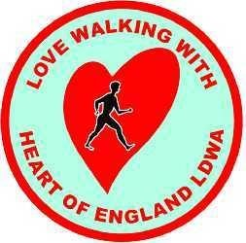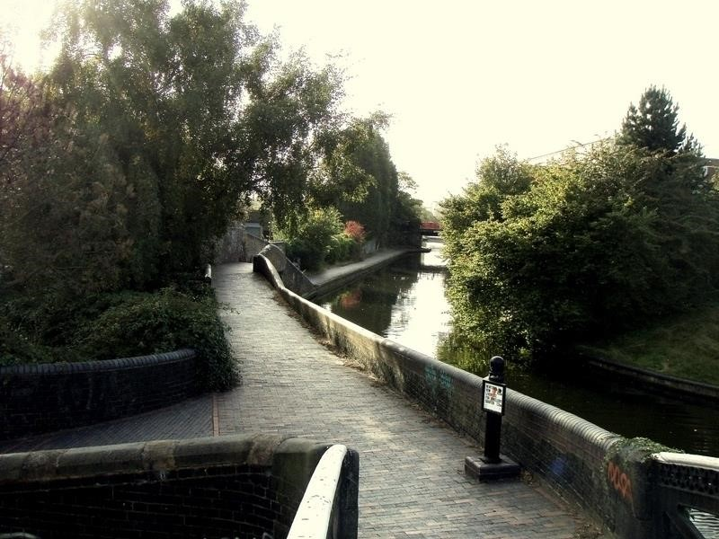

BIRMINGHAM CANAL
CANTER / MINI CANTER

SATURDAY 19th AUGUST 26mls/18mls
RUN or WALK
New Date/New Venue/New Route !!!
Explore the big Heart of England with the Heart of England LDWA

BIRMINGHAM CANAL CANTER / MINI CANTER
SATURDAY 19th AUGUST 2017 MOSELEY RUGBY CLUB,
BILLESLEY COMMON, YARDLEY WOOD ROAD B’HAM B13 0PT

Details may be held on computer for the sole purpose of administering the event- the LDWA is registered under the Data Protection Act.

PLEASE COMPLETE IN BLOCK CAPITALS separate sheet per entrant

Forename ..................................................... Surname................................................................
Address ............................................................................................................................................
…………..….................................................................................... Postcode ..............................
Emergency telephone number (inc. Std code) …..............................................................................
Mobile number contactable on the day ............................................................................................
Car registration on day (if left during walk) ….................................................................................
Email address ...................................................................................................................................
( please write email address carefully, particularly underscores hyphens and full stops)
Vegetarian meal option required □ LDWA Membership No….................Group ......................
Walker □ Runner □ Full Route (26 miles) □  Mini Canter (18 miles) □

Please enter me for the above event
- I consider myself fit enough to take part in the event.
- I agree to abide by the rules of the event
- I understand that no liability is accepted by the organisers for any injury damage / loss caused to me as a result of participating in the event.
- I agree to follow the waterways code and show consideration for others
- I enclose cheque or postal order payable to LDWA Heart of England for £13.00 / £9.00
- “I understand that the personal information submitted as part of this entry form will be held by the event organisers for a period of up to three years after the event is held for the purposes of managing this event only. I further understand that photographs are likely to be taken at the event, which may be featured in Strider magazine or on LDWA websites. In addition, I understand that Summary Information* may be published immediately and may be held in perpetuity for the purposes of providing a record of the event. I will have the right to request that all my personal Summary Information is anonymised.” Note also your name will be entered on the Sportident list of entrants.

Signed............................................ If under 18 signature of parent/guardian...................................... Name of parent or guardian................................ Specified responsible adult..................................... Entrants as young as 12 may participate, those younger than 18 on the day of the event must have the signature of a parent or guardian. Additionally, those younger than 16 must be accompanied by a specified responsible adult at all times.
Please detach this form and send with SAE (if email address not supplied) & cheque payable to Heart of England LDWA: Entry Secretary Rose Harris, 41 Grange Road, Cradley Heath, Warley, West Midlands B64 6RT. Or enter online at www.sientries.co.uk - note additional £1.00 for online entry

*Summery information includes name, age, gender, postal town, email address, LDWA membership number, event name and date, distance covered, time recorded as well as any other linked walking achievement.

